Rotational intravascular multi-direction ultrasound catheter for sonothrombolysis of retracted clots: in-vitro and in-vivo study
Huaiyu Wu^{a,}, Jinwook Kim^{b,*}, Bohua Zhang^{a,*}, Gabe Owens^{c}, Greyson Stocker^{c}, Mengyue Chenª, Benjamin C. Kreagerª, Ashley Cornett^{c}, Kathlyne Bautista^{b}, Tarana Kaovasia^{c}, Paul A. Dayton^{b}, Zhen Xu^{c,†}, and Xiaoning Jiang^{a,}
ªDepartment of Mechanical and Aerospace Engineering, North Carolina State University, Raleigh, NC 27695, USA
^{b}Joint Department of Biomedical Engineering, at The University of North Carolina at Chapel Hill, Chapel Hill, NC 27599, USA
^{c} Department of Biomedical Engineering, University of Michigan, Ann Arbor, MI 48109 USA

Supplementary Material
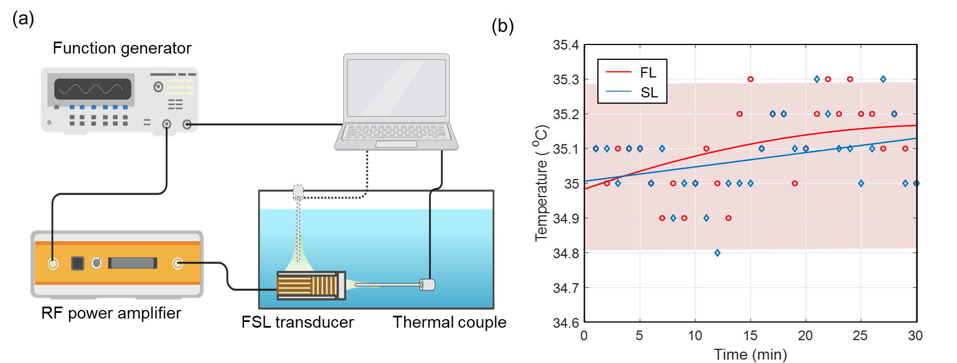
Fig. S1 (a) Experiment setup for the temperature variation during treatment in-vitro with FSL transducer with input of 80 Vpp, 1 kHz PRF and 5% duty cycle. (b) Temperature variation for 30 min for both FL and SL elements. The temperature variations were less than 0.4 ºC for both elements.

These authors equally contributed to this work.
Corresponding authors Email address: xjiang5@ncsu.edu; zhenx@umich.edu

