Supplementary data for

A New Method for Inferencing and Representing a Workpiece Residual Stress Field Using Monitored Deformation Force Data
Zhiwei Zhao ^{a,#}, Changqing Liu ^{a,#}, Yingguang Li ^{a,}*, James Gao ^{b}
ª College of Mechanical and Electrical Engineering, Nanjing University of Aeronautics and Astronautics, Nanjing 210016, China
^{b} School of Engineering, University of Greenwich, Chatham Maritime ME4 4TB, UK

* Corresponding author.
E-mail address: liyingguang@nuaa.edu.cn (Y. Li).
# These authors contributed equally to this work.

Note A: Analysis of singular values of the volume coefficient matrix M
Some properties of the volume coefficient matrix M of this workpiece are further analyzed below:
Here, $M_{10}$ with the first 10 layers’ deformation forces is used as the sample. Its scale is $280×104$. For the convenience of observation and statistics, the column of M is divided into two parts, and the first 52 columns are the coefficients relevant to $σ_{x}$, in which the four stress values of each layer are sequenced as areas order and then expanded along the depth direction. The last 52 columns are the coefficients relevant to $σ_{y}$, and the sequence is the same as the first 52 columns. The sensitivity of accuracy of the residual stress field to the error is mainly affected by the singular value of matrix M. The Singular Value Decomposition method is used to obtain the singular values. The truncated singular value method is used to analyze the effect of singular value on matrix $M_{10}$.
$$M_{10}=UΣV^{T}$$ | (A.1)
It is obvious that matrix $M_{10}$ is a column full rank matrix, and its rank is 104. Thus, there are 104 singular values on the diagonal of $M_{10}$. It is also proved that, with perfect measurements, it is possible to infer the 104 unknowns of the residual stress field precisely. In $Σ$, the singular values are arranged from largest to smallest, and the previous values are larger and contain more valid information. Here, the first k singular values are used to reconstruct $M_{10}$, and the influence of different singular values on the matrix is analyzed by comparing the errors of the reconstructed matrix. The error shows the effect of the ignored singular value on the matrix. The reconstruction error is shown in Fig.A. 1.
$$M_{10,k}=U_{k}Σ_{k}V_{k}^{T}$$ | (A.2)
Fig.A. 1 (a-f) show the reconstruction errors using 64 to 104 (adding 8 singular values every time) singular values, respectively. The following conclusions can be drawn: (a) Large singular values mainly affect the stress coefficient of the areas with removed materials in $M_{10}$, and as the number of singular values increases, the reconstruction error of the stress coefficient of the deeper layer decreases; (b) The influence of large singular values on the stress coefficient of $σ_{x}$ is greater than that of $σ_{y}$, and small singular values control the stress coefficient of $σ_{y}$. This means that, in the solution process, the measurement errors mainly affect the solution of $σ_{y}$; and (c) As the number of the singular values increases, the error area of the coefficient related to deformation force measurement of deeper layers decreases preferentially. As seen in Fig.A. 1 (e), the errors are concentrated in the coefficient regions associated with deeper stress of $σ_{y}$ and deformation force measurements of the surface. It indicates that the deep $σ_{y}$ has limited effect on the deformation force measurement of the surface. Through the analysis of singular values, the conclusions verify the above-inferred conclusion with error analysis. Moreover, the above conclusions are influenced by the geometry of the part (the long beam), the layout of the deformation force measurement (the far end of the beam), and Saint Venant's principle.
Fig.A. 1 Analysis of singular values of volume matrix $M_{10}$. (a-f) The reconstruction errors using 64 to 104 (adding 8 singular values every time) singular values, respectively.

Note B: Analysis and comparison of the proposed method and TR method
Firstly, we find that matrix M has a unique ability to resist error interference:
$|\dot{σ}-\overline{σ}|=|M^{-1}M\dot{σ}-M^{-1}M\overline{σ}|$  $$\left|δσ\right| = \left|M^{-1}\left(M\dot{σ}-\overline{f}\right)\right|$$  $$\left|δσ_{i}\right| =|\sum_{j}{M_{ij}^{-1}}(M\dot{σ}-\overline{f})|=|\sum_{j}{v_{ij}Σ^{-1}U^{-1}E}|$$ | (B.1)
where $δσ_{i}$ is the inferred error of the $i-th$ residual stress field value. $E$ is the predicted deformation force error, which will be smaller when the inferred error is small. $\overline{f}$ is the real deformation force without noise. According to the calculation, it is found that$\sum_{j}{v_{ij}Σ^{-1}U^{-1}}$ of the areas with removed material is less than 1, as illustrated in Fig.B. 1 (a), even though $v_{ij}Σ^{-1}U^{-1}$ is larger than 1, which could be deemed as an error coefficient. It shows that it has a strong anti-interference ability to error. It ensures that the proposed method can infer the residual stress field values in the areas with removed materials more accurately. This property is derived from the properties of matrix M and is worth exploring further. The bias of the proposed method and the TR method are analyzed. The formula is as below:
$$Bias\left(\dot{σ_{i}}\right)=-{(λ}^{*}{\left(M^{T}M+λ^{*}G\right)}^{-1})_{i} \overline{σ}= {\left(-λ{\left(M^{T}M+λK\right)}^{-1}M^{-1}\right)}_{i}\overline{f}$$ | (B.2)
Again, the sum of ${\left(-λ{\left(M^{T}M+λK\right)}^{-1}M^{-1}\right)}_{i}$ is calculated, as illustrated in Fig.B. 1 (b) and (c). It is found that the bias of the TR method only change the error coefficients of the residual stress field in the areas with removed materials, while those in the areas without removed materials are almost unchanged. By contrast, the error coefficients for residual stress field values in all areas are reduced by introducing the regularization matrix K. Moreover, the influence of the regularization matrix introduced by the proposed method on the covariance is analyzed, compared with the TR method. The formula is as below:
$$D\left(\dot{σ}\right)= τ^{2}{\left(M^{T}M+λK\right)}^{-1}M^{T}M{\left(M^{T}M+λK\right)}^{-1}$$ | (B.3)
V = $(M{\left(M^{T}M\right)}^{-1}M^{T}-I)\dot{f}$  $${\dot{τ}}^{2}=\frac{V^{T}V}{m-n}$$ | (B.4)  (B.5)
Where $τ^{2}$ is the unit weight variance of measured deformation force, and is estimated by the least square method. $m$ is the amount of the measured deformation forces, $n$is the amount of the unknown residual stress field values. As for the covariance, since ${\dot{τ}}^{2}$ of the same set of measured deformation force is the same, the diagonal value of ${\left(M^{T}M+λ^{*}K\right)}^{-1}M^{T}M{\left(M^{T}M+λ^{*}K\right)}^{-1}$ is compared between the TR method and the proposed method with the same $λ$, as illustrated in Fig.B. 1 (d) and (e). It can be seen that the variance of different areas is adjusted by the introduction of matrix K. The adjustment of bias and variance will effectively improve the accuracy of the residual stress field.
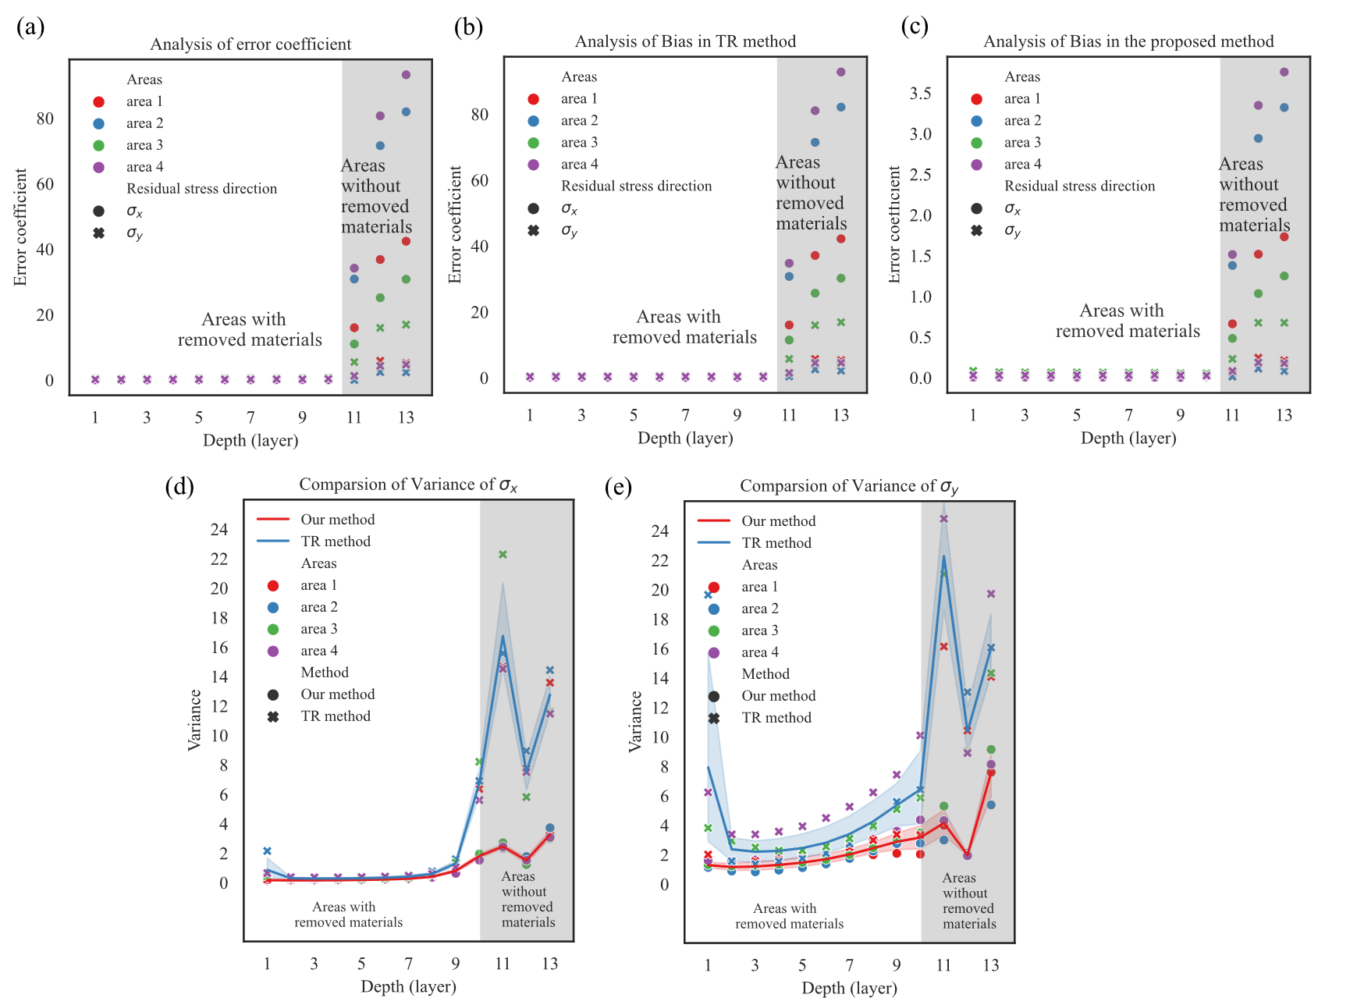
Fig.B. 1 Comparison of bias and variance between the proposed method and TR method.
To verify the advantages of the proposed method, comparison with the TR method is applied to the simulation data group with 2% and 5% noise, respectively. The RMSE and probability of the two methods are calculated, as illustrated in Fig.B. 2. It can be seen that by adjusting the variance and bias, the method reduces the lower bound of the prediction error, especially for the residual stress field in the areas without removed materials, while appropriately amplifying the variance of the residual stress field in the areas with removed material. Moreover, a method was proposed to evaluate the reliability of inferred results, that is, to calculate the probability of the true residual stress field value in the distribution formed by the inferred results plus the bias and the inferred variance as the variance of the distribution. For the convenience of comparison, the logarithm value of probability is calculated, the formula is as below:
$$log_prob\left( σ \right)=\sum_{i}^{n}{-\frac{{\left(\dot{σ_{i}}-\overline{σ_{i}}\right)}^{2}}{2D{\left(\dot{σ}\right)}_{ii}}-\log\left(\sqrt{D{\left(\dot{σ}\right)}_{ii}}\right)}-log(\sqrt{2π})$$ | (B.6)
By definition, a larger probability means a more reliable inference, and the logarithm of the probability is negative, as illustrated in Fig.B. 3. It can be seen that the result obtained by the TR method is unreliable for the data with large noise. However, the proposed method has reliable inference results for the data with large noise due to proper adjustment of variance and bias.

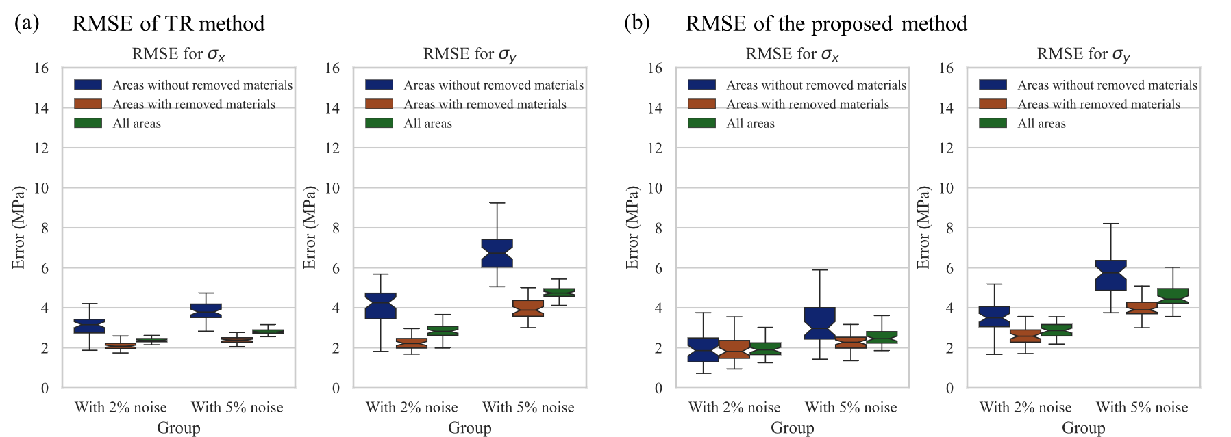
Fig.B. 2 RMSE of the proposed method and TR method.

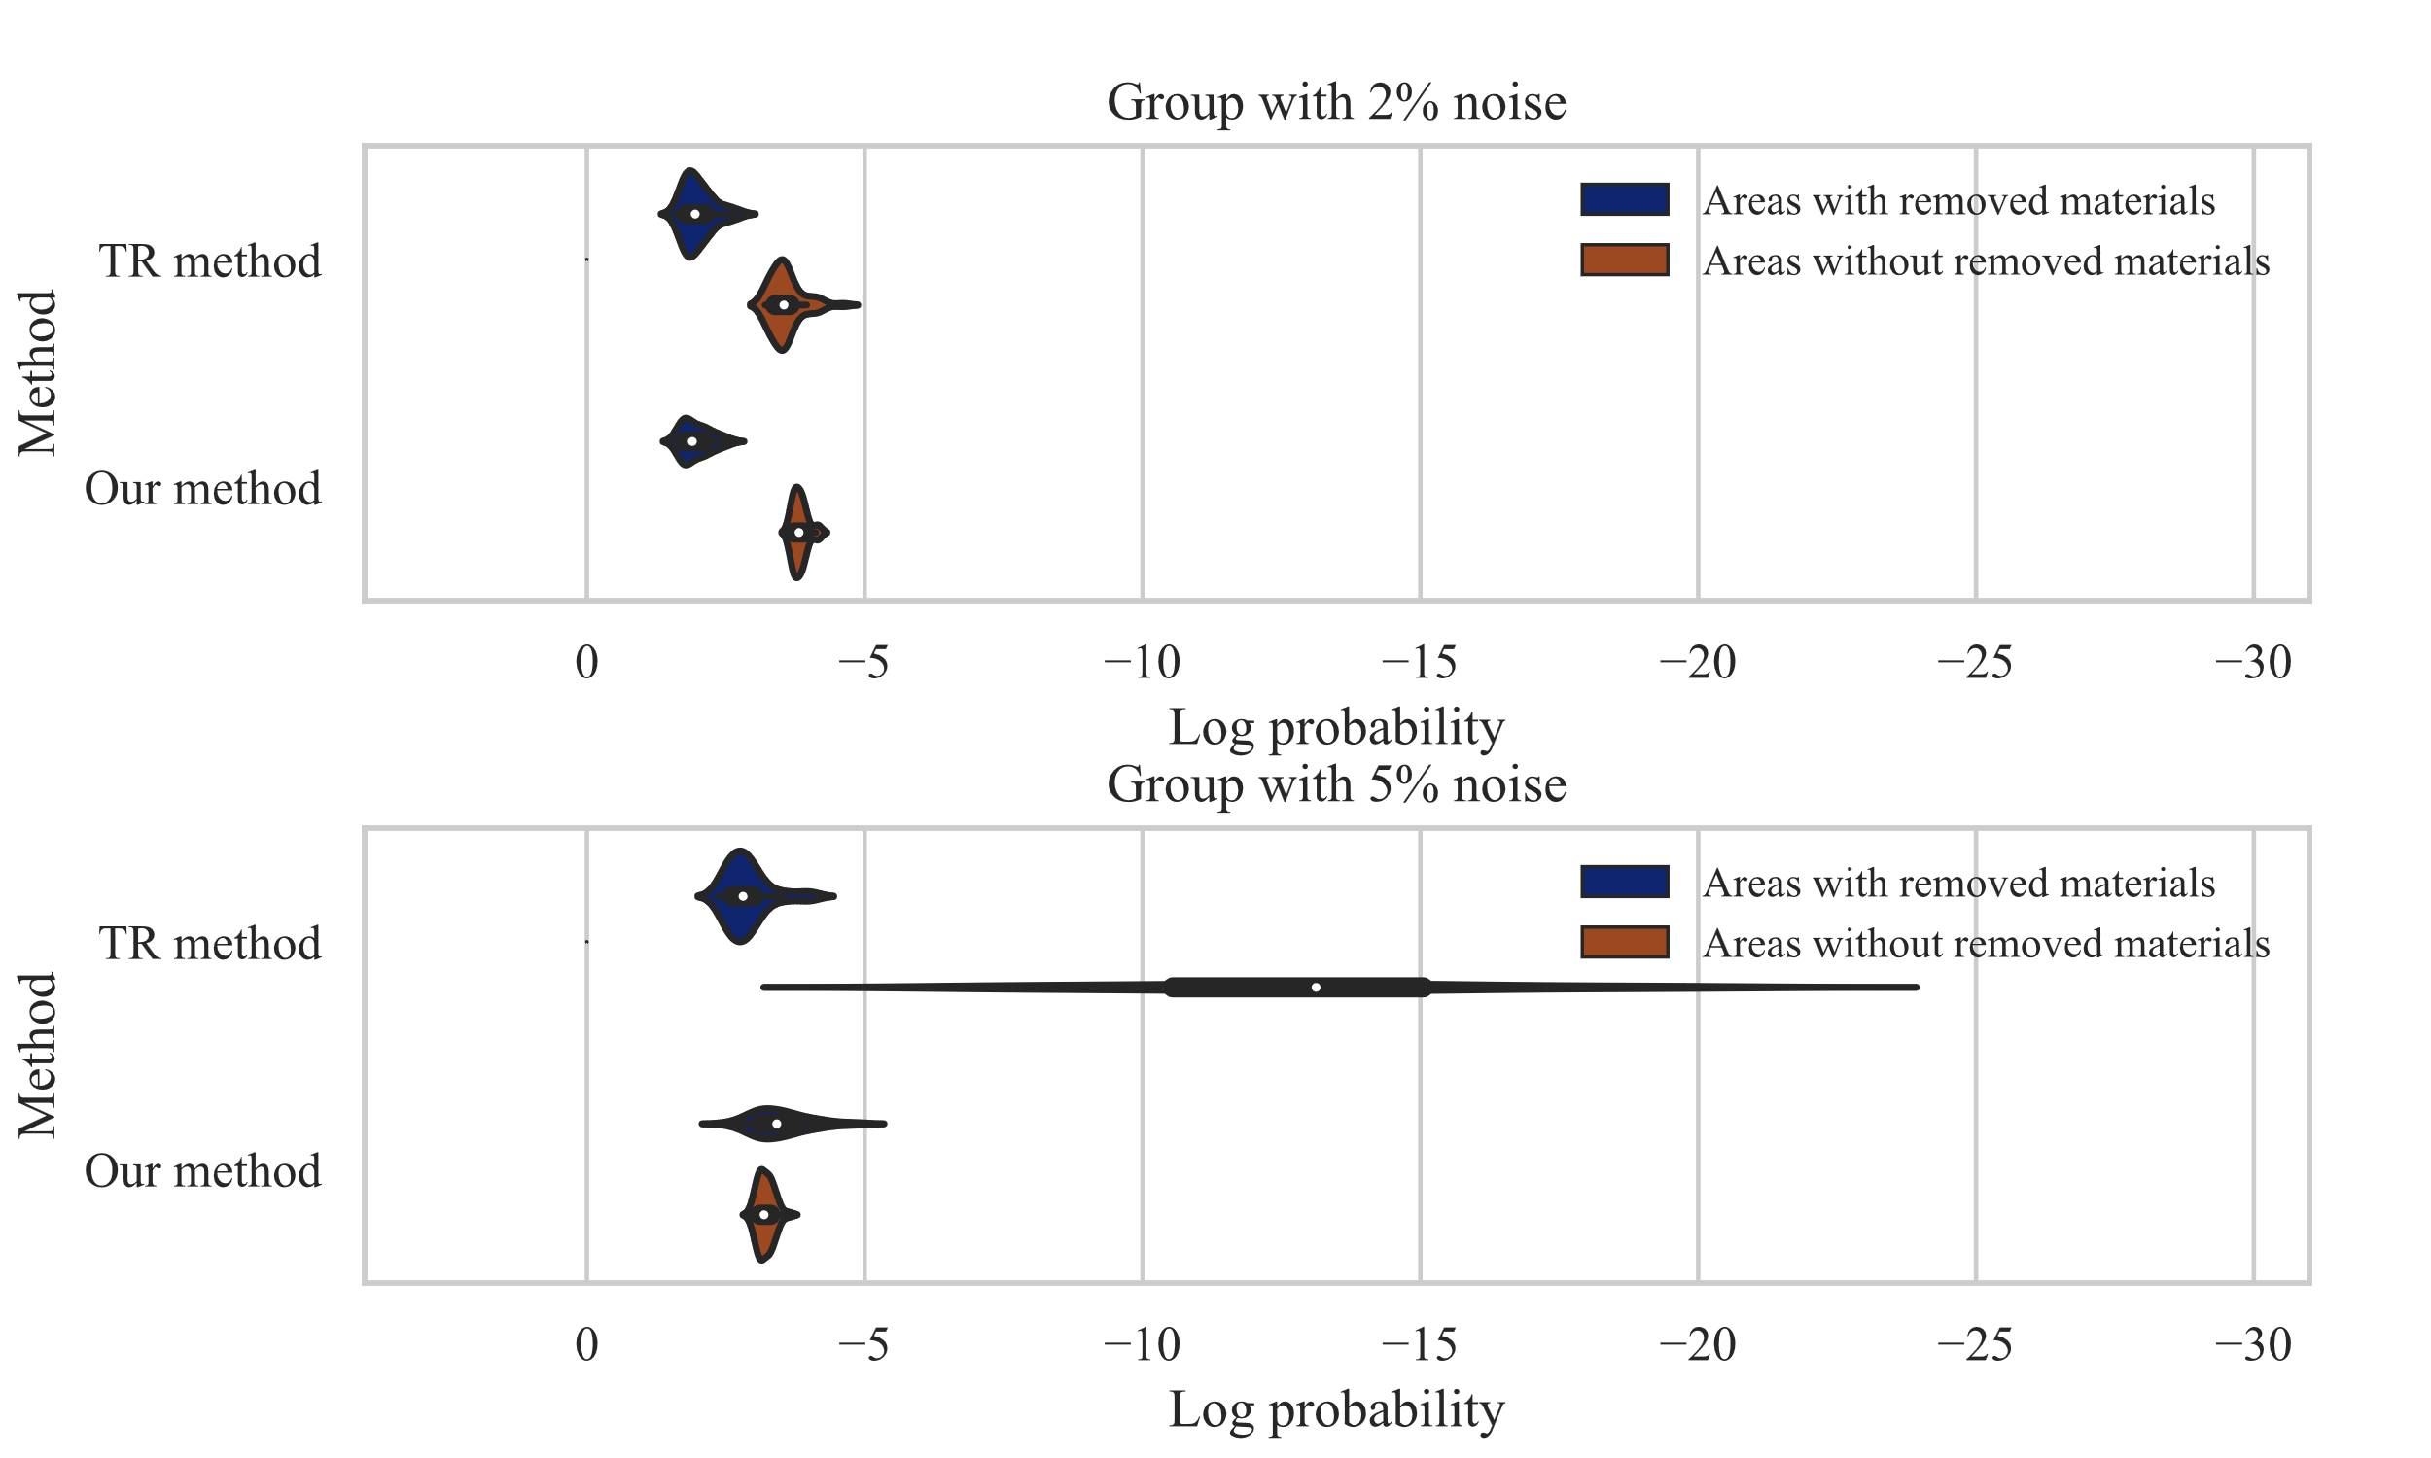
Fig.B. 3 Logarithm probability of the proposed method and TR method.

Note C: Prediction error of deformation force and residual stress field inference probability
RMSE of predicted deformation force and logarithmic probability of residual stress field inference using different layers’ deformation data are illustrated in Fig.C. 1. It can be deemed as the conditions of the inference result accuracy. We suggest comprehensive analysis from the deformation force prediction results of the next layer machining process and probability values of the RS inference result to judge the accuracy and reliability.
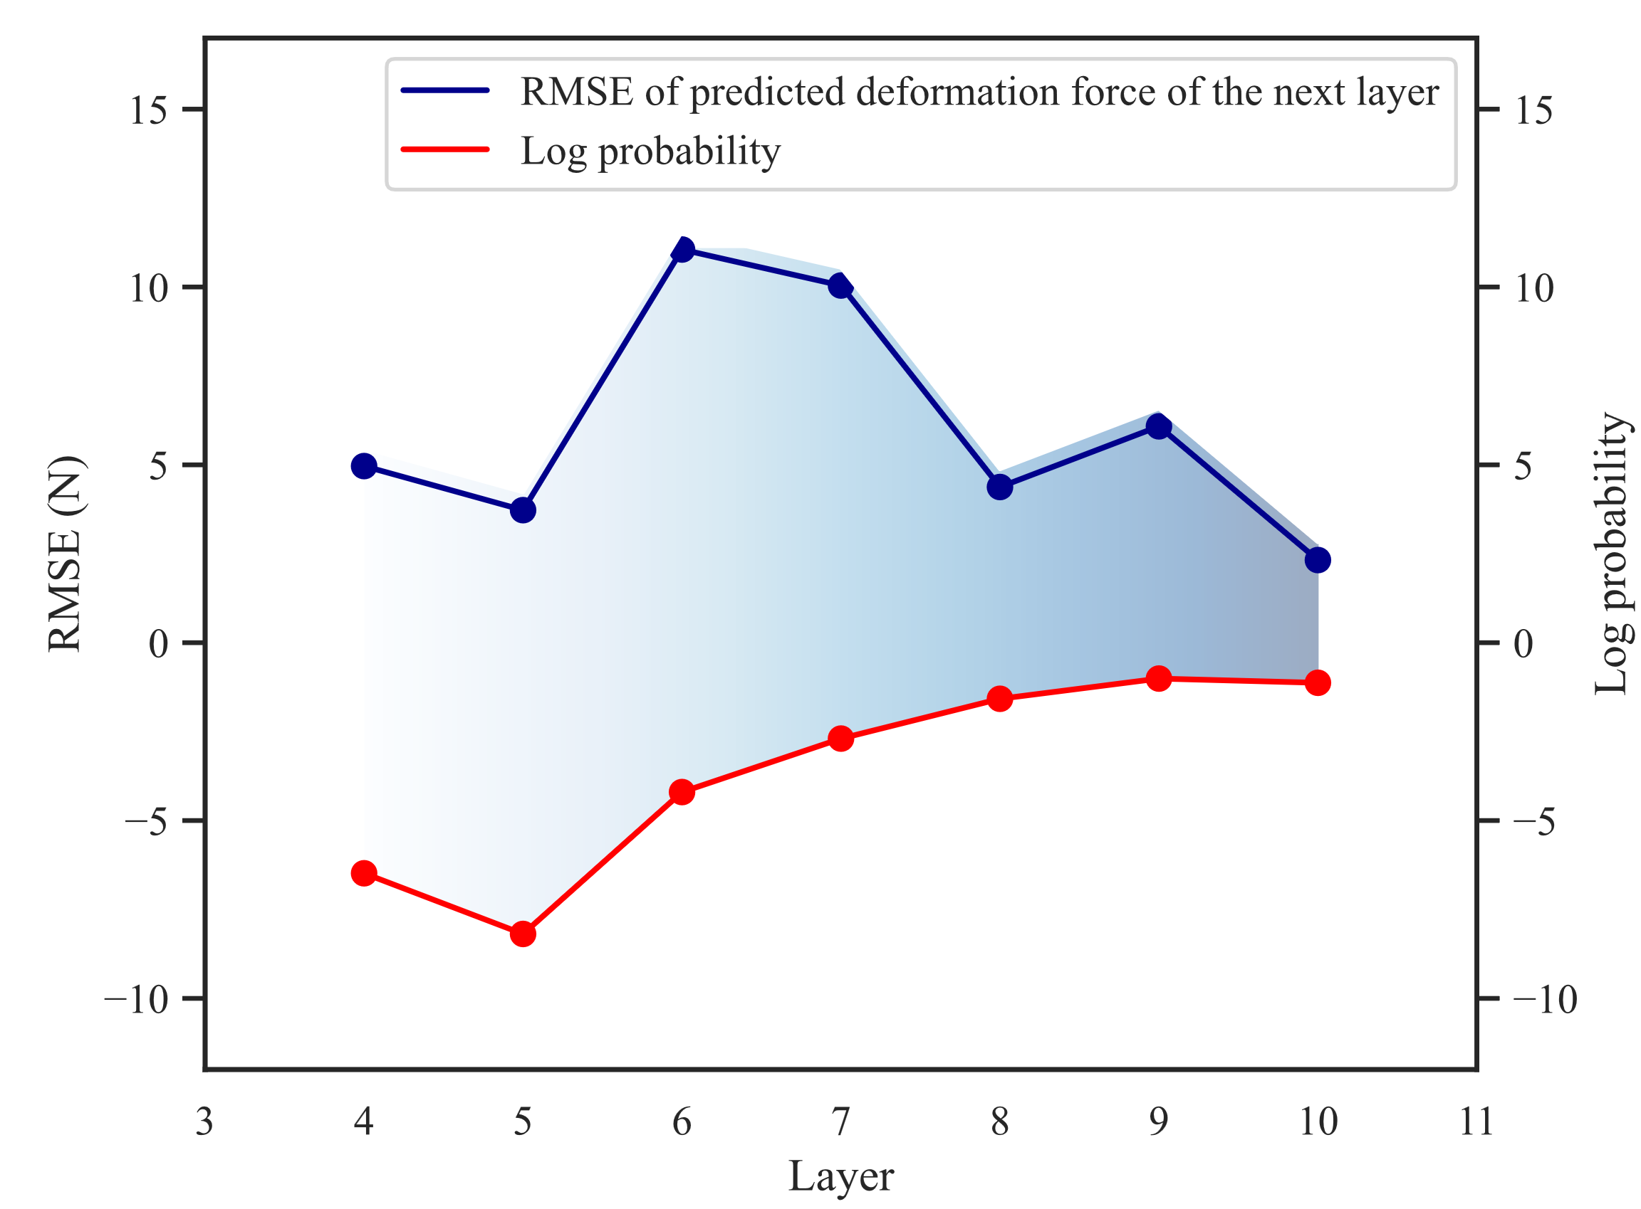
Fig.C. 1 RMSE of predicted deformation force and logarithmic probability of residual stress field inference

Note D: Inference results of other aircraft structural parts
Part 1: The part is of the same size and from the same batch as the part used for validation. The inferred residual stress field and the validation results are illustrated in Fig.D. 1 and Fig.D. 2. It verifies that the residual stress field of the same batch of materials varies greatly.
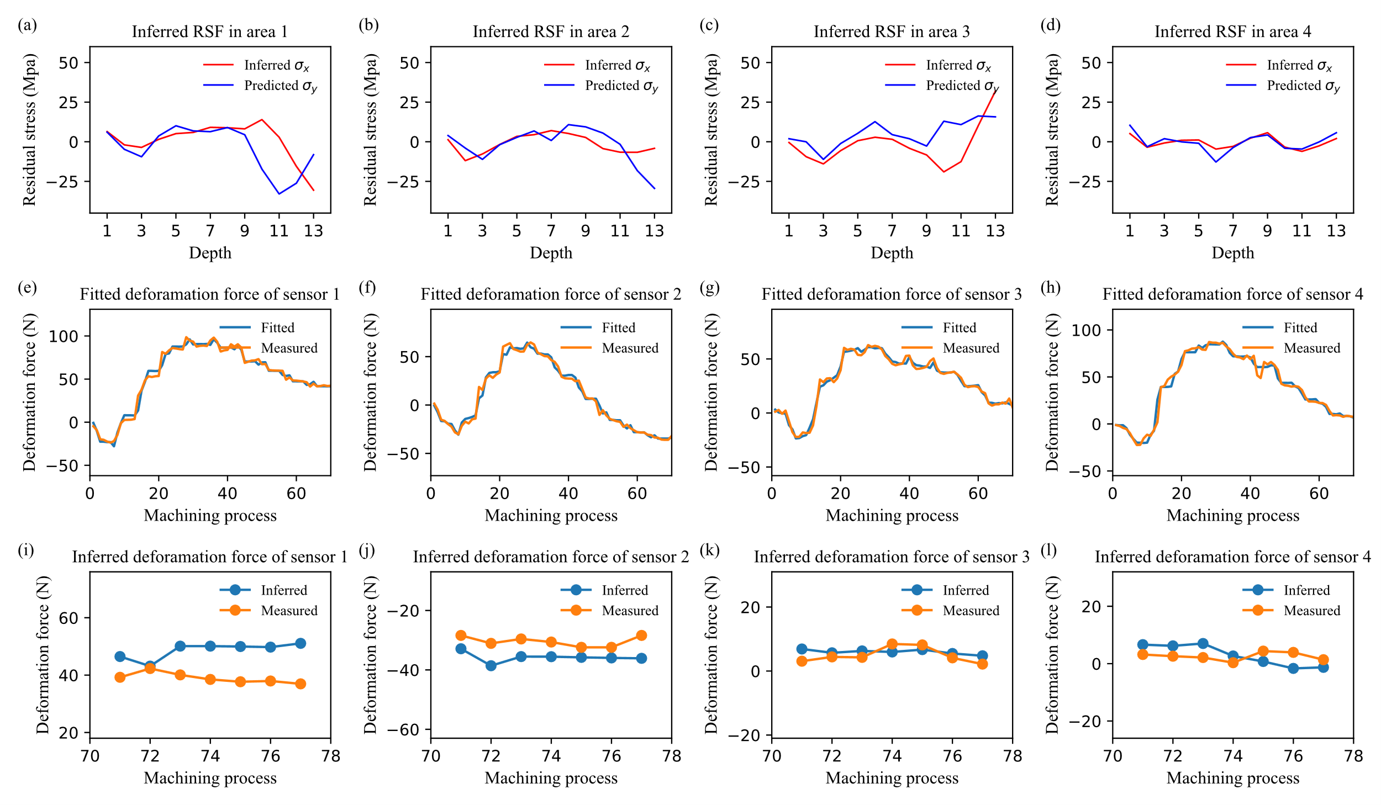
Fig.D. 1 The residual stress field inference and deformation force predicted result of the part 1

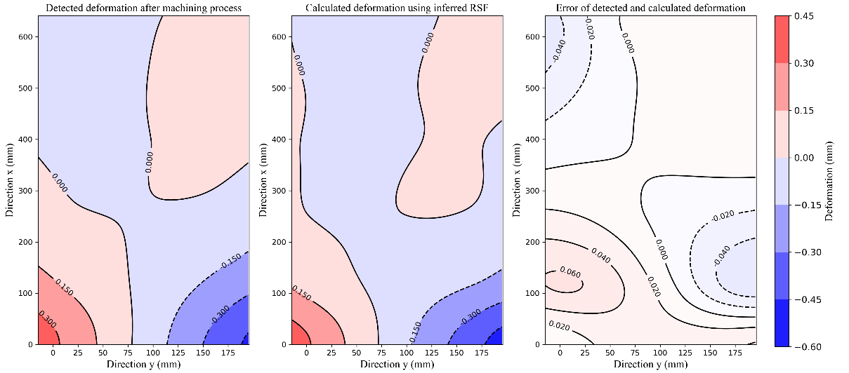
Fig.D. 2 The calculated deformation result using the inferred residual stress field of the part 1
Part 2: The size of the part is 640mm×180mm×24mm, and the material is from the same batch as the part used for validation, but the surface material is removed from the original material to the remaining 24mm. The inferred residual stress field and the validation results are illustrated in Fig.D. 3 and Fig.D. 4. Its RS level is the same as that of the part in the validation section, and its residual stress field distribution trend is consistent with that of the M-distributed residual stress field after machining, releasing and re-balancing.
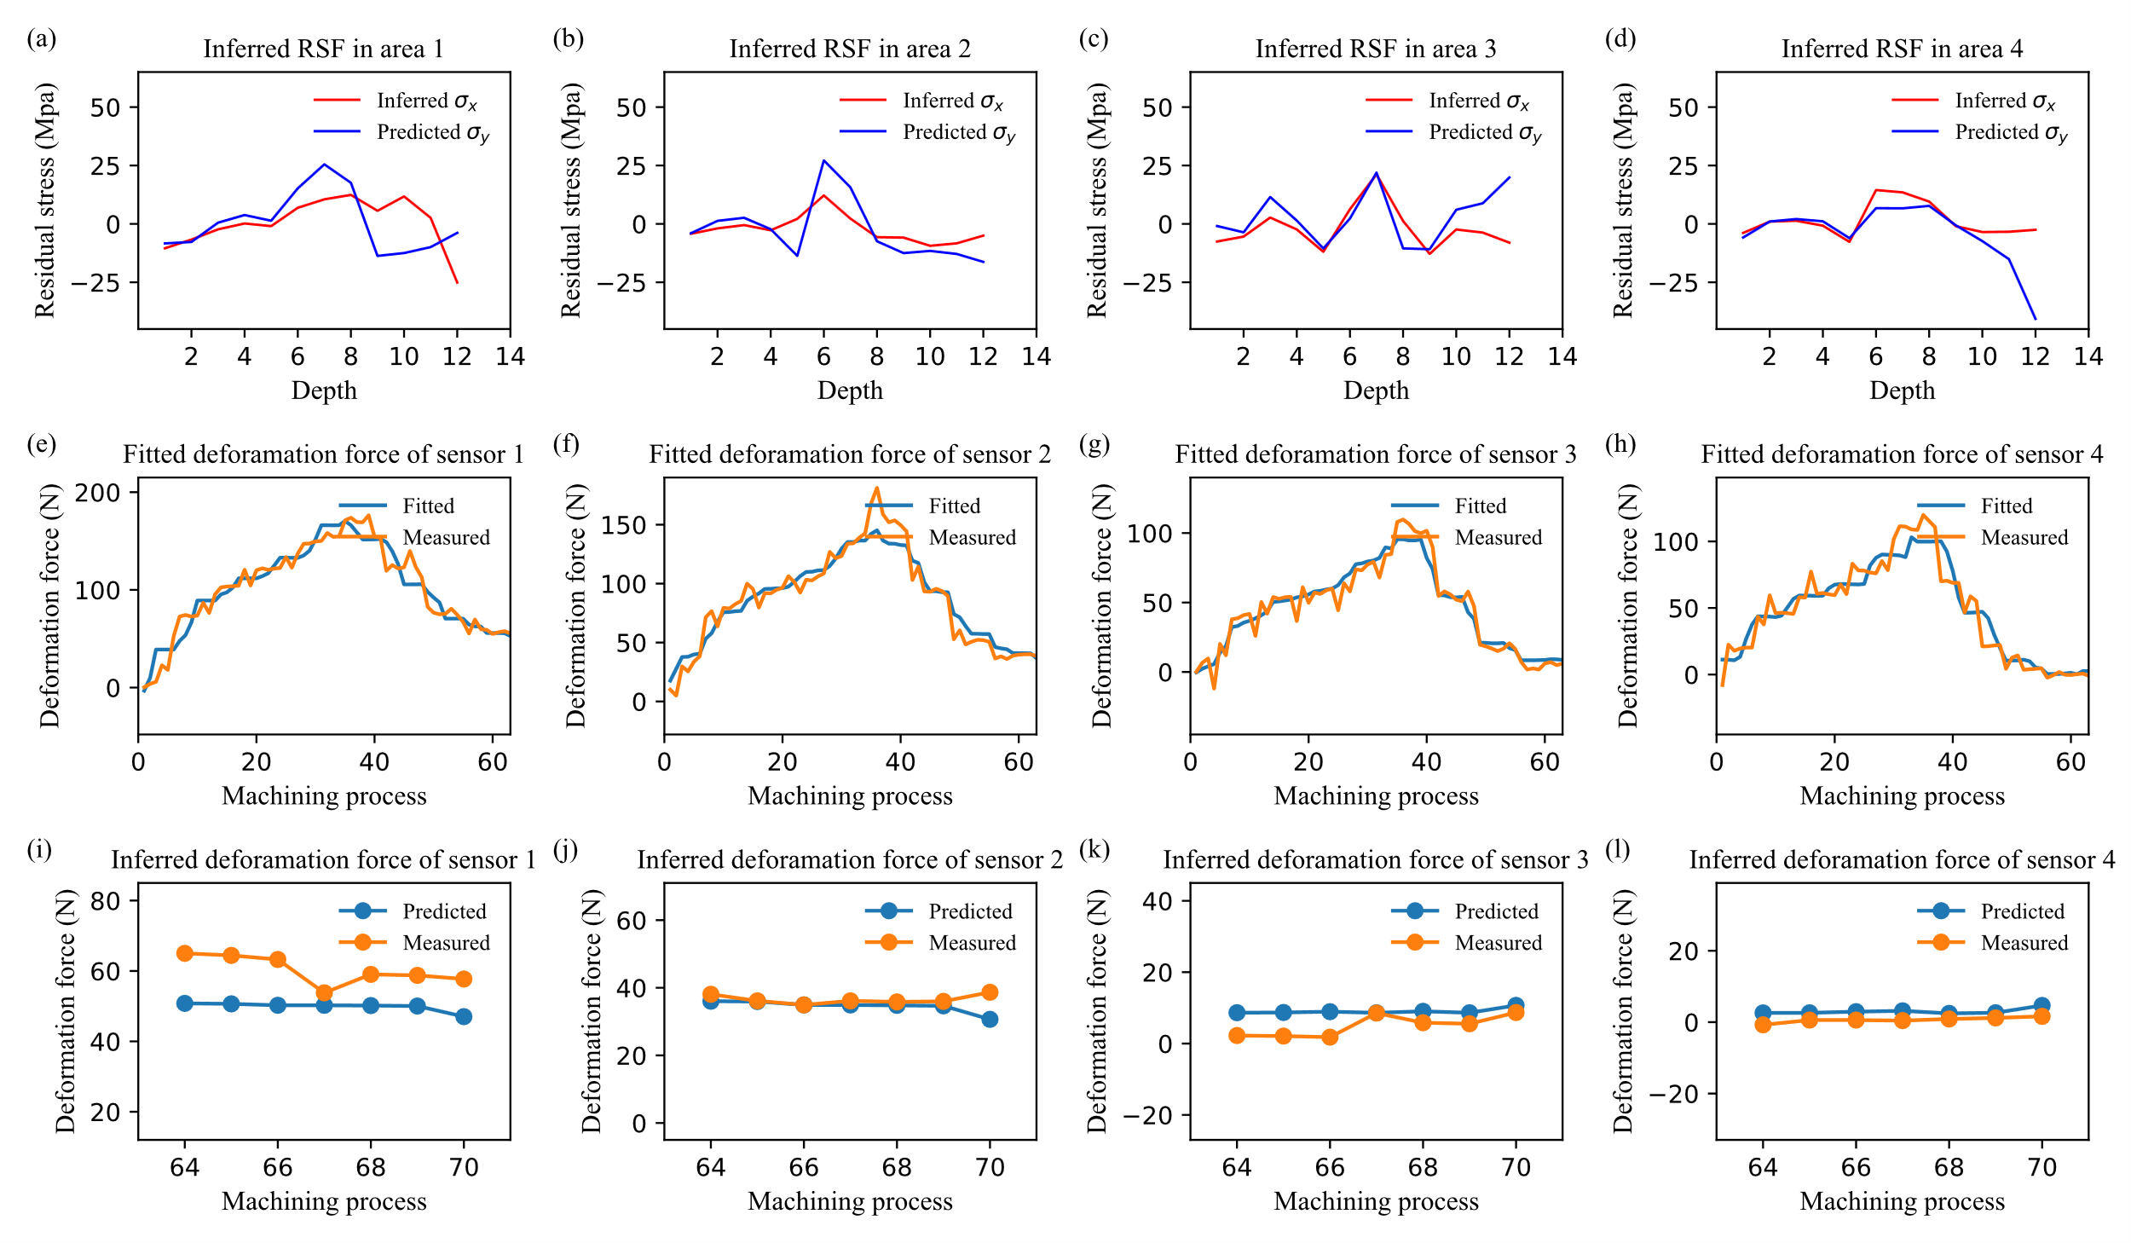
Fig.D. 3 The residual stress field inference and deformation force predicted result of the part 2
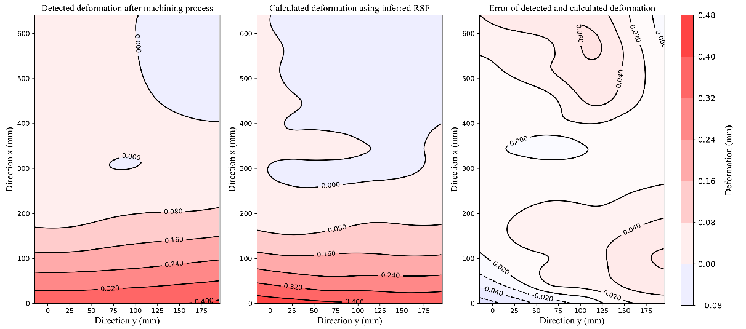
Fig.D. 4 The calculated deformation result using the inferred residual stress field of the part 2

