Supplementary data for

High Spatial Resolution Ozone Profiles Retrieved from the First Chinese Ultraviolet–Visible Hyperspectral Satellite Instrument
Fei Zhao^{a,#}, Cheng Liu^{a,b,c,d,e,}*,#, Qihou Hu^{c}, Congzi Xia^{f}, Chengxin Zhangª, Wenjing Su^{g}
ª Department of Precision Machinery and Precision Instrumentation, University of Science and Technology of China, Hefei,230026, China
^{b} Center for Excellence in Regional Atmospheric Environment, Institute of Urban Environment, Chinese Academy of Sciences, Xiamen 361021, China
^{c} Key Lab of Environmental Optics and Technology, Anhui Institute of Optics and Fine Mechanics, Chinese Academy of Sciences, Hefei 230031, China
^{d} Key Laboratory of Precision Scientific Instrumentation of Anhui Higher Education Institutes, University of Science and Technology of China, Hefei 230026, China
^{e} Anhui Province Key Laboratory of Polar Environment and Global Change, University of Science and Technology of China, Hefei 230026, China
^{f} Greater Bay Area (GBA) Branch of Aerospace Information Research Institute, Chinese Academy of Sciences, Guangzhou 510700, China
^{g} Department of Environmental Science and Engineering, University of Science and Technology of China, Hefei 230026, China

Correspondence author.
Email address: chliu81@ustc.edu.cn (C. Liu).
#These authors contributed equally to this work.
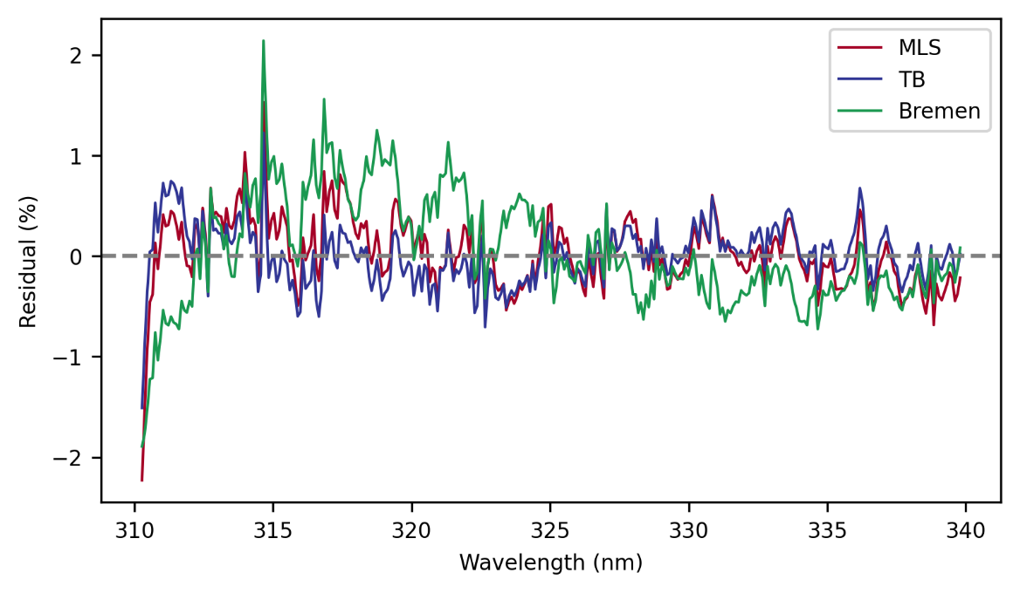
Fig. S1. Comparison of fitting residuals of using Microwave Limb Sounder (MLS), Tropopause-based climatology (TB), and total ozone dependent dynamic ozone climatology derived from the Bremen.
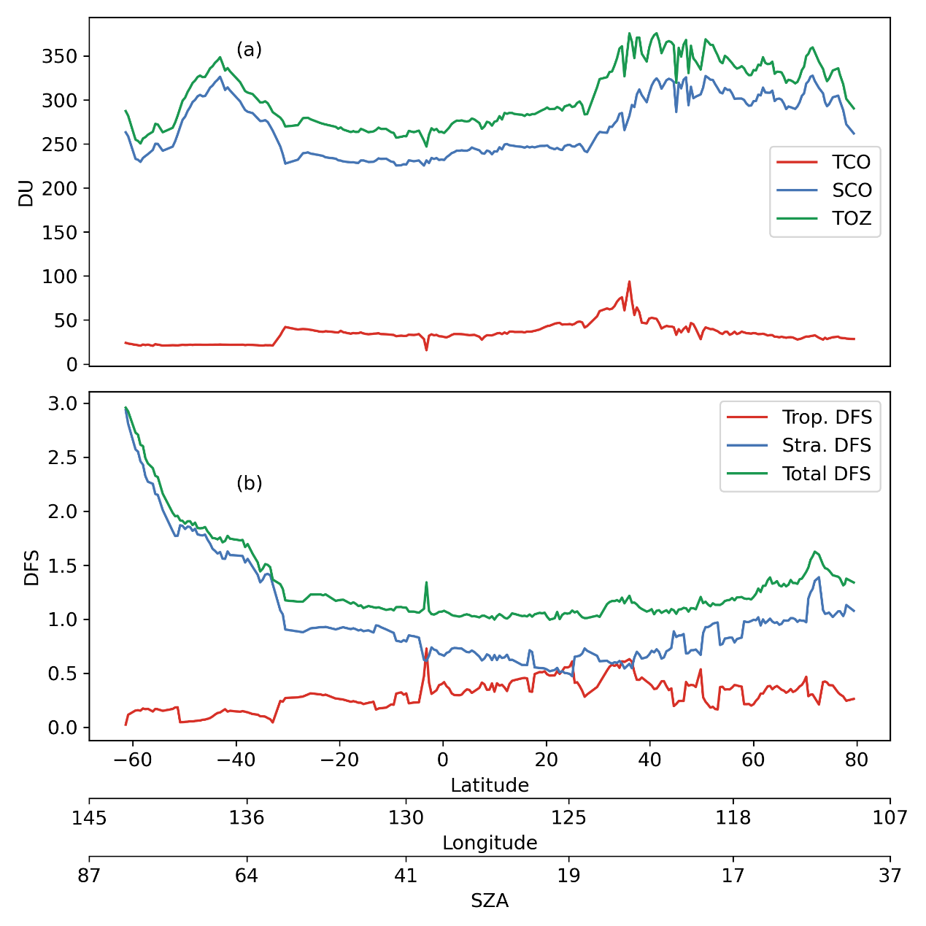
Fig. S2. (a) Total (green), stratospheric (blue) and tropospheric (red) column ozone and (b) total (green), stratospheric (blue) and tropospheric (red) degrees of freedom (DFS) for the orbit 6181 (20190707).
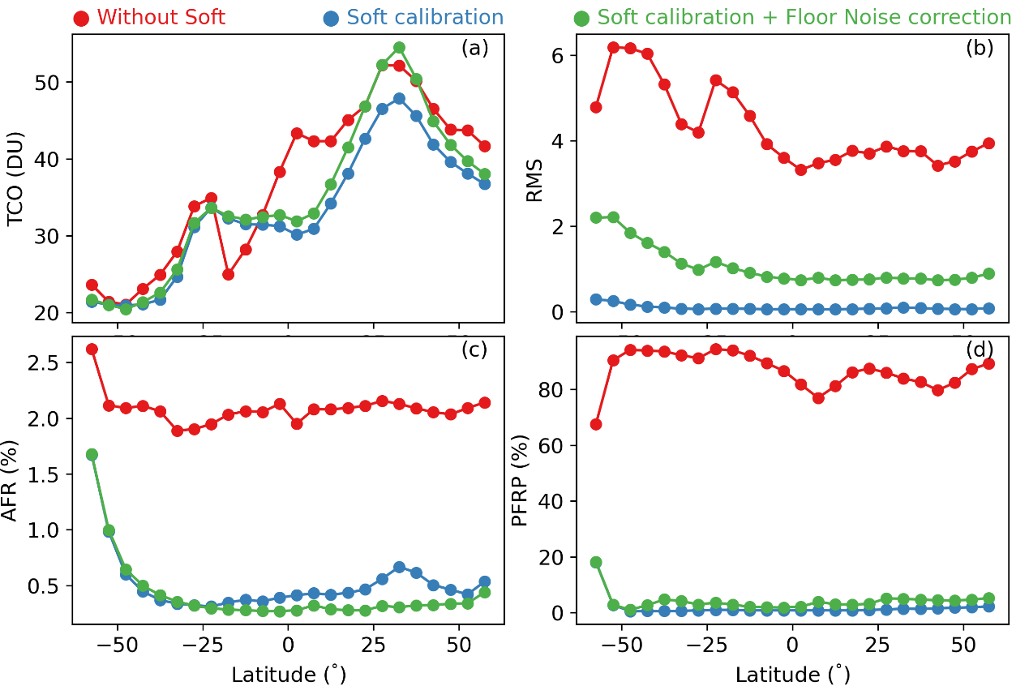
Fig. S3. Monthly mean of retrieved TCO (a), RMS (b), averaging fitting residual (AFR) (c), and percentage of failed retrieval pixels (PFRP) (d) with different settings between 60°S-60°N in June 2019. Different colors represent different configuration results.

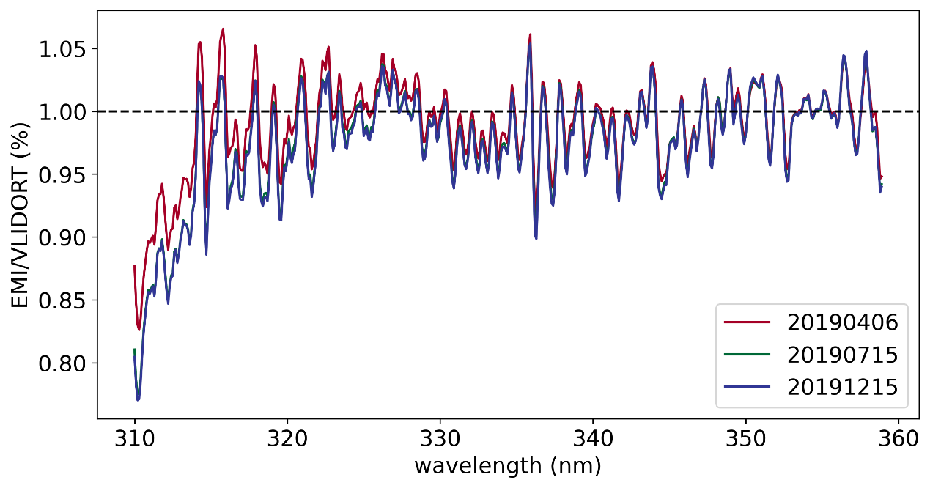
Fig S4. Soft correction spectrum at cross-track position 95 as a function of ranging from 310 nm to 360 nm. The 3 days are shown in different colors.
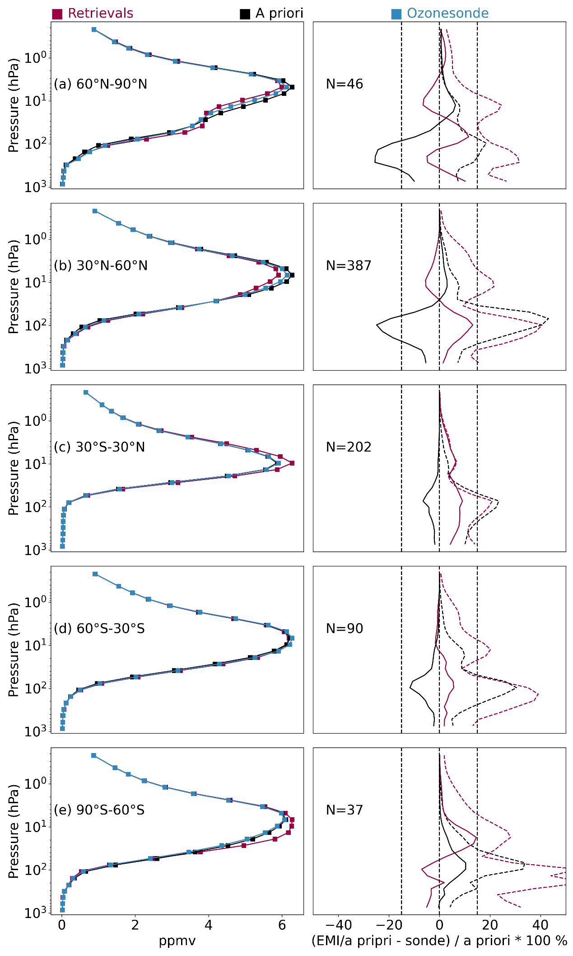
Fig. S5. (left) Comparisons of ozone profiles among EMI (red), ozonesonde (blue), and a priori (black) at five latitude bands from November 2018 to April 2020. (right) Mean relative biases (solid lines) and standard deviations (dash lines) between EMI (red) and a priori (black) relative to ozonesonde with EMI averaging kernels at five latitude bands. The legends indicate the band information and the number (N) of coincident pairs.
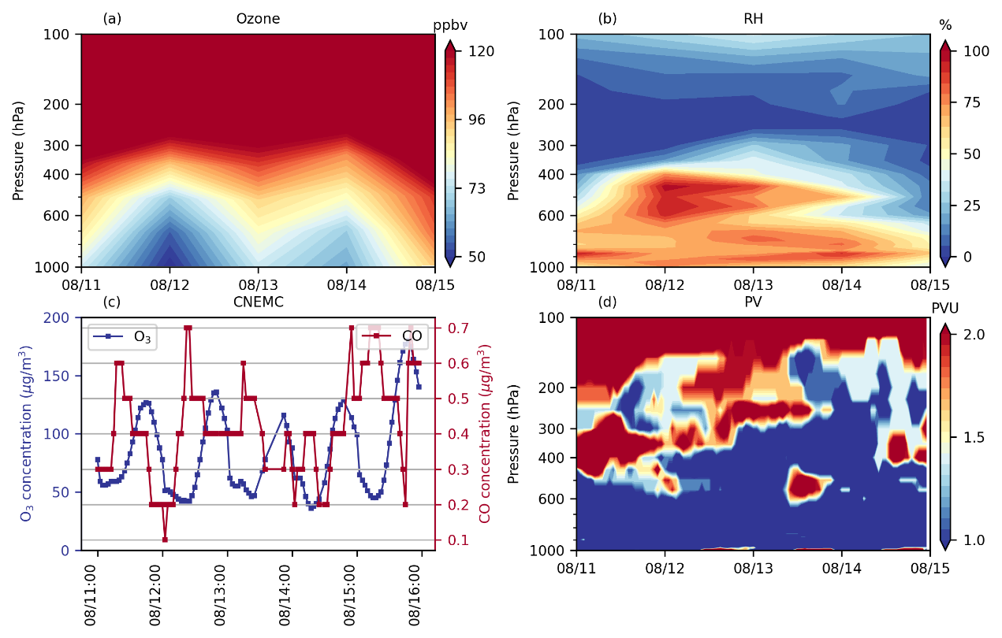
Fig. S6. Similar to Fig. 8 but for Luohe.
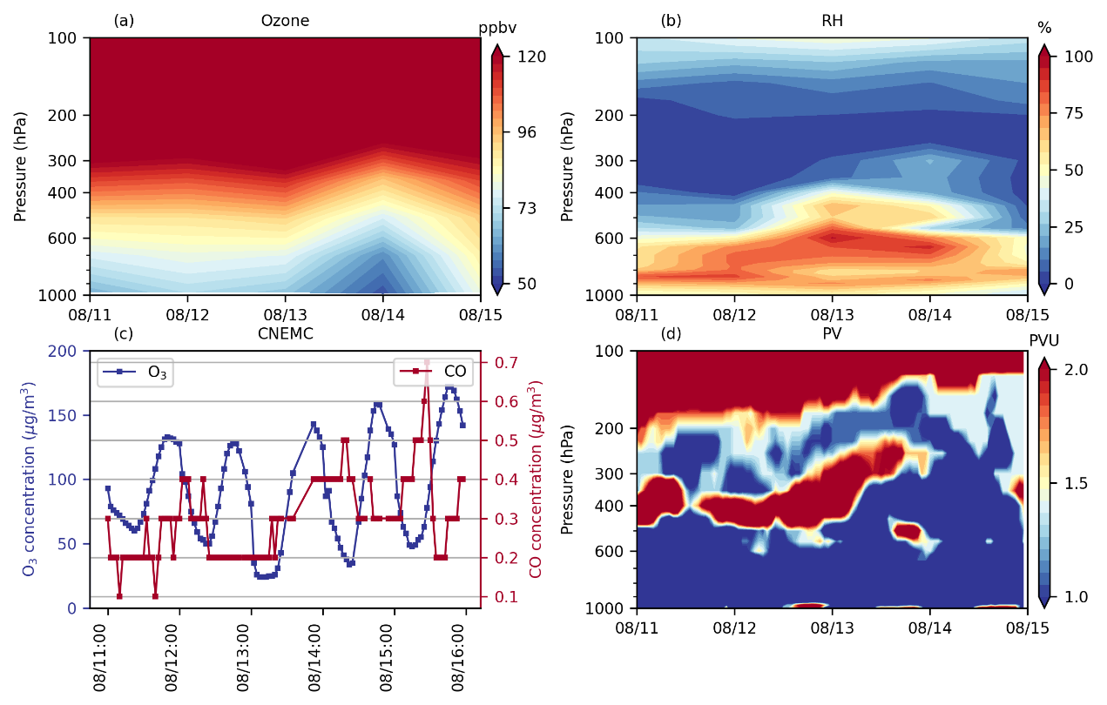
Fig. S7. Similar to Fig. 8 but for Xinyang.

