Supplementary data for

Fingerprint Spectral Signatures Revealing the Spatiotemporal Dynamics of Bipolaris Spot Blotch Progression for Presymptomatic Diagnosis
Fengle Zhu ^{a,#}, Zhenzhu Su ^{b,#}, Alireza Sanaeifar ^{c}, Anand Babu Perumala ^{c}, Mostafa Gouda ^{c,d}, Ruiqing Zhou ^{c}, Xiaoli Li ^{c,}*, Yong He ^{c}
ª College of Mechanical Engineering, Zhejiang University of Technology, Hangzhou 310023, China
^{b} State Key Laboratory for Rice Biology, Institute of Biotechnology, Zhejiang University, Hangzhou 310058, China
^{c} College of Biosystems Engineering and Food Science, Zhejiang University, Hangzhou 310058, China
^{d} Department of Nutrition & Food Science, National Research Centre, Cairo 12311, Egypt

* Corresponding author.
E-mail address: xiaolili@zju.edu.cn (X. Li)
# These authors contributed equally to this work.

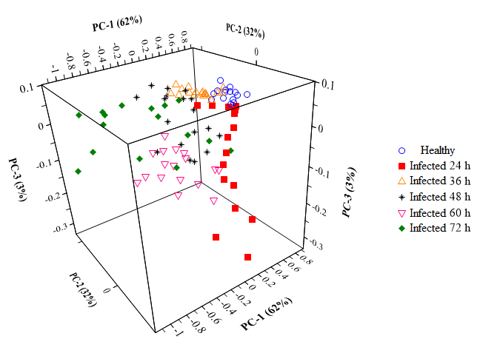
Fig. S1. Distribution of the mean spectra of all samples under different infection time points in the first three principal components (PCs) spaces.
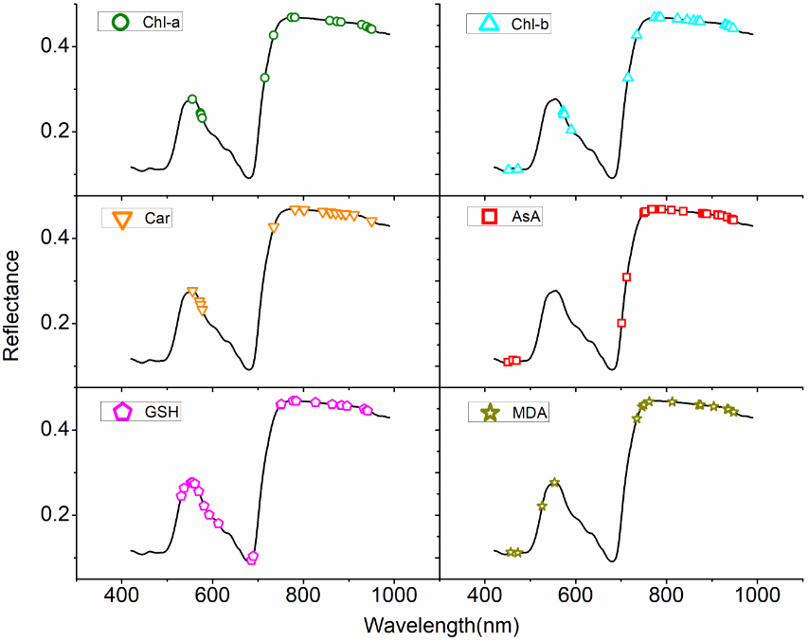
Fig. S2. Distribution of the optimal characteristic spectral wavelengths of the final MLR determination models of the leaf biochemical indicators.
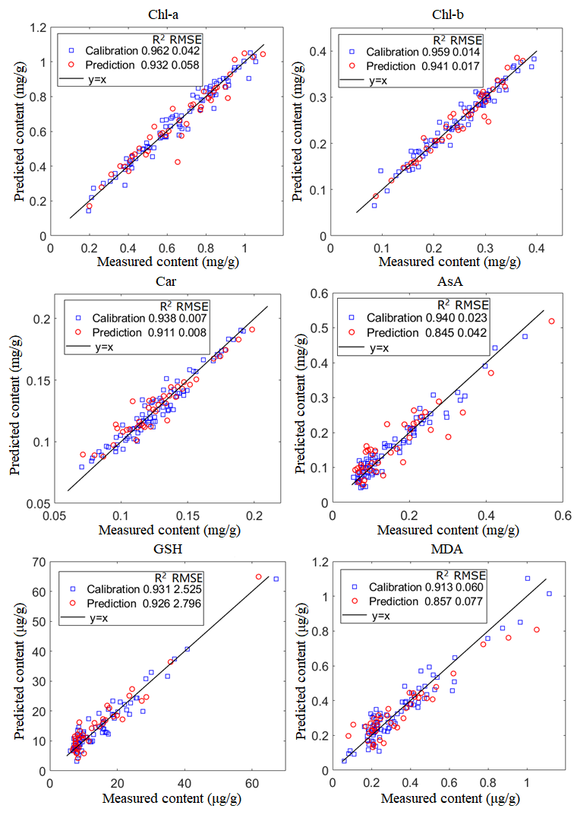
Fig. S3. Measured vs. predicted contents of leaf biochemical indicators under spot blotch stress using the final MLR determination models.

Table S1
The specific primers for real-time PCR.
Primer name | Sequence
BM-F | AAGAAGGTCGGCTACAAC
BM-R | CAGTGGACTTAGACTTGGT
HvUbiq-F | CAGTAGTGGCGGTCGAAGTG
HvUbiq-R | ACCCTCGCCGACTACAACAT
EF728 | CAT CGA GAA GTT CGA GAA GG
EF986 | TAC TTG AAG GAA CCC TTA CC

Table S2
ANOVA of the influence of infection time on leaf biochemical indicators.
 | Source | SS | DF | MS | F-value | Prob>F
24 h | Chl-a | 0.000887 | 1 | 0.000887 | 0.12018 | 0.73265
24 h | Chl-b | 0.000661 | 1 | 0.000661 | 0.643614 | 0.432326
24 h | Car | 4.58E-05 | 1 | 4.58E-05 | 0.232483 | 0.635197
24 h | AsA | 9.58E-05 | 1 | 9.58E-05 | 0.116033 | 0.737115
24 h | GSH | 0.805804 | 1 | 0.805804 | 0.393818 | 0.537769
24 h | MDA | 0.001505 | 1 | 0.001505 | 0.91946 | 0.349661
36 h | Chl-a | 0.249782 | 1 | 0.249782 | 34.48331 | 7.90E-06
36 h | Chl-b | 0.020864 | 1 | 0.020864 | 17.61186 | 0.000406
 | Car | 0.001863 | 1 | 0.001863 | 10.94015 | 3.35E-03
 | AsA | 0.000959 | 1 | 0.000959 | 0.188631 | 0.668488
 | GSH | 28.2902 | 1 | 28.2902 | 1.668762 | 0.210461
 | MDA | 0.004857 | 1 | 0.004857 | 0.248369 | 0.623405
48 h | Chl-a | 0.290598 | 1 | 0.290598 | 27.56288 | 3.33E-05
48 h | Chl-b | 0.022628 | 1 | 0.022628 | 17.29512 | 4.45E-04
 | Car | 0.001802 | 1 | 0.001802 | 7.498424 | 0.012315
 | AsA | 0.019649 | 1 | 0.019649 | 4.123842 | 0.055136
 | GSH | 69.21592 | 1 | 69.21592 | 2.544148 | 0.126385
 | MDA | 0.059285 | 1 | 0.059285 | 3.739835 | 0.066721
60 h | Chl-a | 0.335951 | 1 | 0.335951 | 26.20745 | 5.23E-05
60 h | Chl-b | 0.032076 | 1 | 0.032076 | 18.21372 | 0.000376
 | Car | 0.001788 | 1 | 0.001788 | 7.972116 | 0.010853
 | AsA | 0.055297 | 1 | 0.055297 | 6.092743 | 0.022715
 | GSH | 469.149 | 1 | 469.149 | 4.257987 | 0.052999
 | MDA | 0.207964 | 1 | 0.207964 | 4.393217 | 0.049008
72 h | Chl-a | 0.664102 | 1 | 0.664102 | 46.08066 | 1.75E-06
72 h | Chl-b | 0.065558 | 1 | 0.065558 | 32.04913 | 1.86E-05
 | Car | 0.001805 | 1 | 0.001805 | 7.387605 | 0.013648
 | AsA | 0.123365 | 1 | 0.123365 | 13.92574 | 0.001414
 | GSH | 1201.174 | 1 | 1201.174 | 6.92466 | 0.017501
 | MDA | 1.119394 | 1 | 1.119394 | 10.90624 | 0.003745

Table S3
Results of MLR models for quantifying leaf biochemical indicators based on characteristic spectral wavelengths chosen by different variable selection methods.
Biochemical indicator | Method | R²_{c} | RMSEC | R²_{p} | RMSEP | Bands number
Chl-a (mg/g) | RF | 0.962 | 0.042 | 0.932 | 0.058 | 15
Chl-a (mg/g) | CARS | 0.969 | 0.039 | 0.933 | 0.057 | 21
Chl-a (mg/g) | SPA | 0.931 | 0.057 | 0.891 | 0.073 | 10
Chl-a (mg/g) | Stepwise | 0.948 | 0.050 | 0.914 | 0.065 | 8
Chl-b (mg/g) | RF | 0.941 | 0.017 | 0.915 | 0.020 | 13
Chl-b (mg/g) | CARS | 0.959 | 0.014 | 0.941 | 0.017 | 21
Chl-b (mg/g) | SPA | 0.909 | 0.022 | 0.908 | 0.021 | 12
Chl-b (mg/g) | Stepwise | 0.927 | 0.019 | 0.919 | 0.020 | 10
Car (mg/g) | RF | 0.938 | 0.007 | 0.911 | 0.008 | 18
Car (mg/g) | CARS | 0.926 | 0.007 | 0.882 | 0.010 | 15
Car (mg/g) | SPA | 0.900 | 0.008 | 0.859 | 0.011 | 21
Car (mg/g) | Stepwise | 0.906 | 0.008 | 0.876 | 0.010 | 14
AsA (mg/g) | RF | 0.922 | 0.026 | 0.792 | 0.048 | 26
AsA (mg/g) | CARS | 0.940 | 0.023 | 0.845 | 0.042 | 26
AsA (mg/g) | SPA | 0.854 | 0.036 | 0.800 | 0.047 | 14
AsA (mg/g) | Stepwise | 0.829 | 0.038 | 0.793 | 0.048 | 11
GSH (μg/g) | RF | 0.931 | 2.525 | 0.926 | 2.796 | 23
GSH (μg/g) | CARS | 0.911 | 2.877 | 0.908 | 3.110 | 20
GSH (μg/g) | SPA | 0.890 | 3.191 | 0.890 | 3.415 | 23
GSH (μg/g) | Stepwise | 0.918 | 0.028 | 0.913 | 0.030 | 24
MDA (μg/g) | RF | 0.908 | 0.061 | 0.841 | 0.081 | 17
MDA (μg/g) | CARS | 0.913 | 0.060 | 0.857 | 0.077 | 16
MDA (μg/g) | SPA | 0.858 | 0.077 | 0.734 | 0.105 | 14
MDA (μg/g) | Stepwise | 0.843 | 0.081 | 0.749 | 0.102 | 17

Table S4
Assignment analysis of the optimal characteristic spectral wavelengths in constructing the final MLR determination models for leaf biochemical indicators.
Biochemical indicator | Characteristic spectral wavelengths (nm)
Chl-a (mg/g) | 555.8 (green reflection), 573.5 (green reflection), 574.7 (green reflection), 577.2, 715.3 (red edge), 734.7 (red edge, fourth overtone of C–H), 773.6 (red edge, fourth overtone of C–H), 781.4 (fourth overtone of C–H), 858.2, 873.8, 883.0 (third overtone of C–H), 928.6 (third overtone of C–H), 939.0, 946.8, 950.8
Chl-b (mg/g) | 451.7 (blue absorption), 472.6, 572.2 (green reflection), 573.5 (green reflection), 574.7 (green reflection), 589.9, 715.3 (red edge), 734.7 (red edge, fourth overtone of C–H), 773.6 (red edge, fourth overtone of C–H), 781.4 (fourth overtone of C–H), 786.6 (fourth overtone of C–H), 824.3, 845.2, 859.5, 868.6, 873.8, 928.6 (third overtone of C–H), 931.2, 936.4, 939.0, 946.8
Car (mg/g) | 555.8, 570.9, 573.5, 577.2, 734.7 (fourth overtone of C–H), 781.4 (fourth overtone of C–H), 800.9, 802.2, 842.6, 858.2, 859.5, 860.8, 871.2, 883.0 (third overtone of C–H), 892.1 (third overtone of C–H), 893.4 (third overtone of C–H), 911.7 (third overtone of C–H), 950.8
AsA (mg/g) | 450.5, 461.5, 470.1, 701.1, 712.7, 750.2 (third overtone of O–H, fourth overtone of C–H), 752.8 (fourth overtone of C–H), 754.1 (fourth overtone of C–H), 767.1 (fourth overtone of C–H), 768.4 (fourth overtone of C–H), 787.9 (fourth overtone of C–H), 790.5 (fourth overtone of C–H), 811.3, 837.3, 879.1, 883.0 (third overtone of C–H), 886.9 (third overtone of C–H), 889.5 (third overtone of C–H), 913.0 (third overtone of C–H), 914.3 (third overtone of C–H), 922.1 (third overtone of C–H), 933.8 (second overtone of O–H), 942.9 (second overtone of O–H), 944.2 (second overtone of O–H), 945.5 (second overtone of O–H), 948.1 (second overtone of O–H)
GSH (μg/g) | 530.8, 537.0, 552.1, 555.8, 560.9, 569.7, 581.0, 592.4, 612.7, 685.7, 689.5, 750.2 (third overtone of O–H, fourth overtone of C–H), 751.5 (fourth overtone of C–H), 777.5 (fourth overtone of C–H), 784.0 (fourth overtone of C–H), 826.9 (third overtone of N-H), 863.4, 883.0 (third overtone of C–H), 884.3 (third overtone of C–H), 896.0 (third overtone of C–H), 933.8 (second overtone of O–H), 940.3 (second overtone of O–H), 941.6 (second overtone of O–H)
MDA (μg/g) | 456.6, 472.6, 525.8, 553.3, 734.7 (fourth overtone of C–H), 746.4 (fourth overtone of C–H), 750.2 (fourth overtone of C–H), 761.9 (fourth overtone of C–H), 812.6, 871.2, 875.2, 903.8 (third overtone of C–H), 933.8, 935.1, 936.4, 948.1

