Supplementary data for

Automated Concrete Bridge Damage Detection Using an Efficient Vision Transformer-Enhanced Anchor-Free YOLO
Xiaofei Yang^{a*}, Enrique del Rey Castilloª, Yang Zouª, Liam Wotherspoonª, Jianxi Yang^{b}, Hao Li^{c}
ªDepartment of Civil and Environmental Engineering, University of Auckland, Auckland 1023, New Zealand
^{b}School of Information Science and Engineering, Chongqing Jiaotong University, Chongqing 400074, China
^{c}School of Traffic and Transportation, Chongqing Jiaotong University, Chongqing 400074, China
*Corresponding author.
fyan983@aucklanduni.ac.nz (X. Yang)
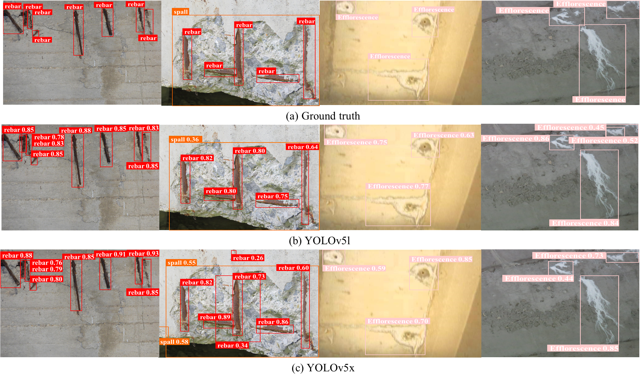
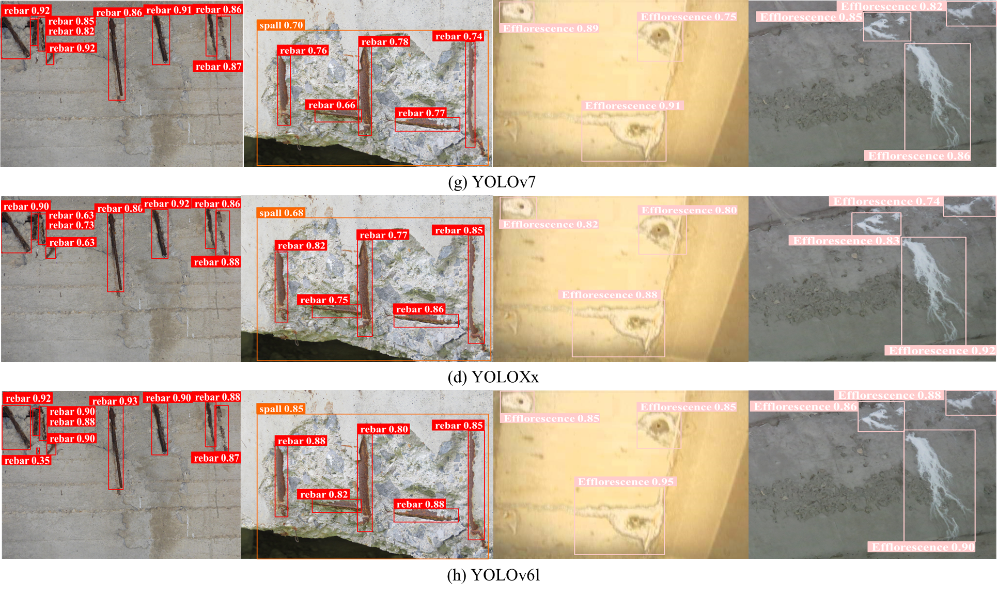
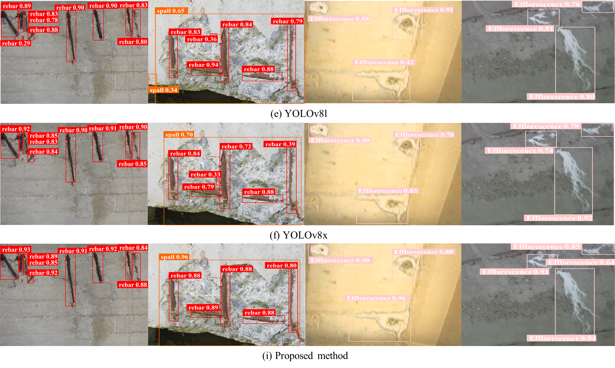
Fig. S1 Visual comparison examples of the predicted results from different deep learning networks.

