Supplementary file for
Icaritin Improves the Hematopoiesis-Supportive Function of MSCs via A PRDX1–MAPK Axis After Chemotherapy
Pengli Huang ^{a,#}, Rui Jing ^{b,#}, Wendan Zhang ^{c,#}, Jun Xia ^{d,e,#}, Xin Luan ª, Ji Ye ^{b}, Saisai Tian ^{b}, Hao Zhang ª, Qun Wang ª, Honghong Jiang ^{c}, Ningbo Wu ^{f}, Mengting Xu ª, Guangyong Zheng ª, Dong Lu ª, Fei Qian ª, Tao Cheng ^{g}, Weian Yuan ^{h}, Feng Liu ^{d,e,i,}*, Sanhong Liu ^{a,}*, Weidong Zhang ^{b,j,}*
ª State Key Laboratory of Discovery and Utilization of Functional Components in Traditional Chinese Medicine & Shanghai Frontiers Science Center of TCM Chemical Biology, Institute of Interdisciplinary Integrative Medicine Research, Shanghai University of Traditional Chinese Medicine, Shanghai 201203, China
^{b} Department of Phytochemistry, School of Pharmacy, Second Military Medical University, Shanghai 200433, China
^{c} Faculty of Pediatrics, the Seventh Medical Center, Beijing Key Laboratory of Pediatric Organ Failure, National Engineering Laboratory for Birth Defects Prevention and Control of Key Technology, Chinese PLA General Hospital, Beijing 100700, China
^{d} State Key Laboratory of Organ Regeneration and Reconstruction, Beijing Institute for Stem Cell and Regenerative Medicine, Institute of Zoology, Chinese Academy of Sciences, Beijing 100101, China
^{e} University of Chinese Academy of Sciences, Beijing 100049, China
^{f} Shanghai Institute of Immunology, Department of Immunology and Microbiology, Shanghai Jiao Tong University School of Medicine, Shanghai 200025, China
^{g} Institute of Hematology and Blood Diseases Hospital, Chinese Academy of Medical Sciences and Peking Union Medical College, Tianjin 300020, China
^{h} Shuguang Hospital, Shanghai University of Traditional Chinese Medicine, Shanghai 201203, China
^{i} School of Life Sciences, Shandong University, Qingdao 266237, China
^{j} Institute of Medicinal Plant Development, Chinese Academy of Medical Sciences and Peking Union Medical College, Beijing 100193, China

# These authors contributed equally to this work.

* Corresponding authors.
E-mail addresses: wdzhangy@hotmail.com (W. Zhang); liush@shutcm.edu.cn (S. Liu); liuf@sdu.edu.cn (F. Liu)

Table S1
Sequences of the primers used in this study.
Primer name | Forward primer (5’–3’) | Reverse primer (5’–3’)
cmyb | TGATGCTTCCCAACACAGAG | TTCAGAGGGAATCGTCTGCT
pu.1 | AGGAGTGTATGAGAGACCACATCAG | ATTTCGCAGAAGGTCAAGCA
lyz | GTGAAAATGGACGGGCTGAA | CTTTGTTTGCGCTGCTCACA
gata1 | TCTGAGCCTTCTCGTTGGG | CTCTGGACGCTGGTGGAATA
rag1 | AGAGGACAGTGGGTAAAGA | ATGGGTTCAGGTGTTGGTT
cxcl12a | CAACTGCCCCTTCCAAGTCA | ACATATCTGTGACGGTGGGC
β-actin | GCTGTTTTCCCCTCCATTGTT | TCCCATGCCAACCATCACT
prdx1 mutant | AGGACCAAAACACCCCGAAA | AACAGGTAACCATGACTTGCATT
prdx1 mRNA | TATTATCTCGAGATGGACTACAAGGACGATGATGACAAG TGGCAGCTGGAAATGCACA | TATTATTCTAGATTAATTTTGCTTGGAGAAGAAGT
prdx1 probe | CCCGCGAGTTCACTTTCATTC | TGAACAAACCAACTCAAACGGT
Cxcl12 | TGAACAAACCAACTCAAACGGT | TGAACAAACCAACTCAAACGGT
Vegfc | GAGGTCAAGGCTTTTGAAGGC | CTGTCCTGGTATTGAGGGTGG
Angpt1 | CACATAGGGTGCAGCAACCA | CGTCGTGTTCTGGAAGAATGA
Cxcl9 | TCCTTTTGGGCATCATCTTCC | TTTGTAGTGGATCGTGCCTCG
Gapdh | AGGTCGGTGTGAACGGATTTG | TGTAGACCATGTAGTTGAGGTCA
Prdx1 (△Cys52) | TTACTTTTGTGGCTCCCACGGAGATCATTGCTTTCAGTGA | AATGGGAGAACTGAAATGAAAACACCGAGGGTGCCTCTAG
Prdx1 (△Ser126) | TGAAGGTATCGCTTTCAGGGGCCTTTTTATTATTGATGAT | ACCTCAGAATTTCCGACTACTTCCATAGCGAAAGTCCCCG

Table S2
Sequences of the siRNAs used in this study.
Name | Sense (5’–3’) | Antisense (5’–3’)
siPRDX1-1 | GCUCCCAACUUCAAAGCUATT | UAGCUUUGAAGUUGGGAGCTT
siPRDX1-2 | CCAGUUCACUGACAAACAUTT | AUGUUUGUCAGUGAACUGGTT

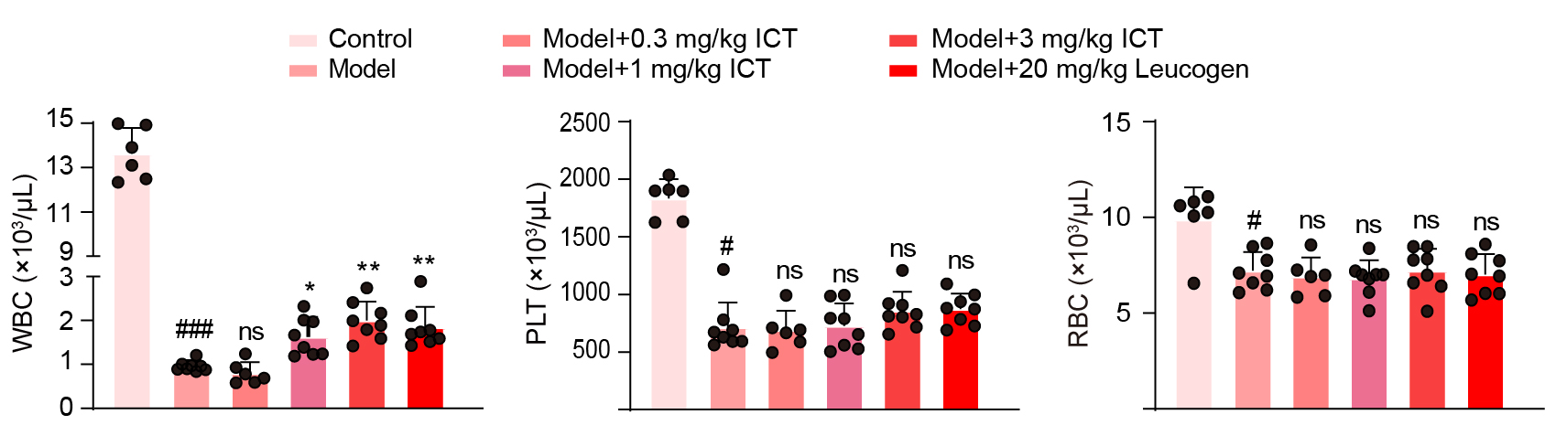
Fig. S1. The dose-response data for ICT in vivo. Numbers of WBCs, PLTs, and RBCs in the peripheral blood of control mice, model mice, model plus 0.3, 1 or 3 mg∙kg^{–1} ICT-treated mice, and model plus 20 mg∙kg^{–1} leucogen-treated mice on day 9 (n = 6–8 per group). The data are presented as the means ± SD. One-way ANOVA was used to determine significant differences among multiple groups. #P < 0.05 and ###P < 0.001 indicates statistical significance between control group and model group; *P < 0.05 and **P < 0.01 indicates statistical significance between model group and ICT-treated group; ns indicates no statistical significance between model group and ICT-treated group.
Fig. S2. ICT has no effect on spleen hematopoiesis or c-Kit⁺ cells after chemotherapy. (A) Gating strategy for the characterization of LT-HSCs. (B) Images and weights of spleens from model mice and ICT-treated mice (n = 4 per group). (C) The frequency of LT-HSCs in spleen cells from model mice and ICT-treated mice (n = 4 per group). (D) Schematic diagram of the in vitro assay of c-Kit⁺ BM cells. (E) Viability of c-Kit⁺ cells treated with vehicle or ICT at doses ranging from 0.03 to 100 μmol∙L^{–1} for 6 d (n = 3 per group). (F) Frequencies of LT-HSCs in c-Kit⁺ BM cells treated with vehicle or ICT at doses ranging from 0.1 to 1 μmol∙L^{–1} for 6 d (n = 4 per group). (G) Numbers of colony-forming units in 1000 c-Kit⁺ cells pretreated with vehicle or 1 μmol∙L^{–1} ICT for 6 d (n = 3 per group). (H) PB chimerism of CD45.2 cells from c-Kit⁺ BM cells treated with vehicle or 1 μmol∙L^{–1} ICT in CD45.1 recipient mice at 4, 8, 12 and 16 weeks post-BMT (n = 4 per group). (I) BM chimerism of CD45.2 cells from c-Kit⁺ BM cells treated with vehicle or 1 μmol∙L^{–1} ICT in CD45.1 recipient mice at 16 weeks post-BMT (n = 4 per group). (J) Percentages of donor-derived B, T, and myeloid lineage cells in the BM of recipient mice at 16 weeks post-BMT (n = 4 per group). The data are presented as the means ± SD. A two-tailed unpaired t test was performed to assess statistical significance between two groups, while one-way ANOVA was used to determine significant differences among multiple groups. *P < 0.05, **P < 0.01, and ***P < 0.001 versus the indicated group; ns indicates not significant.

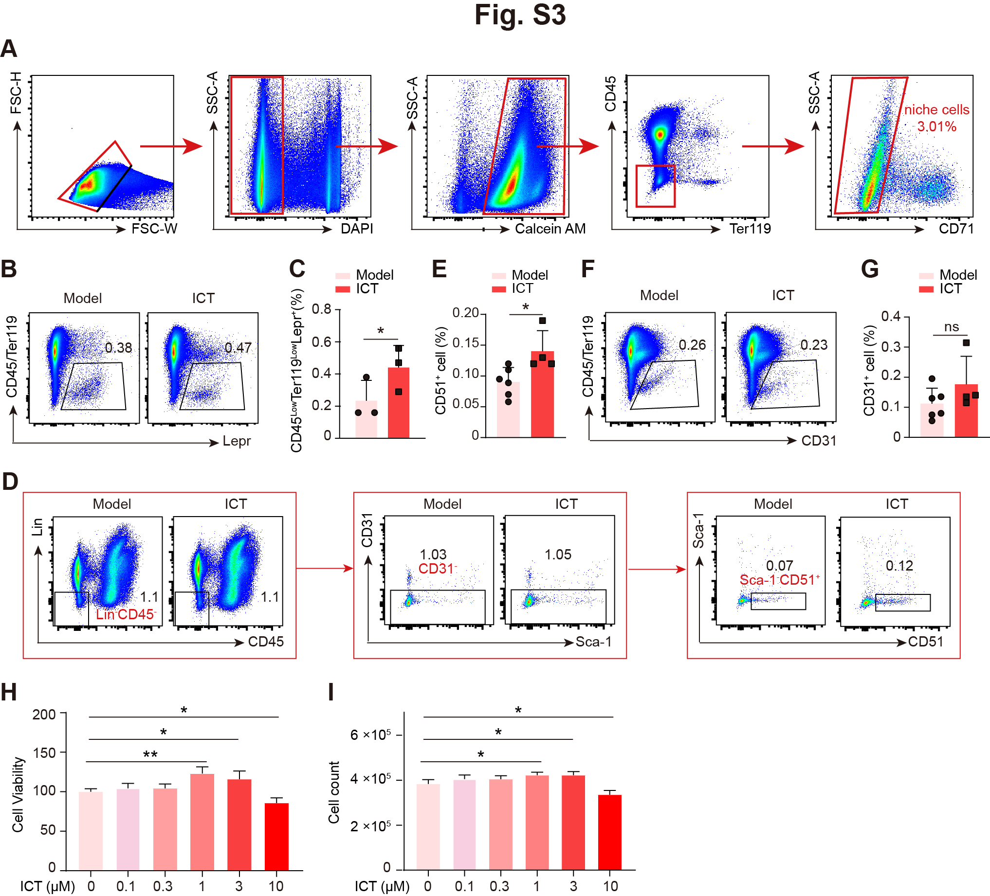
Fig. S3. ICT regulates the BM microenvironment after chemotherapy. (a) Gating strategy for the isolation of mouse bone and BM stroma. (b) Representative flow cytometry plots showing the percentages of MSCs in hind limb BM cells from model mice or ICT-treated mice (n = 3 per group). (c) Frequencies of MSCs from the mice treated as described in (b). (d) Representative flow cytometry plots showing the percentages of OBs in hind limb BM cells from model mice or ICT-treated mice (n = 4–6 per group). (e) Frequencies of OBs in the mice described in (d). (f) Representative flow cytometry plots showing the percentages of ECs in hind limb BM cells from model mice or ICT-treated mice (n = 4–6 per group). (g) Frequencies of ECs from the mice treated as described in (f). (h) Viability of MSCs treated with 0 to 10 μmol∙L^{–1} ICT for 6 d (n = 4 per group). (I) Cell counts of MSCs treated with 0 to 10 μmol∙L^{–1} ICT for 6 d (n = 4 per group). The data are presented as the means ± SD. A two-tailed unpaired t test was performed to assess statistical significance between two groups, while one-way ANOVA was used to determine significant differences among multiple groups. *P < 0.05, **P < 0.01, and ***P < 0.001 vs the indicated group; ns indicates not significant.

Table S3
scRNA-seq clusters, gene markers, and ICT-related changes.
Clusters | Gene markers | ICT-related fold changes
C0: MSC | Adipoq, Cxcl12, Lepr, Vcam1, Kitl | 1.63
C1: Pericyte-1 | Acta2, Tagln, Rgs5, Tpm2, Myl9 | 0.58
C2: Endothelial cell -1 | Cldn5, Lrg1, Cdh5, Pecam1, Emcn | 0.93
C3: Fibroblast-1 | Myoc, Gsn, Apod, S100a4, Dcn | 0.65
C4: Chondrocyte-1 | Col2a1, Ppa1, Col9a2, Lect1, Acan | 0.60
C5: Osteoblast-1 | Bglap, Bglap2, Dmp1, Ibsp, Fap | 1.91
C6: Fibroblast-2 | Clu, Prg4, Comp, Cilp, Dcn | 0.79
C7: Endothelial cell -2 | Sdpr, Egfl7, Pecam1, Cdh5, Flt1 | 0.70
C8: Fibroblast-3 | Itgbl1, Fmod, Mfap4, Ogn, Dcn, | 1.06
C9: Fibroblast-4 | Sfrp4, Apod, Rbp1, Nbl1, Fbln1 | 1.26
C10: cycling | Mki67, Ube2c, Stmn1, Top2a, Hmgb2 | 0.46
C11: Fibroblast-5 | Prg4, Fn1, Fgl2, Hbegf, Pcsk6 | 0.96
C12: osteoprogenitors | Spp1, Mepe, Fam20c, Tnc, Ank | 0.81
C13: chondrocyte-2 | Col9a3, Lect1, Col2a1, Acan, Ube2c | 0.57
C14: preosteoblasts | Phex, Col1a1, Wif1, Dkk1, sp7 | 1.04
C15: Pericyte-2 | Acta2, Myh11, Tagln, Myl9, Tpm2 | 0.68
C16: Fibroblast-6 | Gatm, Fxyd6, Igfbp6, Klf5, Gsn | 0.63

Table S4
Inhibition rates of ICT against the peroxidase activities of PRDX2–PRDX6.
Inhibitions | PRDX2 | PRDX3 | PRDX4 | PRDX5 | PRDX6
ICT (250 μmol∙L^{–1}) | ~ 0% | ~ 0% | ~ 0% | ~ 0% | ~ 0%
ICT (125 μmol∙L^{–1}) | ~ 0% | ~ 0% | ~ 0% | ~ 0% | ~ 0%

