Supplementary file for
Activation of the Macrophage-Associated Inflammasome Exacerbates Myocardial Fibrosis Through the 15-HETE-Mediated Pathway in Acute Myocardial Infarction
Xu Chen ^{a, b,#}, Zhiyong Du ^{c,#}, Dongqing Guo ^{d}, Jincheng Guo ª, Qianbin Sun ª, Tiantian Liu ª, Kun Hua ^{c}, Chun Li ^{e,}*, Yong Wang ^{a,}*, Wei Wang ^{a,f}*
ª School of Traditional Chinese Medicine, Beijing University of Chinese Medicine, Beijing 100029, China
^{b} Department of Pharmacy, Air Force Medical Center, Air Force Medical University, Beijing, 100142, China
^{c} National Clinical Research Center for Cardiovascular Diseases, Beijing Institute of Heart Lung and Blood Vessel Disease, Beijing Anzhen Hospital, Capital Medical University, Beijing 100029, China
^{d} School of Life Sciences, Beijing University of Chinese Medicine, Beijing 100029, China
^{e} Modern Research Center for Traditional Chinese Medicine, Beijing University of Chinese Medicine, Beijing 100029, China
^{f} State Key Laboratory of Traditional Chinese Medicine Syndrome, Guangzhou University of Chinese Medicine, Guangzhou 510006, China

# These authors contributed equally to this work.

* Corresponding authors.
E-mail addresses: lichun19850204@163.com (C. Li); doctor_wangyong@163.com (Y. Wang); wangwei26960@126.com (W. Wang)

Table S1
Patient characteristics.
All subjects (n = 428) | No subjects (n = 197) | Event subjects (n = 231)
Demographics
Age (years) | 54.85 ± 10.69 | 54.65 ± 10.85
Male (Sex), n (%) | 146 (74.1%) | 174 (75.3%)
Clinical history
Antihypertensive treatment, n (%) | 105 (53.2%) | 126 (54.5%)
Hypoglycemic treatment, n (%) | 46 (23.3%) | 47 (20.3%)
Clinical lipid profiles
Baseline LDL-C (mmol∙L^{–1}) | 0.96 [1.89, 3.17] | 1.03 [1.84, 2.98]
Baseline TC (mmol∙L^{–1}) | 4.02 [3.40, 4.96] | 3.95 [3.45, 4.86]
Baseline TG (mmol∙L^{–1}) | 1.81 ± 1.09 | 1.82 ± 1.99
Baseline HDL-C (mmol∙L^{–1}) | 1.06 ± 0.76 | 1.16 ±1.017
Cardiac function
Baseline CREA (μmol∙L^{–1}) | 72.72 ± 19.06 | 69.39 ± 13.62
Baseline CK (U∙L^{–1}) | 197.64 ± 453.94 | 301.90 ± 1114.23
BNP (pg∙mL^{–1}) | 47.03 ± 11.83 | 85.69 ± 101.50
Continuous data are presented as mean ± SD or median [interquartile range], and categorical variables are presented as %.

Table S2
Key Resources and Reagents
Reagent or resource | Source | Identifier
anti-p65NF-κB | Abways | CY5034
anti-Caspase-1 | Abcam | ab1872
anti-NLRP3 | Abcam | ab214185
anti-ASC | Santa Cruz Biotechnology | sc-514414
anti-IL-18 | ProteinTech Group | 10663
anti-IL-1β | ProteinTech Group | 5103
anti-GSDMD | Cell Signaling Technology | 93709S
anti-collagen I | Abways | CY3816
anti-collagen III | Abways | CY5034
anti-α-SMA | Abways | CY5295
anti-Smad2 | Abcam | ab33875
anti-p-Smad2 | Cell Signaling Technology | 18338
Anti- Smad3 | Abcam | ab28379
Anti- p-Smad3 | Cell Signaling Technology | 9520
anti-GAPDH | Abways | AB0037
Alexa Fluor 488 goat anti-rat IgG | Abcam | ab16284
Alexa Fluor 594 goat anti-mouse IgG | Abcam | ab97250
anti-α-actinin | ProteinTech Group | 66125
anti-CD31 | Abcam | ab182981
anti-CD86 | Abcam | ab119857
anti-Vimentin | Abcam | ab92547
Mouse IL-1β ELISA Kit | Boster | EK0529
Mouse IL-18 ELISA Kit | Boster | EK0393

Fig. S1. Cardiac function evaluation at different timepoints after LAD ligation between sham and control. The levels of left ventricular ejection fraction (LVEF), left ventricular fractional shortening (LVFS), left ventricular anterior wall thickness (LVAW;d), left ventricular end-systolic anterior wall thickness (LVAW;s), left ventricular end-diastolic internal diameter (LVID;d), left ventricular end-systolic internal diameter (LVID;s), Left ventricular posterior wall (LVPW;s), and left ventricular anterior wall thickness (LVPW;d) recorded by echocardiography. vs control group. n = 5 per group.

Fig. S2. Cardiac function evaluation at different timepoints after LAD ligation. The levels of left ventricular anterior wall thickness (LVAW;d), left ventricular end-systolic anterior wall thickness (LVAW;s), left ventricular end-diastolic internal diameter (LVID;d), left ventricular end-systolic internal diameter (LVID;s), Left ventricular posterior wall (LVPW;s), and left ventricular anterior wall thickness (LVPW;d) recorded by echocardiography. *P < 0.05, ***P < 0.001, vs hom group. n = 7 per group.

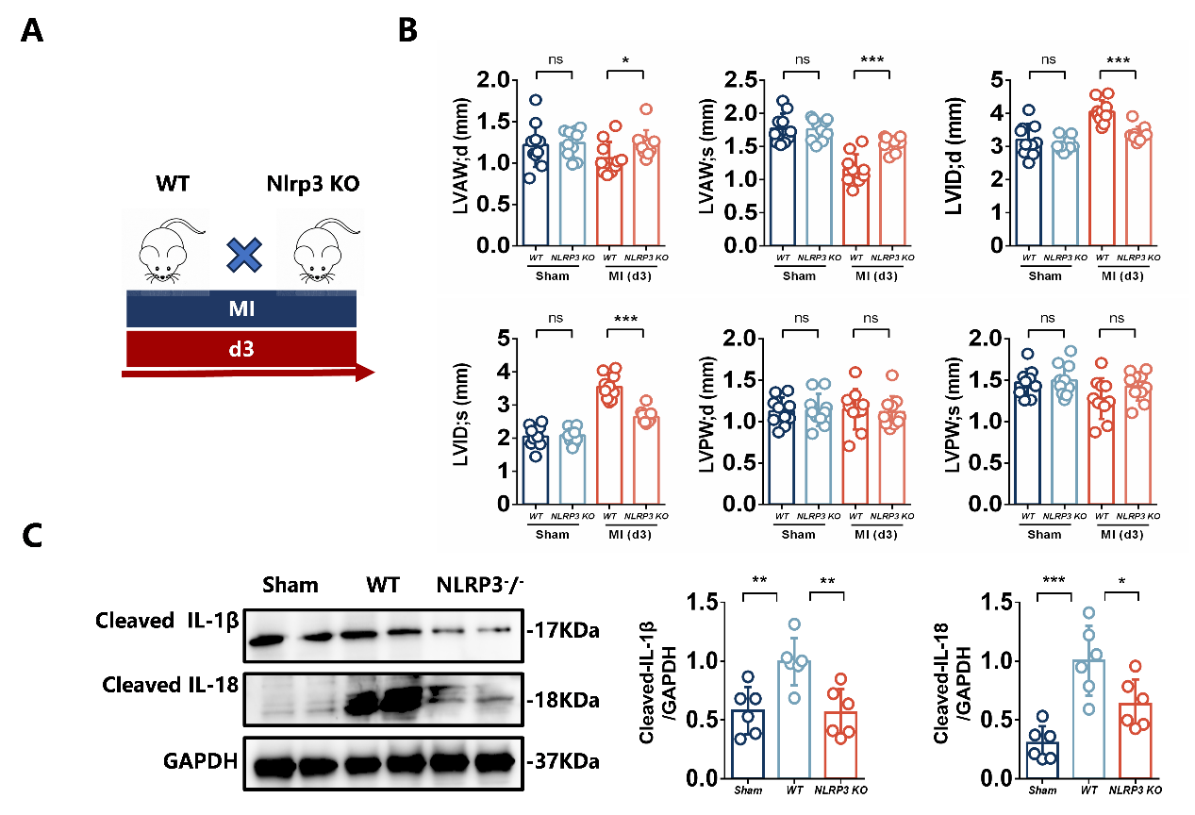
Fig. S3. Nlrp3 knockout inhibits MI-induced myocardial injury. (A) The experimental protocol for this part in MI mice. (B) Echocardiographic measurements of left ventricular anterior wall thickness (LVAW;d), left ventricular end-systolic anterior wall thickness (LVAW;s), left ventricular end-diastolic internal diameter (LVID;d), left ventricular end-systolic internal diameter (LVID;s), Left ventricular posterior wall (LVPW;s), and left ventricular anterior wall thickness (LVPW;d) in different groups. (C) Representative immunoblots of NLRP3 inflammasome related proteins in the cardiac tissues. *P < 0.05, **P < 0.01, ***P < 0.001, ns: not significant vs model group.
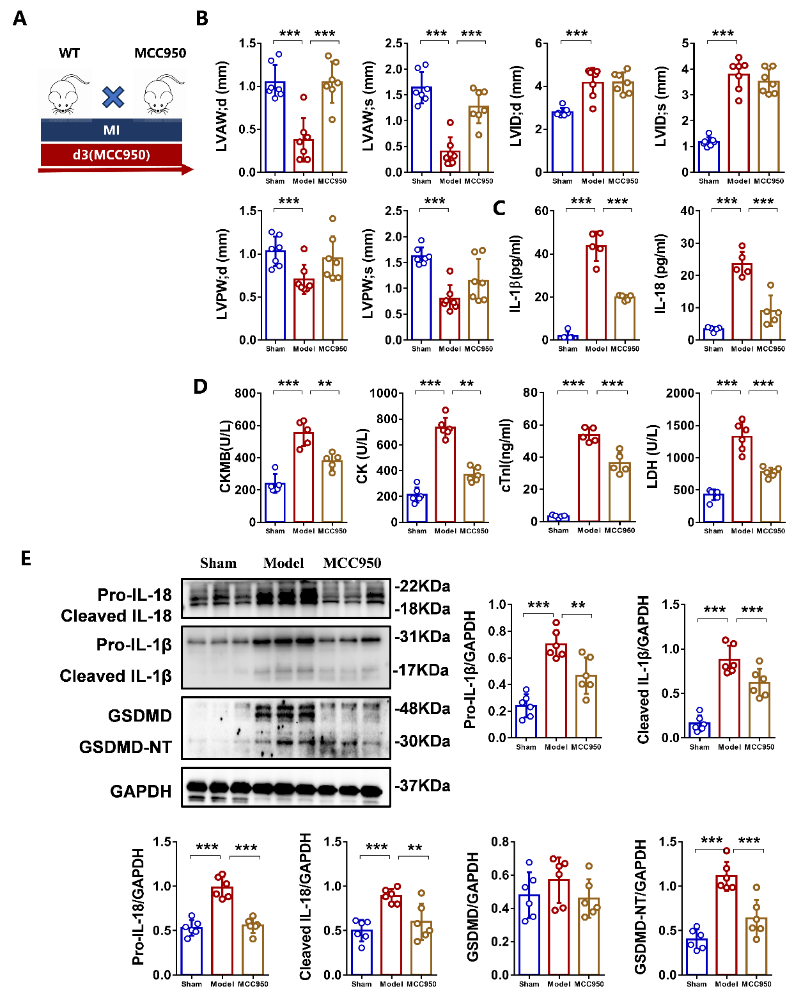
Fig. S4. MCC950 prevented MI-induced cardiac dysfunction and injury. (A) The experimental protocol for this part in MI mice. (B) Echocardiographic measurements of left ventricular ejection fraction (LVEF), left ventricular fractional shortening (LVFS), left ventricular anterior wall thickness (LVAW;d), left ventricular end-systolic anterior wall thickness (LVAW;s), left ventricular end-diastolic internal diameter (LVID;d), left ventricular end-systolic internal diameter (LVID;s), Left ventricular posterior wall (LVPW;s), and left ventricular anterior wall thickness (LVPW;d) in different groups. (C) Plasma levels of IL-1β and IL-18. (D) The serum LDH, CK, CK-MB, and cTn-I. (E) Representative immunoblots of NLRP3 inflammasome related proteins in the cardiac tissues of sham, model and MCC950-treated mice. **P < 0.01, ***P < 0.001 vs model group.

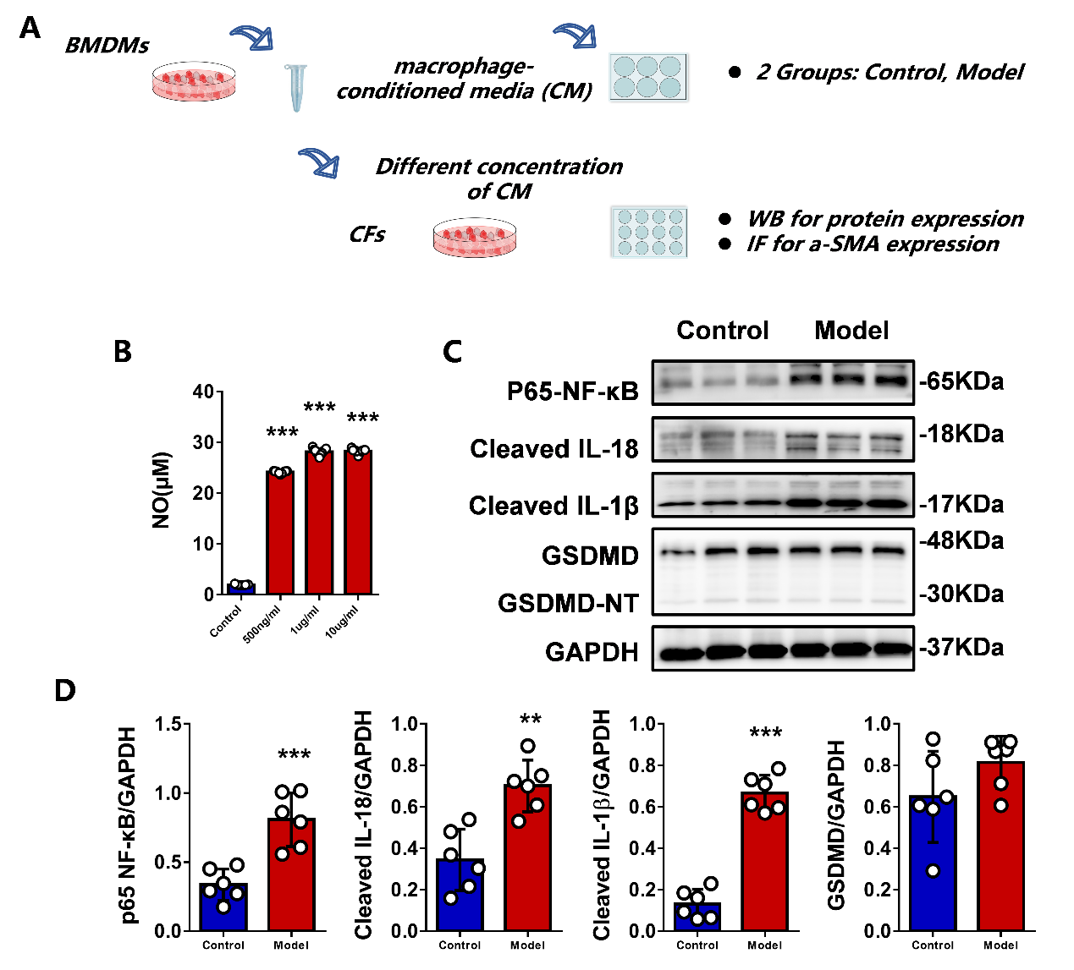
Fig. S5. Myocardial fibrosis model of fibroblast was established by LPS-stimulated macrophage-conditioned media. (A) The process for the in vitro study. (B) Levels of nitric oxide (NO) in macrophage supernatants were assessed by ELISA assay (n = 11 per group). (C) Western blots. (D) Semiquantification assay. ** P < 0.01, ***P < 0.001 vs control group.

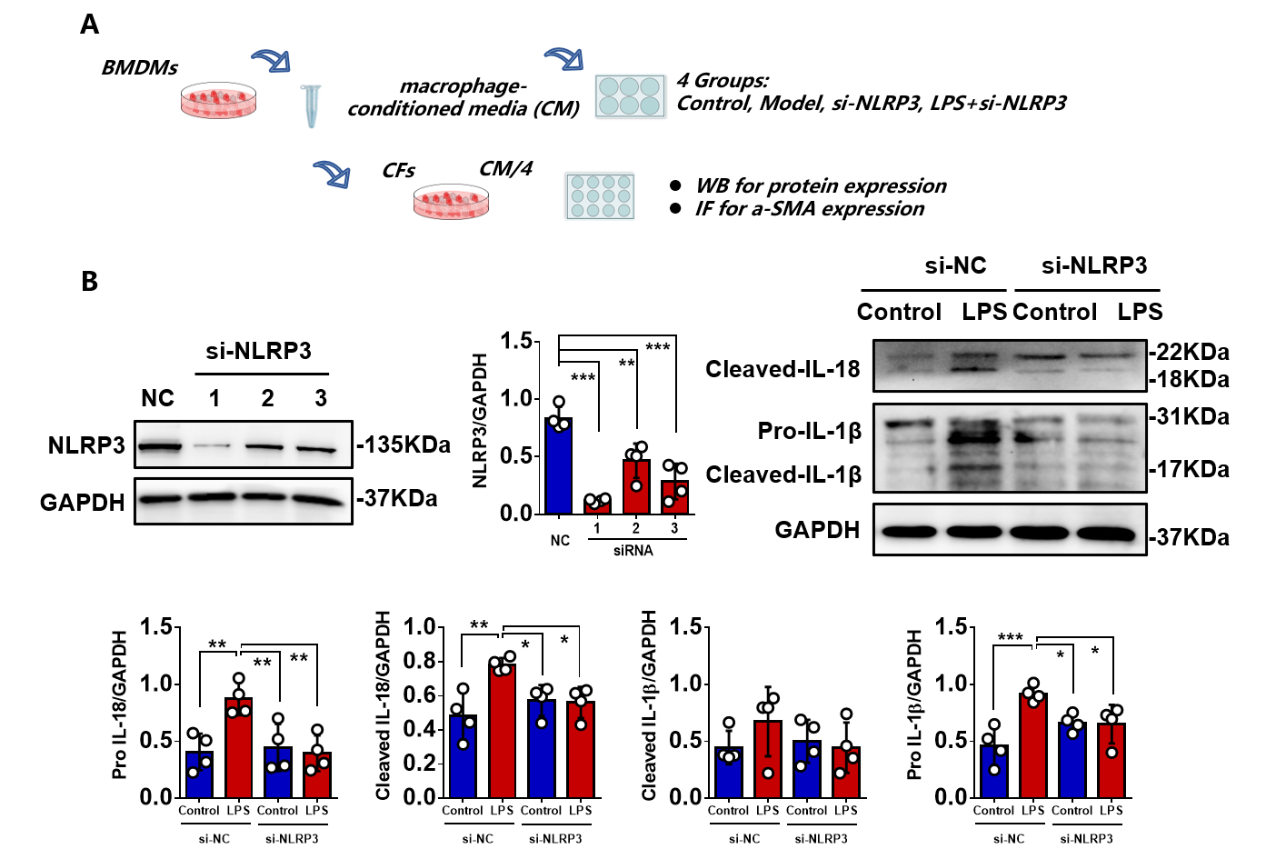
Fig. S6. si-Nlrp3 protected fibroblast against myocardial fibrosis induced by macrophage-conditioned media. (A) The process for the in vitro study. (B–D) Representative immunoblots of NLRP3 inflammasome related proteins in BMDMs. *P < 0.05, **P < 0.01, ***P < 0.001 vs model group.

