Supplementary data for
A Neuro Metasurface Mode-Router for Fiber Mode Demultiplexing and Communications
Yu Zhao ^{a,#}, Huijiao Wang ^{a,#}, Zile Li ^{a,b,#}, Tian Huang ª, Chao Yang ^{c}, Ying Qiu ^{c}, Yuhan Gong ^{c}, Zhou Zhou ª, Congling Liang ª, Lei Yu ^{a,}*, Jin Tao ^{b,c,}*, Shaohua Yu ^{b}, Guoxing Zheng ^{a,b,d,}*
ªElectronic Information School & School of Microelectronics, Wuhan University, Wuhan 430072, China
^{b} Peng Cheng Laboratory, Shenzhen 518055, China
^{c} State Key Laboratory of Optical Communication Technologies and Networks, China & Information Communication Technologies Group Corporation (CICT), Wuhan 430074, China
^{d} Wuhan Institute of Quantum Technology, Wuhan 430206, China
* Corresponding authors.
E-mail addresses: ly.wd@whu.edu.cn (L. Yu), taojin@wri.com.cn (J. Tao), gxzheng@whu.edu.cn (G. Zheng).
# These authors contributed equally to this work.
S1. Fiber mode coupling configuration
We utilize a fused-type fiber mode coupler for mode converting and mode coupling, as shown in Fig. S1. The mode coupling configuration is composed of SMF and FMF which are fused by traveling flame along the longitudinal direction, enabling the light coupled from one piece of fiber to another piece. The FMF is fabricated by Fiberhome Corporation, which supports the LP₀₁ mode and two degenerate LP₁₁ modes, referring as the LP_{11a} and LP_{11b} modes.
Specially, the LP₀₁ mode transmitted through the FMF maintains the LP₀₁ mode in fused area and the output mode from the FMF is still the LP₀₁ mode. When the LP₀₁ mode is launched into the SMF port, the mode coupling occurs, and part of energy transform into the LP₁₁ mode. The output mode is the LP₀₁ mode from the SMF and the LP₁₁ mode from the FMF.
In order to avoid the converted LP₁₁ mode in the FMF converting back to SMF, the diameter, cladding diameter and coupling length should be properly designed. In simulation, the cladding diameter and index of SMF and FMF are 125 μm and 1.444 and the core diameter of the two fibers are 9 μm and 13.5 μm, respectively. The above parameters are used to obtain the standard amplitude distribution of the mode fields in data collection.
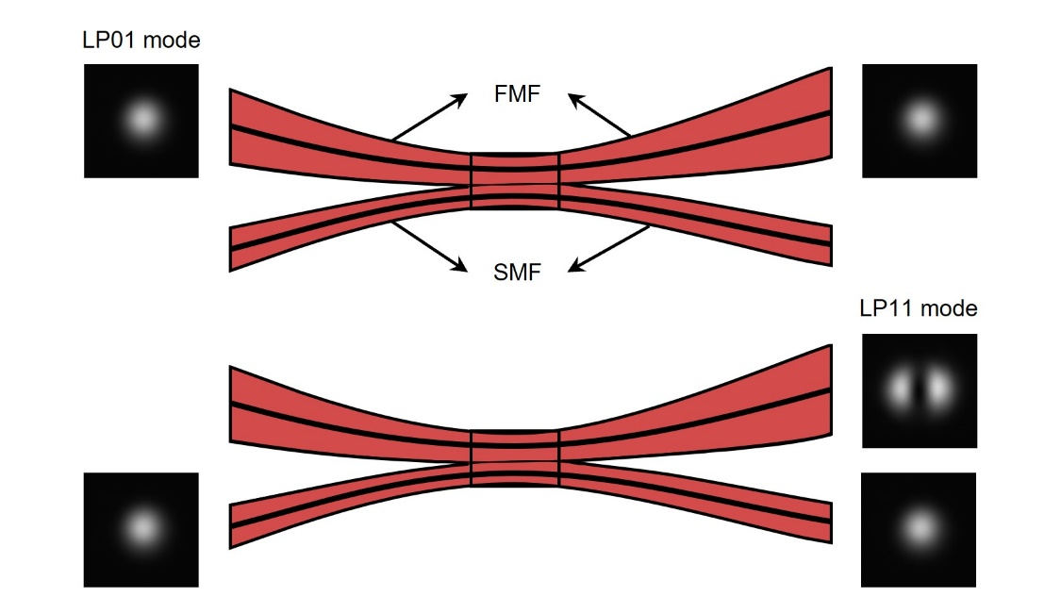
Fig. S1. Model and function of the fused-type fiber mode coupler.

S2. Training configuration
The time used for our neural network architecture to optimize the metasurface is almost 3 hours. Our network is implemented using Python (v3.8.13) and Pytorch (v1.12.0) on an NVIDIA GeForce RTX 3090 GPU and Intel (R) Core (TM) i9-10900X CPU @ 3.70GHz with 128 GB of RAM, running on the Ubuntu 20.04 operating system.
S3. Data collection for neural network training
Concerning the input mode fields in the communication system, we employ two sets of parameters to generate simulation images depicting the mode field distribution. The first set encompasses the geometric structure parameters of the fiber, such as diameters, numerical aperture, normalized frequency, and eigenvalues, serving as fixed parameters that establish the standard amplitude distribution of the optical fields for the modes. The second set involves planar position parameters of the fiber, encompassing translation along the x-axis and y-axis, rotation along the central axis of the field, and zooming around the central point of the field. These serve as variable parameters determining the transformed mode field distribution.
Initially, relying on the theoretical dimension parameters of the optical fiber, we establish reference values for fixed parameters and generate reference field distributions for the LP₀₁ and LP₁₁ modes. We choose the images of mode optical fields captured by an infrared camera positioned 2 cm from the collimating lens. Based on the 860 nm cell size of the nanobricks on the metasurface and the 20 nm pixel size of the images from the infrared camera, we determine the dimensions of the metasurface to be 1000 × 1000 pixels and extracted the actual mode field distributions from the images using pixels measuring 43 × 43, corresponding to an area of 860 μm × 860 μm. Subsequently, we scan the values of the fixed parameters, fitting the reference field distributions to actual field distributions captured by the infrared camera. We determine the standard LP₀₁ mode field distribution, exhibiting a correlation coefficient of 0.9851 in comparison with the actual LP₀₁ mode field distribution. Similarly, we ascertain the standard LP₁₁ mode field distribution with a correlation coefficient of 0.9737 compared with the actual LP₁₁ mode field distribution.
Conclusively, based on the standard field distributions, we introduce variable parameters, adjustable within experimentally controllable ranges, to generate field distribution datasets. In the dimension of position translation, considering the unequal areas of the LP₀₁ and LP₁₁ mode standard field distributions, we set translation scale of the LP₀₁ mode in the positive and negative directions of the x and y axes to be 8.6 µm, with a resolution of 1.72 µm. Correspondingly, the translation scale of the LP₁₁ mode in the positive and negative directions of the x and y axes is set to be 10.75 µm, with a resolution of 2.15 µm. Addressing the angle rotation dimension, we establish a rotation scale of 2 degrees for both clockwise and counterclockwise directions for the two modes, with a resolution of 1 degree. Lastly, in the areal zooming dimension, we set the reduction scale as 0.9 with a resolution of 0.01 and the enlargement scale as 1.1 with a resolution of 0.01 for the two modes.

S4. Loss function across the training procedure
An intuitive loss function denotes the sum of the energy difference of each pixel between the target output plane and the actual output plane. However, the light region occupies an extremely small portion of the output plane, extremely 10 × 10 pixels. This loss function would distribute energy evenly across the output plane, failing to emphasize the energy of the light target region over the dark background region. Therefore, to concentrate the energy of each mode solely at the designed target region, we introduce Loss_{back} and Loss_{corr}.
Initially, we employ the loss function Loss_{back} to maximize the energy concentrated on the two designed target regions. Loss_{back} is defined as the ratio of the energy in the target region to the energy in the whole actual output plane, and it can be expressed as
Here, x₀₁ and y₀₁ represent the numerical coordinates of the center in the target region for the LP₀₁ mode, x₁₁ and y₁₁ represent the numerical coordinates of the center in the target region for the LP₁₁ mode. Δl and Δw denote the target ranges (e.g., Δl = 10, Δw = 10), which means that the length and width of the target region are respectively 2Δl + 1, 2Δw + 1. Lo and Wo represent the length and width of the output plane. O_{actual} (m, n) denotes the pixel value at the coordinate (m, n) of the output plane. As shown in the Fig. S2, Loss_{back} is to be maximized during the training process to augment the energy of the target regions, thereby increasing the signal-to-noise ratio (SNR) in the output plane, and enhancing the efficiency of the metasurface device.
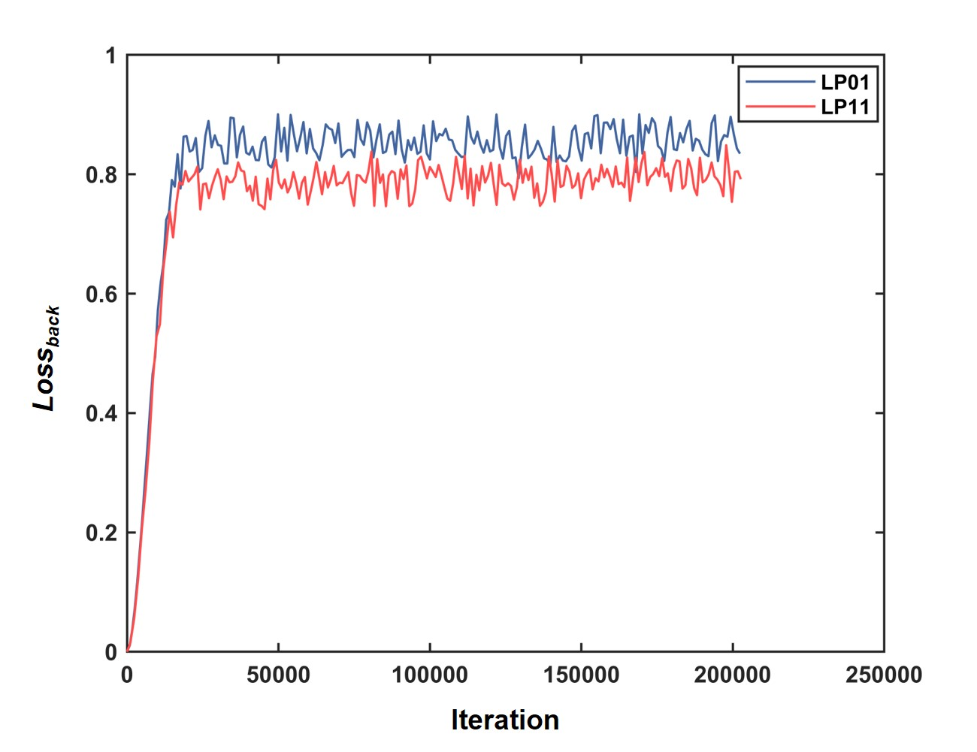
Fig. S2. Training procedure as the Loss_{back} increases.

However, relying on Loss_{back} solely is insufficient, as it could result in a local optimum solution where energy of the two target regions could be nearly equal under one mode input. Consequently, a loss function Loss_{corr} is introduced to mitigate inter-mode crosstalk. Loss_{corr} is defined as the ratio of the energy in the target region to the energy in the other target region according to the transmitted mode, which can be expressed as
As shown in the Fig. S3, Loss_{corr} is to be minimized during the training process to ensure a significant difference between the energy of the two target regions when one mode transmitted, facilitating the distinction between the two modes.
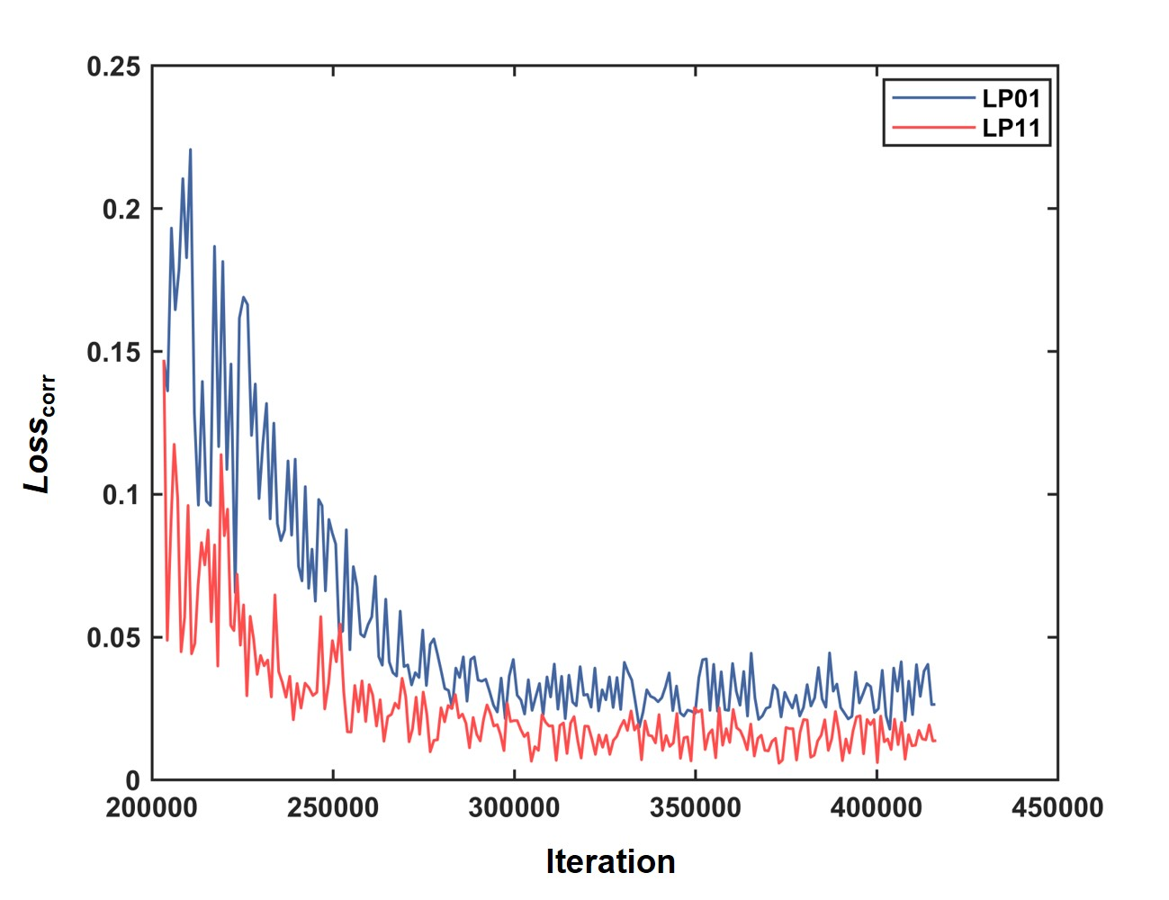
Fig. S3. Training procedure as the Loss_{corr} decreases.

S5. Nanostructure simulations
For achieving remarkable transmittance within the infrared communication wavelength of 1550 nm, we use an all-silicon structure, illustrated in Fig. S4a for a unit-cell, consisting of monocrystalline silicon nanobrick sitting on a substrate. Each nanobrick possesses the same dimensions but different orientation angles denoted as α.
Our aim is to maximize the transmittance for the cross-polarized component of the nanobricks, consequently leading to superior PB phase modulation efficiency. Determining the height of the nanobricks to be 1000 nm, other geometric parameters of the nanobricks, as cell size, length, and width, were scanned via COMSOL Multiphysics software. The ultimate optimized nanostructure, with cell size of 860 nm × 860 nm, length of 680 nm and width of 260 nm, possess a high transmittance over 70% and covers a complete phase delay from 0 to 360 degrees for the cross-polarized component, as illustrated in Fig. S4b.
Considering the potential to incorporate a wavelength-division multiplexing scheme into the proposed mode-division multiplexing communication system, we simulate the optical responds of the nanostructure at operating wavelengths ranging from 1548 to 1552 nm, which can satisfy demands of wavelength-division multiplexing. The nanostructure within the above geometric dimensions, exactly maintains a transmittance about 70% and completely covers a phase delay from 0 to 360 degrees for the cross-polarized component, as illustrated in Fig. S4c and d.
Fig. S4. Design of the nanostructural unit-cell for the neuro-meta-router. a) The schematic of the all-dielectric nanostructure unit-cell. b) The simulated transmittance and phase delay verse the orientation angles of the nanostructure for the cross-polarized component under normal circularly polarized light incidence at an operating wavelength of 1550 nm. c, d) The simulated transmittances and phase delays verse the orientation angles of the nanostructure for the cross-polarized component under normal circularly polarized light incidence at operating wavelengths from 1548 to 1552 nm.

S6. Optical field distributions of modes transmitted in the FMF
We captured the optical field distributions of the LP₀₁ and LP₁₁ modes transmitted in the FMF. The infrared camera was placed at 2 cm, 7.5 cm, 15 cm, 22.5 cm, 30 cm from the collimating lens and the captured images are shown in the Fig. S5. We chose the images under 2 cm as the actual distributions for fitting process in data collection, and determined the distance between the metasurface and the collimating lens as 2 cm, correspondingly. Base the images under 7.5 cm, 15 cm, 22.5 cm, 30 cm, we calculated the divergence angles for LP₀₁ and LP₁₁ modes, which are 0.1241 degrees and 0.1053 degrees along the x axes, 0.1203 degrees and 0.1767 degrees along the y axes.
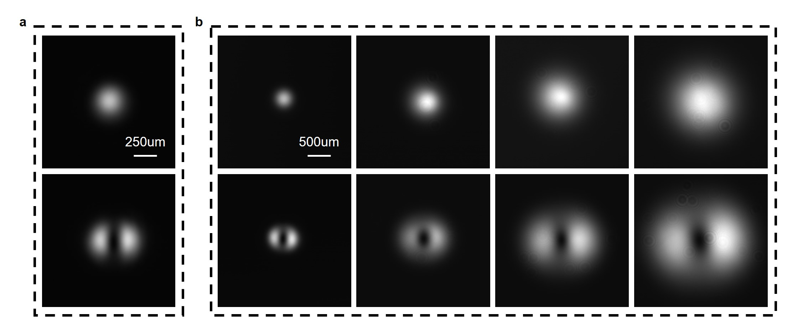
Fig. S5. Captured images of the optical field distributions of the LP₀₁ and LP₁₁ modes. a) Images under 2cm. b) Images under 7.5 cm, 15 cm, 22.5 cm, 30 cm.

S7. Robustness assessment.
Under the overlay of the four transformation dimensions with the scale same as that in the main text, we generate the transformed mode fields which is more consilient with mode fields in experimental environment. The scale of x-axial shifting is 50 μm along the positive axes (Δx = 50 μm), and y-axial shifting is 100 μm along the positive axes (Δy = 100 μm). The scale of planar rotating is 10 degrees clockwise (θ = 10 degrees). And the scale of areal zooming is 1.1 times, corresponding to z-axial shifting with scale of 12.3 mm along the negative axes (Δz = 12.3 mm). The corresponding computed Kirchhoff diffraction distributions for the LP₀₁ and LP₁₁ modes are shown in the Fig. S6. And the enlarged distributions (11 × 11 pixels) of the target regions are shown, the results validate that the optimized metasurface possesses robustness to route transformed modes to the target regions.
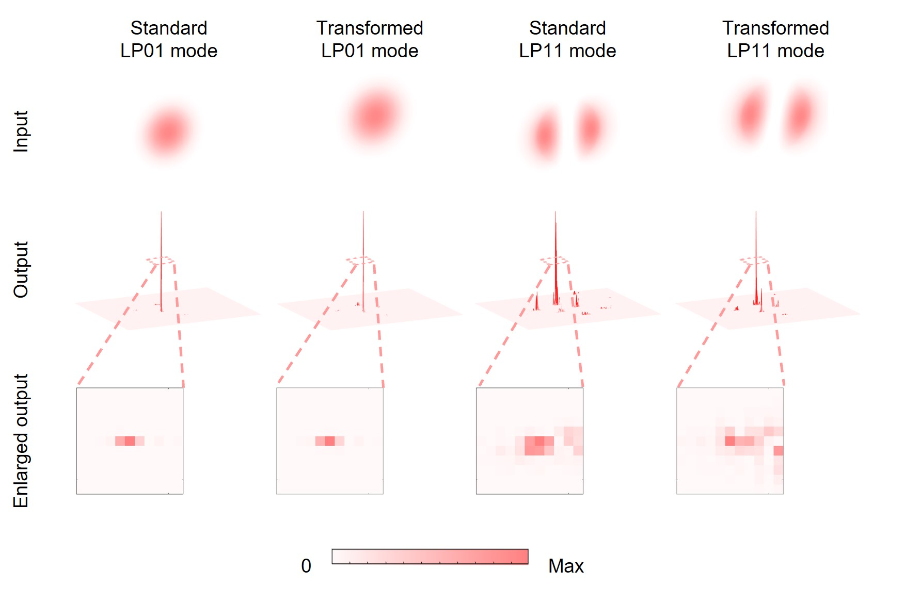
Fig. S6. Numerical simulation results for robustness assessment.
S8. Sample fabrication
The proposed neuro-meta-router consists of a single layer of metasurface, adopting an all-dielectric structure made of monocrystalline silicon. Initially, a PMMA photoresist with a concentration of 1:1 is spin-coated onto the sample. Subsequently, it undergoes exposure through an electron beam exposure machine (eLINE Plus) based on the designed arrangement of nanobricks. Following this, a 25-nm-thick film of Cr is thermally evaporated after the development and fixation process. The Cr in the unexposed area is removed through a lift-off process, forming the Cr film consistent with the designed arrangement of nanobricks on the surface. Finally, etching is conducted using an inductively coupled plasma etcher (PlasmaPro 100Cobra 300) with an etching depth of 1000 nm. And a corrosive is employed to eliminate the remaining Cr, obtaining the final metasurface, as illustrated in Fig. S7.
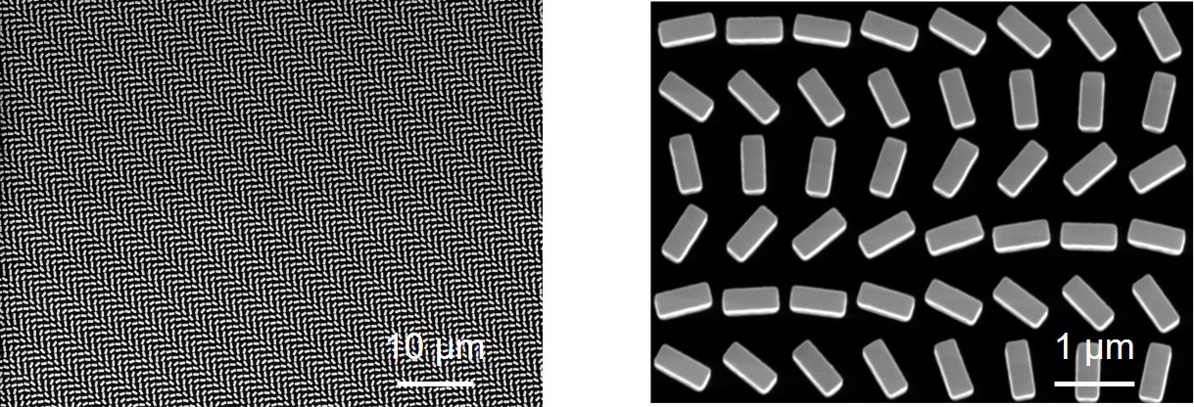
Fig. S7. Partial scanning electron microscope image of the fabricated silicon metasurface.

S9. Conversion between displaying information and circulating bitstreams
For communication of image information, we convert the original image or video into the transmitted bitstream pixel by pixel. The bitstream, or rather the frame, is circulated across the communication system. In reverse process, the received bitstream is directly converted into the recovery image or video pixel by pixel without any compensation technologies like multi-in multi-out technology commonly used in mode-division multiplexing communication.

S10. Image evaluation for communication quality of the NMR system
We utilize a metric which is like BER, calculating the global magnitude of the pixel error between the received image and the transmitted image to evaluate the quality of the received image, which is expressed as

Here, I_{max} denotes the maximum pixel value in the received image, I^{R} denotes the received image, I^{T} denotes the transmitted image, L and W represent the dimensions of the image. For the received images in the LP₀₁ mode channel, the pixel errors are approximately 0, 0.00039, 0.00012, 0.00129, 0.00100, 0.00058, 0.00055, in order. Similarly, for the received images in the LP₁₁ mode channel, the pixel errors are approximately 0, 0.00491, 0.00035, 0.00739, 0.00189, 0.00403, 0.00438. Additionally, the measured BERs of the received images are approximately 0.00018, 0.00061, 0.00015, 0.00110, 0.00094, 0.00068, 0.00047 of the LP₀₁ mode channel, and 0.00051, 0.00590, 0.00120, 0.00680, 0.00320, 0.00520, 0.00490 of the LP₁₁ mode channel.

S11. Comparison of our work to previous similar systems
Considering previous works on metasurface-enbled mode multiplexers, it is worth to mentioning that none of these approaches allow metasurfaces with single-dimension units to handle modes across multiple dimensions within certain environmental perturbation limits for high-capacity communications (see Tab. 1). Previous methods involving metasurfaces composed of multi-cell units and integrated on fiber ports also encounter misalignment issues, and our simplified metasurface construction delivers benefits of reducing design complexity and fabrication difference. Another key feature is scalability to accommodate more higher-order modes and function channels without changing theoretical principles and experimental architectures, as demonstrated in our work with the design for four-mode division. Additionally, our system supports integration of a wavelength-division multiplexing scheme across bandwidths of our architecture. Most importantly, we have successfully implemented practical mode-division multiplexing communications achieving capacities up to 100 Gbps.
Table 1.
Summary of the previously reported work
Function | Construction | Integration | Scalability | Bandwidth | Implementation | Reference
Mode conversion | Multi-dimension | Free space | Two modes | S, C, and L bands | 100 Gb s⁻¹ Communications | Ref. ^{[1]}
Mode conversion | Multi-dimension | Free space | Two modes | S, C, and L bands | 24 Gbaud Communications | Ref.^{[2]}
Mode conversion | Multi-dimension | Free space | Two modes | C band | Simulations | Ref. ^{[3]}
Mode conversion and division | Multi-dimension | Fiber-integrated | Three modes and more | C band | Characterization of modes | Ref. ^{[4]}
Mode division | Multi-dimension | Fiber-integrated | Three modes and more | 1550 nm | Simulations | Ref. ^{[5]}
Mode division | Single-dimension | Free space | Two modes and more | C band | 100 Gbps Communications | Ours

References
[1] S. Kruk, F. Ferreira, N. Mac Suibhne, C. Tsekrekos, I. Kravchenko, A. Ellis, D. Neshev, S. Turitsyn, Y. Kivshar, Laser &amp; Photonics Reviews 2018, 12, 1800031.
[2] E. Nazemosadat, M. Mazur, S. Kruk, I. Kravchenko, J. Carpenter, J. Schröder, P. A. Andrekson, M. Karlsson, Y. Kivshar, Advanced Optical Materials 2019, 7, 1801679.
[3] J. Tao, L. Wu, Y. Yang, Z. Liu, Y. Qiu, G. Zheng, S. Yu, J. Lightwave Technol. 2021, 39, 2438.
[4] J. Oh, K. Li, J. Yang, W. T. Chen, M.-J. Li, P. Dainese, F. Capasso, ACS Photonics 2022, 9, 929.
[5] R. Chen, Y. Chang, Z. Zhuang, Y. Liu, W. Chen, J. Dong, Advanced Optical Materials 2023, 11, 2202317.

