Supplementary materials
Self-Sensing Steel–FRP Composite Bars for Crack Monitoring and Mechanical Behavior Evaluation in Reinforced Concrete Members
Yingwu Zhou ª, Zenghui Ye ª, Feng Xing ^{a,b,}*, Zhongfeng Zhu ^{a,}*, Xiaoxu Huang ª
ª Guangdong Provincial Key Laboratory of Durability for Marine Civil Engineering, Shenzhen University, Shenzhen 518000, China
^{b} School of Mechanics and construction Engineering, Jinan University, Guangzhou 510632, China

* Corresponding authors.
E-mail addresses: xingf@szu.edu.cn (F. Xing), zhongfeng.zhu@szu.edu.cn (Z. Zhu).
Fig. S1 shows the final cracking pattern of the samples in detail. Moreover, a comparison of the measured and calculated curves of the crack width‒member strain is depicted in Fig. S2.
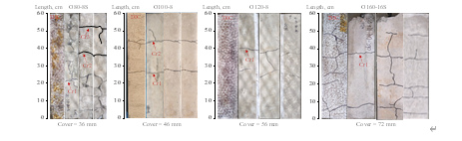
(a)
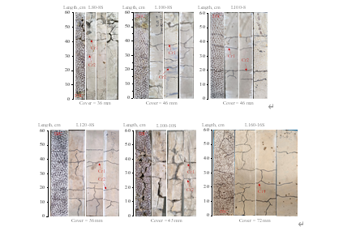
(b)
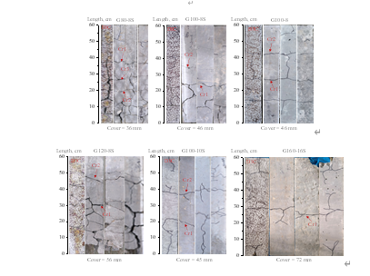
(c)
Fig. S1. Final cracking patterns of the samples. (a) OPC members; (b) LC3 members; (c) GPC members.
(a) O80-8S (b) O100-8 (c) O120-8
(d) O160-16S (e) L80-8S (f) L100-8S
(g) L100-8 (h) L120-8S (i) L100-10S
(j) L160-16S (k) G80-8S (l) G100-8S
(m) G100-8 (n) G120-8S (o) G100-10S
(p) G160-16S
Fig. S2. Comparison of the measured and calculated curves of the crack width–member strain.

