Supplement Materials

A Wearable Stethoscope for Accurate Real-Time Lung Sound Monitoring and Automatic Wheezing Detection Based on an AI Algorithm
Kyoung-Ryul Lee ^{a,†}, Taewi Kim ^{b,†}, Sunghoon Im ^{b,†}, Yi Jae Lee ª, Seongeun Jeong ª, Hanho Shin ª, Hana Cho ª, Sang-Heon Park ª, Minho Kim ^{b}, Jin Goo Lee ^{b}, Dohyeong Kim ^{c}, Gil-Soon Choi ^{d}, Daeshik Kang ^{b,}*, SungChul Seo ^{e,}*, Soo Hyun Lee ^{a,}*
ª Center for Biomicrosystems, Brain Science Institute, Korea Institute of Science and Technology, Seoul 02792, Republic of Korea
^{b} Department of Mechanical Engineering, Ajou University, Suwon 16499, Republic of Korea
^{c} School of Economic, Political and Policy Sciences, The University of Texas at Dallas, Richardson, TX 75080, USA
^{d} Department of Internal Medicine, Kosin University College of Medicine, Busan 49267, Republic of Korea
^{e} Department of Nano, Chemical and Biological Engineering, Seokyeong University, Seoul 02713, Republic of Korea
† These authors contributed equally to this manuscript.
* Corresponding authors. F
E-mail addresses: dskang@ajou.ac.kr (D. Kang), haha0694@gmail.com (S. Seo), shleekist@kist.re.kr (S.H. Lee).

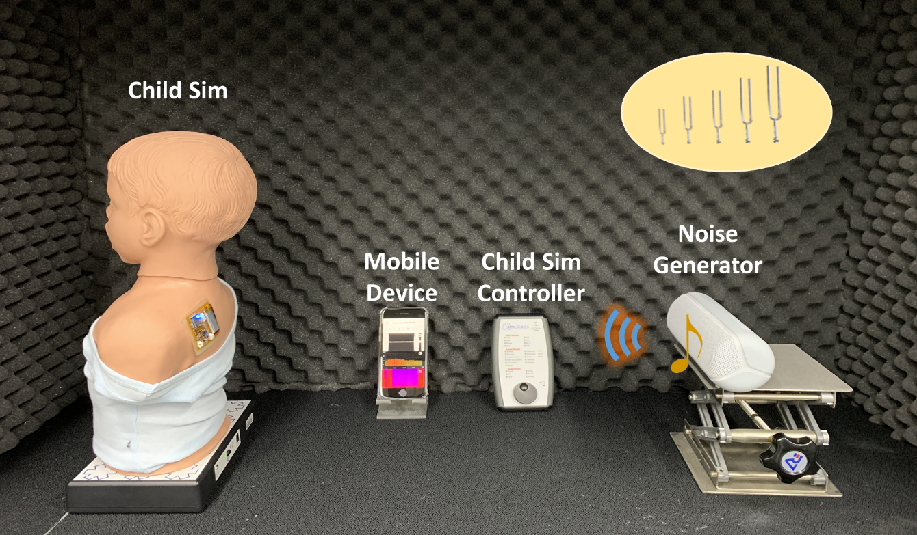
Figure S1. Photograph of experimental set-up

Figure S2. LSMP sensor battery usage result. The LSMP sensor wireless connected to the phone measured bioacoustics data more than 24 hours using 100mAh battery and showed discharge curves throughout two trials.

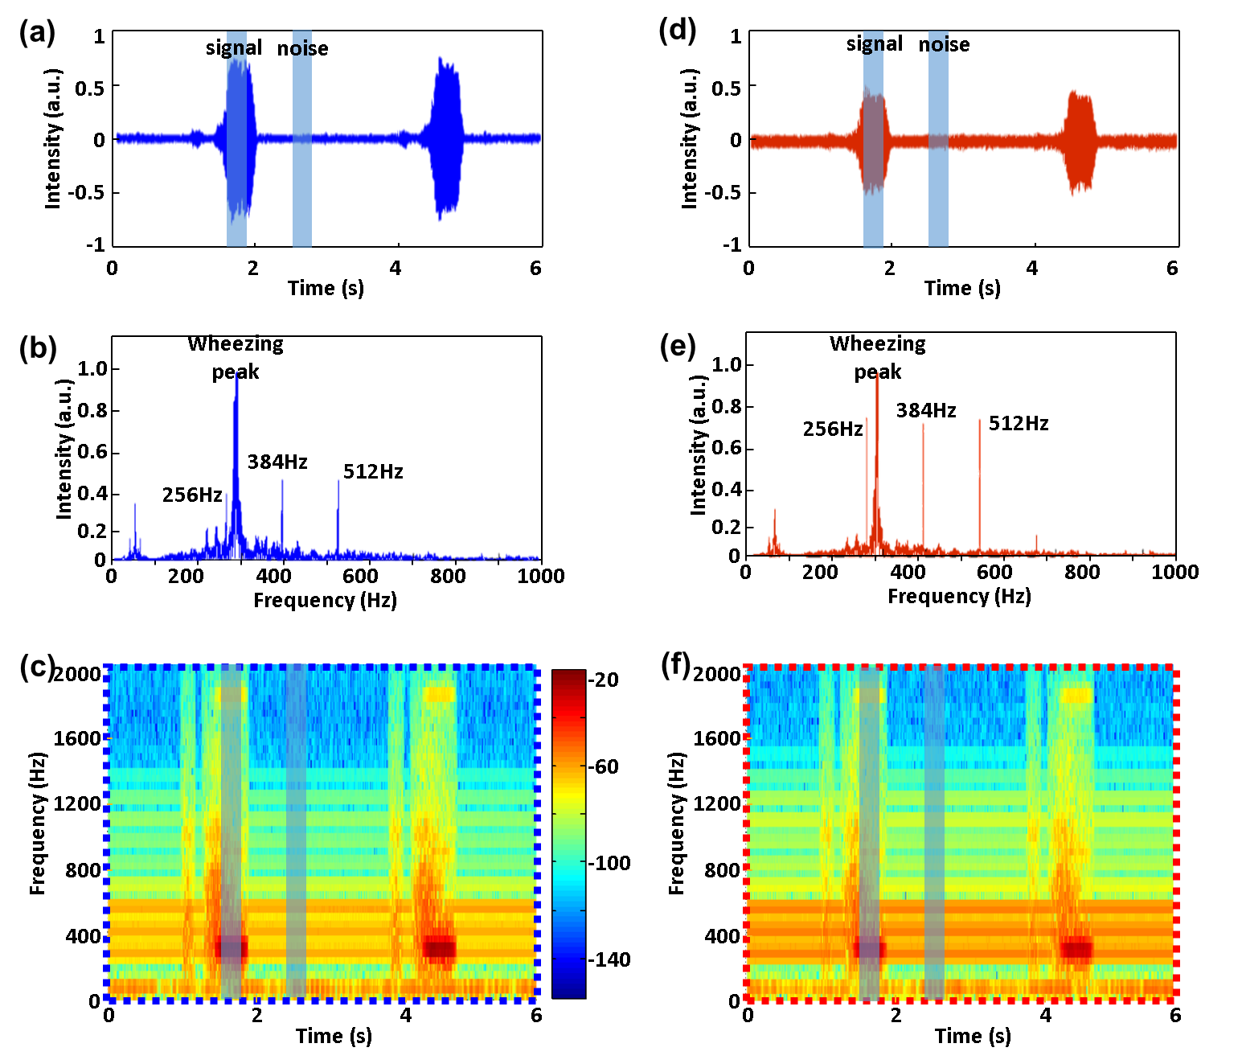
Figure S3. Comparing noise sensitivity for different directional microphones; Child Sim. was used to calculate the SNR of a respiratory interval (signal) and an external tuning fork (noise) when external noise (256 Hz, 384 Hz, 512 Hz) was simultaneously generated while playing wheezing sounds. (a-c) shows the time series data, STFT results and spectrogram information corresponding to a unidirectional microphone recorded for 6 seconds. (d-f) shows the time series data, STFT results and spectrogram information corresponding to an omnidirectional microphone recorded for 6 seconds.

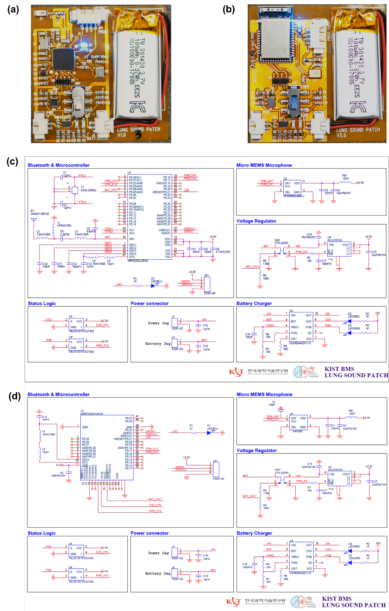
Figure S4. Schematic illustration of LSMP with different antenna type (a) photo of LSMP sensor with external antenna type (b) photo of LSMP sensor with embedded antenna type (c) circuit schematic of LSMP sensor with external antenna type (d) circuit schematic of sensor with embedded antenna type.

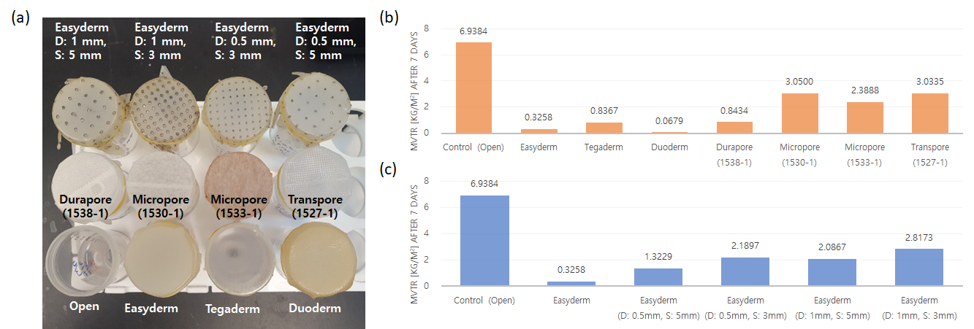
Figure S5. Medical adhesive permeability testing. (a) Several different adhesives are evaluated using a water-filled conical tube, by comparing their permeability which is determined by the transmission rate of gaseous H2O. The adhesives compared include the open method, 3M Easyderm, Tegaderm, Duoderm, Durapore, Micropore, Transpore. (b) The final comparative graph depicting permeability is presented after monitoring for a week at room temperature. (c) We also compared how much the permeability improved by making holes in Easyderm in four ways, with diameters of 0.5 mm and 1 mm, and spacings of 3 mm and 5 mm. Easyderm demonstrated equivalent performance to Micropore and Transpore when holes of 1 mm in diameter and 3 mm in spacing were made.

Figure S6. Signal-to-noise ratio (SNR) value variation of Child Sim’s wheezing over seven days for estimate long-term reliability

SI Section 1: Performance assessment of LSMP
1.1 Auscultation performance assessment with a child heart and lung sound trainer simulator
For the assessment of auscultation characteristics, it is necessary to evaluate the acoustic characteristics of several breathing sounds. In practice, auscultation using a microphone sensor consists of a data stream from which physiological information could theoretically be extracted from the various biological acoustic signals. In fact, various symptoms can be classified through the analysis of recorded lung sounds using an electronic stethoscope (E-stethoscope), and various studies are underway [1, 2].
One of the ways in which we sought to assess the suitability of our device was to record the auscultation waveforms corresponding to a variety of breathing conditions and compare them to the signals recorded from a reference device, the E-stethoscope (Littmann3200, 3M). To this end, we artificially generated them with the Child Sim, then measured and analyzed them with the E-stethoscope and LSMP, respectively. To compare the characteristics of the signals recorded by the LSMP with those of a conventional device, the same sounds were recorded from the Child Sim using an E-stethoscope on extend mode (20 to 2000 Hz) and extracted as a wave file through the Littmann heart and lung visualization software (Littmann StethAssist, 3M) for data analysis. Figure S7(a-c) shows the time-intensity plots from the E-stethoscope, and Figure S7(d-f) shows the corresponding FFT data. Comparing the time-intensity results from the E-stethoscope and LSMP, the data from the E-stethoscope are unclear due to the presence of noise. Because it is difficult to assess the frequency distribution of the bioacoustics signal from time-series analysis, we calculated the fast Fourier transform (FFT) of the waveforms of the normal breathing sound, wheezing sound, and crackles generated by the Child Sim with a Hanning window function and 50% overlap, and plotted the results in Figure S7(d-f), respectively. FFT analysis revealed that the E-stethoscope data contain unexpected noise from its extended mode. Figure S7(g-i) shows the recorded signals from the LSMP corresponding to a normal breathing sound, a wheezing sound, and crackles generated by the Child Sim, respectively, as a time-intensity plot covering two breathing cycles. According to the time-intensity plot (Figure S7(g)), the inhalation and exhalation intensities during normal breathing appear to inhale is slightly smaller than exhale. During wheezing, the intensity and duration of inhalation are decreased compared to normal breathing, while the intensity of the exhalation is increased remarkably (Figure S7(h)); specifically, there is an approximately 4 to 5 times difference in the intensity between inhalation and exhalation. Wheezing mainly occurs in the bronchi due to airflow restriction from airway limitation caused by asthma and COPD. For this reason, the characteristic waveform of a wheeze appears mainly in exhalation rather than inhalation [3].
Crackles exhibit the opposite acoustic characteristics of the wheezing sound; that is, the inhalation occurs over a shorter duration and is of greater intensity than the exhalation. Crackles can be divided into fine and coarse signals and are caused by COPD, pulmonary fibrosis, and pneumonia. They are a discontinuous sound produced by the temporary opening of the airway that has been blocked by sputum or inflammation and is characterized mainly by inhalation. In the case of breathing with crackle sounds, which are bubble-like cavities filled with fluid, the intensity and duration of the inhale are noticeably larger than those of normal breathing, and the intensity of the exhale decreases (Figure S7(i)).
Figure S7(j-l) shows the fast Fourier transform (FFT) of the waveforms of the normal breathing sound Figure S7(j), wheezing sound Figure S7(k), and crackles Figure S7(l) generated by the Child Sim, respectively, over two breathing cycles. In the case of normal breathing, as shown in Figure S7(j), there is no characteristic region in the frequency domain for either inhalation or exhalation. Alternatively, in the case of wheezing, as shown in Figure S7(k), a spectral response appears for the exhalation, a high-intensity, sharp peak at approximately 280 Hz [4]. This is a typical characteristic of monophonic wheezing, a typical symptom of asthma patients as a result of airway obstruction due to small airway deformity, and thus was expected from our analysis.
On auscultation, crackles may sound like bubbling, rattling, or clicking. Unlike wheezing, this is a nonmusical (discontinuous, short, explosive) sound that is audible when there is liquid in the air sacs of the lungs. Crackles occur within a very short duration (approximately 5 ms to 15 ms) due to the mechanism of sound production, which is caused by the explosive opening of small airways. Fine crackles show weak feature points at 650 Hz and coarse crackles at 350 Hz. Given these characteristics, the crackles sound shown in Figure S7(l) produced by the Child Sim and recorded by the LSMP can be classified as coarse crackles [5]. Figure S8 shows the characterization of additional adventitious sounds, including pleural rub, stridor, and pneumonia, generated by the Child Sim according to the LSMP and E-stethoscope. These examples demonstrate that the developed LSMP sensor is capable of extracting cleaner (less noisy) signals than the E-stethoscope for a variety of different auscultation sounds produced under different clinical conditions. We confirmed that normal breathing and different adventitious breathing sounds can be classified by evaluating the auscultation performance of the LSMP and an E-stethoscope using a child heart and lung sound trainer simulator.
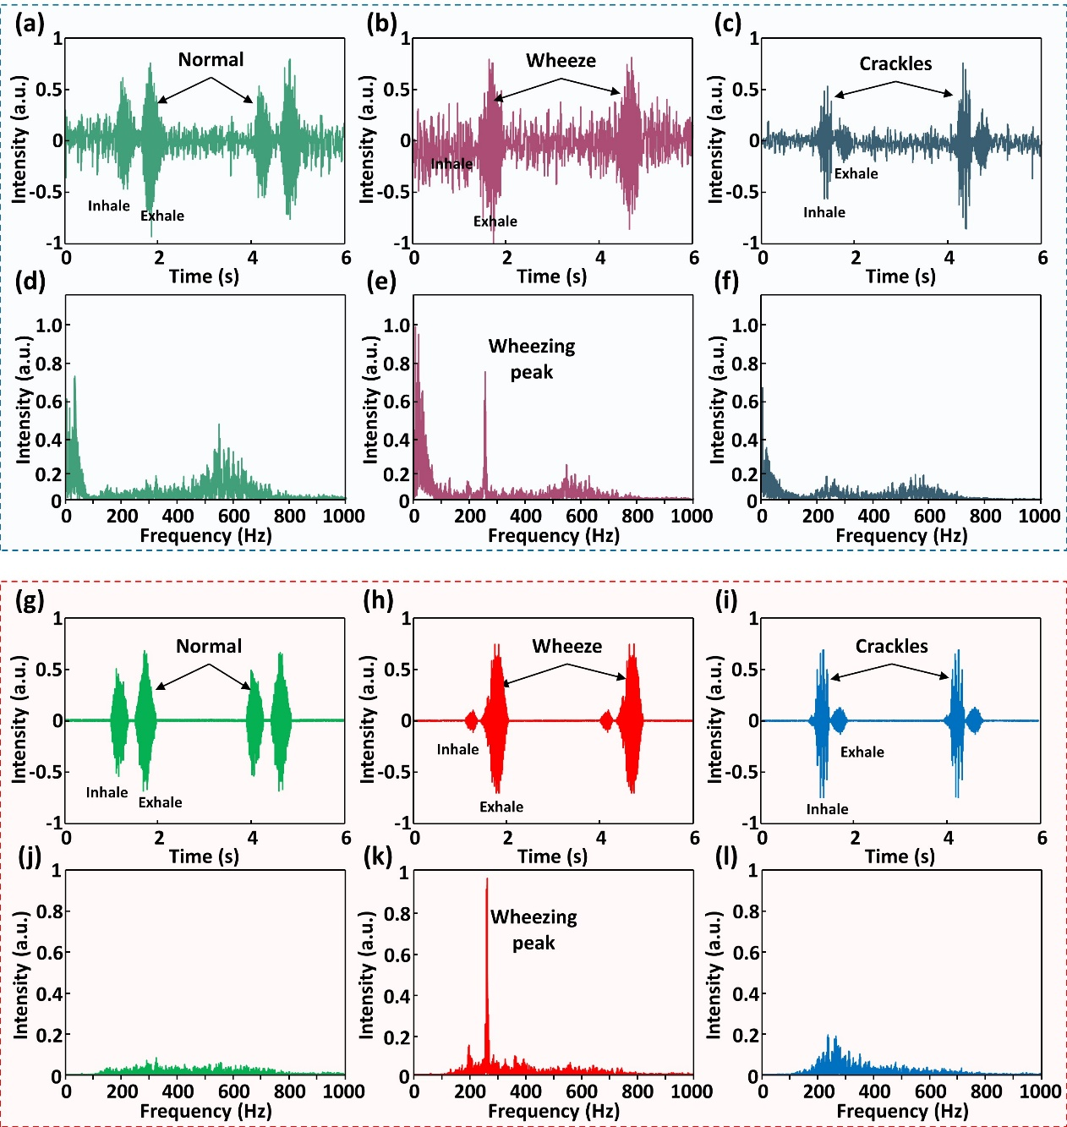
Figure S7. Characterization of the E-stethoscope using the Child Sim (a,b,c) time-intensity analysis of the measured normal, wheeze and crackles sound (d,e,f) power spectrum analysis of normal, wheeze, crackles (g-l) compared data with same experimental set-up on LSMP.

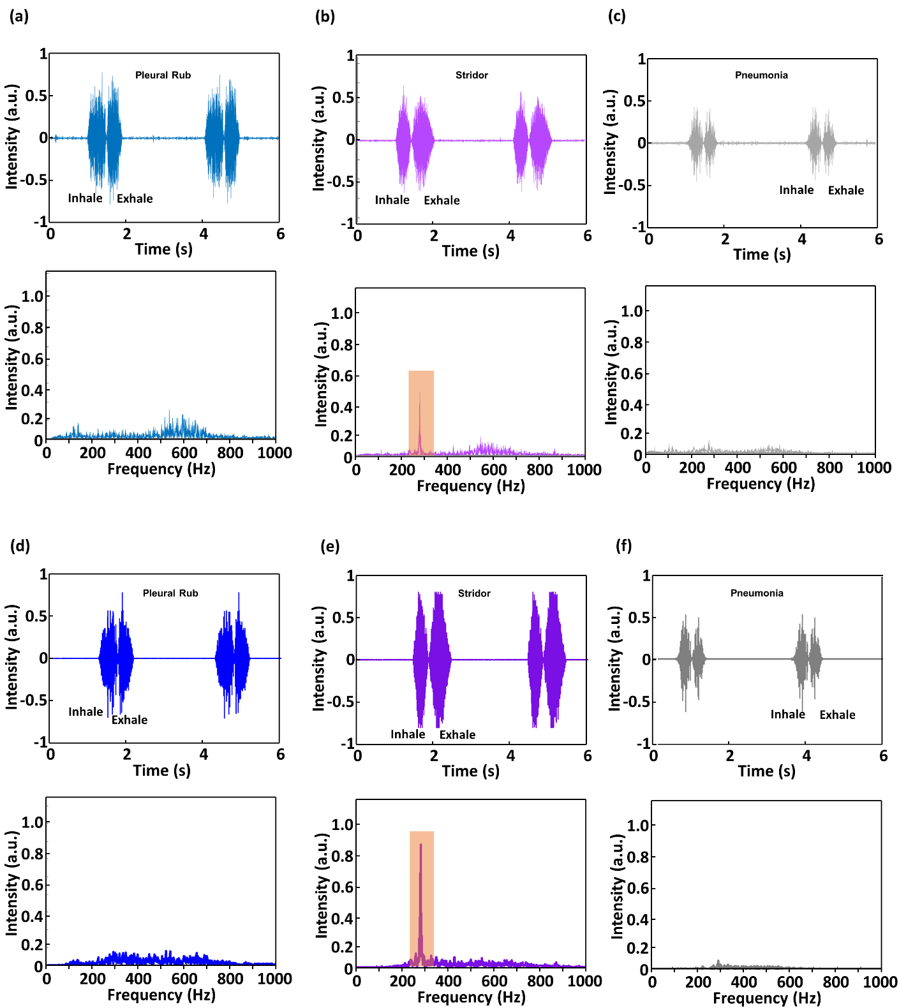
Figure S8. Lung sound characterization using the Child Sim. time-intensity and power spectrum analysis of Pleural Rub, Stridor and Pneumonia shows Littmann E-stethoscope results (a,b,c) and LSMP results (d,e,f).

Figure S9 Comparison of wheeze counting from short-term lung sound used in Figure 2 and additional clinical case ((a) from healthy subject (1), from healthy subject (2).

Figure S10 Comparison of wheeze counting from short-term lung sound used in Figure 3, and additional clinical case (a) from Asthma patient (1), (b) from Asthma patient (2).

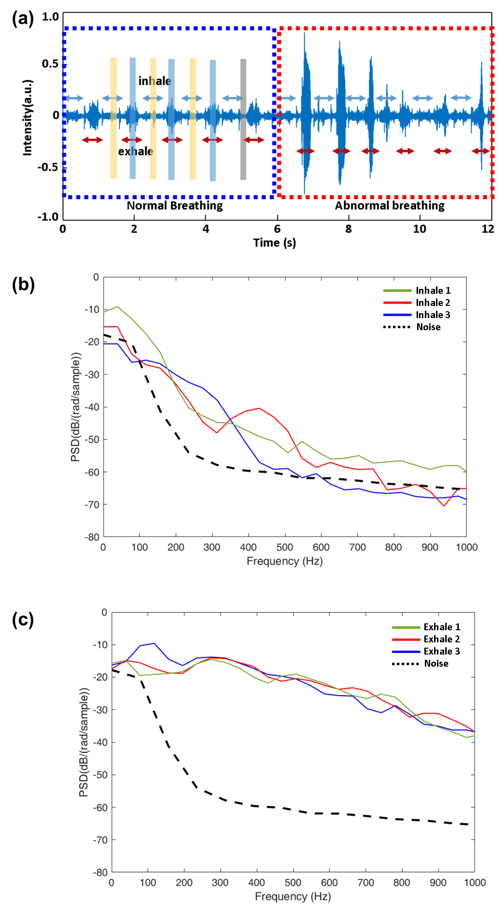
Figure S11. Pediatric asthma patient’s recoded breathing; the PSD results for distinguish the inhalations and exhalations. (a) time-series data recorded over 12 sec for pediatric patients with asthma; inhale data, exhale data, and reference noise data are from yellow colored bar, blue colored bar, and gray colored bar, respectively. (b) PSD result of 3 points inhale and reference noise (c) PSD result of 3 points exhale and reference noise.

Figure S12 Comparison of wheeze counting from short-term lung sound used in Figure 4, and additional three clinical cases (a) from COPD (1), (b) from COPD patient (3), (c) from COPD patient (4), (d) from COPD patient (5).

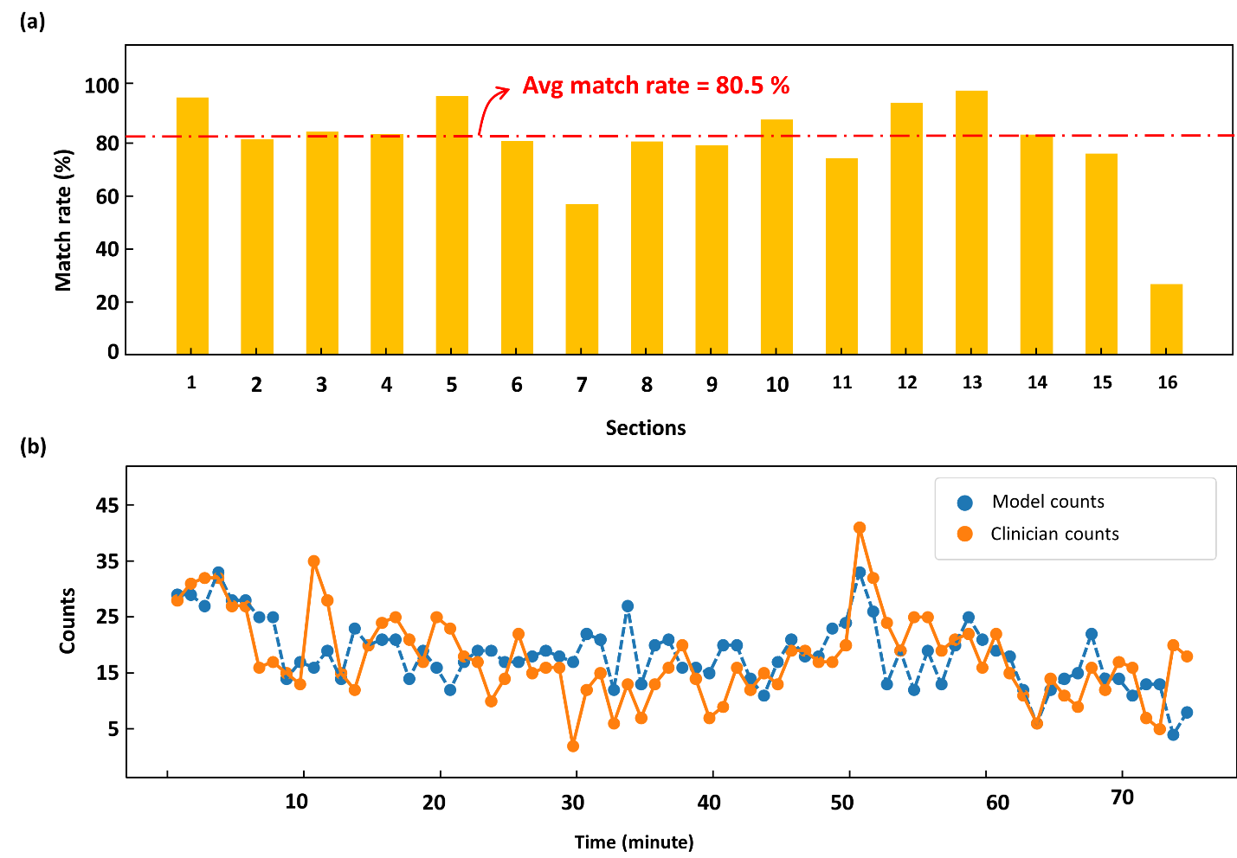
Figure S13. Comparing graph of match rate and 1 minute trajectory (a) Match rate of 16 sections. The length of time for section is 5 minutes. The average of entire match rate is about 80.5%. For the section 7 and 16, low match rate is originated from the noise such as barking, human talking. Especially for section 16, because it is last section of the recordings, there were more noisy sounds such as nurse’s voices. Furthermore, because denominator of the match rate is too small (< 20) the few small errors (<10) made the match rate seems bigger. (b) AI counts and Clinician counts comparing by 1 minute counting.

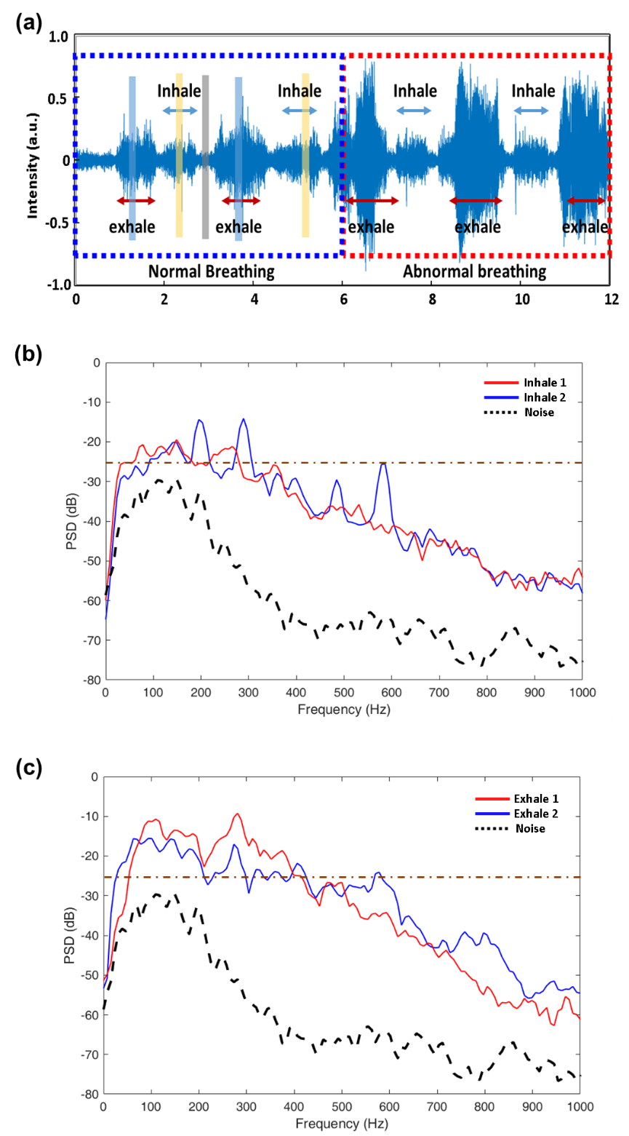
Figure S14. Elderly COPD patient’s recoded breathing: the PSD results for distinguish the inhalations and exhalations. (a) time-series data recorded over 12 sec for elderly patients with COPD; Inhale data from yellow colored bar (0.1-second window) and exhale data from blue colored bar, and reference noise data from gray colored bar, respectively. (b) PSD result of 2 points inhale and reference noise (c) PSD result of 2 points exhale and reference noise.

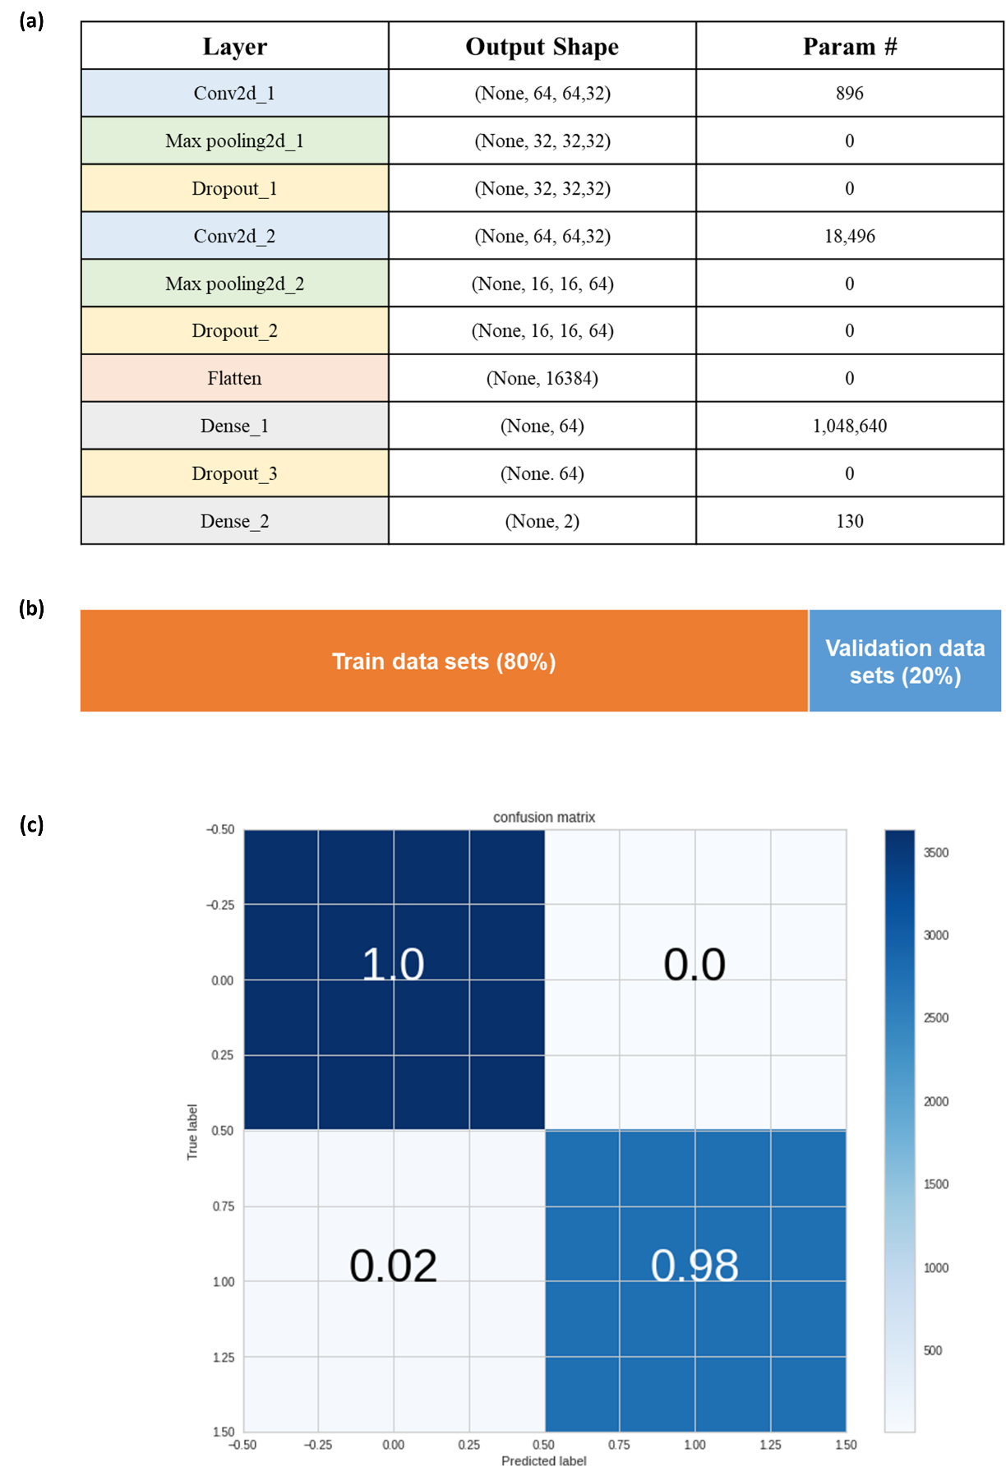
Figure S15. Deep learning architecture and Test and split ratio (a) Summary of used deep learning architecture. (b) Train test split ratio of income data. (c) Confusion matrix of trained model

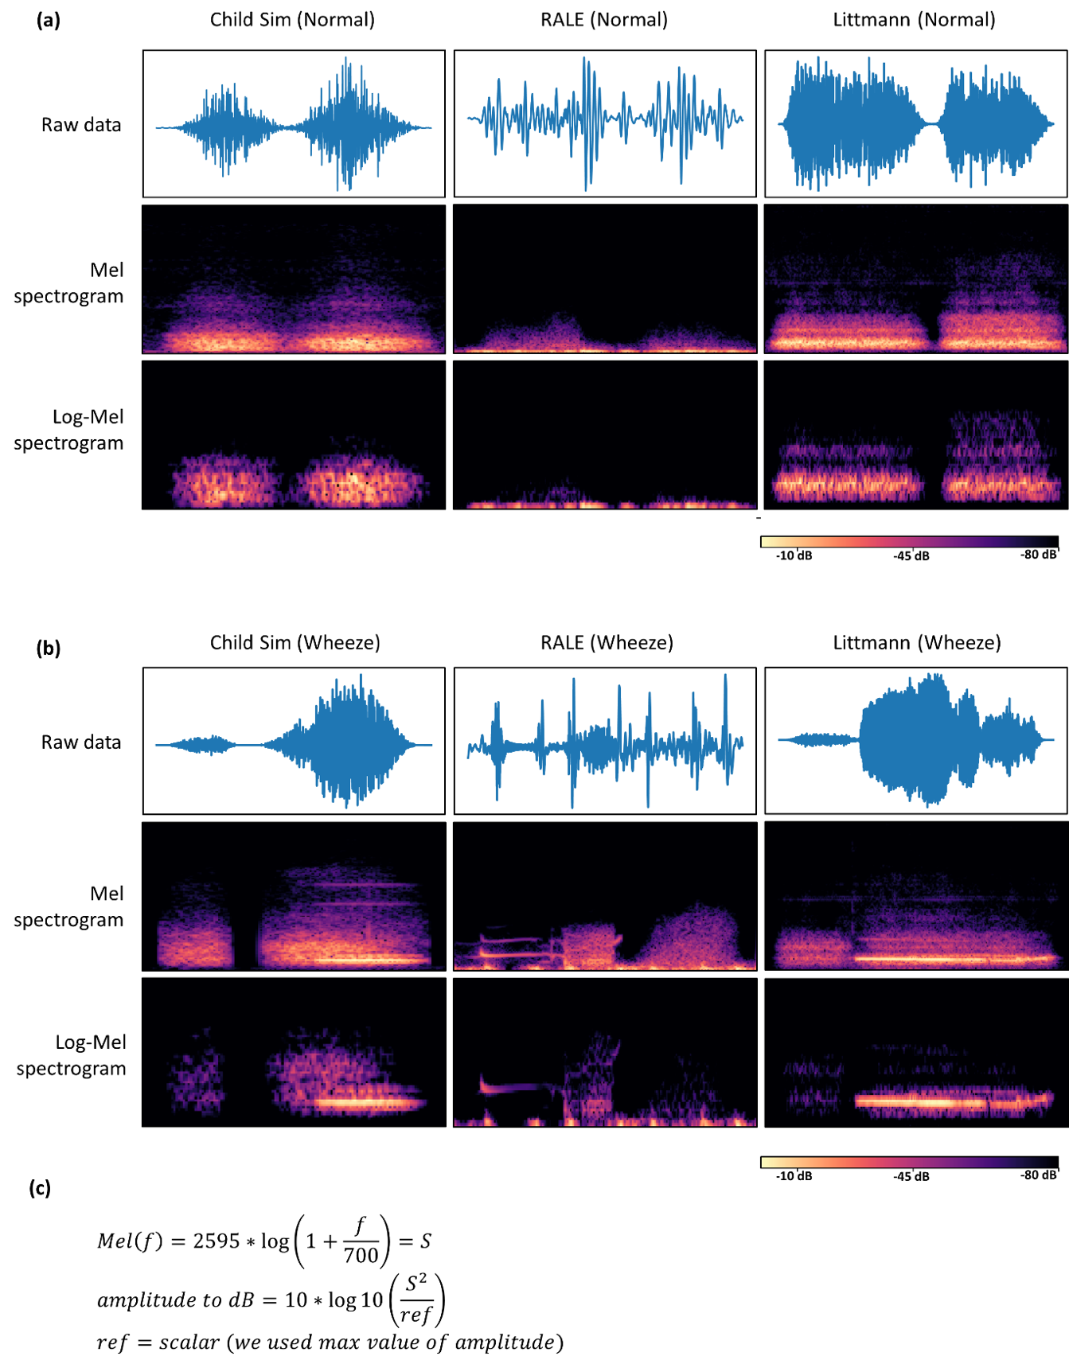

Figure S16. Comparing Mel spectrogram and Log-Mel spectrogram (from Child Sim, RALE, Littmann database) (a) Raw data of normal sound and the below are conversion into Mel spectrogram and log-Mel spectrogram. (b) Raw data of wheeze sounds and the below are conversion into mel spectrogram and log-Mel spectrogram. (c) Calculation of log-mel from mel values.

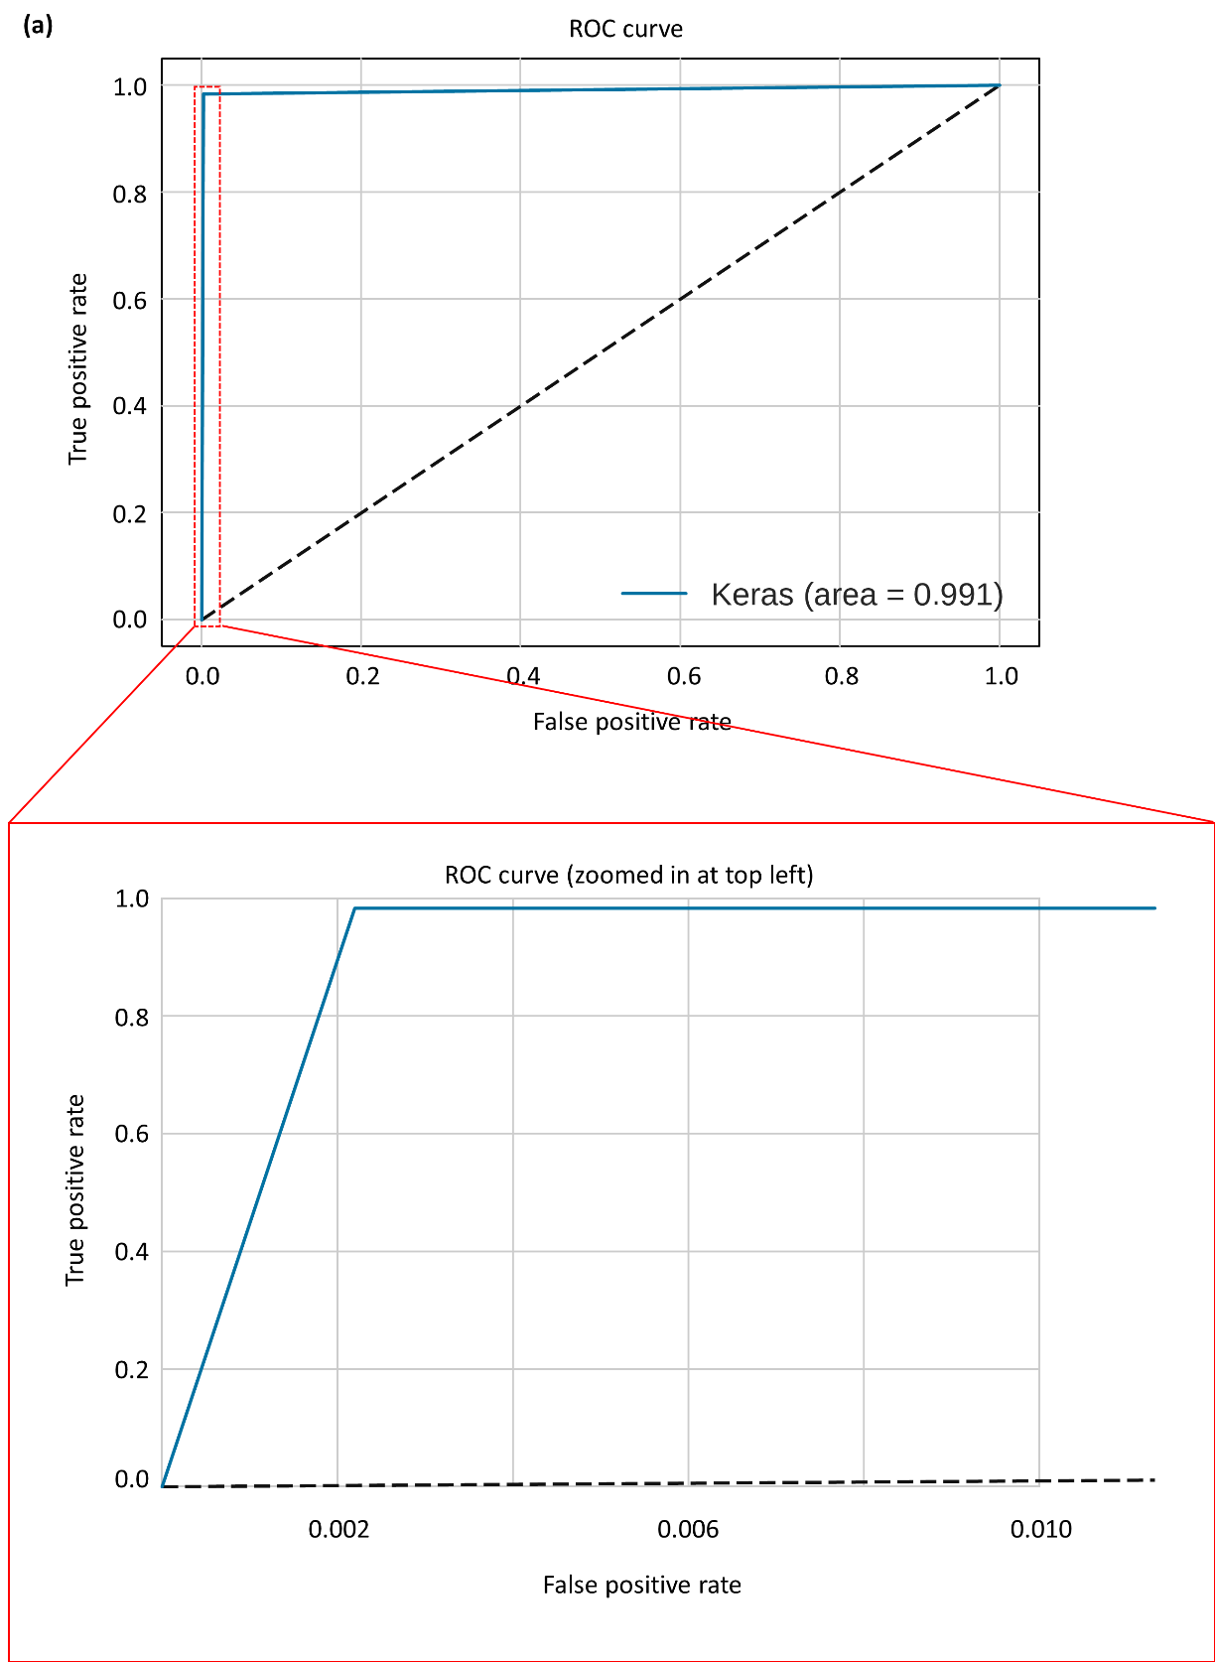
Figure S17. ROC curve (a) ROC curve of built model. Below is the zoomed window in the range of 0 to 0.01 from False positive rate

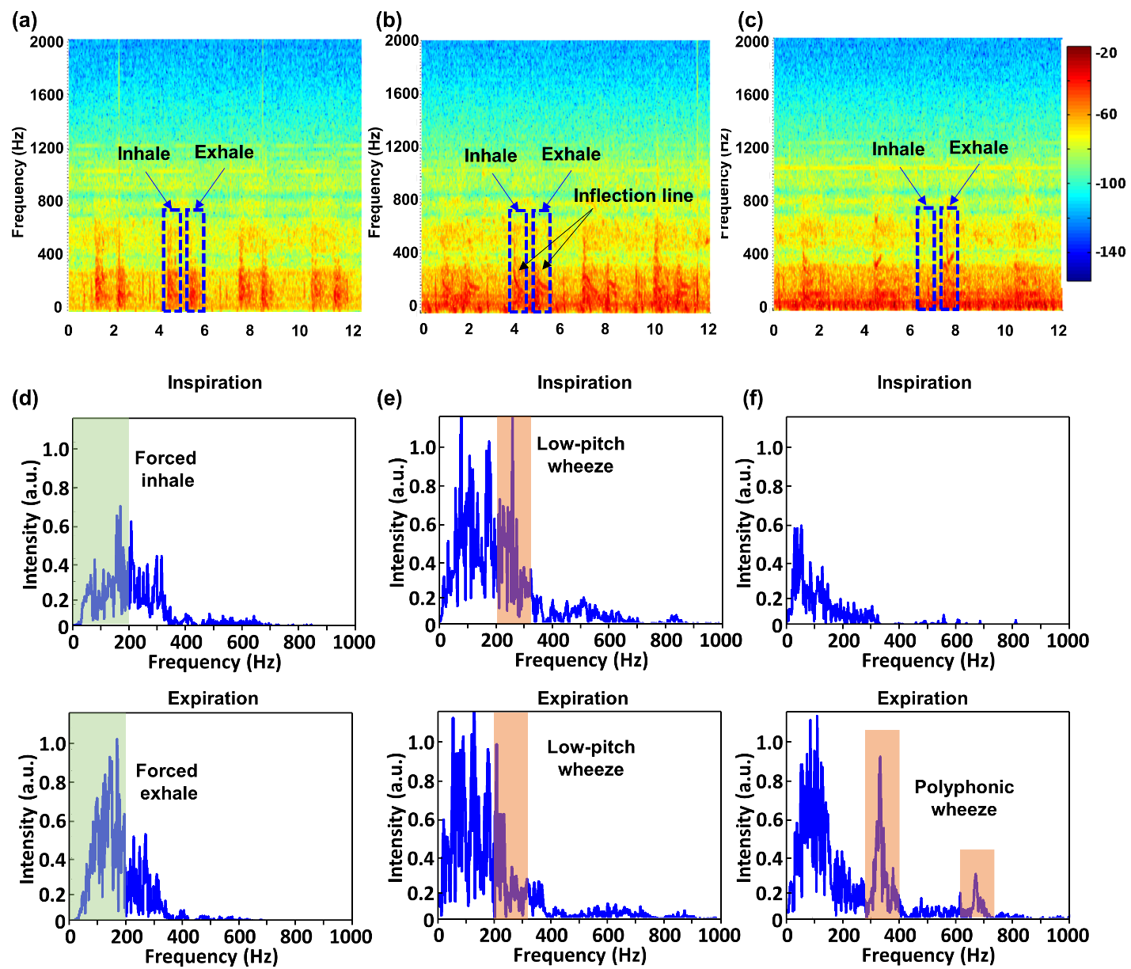
Figure S18. Clinical long-term study on elderly COPD patient with LSMP (a-c) spectrograms information corresponding to normal and abnormal breathing (d-f) representative STFT results in case of inspiration and expiration, respectively.

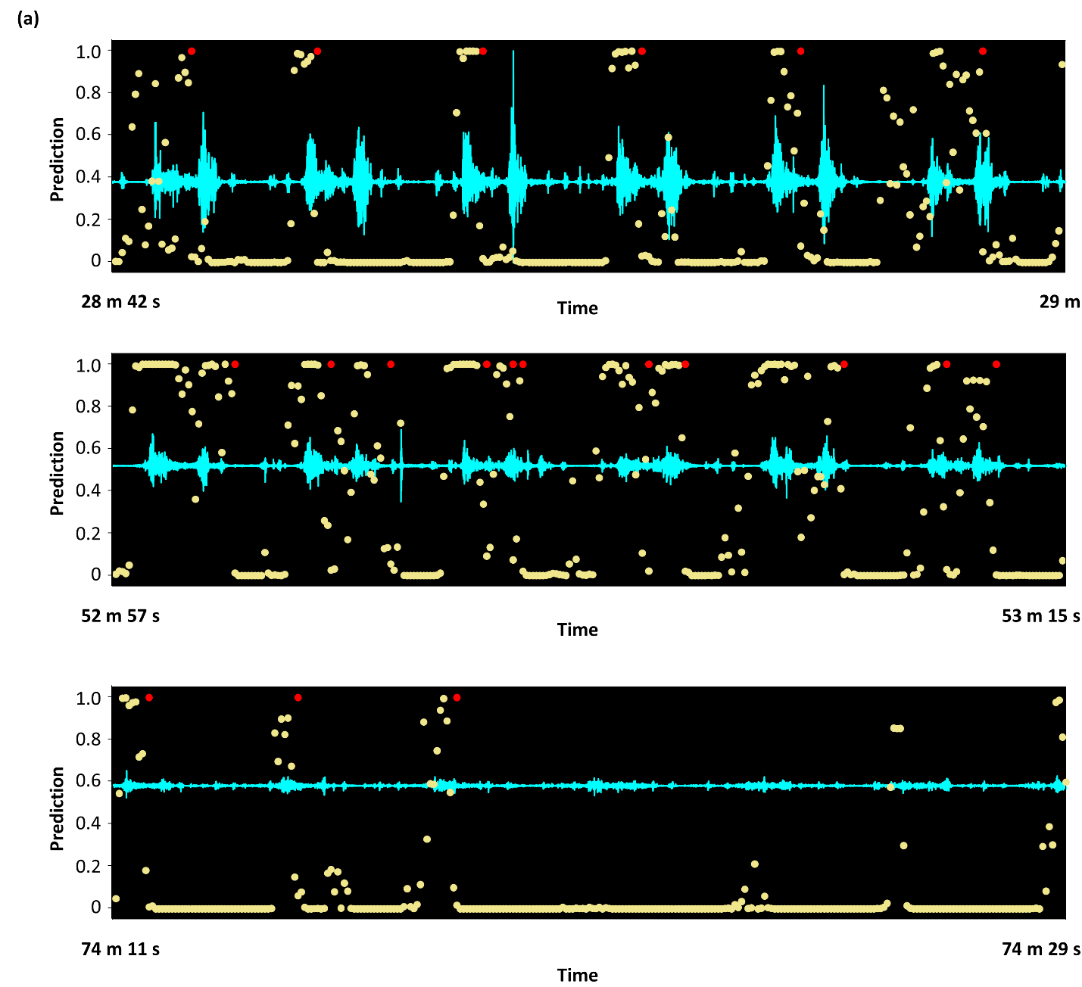
Figure S19. Predicting results of clinical raw data (a) Clinical raw acoustic data and model prediction comparing of 3 extracted regions. All the region’s total time is 18sec and the begin points are 28min 42sec, 52min 57sec and 74min 11sec, each. Yellow dots infer the prediction value of model and red dots are the marks of event count timing.

Table S1. Component list of LSMP
No. | Description | Part | Specification | Quantity | Reference
1 | CAPACITOR | 56 pF | SM/1608 | 1 | C1
2 | CAPACITOR | 10 $μ$F | SM/1608 | 1 | C3
3 | CAPACITOR | 100 nF | SM/1608 | 2 | C16 C17
4 | CAPACITOR | 1 $μ$F | SM/1608 | 3 | C13 C18 C19
5 | CAPACITOR | 10 $μ$F | SM/1608 | 3 | C4 C9 C14
6 | CAPACITOR | 22 $μ$F | SM/1608 | 1 | C15
7 | RESISTOR | 680 | SM/1608 | 1 | R8
8 | RESISTOR | 1K | SM/1608 | 3 | R1 R2 R5
9 | RESISTOR | 10K | SM/1608 | 3 | R3 R4 R7
10 | RESISTOR | 180K | SM/1608 | 1 | R9
11 | RESISTOR | 1.5M | SM/1608 | 1 | R6
12 | INDUCTOR | 15 nH | SM/1005 | 1 | L4
13 | INDUCTOR | 10 $μ$H | SM/1608 | 1 | L5
14 | LED | BLU | SM/1608 | 1 | D1
15 | LED | RED | SM/1608 | 1 | D2
16 | LED | GRN | SM/1608 | 1 | D3
17 | FERRITE BEAD | 120/Y | SM/1608 | 1 | FB1
18 | BLE MODULE | MDBT42Q | RAYTAC | 1 | U1
19 | MIC | VM3000 | Vesper | 1 | U2
20 | CHARGER | XC6806 | LGA-10B01 | 1 | U3
21 | REGULATOR | XCL210 | CL-2025-02 | 1 | U4
22 | LOGIC IC | Buffer | SOT353 | 2 | U5 U6
23 | SWITCH | DPDT | ZX ELECTRO | 1 | SW1
24 | CONNENCTOR | 2 pin | MOLEX | 2 | J1 J2
25 | CONNENCTOR | 4 pin | MOLEX | 1 | JP1
26 | BATTERY | 100 mAh | TW301430 | 1 | Batt1

Table S2. Detailed clinical data and sensing reliability with AI
 | Gender | Age | Diagnosis | Count Accuracy  (AI/human) | Remark
Case 1 | Male | 36 | Healthy (1) | 93.7 % | Figure 2 and Figure S9 (a)
Case 2 | Male | 15 months | Asthma (1) | 88.5% | Figure 3 and Figure S10 (a)
Case 3 | Male | 72 | COPD (1) | 88.7 % | Figure 4 and Figure S12 (a)
Case 4 | Female | 71 | COPD (2) | 87.7 % | Figure 5 and Figure S13
Case 5 | Male | 32 | Healthy (2) | 86.6 % | Figure S9 (b)
Case 6 | Male | 6 months | Asthma (2) | 93.8 % | Figure S10 (b)
Case 7 | Male | 68 | COPD (3) | 98.8 % | Figure S12 (b)
Case 8 | Male | 75 | COPD (4) | 90.5 % | Figure S12 (c)
Case 9 | Male | 69 | COPD (5) | 96.3 % | Figure S12 (d)

Reference
[1] M.A. Shah, I.A. Shah, D.G. Lee, S. Hur, Design Approaches of MEMS Microphones for Enhanced Performance, J Sensors 2019 (2019).
[2] K. Lee, X. Ni, J.Y. Lee, H. Arafa, D.J. Pe, S. Xu, R. Avila, M. Irie, J.H. Lee, R.L. Easterlin, D.H. Kim, H.U. Chung, O.O. Olabisi, S. Getaneh, E. Chung, M. Hill, J. Bell, H. Jang, C. Liu, J.B. Park, J. Kim, S.B. Kim, S. Mehta, M. Pharr, A. Tzavelis, J.T. Reeder, I. Huang, Y. Deng, Z. Xie, C.R. Davies, Y. Huang, J.A. Rogers, Mechano-acoustic sensing of physiological processes and body motions via a soft wireless device placed at the suprasternal notch, Nat Biomed Eng 4(2) (2020) 148-158.
[3] H. Jeong, J.Y. Lee, K. Lee, Y.J. Kang, J.T. Kim, R. Avila, A. Tzavelis, J. Kim, H. Ryu, S.S. Kwak, J.U. Kim, A. Banks, H. Jang, J.K. Chang, S.P. Li, C.K. Mummidisetty, Y. Park, S. Nappi, K.S. Chun, Y.J. Lee, K. Kwon, X.Y. Ni, H. Chung, H.W. Luan, J.H. Kim, C.S. Wu, S. Xu, A. Banks, A. Jayaraman, Y.G. Huang, J.A. Rogers, Differential cardiopulmonary monitoring system for artifact-canceled physiological tracking of athletes, workers, and COVID-19 patients, Sci Adv 7(20) (2021).
[4] A. Bhaskar, A simple electronic stethoscope for recording and playback of heart sounds, Adv Physiol Educ 36(4) (2012) 360-362.
[5] G. Yilmaz, M. Rapin, D. Pessoa, B.M. Rocha, A.M. de Sousa, R. Rusconi, P. Carvalho, J. Wacker, R.P. Paiva, O. Chetelat, A Wearable Stethoscope for Long-Term Ambulatory Respiratory Health Monitoring, Sensors-Basel 20(18) (2020).

