Supporting data for

PAM-Expanded Streptococcus thermophilus Cas9 C-to-T and C-to-G Base Editors for Programmable Base Editing in Mycobacteria
Hongyuan Zhang ^{a,b}, Yifei Zhang ^{a,b}, Wei-Xiao Wang ^{c}, Weizhong Chen ª, Xia Zhang ^{d}, Xingxu Huang ^{e,f}, Wei Chen ^{c,}*, Quanjiang Ji ^{a,e,f,}*
ª School of Physical Science and Technology, ShanghaiTech University, Shanghai 201210, China
^{b} University of Chinese Academy of Sciences, Beijing 100049, China
^{c} Clinical Research Center, the Second Hospital of Nanjing, Nanjing University of Chinese Medicine, Nanjing 210003, China
^{d} Department of Tuberculosis, the Second Hospital of Nanjing, Nanjing University of Chinese Medicine, Nanjing 210003, China
^{e} Gene Editing Center, School of Life Science and Technology, ShanghaiTech University, Shanghai 201210, China
^{f} Guangzhou Laboratory, Guangzhou 510120, China

* Corresponding authors.
E-mails: njyy039@njucm.edu.cn (W. Chen); quanjiangji@shanghaitech.edu.cn (Q. Ji)

Protocol for cytosine base editing in M. smegmatis and M. tuberculosis
1.1 Insert spacer sequence into base editing plasmids
(1) Oligonucleotides synthesis
Select a ~20 bp-spacer sequence before a PAM and two oligos were designed in the following form:
Forward oligo: 5’-GAGNNNNNNNNNNNNNNNNN -3’
Reverse oligo: 3’- CNNNNNNNNNNNNNNNNNCAG-5’
Spacer sequences is colored green. When TetR-regulated sgRNA promoter is used, spacer sequences must begin with a G nucleotide for efficient transcription initiation. (2) Phosphorylation of the oligos
10X T4 DNA ligase buffer (NEB) 5 μL
Oligo F (50 μM) 2 μL
Oligo R (50 μM) 2 μL
T4 polynucleotide kinase (NEB) 1 μL
ddH₂O up to 50 μL
Incubate the solution at 37°C for one hour.
(3) Annealing of the oligos
Add 0.5 mL of 5 M NaCl into the phosphorylated product. Incubate the reaction solution at 95°C for 5 min and then slowly cool it down to room temperature (or use a thermocycler for -1°C/15 s). Dilute the annealed oligos 20 folds with ddH₂O.
(4) Golden gate assembly
10X T4 DNA ligase buffer (NEB) 1 μL
empty plasmid (100 fmol/μL) 0.2 μL
annealed oligos (20 fmol/μL) 1 μL
T4 DNA ligase (NEB) 0.2 μL
SapI (NEB) 0.2 μL
ddH₂O up to 10 μL
Run the above reaction to insert the annealed oligos into the empty plasmid using the following protocol
S1: 37°C for 3 min
S2: 16°C for 4 min
go to S1, 24×
S3: 50°C for 5 min
S4: 80°C for 15 min
S5: 10°C ∞
1.2 Transformation
The product was transformed into 100 μL E. coli Top10 competent cells and the cells were plated onto a LB agar plate containing 50 μg/mL kanamycin. The plate was incubated at 37°C for 18 h. The successful construction of the plasmid was confirmed by sequencing.
1.3 Cytosine base editing
See the detailed procedures in the “Competent cell preparation and electroporation
” section and “Editing efficiency evaluation” section of the Methods part.

Supporting Figures

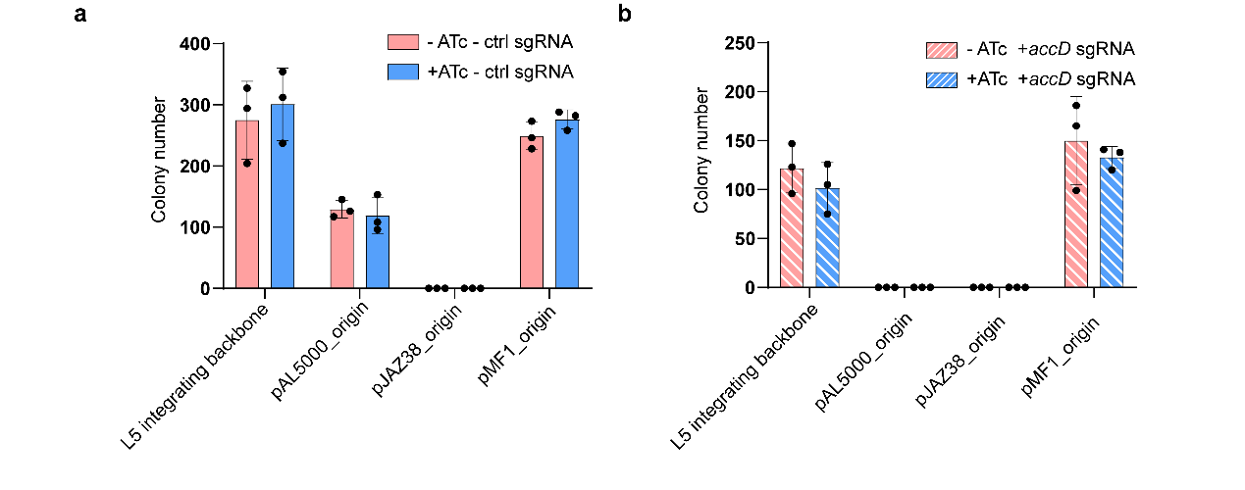
Fig. S1. Cellular toxicity of CBE_{dSt1Cas9} is affected by different plasmid backbone.
(a) Three different plasmid backbones are compatible with CBE_{dSt1Cas9}. Control sgRNA has no target site in M. smegmatis. The data are shown as mean ± SD (n=3). (b) The L5-integrating backbone and the pMF1 backbone are compatible with CBE_{dSt1Cas9}. The data are shown as mean ± SD (n=3).

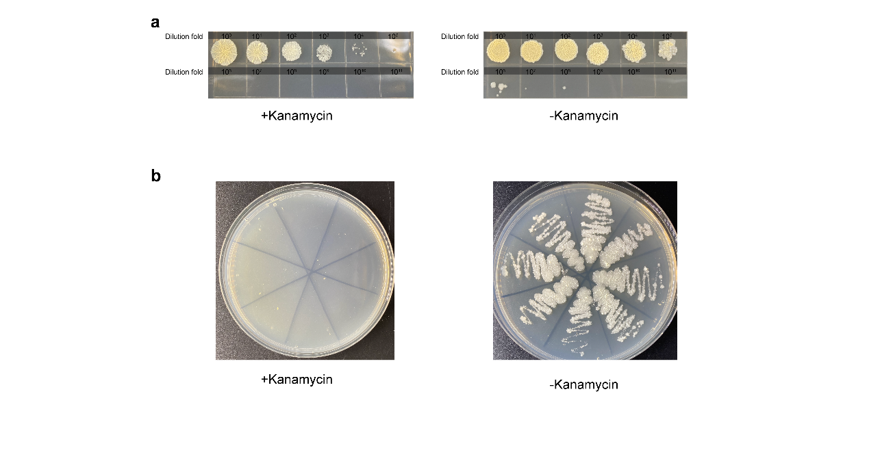
Fig. S2. Plasmid curing after editing.
(a) M. smegmatis containing the editing plasmid were grown in 7H9 in the absence of antibiotic for 4 days. Serial dilutions were plated onto 7H10 agar plates with or without the supplementation of kanamycin. Three independent experiments were performed.
(b) Eight randomly picked colonies after plasmid curing were plated onto 7H10 agar plates with or without the supplementation of kanamycin to confirm the success in plasmid curing. Three independent experiments were performed.

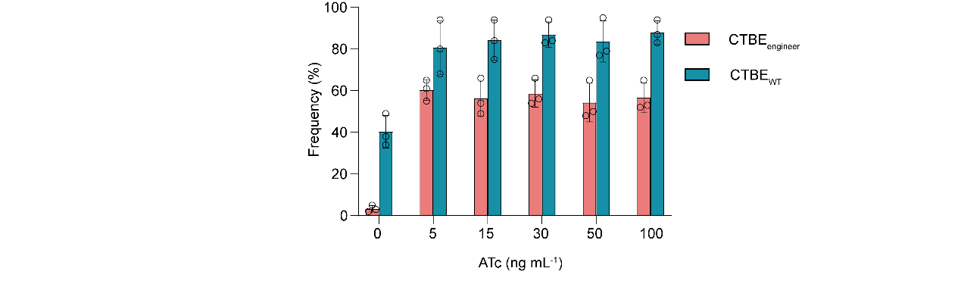
Fig. S3. Optimization of the ATc inducer concentration for base editing.
Different ATc concentrations ranging from 0 to 100 ng/mL were screened. The data are shown as mean ± SD (n=3).
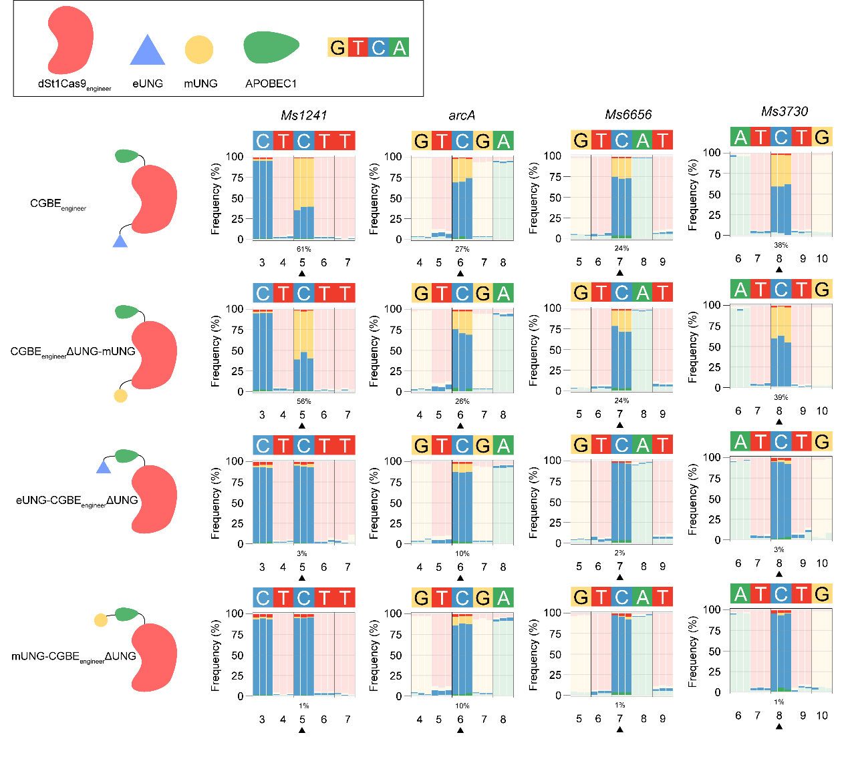
Fig. S4. Screening of UNG for C-to-G base editors.
Bar plots showing on-target C-to-G conversion efficiencies of four different base editors on four endogenous genomic sites in M. smegmatis. Arrowheads indicate cytosines with C-to-G conversions. Numbering on the bottom indicates position of the base in the protospacer with 1 being the most PAM-distal base. Editing frequencies at target site are displayed side-by-side, three independent experiments were performed, and the average C-to-G editing frequencies were noted by black arrowheads.

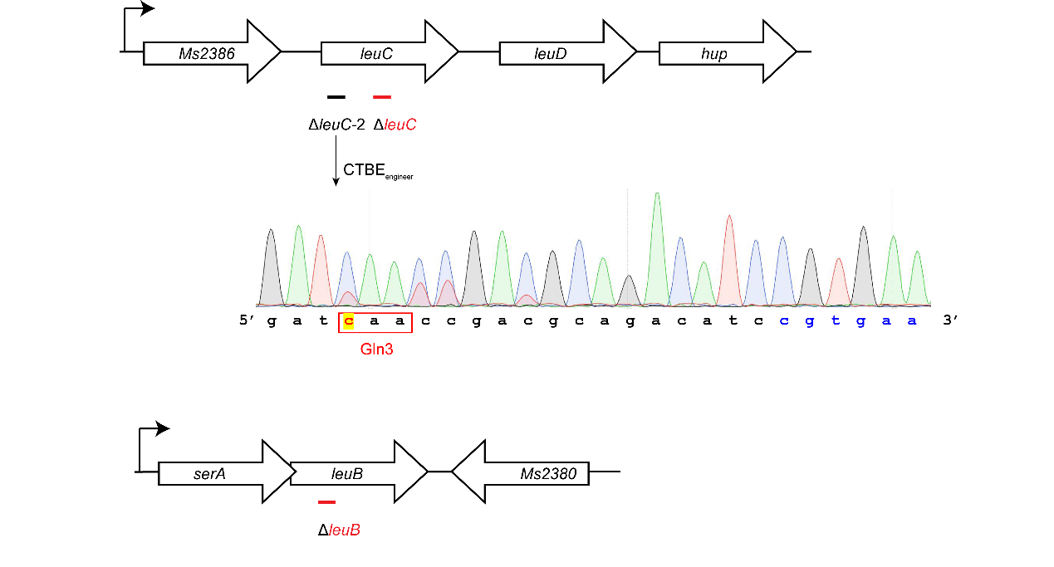
Fig. S5. Three sgRNAs designed to target M. smegmatis L-leucine biosynthesis genes.
Red lines beneath the genes represent sgRNA target sites used in Fig. 3(f); Black line beneath the gene represents sgRNA target site not shown in Figure 3F. The PAM sequence is colored blue.
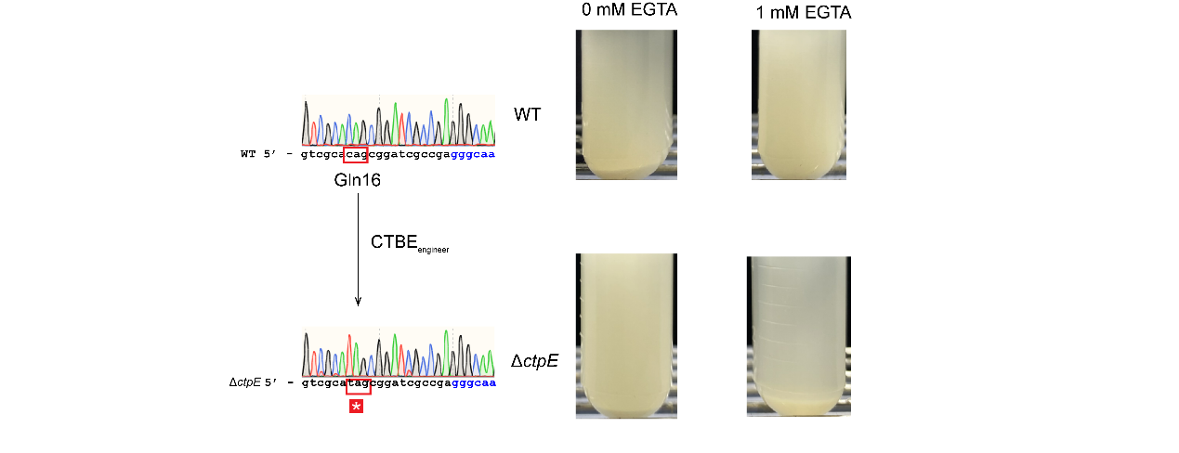
Fig. S6. Successful editing of ctpE by CTBE_{engineer}.
The success in editing of ctpE was first confirmed by sanger sequencing and then the isolated pure mutant was subjected for the phenotypic assay. Wild-type M. smegmatis mc²155 and M. smegmatis mc²155 ΔctpE strains were grown in Middlebrook 7H9 medium to the mid-log phase and then diluted into fresh medium in the presence of 1 mM EGTA or absence of EGTA. The cells were further grown for 48 h at 37°C with continuously shaking and then the cells were left by standing for 1 h. The ctpE mutant strain showed increased cell aggregation in the presence of EGTA. Three independent experiments were performed.

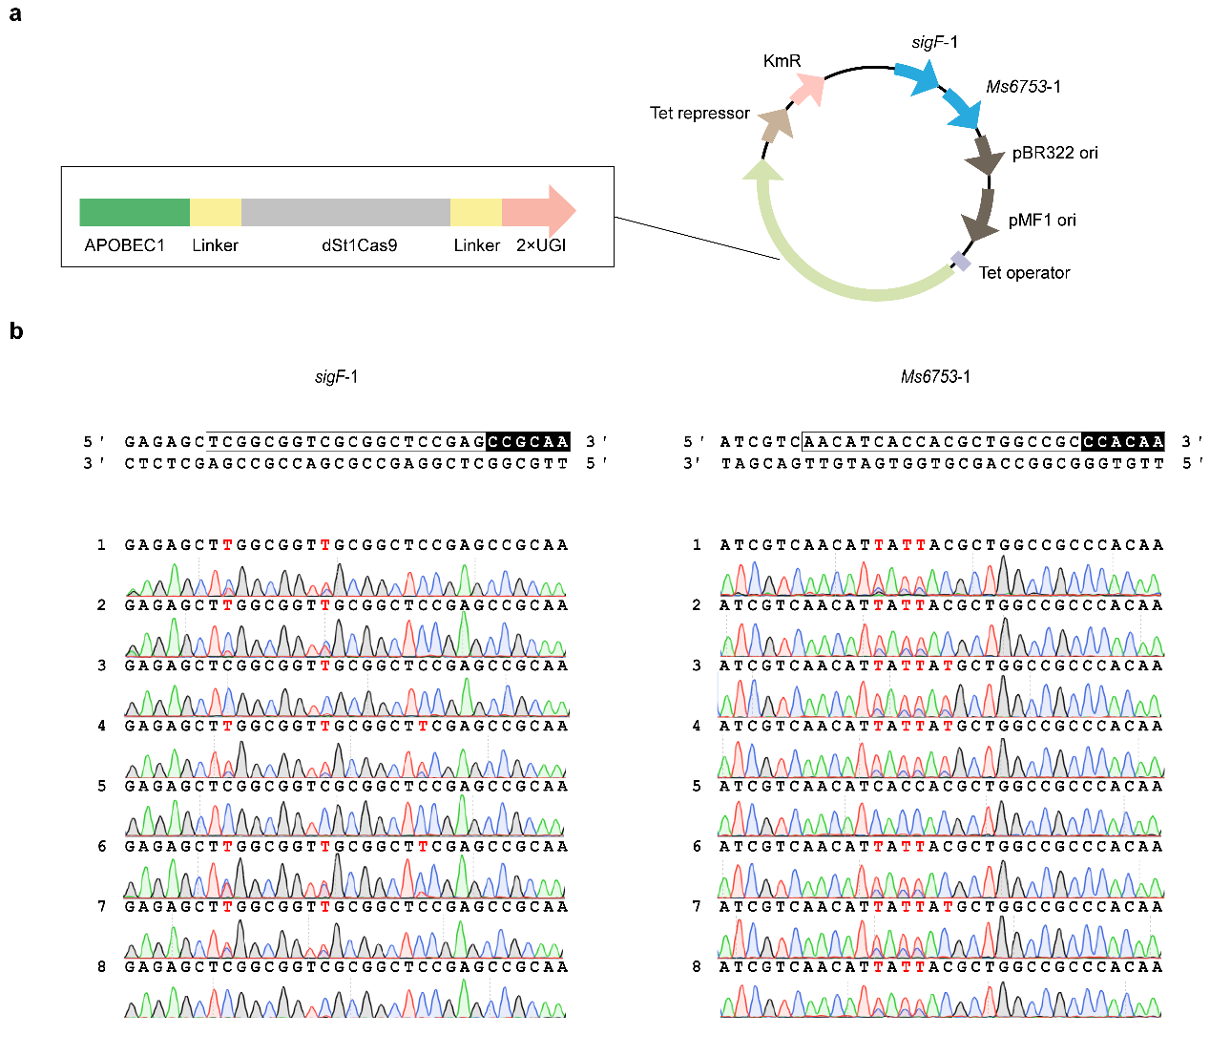
Fig. S7 Multiplexed genome editing with CTBE_{engineer}.
(a) A schematic drawing of a single plasmid for multiplexed C-to-T genome editing. (b) Editing results of the CTBE_{engineer}-mediated multiplexed editing assay. Eight colonies were randomly picked and the target loci were sequenced and aligned. A box and an inverted box indicate the target sequence and PAM, respectively. The edited bases are shown in red.

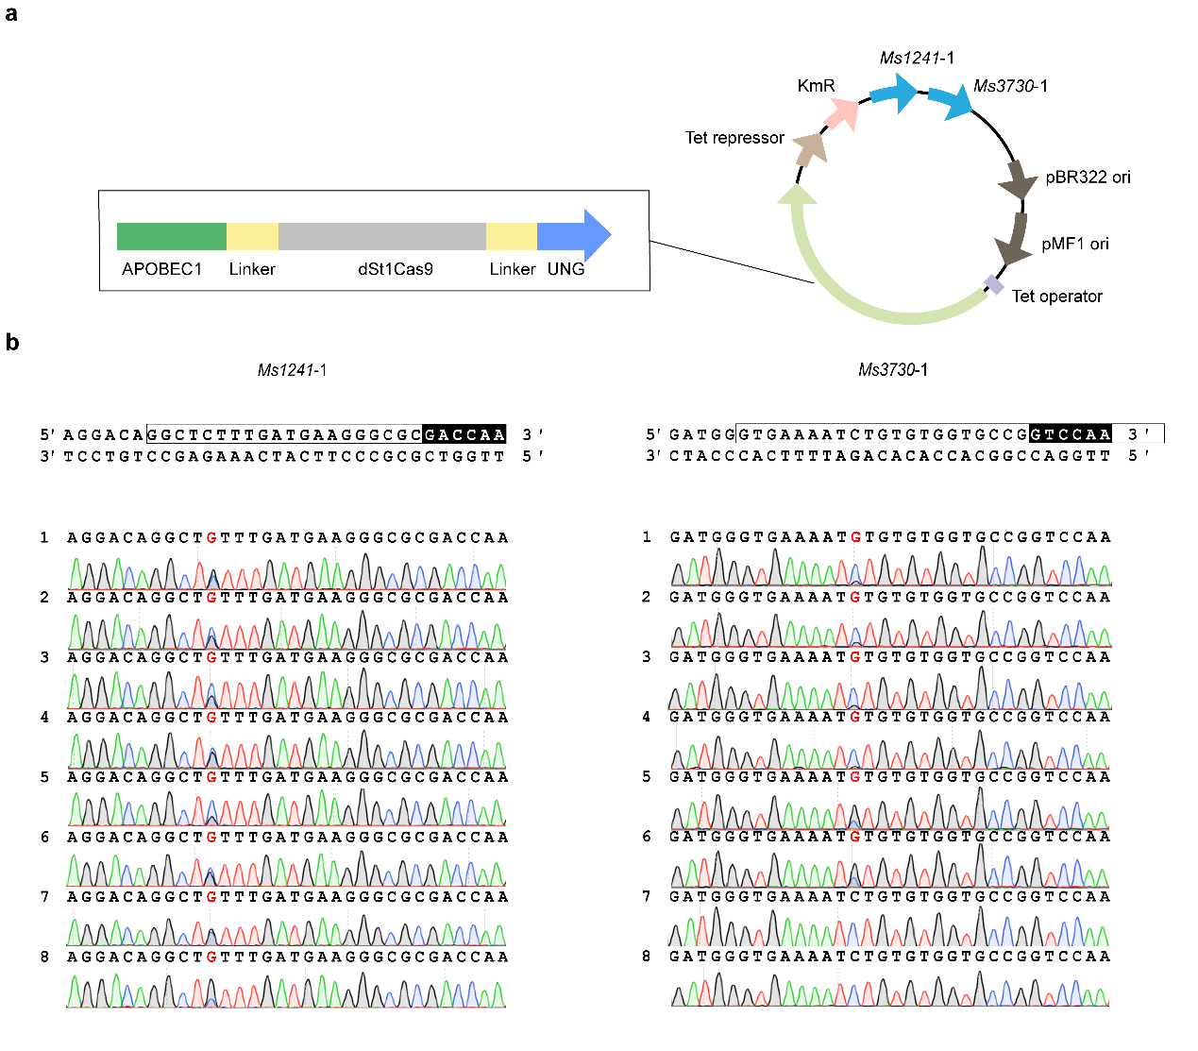Fig. S8. Multiplexed genome editing with CGBE_{engineer}.
(a) A schematic drawing of a single plasmid for multiplexed C-to-G genome editing. (b) Editing results of the CGBE_{engineer}-mediated multiplexed editing assay. Eight colonies were randomly picked and the target loci were sequenced and aligned. A box and an inverted box indicate the target sequence and PAM, respectively. The edited bases are shown in red.

Table S1. List of strains used in this study.
Bacterial strains | Source | Identifier
E. coli Top10 [F- mcrA Δ(mrr-hsdRMS-mcrBC) φ80 lacZΔM15 ΔlacX74 recA1 araΔ139Δ(ara-leu)7697 galU galK rpsL (Str^{R}) endA1 nupG] | WEIDI | Cat# DL1010
M. smegmatis mc²155 | Lab stock | NC_008596.1
M. smegmatis mc²155ΔleuB | This paper | N/A
M. smegmatis mc²155ΔleuC | This paper | N/A
M. smegmatis mc²155ΔctpE | This paper | N/A
M. tuberculosis H37Rv | Lab stock | NC_000962.3
M. tuberculosis H37RvΔkatG | This paper | N/A

Table S2. The reagents used in this study.
LB Broth Powder, Miller | Sangon Biotech | Cat# A507002-0250
LB Agar Powder, Miller | Sangon Biotech | Cat# A507003-0250
Middlebrook 7H9 Broth Base | ELITE-MEDIA | Cat# M1315-01
Middlebrook 7H10 Agar | ELITE-MEDIA | Cat# M1316-01
Bovine albumin V | Energy Chemical | Cat# E1006180000
Anhydrotetracycline | Cayman | Cat# 10009542-25
Kanamycin sulfate | Sangon Biotech | Cat# A506636-0100
Glycerol | Sangon Biotech | Cat# A100854-0500
Dextrose | Sangon Biotech | Cat# A610219-0500
Tween-80 | Solarbio | Cat# T8360-100ml
NaCl | Sangon Biotech | Cat# A100241-0500
leucine | J&K | Cat# 235041-25G
4S Red Plus Nucleic Acid Stain | Sangon Biotech | Cat# A606695-0500
SapI | NEB | Cat# R0569L
Esp3I | NEB | Cat# R0734L
KpnI | NEB | Cat# R3142L
DNase I | NEB | Cat# M0303L
T4 DNA ligase | NEB | Cat# M0202L
T4 polynucleotide kinase | NEB | Cat# M0201S
QuickCut Dpn I | Takara | Cat# 1609
NEBuilder HiFi DNA Assembly Master Mix | NEB | Cat# E2621X
2 × Phanta® Max Master Mix (Dye Plus) | Vazyme Biotech Co. | Cat# P525-03
EasyTaq® DNA Polymerase | Transgen | Cat# AP111-01
TIANquick Midi Purification Kit | TIANGEN | Cat# DP204
Ezup Column Bacteria Genomic DNA Purification Kit | Sangon Biotech | Cat# B518255-0100

Table S3. Primers used for plasmid construction
Primer | Sequence (5'-3')
RNA-St1F1 | gggattgacagctagctcagtcctaggtataatactagttgaagagcaagtgggctcttca
RNA-St1F2 | gtctttgtactctggtaccagaagctacaaagataaggcttcatgccgaaatcaacacc
RNA-St1F3 | ctgtcattttatggcagggtgTttttttgatatcgaattccggggatcctctagagtcgacctgcataatgtgcctgtcaaatggacga
RNA-St1R1 | ctgtcgtccatttgacaggcacattatgcaggtcgactctagaggatccccggaattcgatatcaaaaaaAcaccctgccataaaa
RNA-St1R2 | tgacagggtgttgatttcggcatgaagccttatctttgtagcttctggtaccagagtac
RNA-St1R3 | aaagactgaagagcccacttgctcttcaactagtattatacctaggactgagctagctgtcaa
Con-BEC-F | ggcggtatcgatatgagtagcgaaaccggtcc
Con-BEC-R | GCTGACTCGCTTGTTCCTGGTGTCTCGCTGCCAGAGGAGCCTCCGCTAGATCCTCCAGAtttcagaccggtggcccata
Con-St1Cas9-up-F | CACCAGGAACAAGCGAGTCAGCAACACCAGAGAGCAGTGGCGGCAGCAGCGGCGGCAGCtcggacctggtgctgggcct
Con-St1Cas9-up-R | cccagcaccttgatcagggcctc
Con-St1Cas9-dn-F | cgaggccctgatcaaggtgctg
Con-St1Cas9-dn-R | ttcgctactcatatcgataccgccttctctatc
Sca-SpCas9-up-F | agttgaagagcaagtgggctcttcagttttagagctagaaatagcaagttaaaataa
Sca-SpCas9-dn-F | ggctagtccgttatcaacttgaaaaagtggcaccgagtcggtgcttttttt
Sca-SpCas9-up-R | tagccttattttaacttgctatttctagctctaaaactgaagagcccacttgctcttca
Sca-SpCas9-dn-R | gacaaaaaaagcaccgactcggtgccactttttcaagttgataacggac
Con-SpCas9-up-F | CACCAGGAACAAGCGAGTCAGCAACACCAGAGAGCAGTGGCGGCAGCAGCGGCGGCAGCgataagaaatactcaataggcttagctatc
Con-SpCas9-H840A-up-R | tggaacaatgGCatcgacatcataatc
Con-SpCas9-H840A-dn-F | gatgtcgatGCcattgttccacaaag
Con-SpCas9-H840A-dn-R | tggccagagtattcagtcacctcctagctgac
Con-SpCas9-bone-F | ggaggtgactgaatactctggccatttttctttacc
Sca-cr-LbCpf1-F | agtaatttctactaagtgtagattgaagagcaagtgggctcttcaTtttttt
Sca-cr-LbCpf1-R | gacaaaaaaAtgaagagcccacttgctcttcaatctacacttagtagaaatt
Con-lb-F | CCAGGAACAAGCGAGTCAGCAACACCAGAGAGCAGTGGCGGCAGCAGCGGCGGCAGCatgtcaaagctggagaaattcac
Con-lb-R | tggccagagtattcatgatccatgcttcactgag
Con-bone-lb-F | catggatcatgaatactctggccatttttctttacc
Con-cbeoperon-F | AACTGCACACTCCCCCGCTC
Con-cbeoperon-R | TGATGTGCTGGacgggtactcccagagcctac
Con-Tet-F | ggagtacccgtCCAGCACATCATCAAGAACGA
Con-Tet-R | cgtttcaggaggcgggtcggaattatggaact
Con-Km-F | aattccgacccgcctcctgaaacgcaaaaagcc
Con-Km-R | ggccttttgctcacatgttc
Inser-oiM-F | gaacatgtgagcaaaaggccCGGAGTTCGCCACGTACATCACCACAAC
Inser-oiM-R | GAGCGGGGGAGTGTGCAGTTgggagccggatgggtagttgg
Con-JAZ-F | gaacatgtgagcaaaaggccctcgagcaggccgcccgtcc
Con-JAZ-R | GCGGGGGAGTGTGCAGTTtctggtctgggaaaagatggcaag
Con-AL5000-F | gaacatgtgagcaaaaggccggagacaagcaaattcagcctt
Con-AL5000-R | GCGGGGGAGTGTGCAGTTcctcgatcatctcctccagggt
Add-UGI-F | acaagccgaagctggacttc
Add-UGI-R | cggtaaagaaaaatggccagagtatttaCAG
con-UGI-bone-F | taaatactctggccatttttctttaccg
con-UGI-bone-R | gaagtccagcttcggcttgt
C-UNGbone_F | CCCGAGCCGCCGCTGCCGCCCGAGAAGTCCAGCTTCGGCTTGTCGCC
C-UNGbone_R | gcagagagtgagTAAataCTCTGGCCATTTTTCTTTACCGCC
C-eUNG_F | CCAGAGtatTTActcactctctgccggtaatactggcatcc
C-eUNG_R | GCAGCGGCGGCTCGGGCGGCTCCatggctaacgaattaacctggcatgacgtg
pet28-E1057Q-F | actacgtgCAGctgaagccctacgac
pet28-E1057Q-R | gggcttcagCTGcacgtagtgcttc
Con-lac-F | ggtgacccaatgcgaccagatgc
Con-lac-R | ggagcatctggtcgcattgggtc
D939KF | ttcgacttgtagtacttcagcgac
D939KR | aagtactacaagtcgaagctgggcaacc
E1057QR | acggcttcagctgcacgtagtgcttctgcttcg
E1057QF | gcactacgtgcagctgaagccgtacgacaagc
K1081L1086R | ggccaaGtcgggccagtgcCTgaagggcctgggc
K1081L1086F | cttcAGgcactggcccgaCttggccacg
Con_Km_F2 | tactcaccactgcgatccccggg
Con_Km_R2 | ttttcccggggatcgcagtggtg
C-mUNG_F | CCAGAGtatTTAgggcaacttccagtcgatcggttcg
C-mUNG_R | GCAGCGGCGGCTCGGGCGGCTCCatgaccgcacgaccgctgaacgaac
C-m-bone-F | tggaagttgcccTAAataCTCTGGCCATTTTTCTTTACCGCC
C-m-bone-R | GCCCGAGCCGCCGCTGCCGCCCGAgaagtccagcttcggcttgtc
Con-delmUNG-F | aagctggacttcTAAataCTCTGGCCATTTTTCTTTACCGCC
Con-delmUNG-R | GCCAGAGtatTTAgaagtccagcttcggcttgtc
NeUNG-F | GGcGGTATCGATatggctaacgaattaacctggc
NeUNG-R | CCCGAGCCGCCGCTGCCGCCCGActcactctctgccggtaatactg
Con-NeUNG-bone-F | CGGCAGCGGCGGCTCGGGCGGCTCCatgagtagcgaaaccggtcc
Con-NeUNG-bone-R | ttcgttagccatATCGATACCgCCTtctctatcactg
NmUNG-F | GGcGGTATCGATatgaccgcacgaccgctgaac
NmUNG-R | CGCCCGAGCCGCCGCTGCCGCCCGAgggcaacttccagtcgatcg
Con-NmUNG-bone-R | tcgtgcggtcatATCGATACCgCCTtctctatcactg
Clone-sgRNA-ca-F | CcGAGACGactctgaccagggaaaatagccctctgacc
Clone-sgRNA-ca-R | tggtcaGCGTGCTCCGggccttttgctcacatgttc
Clone-sgRNA-ca-F2 | ccCGGAGCACGCtgaccagggaaaatagccctctgacc
Clone-sgRNA-ca-R2 | CTGTGTtGCCAcTCCGggccttttgctcacatgttc
Con_ori_F_2 | GACTTATCGCcACTGGCAGCAG
Con_ori_R_2 | AATCCTGTTACCAGTGGCTGCTG
KminPLJR_F | gcatggttactcaccactgcgatccccggg
KminPLJR_R | cccggggatcgcagtggtgagtaaccatgc
Con-tet-sgRNA-F | CTTGCGTGCGACTTCtgggctcttcagtctttgtactctggtaccagaagctac
Con-tet-sgRNA-R | gcccaGAAGTCGCACGCAAGCAGcttgctcttcactcccagattatatctatcactgatagggatc
bone3R | tggtcagagtCGTCTCgGTACaGCTCGTACCCGCGCATTCAG
bone3F | aaggccCGGAgTGGCaACACAGCGCCCGAACTTACGGAGCTG
bone2R | ctggtcagagtCGTCTCgGTACGGCTCGTACCCGCGCATTCA
bone2F | CGGAGCACGCtgaccagTGGCaACACAGCGCCCGAACTTACG

Table S4. Plasmids used in this study
Plasmid ID | Figure | Description | Access link
CBE_dSt1Cas9 | Figure 1A, 1B | pLJR962 based plasmid containing a tet-driven APOBEC1-dSt1Cas9 cassette and a J23119-driven sgRNA cassette, amenable to suffer-spacer exchange by Golden Gate assembly (SapI-restriction sites). Kanamycin resistance. | https://benchling.com/s/seq-24JxfrxqN3fD9S9cqNWL
CBE_dSpCas9 | Figure 1A, 1B | pLJR962 based plasmid containing a tet-driven APOBEC1-dSpCas9 cassette and a J23119-driven sgRNA cassette, amenable to suffer-spacer exchange by Golden Gate assembly (SapI-restriction sites). Kanamycin resistance. | https://benchling.com/s/seq-qHhRcGqWfQ2JvtzOo1Ei
CBE_dLbCpf1 | Figure 1A, 1B | pLJR962 based plasmid containing a tet-driven APOBEC1- dLbCpf1 cassette and a J23119-driven crRNA cassette, amenable to suffer-spacer exchange by Golden Gate assembly (SapI-restriction sites). Kanamycin resistance. dLbCpf1 was PCR amplified from pCMV-dCpf1-BE(1). | https://benchling.com/s/seq-9Rdozj5zdJ4AG6hOvwnF
pJAZ38_CBE_dSt1Cas9 | Figure S1A, S1B | pJAZ38 based plasmid containing a tet-driven APOBEC1-dSt1Cas9 cassette and a J23119-driven sgRNA cassette, amenable to suffer-spacer exchange by Golden Gate assembly (SapI-restriction sites). Kanamycin resistance. pJAZ38 replicon is PCR amplified from pMycVec2(2). | https://benchling.com/s/seq-eCAxw2AKj7TCMQpPwaeq
pAL5000_CBE_dSt1Cas9 | Figure S1A, S1B | pAL5000 based plasmid containing a tet-driven APOBEC1-dSt1Cas9 cassette and a J23119-driven sgRNA cassette, amenable to suffer-spacer exchange by Golden Gate assembly (SapI-restriction sites). Kanamycin resistance. pAL5000 replicon is PCR amplified from pKM461(3). | https://benchling.com/s/seq-w9FCyHxr76JAJjaG92iZ
pMF1_CBE_dSt1Cas9 | Figure S1A, S1B, Figure S2 | pMF1 based plasmid containing a tet-driven APOBEC1-dSt1Cas9 cassette and a J23119-driven sgRNA cassette, amenable to suffer-spacer exchange by Golden Gate assembly (SapI-restriction sites). Kanamycin resistance. | https://benchling.com/s/seq-v5Xwc8l9CNjue5KkGhMZ
pMF1_CTBE_cons | Figure 1D, Figure 3B, Figure S3 | pMF1 based plasmid containing a tet-driven APOBEC1-dSt1Cas9-UGI cassette and a J23119-driven sgRNA cassette, amenable to suffer-spacer exchange by Golden Gate assembly (SapI-restriction sites). Kanamycin resistance. | https://benchling.com/s/seq-s9wQGCaj8jr2ApBVsh17
pMF1_CGBE_cons | Figure 1E | pMF1 based plasmid containing a tet-driven APOBEC1-dSt1Cas9-eUNG cassette and a J23119-driven sgRNA cassette, amenable to suffer-spacer exchange by Golden Gate assembly (SapI-restriction sites). Kanamycin resistance. | https://benchling.com/s/seq-ZW5F0fKJxl77a84Cw3TT
pMF1_CTBE_{engineer}_cons | Figure 3B, 3C, 3F, Figure S3, Figure S5, Figure S6 | pMF1 based plasmid containing a tet-driven APOBEC1-dSt1Cas9 (D939K/E1057Q/N1081K/K1086L)-UGI cassette and a J23119-driven sgRNA cassette, amenable to suffer-spacer exchange by Golden Gate assembly (SapI-restriction sites). Kanamycin resistance. | https://benchling.com/s/seq-PvSFdEuLTBnAeh7eaXlT
pMF1_CGBE_{engineer}_cons | Figure 3B, 3C, 3F | pMF1 based plasmid containing a tet-driven APOBEC1-dSt1Cas9 (D939K/E1057Q/N1081K/K1086L)-eUNG cassette and a J23119-driven sgRNA cassette, amenable to suffer-spacer exchange by Golden Gate assembly (SapI-restriction sites). Kanamycin resistance. | https://benchling.com/s/seq-X0LbxSo2MJ5fsrjdemV6
pMF1_CGBE_{engineer}ΔUNG-mUNG | Figure S4 | pMF1 based plasmid containing a tet-driven APOBEC1-dSt1Cas9 (D939K/E1057Q/N1081K/K1086L)-mUNG cassette and a J23119-driven sgRNA cassette, amenable to suffer-spacer exchange by Golden Gate assembly (SapI-restriction sites). Kanamycin resistance. | https://benchling.com/s/seq-3Lw309sj8KqK8OXtzAab
pMF1_eUNG-CGBE_{engineer}ΔUNG | Figure S4 | pMF1 based plasmid containing a tet-driven eUNG-APOBEC1-dSt1Cas9 (D939K/E1057Q/N1081K/K1086L) cassette and a J23119-driven sgRNA cassette, amenable to suffer-spacer exchange by Golden Gate assembly (SapI-restriction sites). Kanamycin resistance. | https://benchling.com/s/seq-OPq2te21WQRuISavfWNz
pMF1_mUNG-CGBE_{engineer}ΔUNG | Figure S4 | pMF1 based plasmid containing a tet-driven mUNG-APOBEC1-dSt1Cas9 (D939K/E1057Q/N1081K/K1086L) cassette and a J23119-driven sgRNA cassette, amenable to suffer-spacer exchange by Golden Gate assembly (SapI-restriction sites). Kanamycin resistance. | https://benchling.com/s/seq-Civ8xcJwmeS4f7jmJIK2
pMF1_CTBE_{engineer}_cons-cysS-1+sigF-1+Ms6753-1 | Figure 4B | pMF1 based plasmid containing a tet-driven APOBEC1-dSt1Cas9 (D939K/E1057Q/N1081K/K1086L)-UGI cassette and three J23119-driven sgRNA cassette, the additional two sgRNA expression cassettes were inserted into the backbone by Gibson assembly. Kanamycin resistance. | https://benchling.com/s/seq-LO4htcXojm1cNu94zf5e
pMF1_CGBE_{engineer}_cons-Ms1241-1+Ms3730-1+Ms6656-1 | Figure 4D | pMF1 based plasmid containing a tet-driven APOBEC1-dSt1Cas9 (D939K/E1057Q/N1081K/K1086L)-eUNG cassette and three J23119-driven sgRNA cassette, the additional two sgRNA expression cassettes were inserted into the backbone by Gibson assembly. Kanamycin resistance. | https://benchling.com/s/seq-OJX4sojTwHW6fKqEJ70L
pMF1_CTBE_{engineer} | Figure 5A, 5B | pMF1 based plasmid containing a tet-driven APOBEC1-dSt1Cas9 (D939K/E1057Q/N1081K/K1086L)-UGI cassette and a tet-driven sgRNA cassette, amenable to suffer-spacer exchange by Golden Gate assembly (SapI-restriction sites). Kanamycin resistance. | https://benchling.com/s/seq-nwtJTVZYWDNWCGQA6hJr
pMF1_CTBE_{engineer}_cons-sigF-1+Ms6753-1 | Figure S7 | pMF1 based plasmid containing a tet-driven APOBEC1-dSt1Cas9 (D939K/E1057Q/N1081K/K1086L)-UGI cassette and two J23119-driven sgRNA cassette, the additional one sgRNA expression cassettes were inserted into the backbone by Gibson assembly. Kanamycin resistance. | https://benchling.com/s/seq-jcOBWnpw2jO95Ywamti1
pMF1_CGBE_{engineer}_cons-Ms1241-1+Ms3730-1 | Figure S8 | pMF1 based plasmid containing a tet-driven APOBEC1-dSt1Cas9 (D939K/E1057Q/N1081K/K1086L)-eUNG cassette and two J23119-driven sgRNA cassette, the additional one sgRNA expression cassettes were inserted into the backbone by Gibson assembly. Kanamycin resistance. | https://benchling.com/s/seq-Xijli4mLuzNRKMwEzlyA

Table S5. Targeting sequences used for base editing
Effecter protein | sgRNA targeting sequence (5'–3') | sgRNA name | PAM (5'–3') | Gene | Figure
SpCas9 | CGTCGGCGTCAGCTACCAGC | pta site 1 | AGG | pta | 1A, 1B
SpCas9 | CGATCGCCGAGATCGTCGAT | pta site 2 | CGG | pta | 1A, 1B
SpCas9 | GCGCGCATCGCGGTCAACCT | pta site 3 | CGG | pta | 1A, 1B
SpCas9 | GATCTTCCTCGACCGTCCGC | ackA site 1 | TGG | ackA | 1A, 1B
SpCas9 | ACATCGAGTCGATGCTCAAC | ackA site 2 | CGG | ackA | 1A, 1B
LbCpf1 | TGCAGCTCAGCAACCGACGGCGC | pta site 4 | TTTC | pta | 1A, 1B
LbCpf1 | ATGTGCCTGGAGGATCGCGTACT | pta site 5 | TTTG | pta | 1A, 1B
LbCpf1 | AGCGACGACGACCCTGAGTTGAC | ackA site 3 | TTTC | ackA | 1A, 1B
LbCpf1 | ATGGCACGTCGCACGAGTACGTC | ackA site 4 | TTTC | ackA | 1A, 1B
LbCpf1 | GCGTGCTCATCCCCGGATTCGAT | ackA site 5 | TTTC | ackA | 1A, 1B
St1Cas9 | AGGCTCGCAGCCCTCGAGCG | gyrA site 1 | GCAGAA | gyrA | 1A, 1B, 1D
St1Cas9 | CAGTCGTGCGTCGAGCAGAC | gyrA site 2 | GAAGAA | gyrA | 1A, 1B, 1D
St1Cas9 | CAATCGGACCGAACTATTGC | hp-3 | CGAGAA | Ms69 | 1A, 1B, 1D
St1Cas9 | GCGTCCGCTGCGGCCCTAGG | hp-4 | TCAGAA | Ms71 | 1A, 1B, 1D
St1Cas9 | CGCATCGGCCGGCGCCGGTG | hp-5 | GCAGAA | Ms71 | 1A, 1B, 1D, S3
St1Cas9 | AGCTCCAGGGTGATGTGCCC | dcd site 1 | GGAGAA | dcd | 1E, 3D
St1Cas9 | GGGAGTCTTGGTGGCGCGCA | hp-6 | GCGGAA | Ms3108 | 1E, 3D
St1Cas9 | GGAGTCTTGAAGAAGACGTG | hp-7 | GTAGAA | Ms3171 | 1E, 3D
St1Cas9 | GGTGAATCTGGTGGCCGGGT | hp-8 | CGGGAA | Ms5251 | 1E, 3D
St1Cas9 | TGGGGATCGATGGTCTCGAC | hp-9 | GCGGAA | Ms5130 | 1E
St1Cas9 | CGATCATCGCGCCCGGTTCG | n/a | GCAAAA | accD | 3B, 3C
St1Cas9 | CGTACTCGTGCGACGTGCCA | n/a | TGAAAA | ackA | 3B, 3C
St1Cas9 | ACGCGATCCTCCAGGCACAT | n/a | CAAAAA | pta | 3B, 3C
St1Cas9 | GGCTTCGCCCGGTACTGGCT | n/a | GCACAA | cysS | 3B, 3C, 4A, 4B
St1Cas9 | AACATCACCACGCTGGCCGC | n/a | CCACAA | Ms6753 | 3B, 3C, 4A, 4B, S7A, S7B
St1Cas9 | GGCACCGTTACCCAGGTGCA | n/a | GCACAA | ackA | 3B, 3C
St1Cas9 | CCCGAAGGCGTCCAGACCGC | n/a | CGAGAA | accD | 3B, 3C
St1Cas9 | GTCGAGGGCGACACCTCGGT | n/a | GGAGAA | aceA | 3B, 3C
St1Cas9 | GGTCACTGCCTTGCCGCGCA | n/a | CGAGAA | ahpD | 3B, 3C
St1Cas9 | TCAGCTCACCGTCGCGCAGC | n/a | AGATAA | Ms33 | 3B, 3C
St1Cas9 | CCGGATAGCCGCCCTGGTCG | n/a | GGATAA | Ms35 | 3B, 3C
St1Cas9 | TCAGGAGAACCACCTATGAC | n/a | CGATAA | Ms35 | 3B, 3C
St1Cas9 | CCGATCATCGCGCCCGGTTC | n/a | GGCAAA | accD | 3B, 3C
St1Cas9 | AGGGCGAGGGCGTCGCGACC | n/a | GGCAAA | cysS | 3B, 3C
St1Cas9 | GCGCGCGGAATTGTCCAGTG | n/a | TGCAAA | Ms35 | 3B, 3C
St1Cas9 | TCCGATGCGGTGGGCGCCCG | n/a | GCCCAA | Ms1804 | 3B, 3C
St1Cas9 | CTCGACCTGCACCCGGCGAT | n/a | CGCCAA | pta | 3B, 3C
St1Cas9 | GTGTTGCGCCGCTGGCTGAC | n/a | CGCCAA | cysS | 3B, 3C
St1Cas9 | CGCTCTACGACGCGCCGTTC | n/a | CCCGAA | accD | 3B, 3C
St1Cas9 | GTGTAGCCGCGCTCCTCGGC | n/a | AGCGAA | aceA | 3B, 3C
St1Cas9 | GAAACCGCCAGCGACCACAG | n/a | CTCGAA | ahpD | 3B, 3C
St1Cas9 | GCAGACCCGGGAATACCGTG | n/a | GTCTAA | Ms55 | 3B, 3C
St1Cas9 | ACGGACTCGCCGGTCGGGAA | n/a | GTCTAA | Ms69 | 3B, 3C
St1Cas9 | GGGTTCTATCGCAGGAGTCG | n/a | GTCTAA | Ms71 | 3B, 3C
St1Cas9 | CGCCGTCGGTTGCTGAGCTG | n/a | CAGAAA | pta | 3B, 3C
St1Cas9 | GTGACCACAGCCGTTGATCG | n/a | CCGAAA | ahpD | 3B, 3C
St1Cas9 | CCACGCAGGCACCCGCCACC | n/a | GCGAAA | accD | 3B, 3C
St1Cas9 | TCGGCGGTCGCGGCTCCGAG | n/a | CCGCAA | sigF | 3B, 3C, 4A, 4B, S7A, S7B
St1Cas9 | CGGGTGACCTCGACGTCGCA | n/a | GCGCAA | pta | 3B, 3C
St1Cas9 | TCCTCGGGTGCGGCGGTGCG | n/a | CCGCAA | Ms6753 | 3B, 3C
St1Cas9 | CGGGTGTCGCGGGCTCGCAC | n/a | TGGGAA | aceA | 3B, 3C
St1Cas9 | ACTCCGGACATGTCCGATGT | n/a | GCGGAA | cysS | 3B, 3C
St1Cas9 | ACGCGGTGAACCGGTTCGAC | n/a | GTGGAA | Ms1804 | 3B, 3C
St1Cas9 | AATCAGATTGTGCTGCACCT | n/a | GGGTAA | ackA | 3B, 3C
St1Cas9 | GCCTCACCCGAGGGCGACAC | n/a | CGGTAA | pta | 3B, 3C
St1Cas9 | GCGATCGGCCGCGAGATCCT | n/a | GTGTAA | Ms33 | 3B, 3C
St1Cas9 | CCGGTGGAACAAGTGGAACC | n/a | GGTAAA | Ms71 | 3B, 3C
St1Cas9 | TCTCCACCGAGGCTCGAATT | n/a | CATAAA | Ms71 | 3B, 3C
St1Cas9 | GCAATCGGCCTGATTGGCAC | n/a | CGTAAA | Ms71 | 3B, 3C
St1Cas9 | AAGCTGGTGGACGGGCTGGG | n/a | CCTCAA | pta | 3B, 3C
St1Cas9 | GCGGCCGCCTTCCTGCAGAT | n/a | GGTCAA | accD | 3B, 3C, S1B, S2
St1Cas9 | GCACGCGGCCACGGCAGCAT | n/a | CGTCAA | Ms6753 | 3B, 3C
St1Cas9 | CGCTCAGCGGAACCGGGCAG | n/a | GGTGAA | accD | 3B, 3C
St1Cas9 | AGCCCGGCTGCGACGTCGTC | n/a | GATGAA | Ms6753 | 3B, 3C
St1Cas9 | GCCCGGTCTAGCAGCTGGTA | n/a | GGTGAA | pta | 3B, 3C
St1Cas9 | ATTCCGGAGCCGCCCGACCC | n/a | ATTTAA | Ms69 | 3B, 3C
St1Cas9 | AATTCTCGGAATTCGGCAGC | n/a | GTTTAA | Ms71 | 3B, 3C
St1Cas9 | GTGTGCCCCGATGCCTGGCT | n/a | GCTTAA | Ms514 | 3B, 3C
St1Cas9 | GTCATTGTGATTGTTCTTGA | n/a | CCGAAA | Ms2102 | 3D
St1Cas9 | ATCCGAGATATGTGGCGCCG | n/a | CACAAA | Ms3396 | 3D
St1Cas9 | TTCGGTGAGTTGTGAGGCCT | n/a | CGGCAA | Ms3952 | 3D
St1Cas9 | GATCCGAATGATGTGCCGCC | n/a | GGAGAA | Ms5350 | 3D
St1Cas9 | TGTCGGGAGAGGTGGCCTGT | n/a | GGACAA | Ms5449 | 3D
St1Cas9 | GATCTGGGTGTTGAGAACAA | n/a | GCAGAA | Ms1732 | 3D
St1Cas9 | GGCTCTTTGATGAAGGGCGC | n/a | GACCAA | Ms1241 | 3D, 4C, 4D, S4, S8A, S8B
St1Cas9 | AAGTCGTGGATGGACATCAA | n/a | GCGCAA | Ms300 | 3D
St1Cas9 | GGCGTCGAGGTGGAGGAGGC | n/a | CACCAA | arcA | 3D, S4
St1Cas9 | GTGATCTATGTGGTCGCCAA | n/a | GGGCAA | Ms6466 | 3D
St1Cas9 | GTGATCAGAAAGTACTCGCC | n/a | GCGCAA | Ms6878 | 3D
St1Cas9 | AGGGCTCAGGAAGTGGCGTC | n/a | GCGCAA | Ms3808 | 3D
St1Cas9 | AAAGTTCAGGTGTGTTTCGC | n/a | CGAAAA | Ms3925 | 3D
St1Cas9 | GTGATTCATGTGGATCGGTT | n/a | CCCCAA | Ms3952 | 3D
St1Cas9 | GGAAGTCATAGAAGTGCAGA | n/a | GACCAA | Ms6656 | 3D, 4C, 4D, S4
St1Cas9 | AGGGTTTCAGGGGGAACCGC | n/a | CCGCAA | Ms470 | 3D
St1Cas9 | TGAAAATCTGTGTGGTGCCG | n/a | GTCCAA | Ms3730 | 3D, 4C, 4D, S4
St1Cas9 | AGGGTTTCAGGGGGAACCGC | n/a | CCGCAA | Ms470 | 3D
St1Cas9 | TGTGGTTCGGTGAACTCCTC | n/a | ACGCAA | Ms484 | 3D
St1Cas9 | AAGTAGTTCTTGAGCGGCCG | n/a | CAGGAA | Ms3584 | 3D
St1Cas9 | GTGGTGTTCATGGAAAAGGT | n/a | CGGCAA | Ms2890 | 3D
St1Cas9 | GATGGTGTCGAGGAGGCGCG | n/a | CCGCAA | Ms3059 | 3D
St1Cas9 | GGTGAGGGTCTTGATCCGAC | n/a | CGGAAA | Ms3098 | 3D
St1Cas9 | GAGGTGAATCGTGTTGCCGT | n/a | GGTGAA | Ms818 | 3D
St1Cas9 | GTTGAGGTTCCGGTGTAGCC | n/a | GTAGAA | Ms6266 | 3D
St1Cas9 | GTGCGCGACCACAGGCTGCC | n/a | CGCGAA | leuB | 3F
St1Cas9 | ACCCAGGTCGAGACATTGCG | n/a | GAGCAA | leuC | 3F
St1Cas9 | GATCAACCGACGCAGACATC | n/a | CGTGAA | leuC | S5
St1Cas9 | GTCGCACAGCGGATCGCCGA | n/a | AAGCAA | ctpE | S6
St1Cas9 | GCATTTCCAGTGGCGTGCACA | n/a | GCACAA | ahpC (Rv2428) | 5A
St1Cas9 | GGCATGGTCCAGGAGATCCG | n/a | TGCCAA | ctpE (Rv908) | 5A
St1Cas9 | GGGGTCTCTCAGGCCCGTGT | n/a | CTCCAA | Rv3183 | 5A
St1Cas9 | GCCCTTGTCACGGACGATTTT | n/a | GCGGAA | fade (Rv244) | 5A
St1Cas9 | GCCCGAGCAACACCCACCCATT | n/a | ACAGAA | katG (Rv1908) | 5B

Table S6. RNA and DNA sequences used in the cleavage assay.

Description | Sequenceª | Figure
sgRNA-St1Cas9 | 5’-GGGGUGCUAAGAUUAAUCAGGAUGUUUUUGUACUCGAAAGAAGCUACAAAGAUAAGGCUUCAUGCC  GAAAUCAACACCCUGUUCAUUUUAUGGCAGGGUGU | 2B, 2C
pUC19-AAAA^{b}  target plasmid 1, AAAAAA PAM | 5'-•••GGGTTGAAAGGTGCTAAGATTAATCAGGATAAAAAATTTTTTTAGC•••-3'  3'-•••CCCAACTTTCCACGATTCTAATTAGTCCTATTTTTTAAAAAAATCG•••-5' | 2C
pUC19-ACAA^{b}  target plasmid 2, AAACAA PAM | 5'-•••GGGTTGAAAGGTGCTAAGATTAATCAGGATAAACAATTTTTTTAGC•••-3'  3'-•••CCCAACTTTCCACGATTCTAATTAGTCCTATTTTGTAAAAAAATCG•••-5' | 2C
pUC19-AGAA^{b}  target plasmid 3, AAAGAA PAM | 5'-•••GGGTTGAAAGGTGCTAAGATTAATCAGGATAAAGAATTTTTTTAGC•••-3'  3'-•••CCCAACTTTCCACGATTCTAATTAGTCCTATTTTCTAAAAAAATCG•••-5' | 2C
pUC19-ATAA^{b}  target plasmid 4, AAATAA PAM | 5'-•••GGGTTGAAAGGTGCTAAGATTAATCAGGATAAATAATTTTTTTAGC•••-3'  3'-•••CCCAACTTTCCACGATTCTAATTAGTCCTATTTTATAAAAAAATCG•••-5' | 2B, 2C
pUC19-CAAA^{b}  target plasmid 5, AACAAA PAM | 5'-•••GGGTTGAAAGGTGCTAAGATTAATCAGGATAACAAATTTTTTTAGC•••-3'  3'-•••CCCAACTTTCCACGATTCTAATTAGTCCTATTTTTGAAAAAAATCG•••-5' | 2C
pUC19-CCAA^{b}  target plasmid 6, AACCAA PAM | 5'-•••GGGTTGAAAGGTGCTAAGATTAATCAGGATAACCAATTTTTTTAGC•••-3'  3'-•••CCCAACTTTCCACGATTCTAATTAGTCCTATTTTGGAAAAAAATCG•••-5' | 2C
pUC19-CGAA^{b}  target plasmid 7, AACGAA PAM | 5'-•••GGGTTGAAAGGTGCTAAGATTAATCAGGATAACGAATTTTTTTAGC•••-3'  3'-•••CCCAACTTTCCACGATTCTAATTAGTCCTATTTTCGAAAAAAATCG•••-5' | 2C
pUC19-CTAA^{b}  target plasmid 8, AACTAA PAM | 5'-•••GGGTTGAAAGGTGCTAAGATTAATCAGGATAACTAATTTTTTTAGC•••-3'  3'-•••CCCAACTTTCCACGATTCTAATTAGTCCTATTTTAGAAAAAAATCG•••-5' | 2B, 2C
pUC19-GAAA^{b}  target plasmid 9, AAGAAA PAM | 5'-•••GGGTTGAAAGGTGCTAAGATTAATCAGGATAAGAAATTTTTTTAGC•••-3'  3'-•••CCCAACTTTCCACGATTCTAATTAGTCCTATTTTTCAAAAAAATCG•••-5' | 2C
pUC19-GCAA^{b}  target plasmid 10, AAGCAA PAM | 5'-•••GGGTTGAAAGGTGCTAAGATTAATCAGGATAAGCAATTTTTTTAGC•••-3'  3'-•••CCCAACTTTCCACGATTCTAATTAGTCCTATTTTGCAAAAAAATCG•••-5' | 2C
pUC19-GGAA^{b}  target plasmid 11, AAGGAA PAM | 5'-•••GGGTTGAAAGGTGCTAAGATTAATCAGGATAAGGAATTTTTTTAGC•••-3'  3'-•••CCCAACTTTCCACGATTCTAATTAGTCCTATTTTCCAAAAAAATCG•••-5' | 2C
pUC19-GTAA^{b}  target plasmid 12, AAGTAA PAM | 5'-•••GGGTTGAAAGGTGCTAAGATTAATCAGGATAAGTAATTTTTTTAGC•••-3'  3'-•••CCCAACTTTCCACGATTCTAATTAGTCCTATTTTACAAAAAAATCG•••-5' | 2B, 2C
pUC19-TAAA^{b}  target plasmid 13, AATAAA PAM | 5'-•••GGGTTGAAAGGTGCTAAGATTAATCAGGATAATAAATTTTTTTAGC•••-3'  3'-•••CCCAACTTTCCACGATTCTAATTAGTCCTATTTTTAAAAAAAATCG•••-5' | 2C
pUC19-TCAA^{b}  target plasmid 14, AATCAA PAM | 5'-•••GGGTTGAAAGGTGCTAAGATTAATCAGGATAATCAATTTTTTTAGC•••-3'  3'-•••CCCAACTTTCCACGATTCTAATTAGTCCTATTTTGAAAAAAAATCG•••-5' | 2C
pUC19-TGAA^{b}  target plasmid 15, AATGAA PAM | 5'-•••GGGTTGAAAGGTGCTAAGATTAATCAGGATAATGAATTTTTTTAGC•••-3'  3'-•••CCCAACTTTCCACGATTCTAATTAGTCCTATTTTCAAAAAAAATCG•••-5' | 2C
pUC19-TTAA^{b}  target plasmid 16, AATTAA PAM | 5'-•••GGGTTGAAAGGTGCTAAGATTAATCAGGATAATTAATTTTTTTAGC•••-3'  3'-•••CCCAACTTTCCACGATTCTAATTAGTCCTATTTTAAAAAAAAATCG•••-5' | 2B, 2C
ªsgRNA guide sequences and complementary DNA sequences of the target strand are shown in red. The PAM sites of the non-target strand are shown in blue.
^{b}Partial sequences containing different PAM sites were inserted into the vector pUC19.

Table S7. List of off-target candidate sites.
Target | Mismatch | Sequence PAM | Off-target
ctpE | 0 | GTCGCACAGCGGATCGCCGA GGGCAA
Off_1 | 10 | GGTCTGGGTGTGATCGCCGA ACCCAA | Not detected
Off_2 | 8 | CGCGGCATCCGCATCGCCGA GGCCAA | Not detected
Off_3 | 7 | ATAGACGATCTGATCGCCGA GGAGAA | Not detected
Off_4 | 7 | CCCTCTGCGCGCATCGCCGA CATGAA | Not detected
Off_5 | 9 | TTGGGCCTCGACATCGCCGA CATCAA | Not detected
Off_6 | 7 | GCATCCCCCAGGATCGCCGA GCGCAA | Not detected
Off_7 | 4 | GCCAAACAGCTGATCGCCGA GGCCAA | Not detected
Off_8 | 6 | GTCGATTCGGCGATCGCCGA CGCCAA | Not detected
Off_9 | 8 | AAGCTGCAGGAGATCGCCGA CAACAA | Not detected
Off_10 | 8 | AAGCTCCAGGAGATCGCCGA CGCGAA | Not detected
Off_11 | 9 | CGCCCGGGGTCCATCGCCGA CGCCAA | Not detected
Off_12 | 8 | CTCGTCGTCTGCATCGCCGA CTGCAA | Not detected
Off_13 | 6 | TTCGTGAAGCTCATCGCCGA CGCCAA | Not detected
Off_14 | 7 | ATCTATCCGATGATCGCCGA TCTCAA | Not detected
Off_15 | 8 | TACTATCGCGGGATCGCCGA CCCCAA | Not detected
Off_16 | 6 | GCCGAAAAAGAGATCGCCGA CGGCAA | Not detected
Off_17 | 5 | GGCGAATGCCGGATCGCCGA AGTCAA | Not detected
Off_18 | 9 | GGCCGCAGCGTGATCGCCGA CGCCAA | Not detected
Off_19 | 8 | CGCACACTCACCATCGCCGA TTTCAA | Not detected
Off_20 | 9 | ACCGGTGGAATGATCGCCGA CCCGAA | Not detected
Off_21 | 11 | TCGCACGTCTCGATCGCCGA CGACAA | Not detected
Off_22 | 9 | CAGGTGCGCGAGATCGCCGA GACCAA | Not detected
Off_23 | 9 | GCCACGTTCACCATCGCCGA GGACAA | Not detected
Off_24 | 9 | TAGTGGCGACAGATCGCCGA ACACAA | Not detected
Off_25 | 7 | GGTCAGCGGCGCATCGCCGA GGTCAA | Not detected
Off_26 | 6 | GTGTCAGCGCTCATCGCCGA GATCAA | Not detected
Off_27 | 8 | CAGGCCGGCAGGATCGCCGA GGAGAA | Not detected
Off_28 | 11 | CAAGGCACCGTCATCGCCGA GATCAA | Not detected
Off_29 | 8 | GCCGTCACCGGCATCGCCGA TCCGAA | Not detected
Off_30 | 8 | GCGCGAGACTCGATCGCCGA GATCAA | Not detected
Off_31 | 9 | GACCACTGCGTGATCGCCGA CGGCAA | Not detected
Off_32 | 10 | GAGATGGACGACATCGCCGA CTGAAA | Not detected
Off_33 | 11 | ACGTCGACATACATCGCCGA CCCCAA | Not detected
Off_34 | 7 | TACGCCGAGGCCATCGCCGA GATCAA | Not detected
Off_35 | 8 | TACTATCGCGGGATCGCCGA CCCCAA | Not detected
Off_36 | 8 | GGGCTGGACCCGATCGCCGA CGCCAA | Not detected
Off_37 | 6 | GTGGAACTCGGTATCGCCGA GACCAA | Not detected
Off_38 | 11 | ACCTACGTCGACATCGCCGA CCGCAA | Not detected
Off_39 | 6 | CTCGCGTTCCTGATCGCCGA ACGCAA | Not detected
Off_40 | 8 | TGGTCACCGAACATCGCCGA GAGGAA | Not detected
Off_41 | 8 | TCCCCCACGTCGATCGCCGA CAGCAA | Not detected
Off_42 | 5 | GTCGAGAACTGGATCGCCGA ATGCAA | Not detected
Off_43 | 8 | ACCGTCGGTCTGATCGCCGA CCTCAA | Not detected
Off_44 | 7 | GGTTTCTACCGGATCGCCGA GCAGAA | Not detected
Off_45 | 9 | ACGTTCGACCAGATCGCCGA CTTCAA | Not detected
Off_46 | 10 | GCGAAGTTCGTGATCGCCGA CGGCAA | Not detected
Off_47 | 5 | TTCGGCCAGAAGATCGCCGA CGCGAA | Not detected
Off_48 | 7 | GCCAGTGAGGCGATCGCCGA CGGCAA | Not detected
Off_49 | 8 | ATCTTCCGGATCATCGCCGA CATCAA | Not detected
Off_50 | 4 | GCCGCACGTCTGATCGCCGA AGGCAA | Not detected
Off_51 | 9 | GCGCACCCGGACATCGCCGA CGTGAA | Not detected
Off_52 | 8 | TCCCCGGACGCGATCGCCGA CGCGAA | Not detected
Off_53 | 10 | CGGCGCGCG`GATCGCCGA GGCCAA | Not detected
Off_54 | 8 | CGCCCGAGGCTCATCGCCGA GGTCAA | Not detected
Off_55 | 6 | CTCGTGTTCCGGATCGCCGA AATCAA | Not detected
Off_56 | 7 | ATCCGAGACGAGATCGCCGA CCTGAA | Not detected
Off_57 | 8 | CAGGCCGGCAGGATCGCCGA GGAGAA | Not detected
Off_58 | 6 | GACCCGGACCTGATCGCCGA GATCAA | Not detected
Off_59 | 11 | CGGCTGCGCGCCATCGCCGA GGCCAA | Not detected
Off_60 | 6 | GTGGGGCGCCAGATCGCCGA GGTGAA | Not detected
Off_61 | 8 | ATCTTCGCCCGCATCGCCGA GGGCAA | Not detected
Off_62 | 9 | CGCAAGCCCGAGATCGCCGA GGCCAA | Not detected
Off_63 | 5 | ATCGGCCTGCTGATCGCCGA GGTGAA | Not detected
Off_64 | 6 | GTCGTCGACGCGATCGCCGA CCTCAA | Not detected
Off_65 | 7 | TGGGCGTGGCTGATCGCCGA GGTCAA | Not detected
Off_66 | 10 | TGGCTGCGCGAGATCGCCGA CGGCAA | Not detected
Off_67 | 10 | CTGATCGACGCCATCGCCGA GGCCAA | Not detected
Off_68 | 7 | CTCGGCTCGCTCATCGCCGA GGGCAA | Not detected
Off_69 | 7 | ATCAGCACGCTGATCGCCGA ACCCAA | Not detected
Off_70 | 10 | GTGCGCACCACCATCGCCGA CCTCAA | Not detected
Off_71 | 6 | GACGCGGTGCACATCGCCGA GTACAA | Not detected
Off_72 | 7 | GCCGCGGGTGAGATCGCCGA GGGCAA | Not detected
Off_73 | 9 | ACCATGCGCGGTATCGCCGA CGGCAA | Not detected
Off_74 | 9 | CTGCCCTCGATCATCGCCGA CGGGAA | Not detected
Off_75 | 9 | TACGACGCGACCATCGCCGA CACCAA | Not detected
Off_76 | 10 | CAACAGAACGCGATCGCCGA GTTCAA | Not detected
Off_77 | 11 | AAGGGGATCATCATCGCCGA CACCAA | Not detected
Off_78 | 7 | TACGAGCGGCACATCGCCGA ACTCAA | Not detected
Off_79 | 7 | AGCCGCGAGCAGATCGCCGA CGAGAA | Not detected
Off_80 | 9 | CCGATCGAGTCGATCGCCGA GATGAA | Not detected
Off_81 | 9 | TGCGTCGACGACATCGCCGA CGTAAA | Not detected
Off_82 | 5 | GCCGCCGAGTTGATCGCCGA TCACAA | Not detected
Off_83 | 6 | CCGGCCCAGGAGATCGCCGA CGCCAA | Not detected
Off_84 | 8 | GCCGACGACATCATCGCCGA GGGCAA | Not detected
Off_85 | 10 | CACCAGGCCGTGATCGCCGA GGAGAA | Not detected
Off_86 | 8 | ATGGGCGCGGCGATCGCCGA GTTCAA | Not detected
Off_87 | 8 | TTCAAGGTCCAGATCGCCGA CGTCAA | Not detected
Target | Mismatch | Sequence PAM
leuC | 0 | ACCCAGGTCGAGACATTGCG GCGCAA
Off_1 | 9 | TCGGGCACAGCGACATTGCG ACGCAA | Not detected
Off_2 | 9 | GGTGACTCGGTGACATTGCG CGGCAA | Not detected
Off_3 | 9 | TCGACCGGCCCAACATTGCG CTCGAA | Not detected
Off_4 | 10 | AATTTGTAGAGTACATTGCG AGAAAA | Not detected
Off_5 | 8 | TCGATGTCGGTGACATTGCG GATGAA | Not detected
Off_6 | 8 | GGCCGGAAGCCGACATTGCG TTGGAA | Not detected

References
1. Li, X., Wang, Y., Liu, Y., Yang, B., Wang, X., Wei, J., Lu, Z., Zhang, Y., Wu, J., Huang, X. et al. (2018) Base editing with a Cpf1-cytidine deaminase fusion. Nat Biotechnol, 36, 324-327.
2. Kaps, I., Ehrt, S., Seeber, S., Schnappinger, D., Martin, C., Riley, L.W. and Niederweis, M. (2001) Energy transfer between fluorescent proteins using a co-expression system in Mycobacterium smegmatis. Gene, 278, 115-124.
3. Murphy, K.C., Nelson, S.J., Nambi, S., Papavinasasundaram, K., Baer, C.E., Sassetti, C.M. and Nacy, C.A. (2018) ORBIT: a New Paradigm for Genetic Engineering of Mycobacterial Chromosomes. mBio, 9.

