Supplementary data for

Spray-Drying Fabrication of Perovskite Quantum-Dot-Embedded Polymer Microspheres for Display Applications
Yuyu Jing ^{a,c}, Rongjian Zhang ª, Dengbao Han ^{a,b,}*, Huan Liu ^{b}, Wenchao Sun ^{d}, Shengquan Xie ª, Ronghui Wang ª,
Xin Zhong ª, Xian-gang Wu ^{c}, Qingchen Wang ^{c}, Zelong Bai ^{c,e}, Tao Zhang ^{e}, Jing Li ^{e}, Haizheng Zhong ^{a,c,e,}*
ª Hefei Innovation Research Institute of Beihang University, Hefei 230012, China
^{b} Key Laboratory of Bio-Inspired Smart Interfacial Science and Technology of the Ministry of Education, School of Chemistry, Beihang University, Beijing 100191, China
^{c} MIIT Key Laboratory for Low-Dimensional Quantum Structure and Devices, School of Materials Science and Engineering, Beijing Institute of Technology, Beijing 100081, China
^{d} Key Laboratory of Luminescence Science and Technology, Chinese Academy of Sciences & State Key Laboratory of Luminescence and Applications, Changchun Institute of Optics, Fine Mechanics and Physics, Chinese Academy of Sciences, Changchun 130033, China
^{e} Zhijing Nanotech (Beijing) Co., Ltd., Beijing 100081, China

* Corresponding authors.
E-mail addresses: dengbaohan@buaa.edu.cn (D. Han), hzzhong@bit.edu.cn (H. Zhong).

S1. Experimental section

S1.1. Preparation of the patterned micropores
The patterned micropores were fabricated on a glass substrate using laser drilling processes. First, the glass substrate was treated with oxygen plasma at a radio-frequency power of 100 W for 5 min. After the treatment, aluminum paste was spin-coated onto the treated glass at 400 r∙min⁻¹ for 20 s. Following spin coating, the substrate was baked at 90 °C for 1 min and then at 180 °C for 10 min to remove the solvent. The aluminum layer on the surface was then removed by laser drilling to create patterned pixels with a size of 170 μm × 400 μm. Finally, the patterned micropores were prepared. For high-resolution patterned micropores, we use SU8 lithography to fabricate micropores.

S1.2. Preparation of patterned quantum dot color converter (QDCC)
The fabrication of dual-color QDCC using micropores of 170 μm × 400 μm includes the following steps. Firstly, we use the mixture of PQD microspheres and silicone gel to fill the micropores under the protection of a single array metal mask. Secondly, the glass substrate was separated from the metal mask, and the residual composites on the surface of the glass substrate were removed using a polishing process, obtaining a green patterned QDCC. Thirdly, the above steps were repeated to prepare a red patterned QDCC using a different metal mask. Finally, dual-color QDCC was successfully fabricated.
For high-resolution dual-color QDCC patterns, we applied the micropore filling of PQDs. We first scraped green PQDs mixture to form a green patterned QDCC. Subsequently, using the prepared monochromatic QDCC as the substrate, we repeated the SU8 photolithography process to create a new layer of SU8 micropores. Next, red PQDs mixture was coated onto the SU8 micropore model to form red patterns. After curing the PQDs inks at 70 °C for 20 min, the residual PQDs on the surface of the SU8 micropores mold were removed using polishing equipment, resulting in a dual-color QDCC sample.

S2. Cost evaluations

S2.1. Materials costs evaluation
The materials costs of PQDs ($2 USD∙g⁻¹) is lower than CdSe QDs ($5 USD∙g⁻¹) and InP QDs ($14 USD∙g⁻¹) [1]. We assume that the process and costs of fabricating QDs optical films are consistent. Large amounts of organic solvents compunds in the synthesis process are main process costs.

S2.2. Processing cost evaluation
To produce 1 m² PQDs optical films, approximately 35 mL of solvent DMF is needed in the spray-drying process. In comparison, producing 1 m² CdSe or InP QDs optical films needs about 8 times solvent (around 34 mL octadecene, 34 mL toluene, 140 mL acetone, and 50 mL ethyl acetate) more than that of PQDs optical films [2].

S3. Comparison of PQDs fabrication methods
Typical fabrication methods for PQDs include hot injection method, ligand assisted reprecipitation (LARP) method, in situ blade-coating method, and in situ spray-drying method. Hot injection method and LARP method are used to fabricate PQDs solutions with excellent optical properties. However, PL decreasing and aggregation problems are unavoidable during the integration into different applications. The in situ fabrication methods (blade coating and spray drying) offer us a potential solution to these challenges due to its processability and unique advantages. Meanwhile, the costs of blade-coating method and spray-drying method is lower than that of hot injection and LARP method. Furthermore, the spray-drying method has unique advantages: fabrication of dual-color film and higher reliability.

Table S1
The particle size of PMMA microspheres.
Sample No. | D₅₀ (μm) | D₉₀ (μm)
1 | 0.44 | 0.53
2 | 0.59 | 0.68
3 | 0.91 | 1.12
4 | 1.26 | 1.63
5 | 6.05 | 11.92
6 | 7 | 12.67
7 | 10.14 | 19.43
8 | 22.4 | 44.83
9 | 29.37 | 70.29
10 | 40.97 | 112.22

Table S2
Summary of PQDs fabrication methods: hot injection method, LARP method, blade-coating method, and spray-drying method.
Method | Hot injection | LARP | Blade coating | Spray drying
Materials status | Perovskite QDs solutions | Perovskite QDs solutions | Perovskite QDs polymer optical film | Perovskite QDs polymer microspheres
FWHM | < 20 nm | < 20 nm | < 24 nm | < 24 nm
PLQY | > 90% | > 90% | > 90% | > 90%
Applications products | Optical film, QD pattern | Optical film, QD pattern | Optical film | Optical film, QD pattern
Dispersibility | Uniform in solution. Aggregation when integrate in matrix, resulting light scattering | Uniform in solution. Aggregation when integrate in matrix, resulting light scattering | Uniform in all matrix and no light scattering, high transparency in composite materials. | Uniform in all matrix and no light scattering, high transparency in composite materials.
Materials cost | $2 USD∙g⁻¹ | $2 USD∙g⁻¹ | $2 USD∙g⁻¹ | $2 USD∙g⁻¹
Process costª | High (10 mL octadecene, 15 mL toluene, 30 mL ethyl acetate) | Low (5 mL DMF, 25 mL toluene ) | Low (35 mL DMF ) | Low (35 mL DMF)
Reference | [3] | [4] | [5] | This work
ª Organic solvent consumption for 1 m² optical film.

Table S3
Summary of PQDs for backlight display.
QDs type | PL | FWHM | Color gamut | Stability performance | Ref.
CsPbX₃ | 410–700 nm | 12–42 nm | 140% NTSC (all PQDs) | No evaluation | [3]
MAPbX₃ | 405–730 nm, 515 nm (Br) | 17–53 nm | 130% NTSC (MAPbBr₃ + KSF) | No evaluation | [4]
MAPbX₃/PVDF | 440–730 nm, 525 nm (Br) | 17–50 nm | 121% NTSC (MAPbBr₃ + KSF) | 8% PLQY decrease (365 nm 6 W irradiation for 400 h) | [5]
CsPbX₃/mesoporous silica | 460 nm (Cl), 515 nm (Br), 625 nm (I) | 15 (Cl), 20 (Br), 30 (I) nm | 113 % NTSC, 85% Rec. 2020 (all PQDs) | 20% PL intensity decrease (365 nm 6 W irradiation for 96 h) | [6]
MAPbBr₃/polymer | 532 nm | 18 nm | 95% Rec. 2020 (MAPbBr₃ + CdSe 630 nm, 23 nm) | Good stability (heating (100 °C) and cooling cycle in water) | [7]
CsPbBr₃/molecular sieves | 515 nm | 23 nm | 124 % NTSC, 93% Rec. 2020 (CsPbBr₃ + CdSe 632 nm) | 46% PL intensity decrease (85 °C + 150 mW∙cm⁻² for 12 h) | [8]
Rb_{x}Cs_{1–x}PbI₃/PMMA | 620 nm | 31 nm | 130 % NTSC (MAPbBr₃ + Rb_{x}Cs_{1–x}PbI₃) | 5% PL intensity decrease (60 °C, 90% RH for 1000 h; 40 °C, 90% RH + 3 mW∙cm⁻², 455 nm blue light irradiation for 1000 h) | [9]
CsPbX₃/PMMA | 520 nm | 18.6 nm | 126.5% NTSC (CsPbX₃ + KSF) | Unchanged PL intensity (365 nm irradiation for 90 h; 47% PL intensity decrease (in water for 15 d) | [10]
CsPbX₃/mesoporous silica | 520 nm, 634 nm | 20 nm, ~35 nm | 126.5% NTSC (CsPbBr₃ + CsPb(Br/I)₃) | No evaluation | [11]
MAPbBr₃/PMMA, CsPbBrI₂/PMMA | 525 nm, 632 nm | 23 nm, 26 nm | 122% NTSC, 91% Rec. 2020 (MAPbBr₃ + CsPbBrI₂) | 10% PL intensity decrease (70 °C, 455 nm 150 W∙m⁻² blue light irradiation for 1000h; 60 °C, 90% RH for 1000 h) | This work

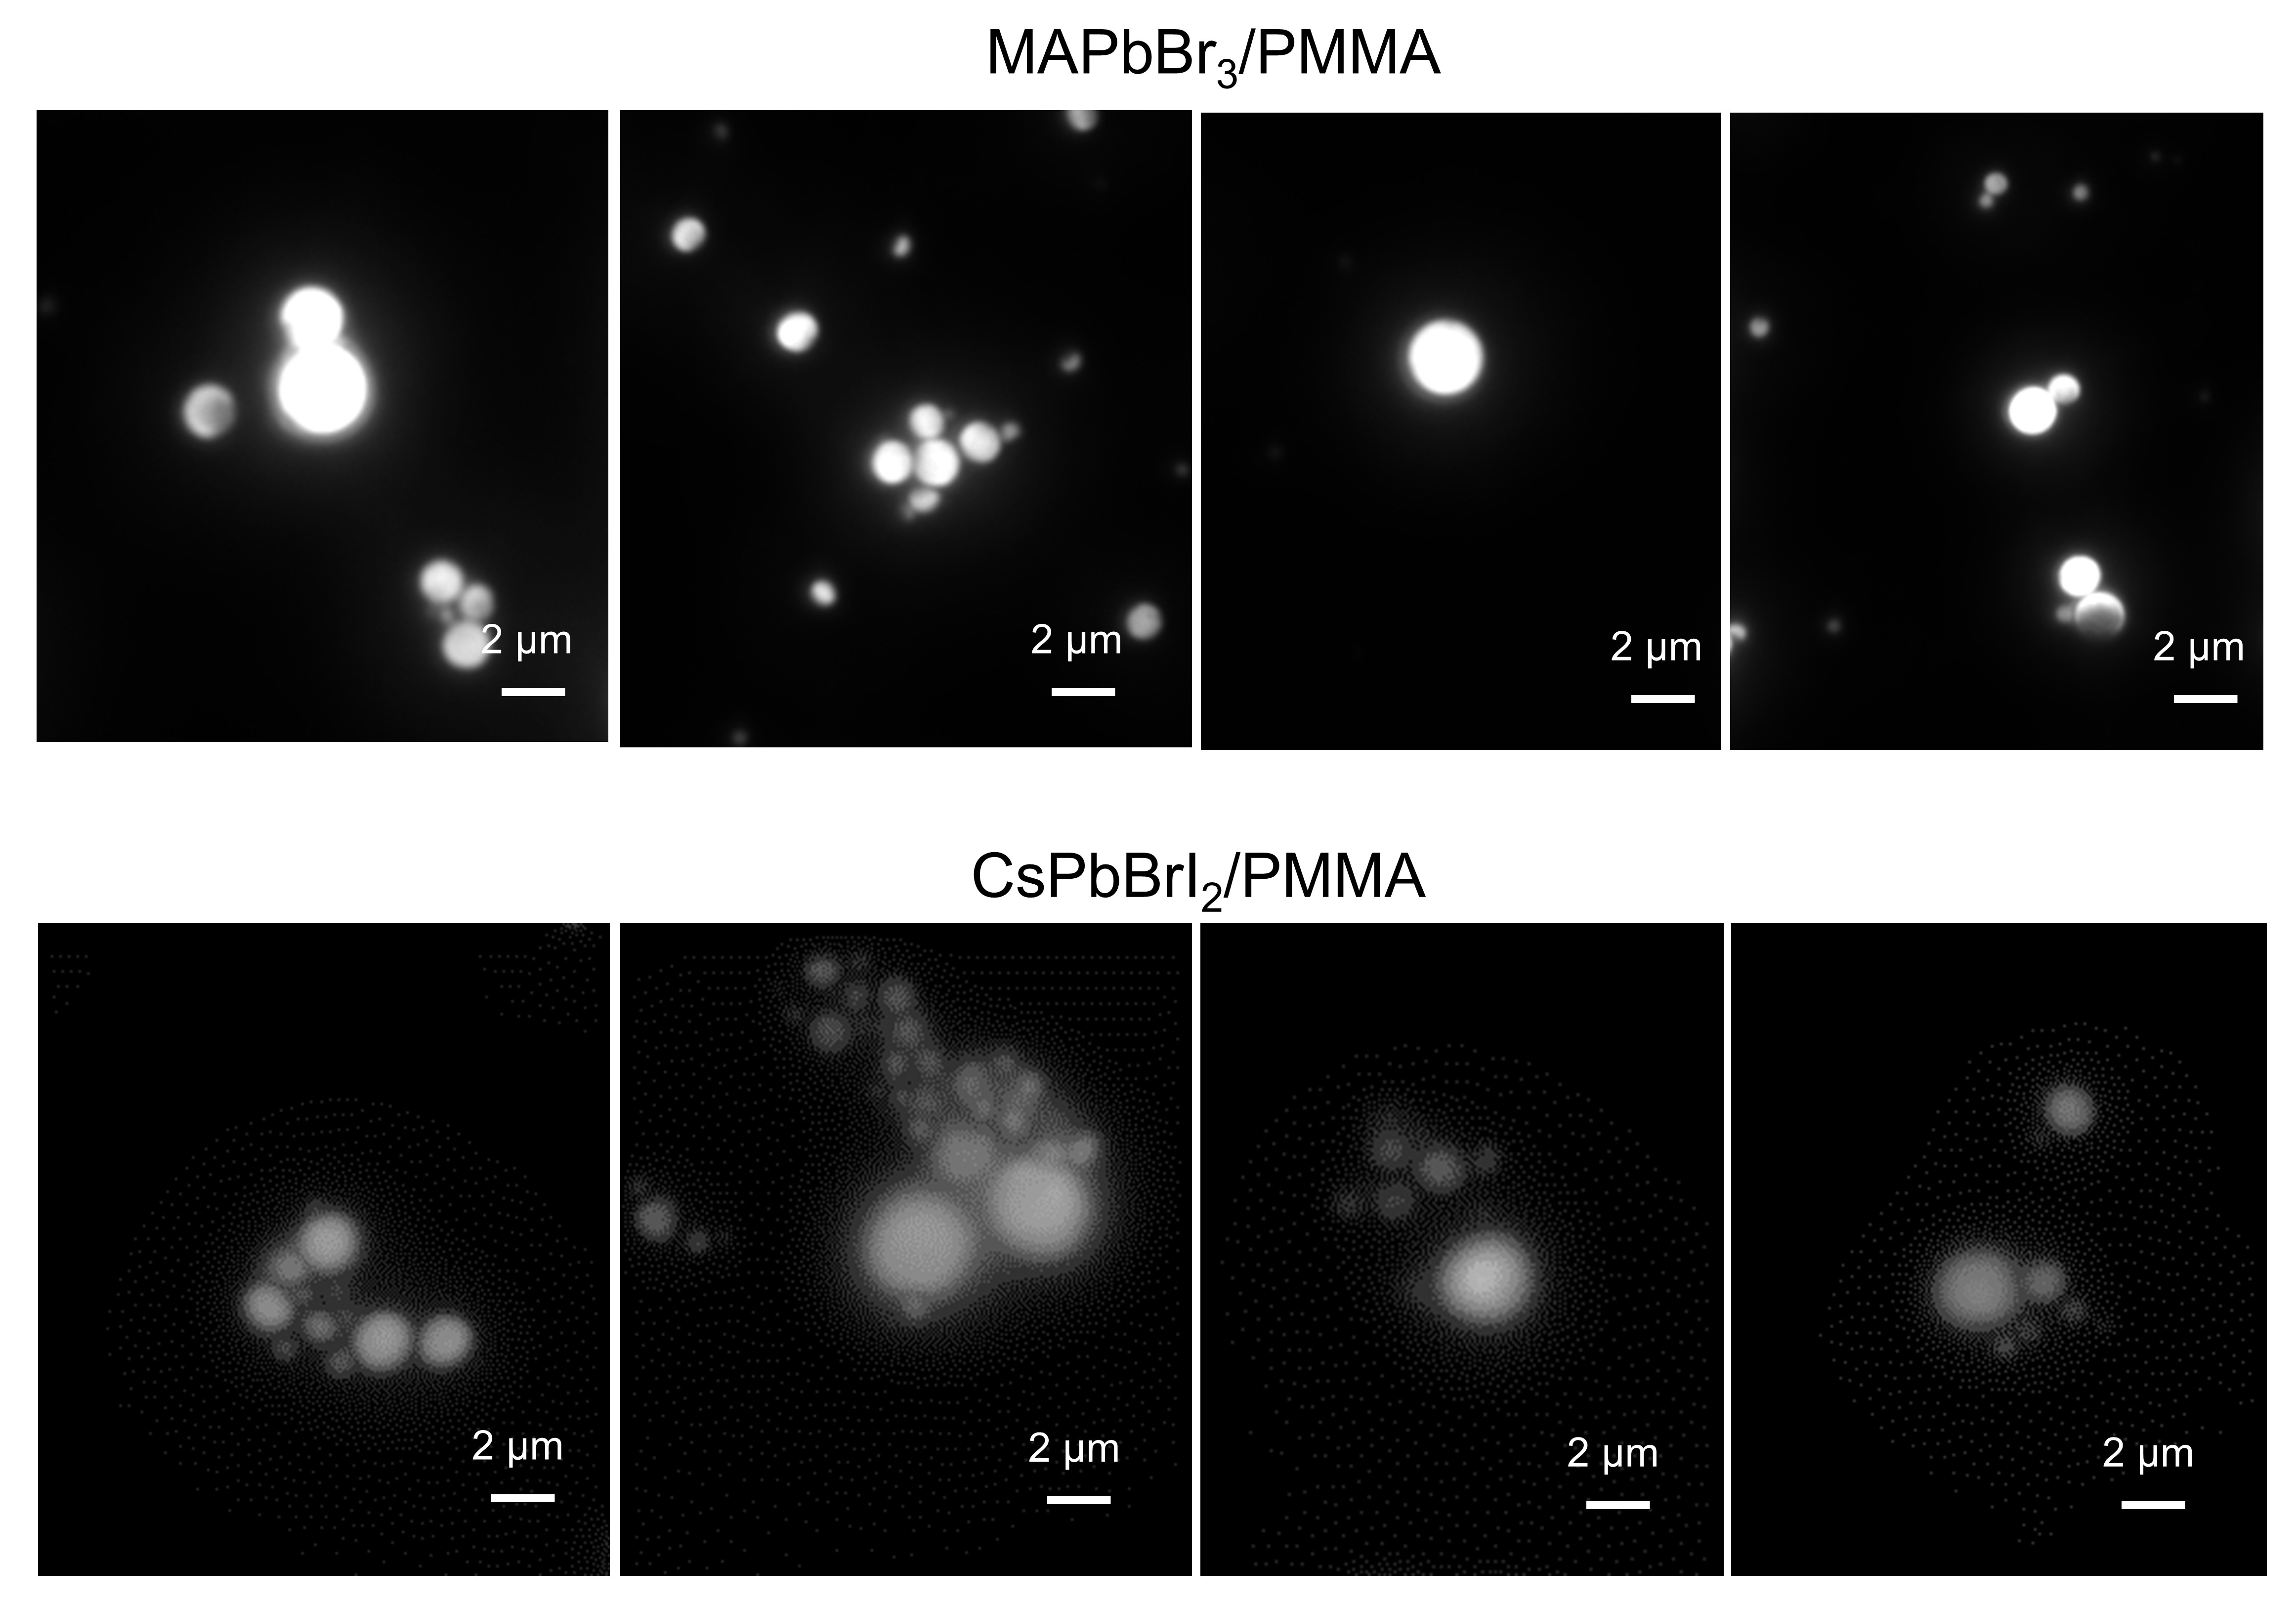
Fig. S1. Uniformity fluorescence images of MAPbBr₃/PMMA and CsPbBrI₂/PMMA PQDs microspheres under an optical microscope.

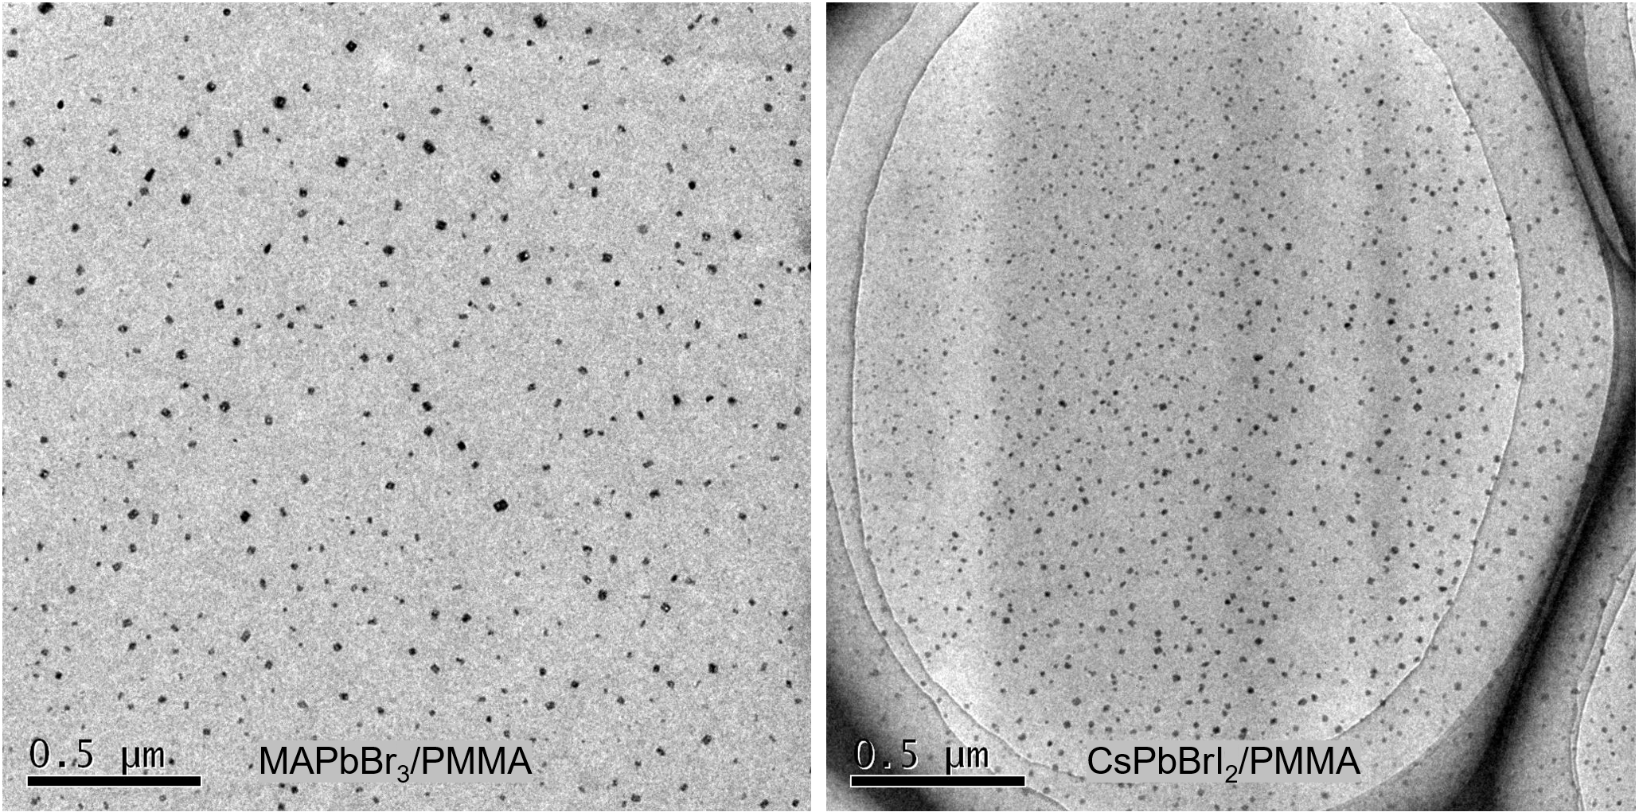
Fig. S2. TEM images of MAPbBr₃/PMMA and CsPbBrI₂/PMMA PQDs microspheres.

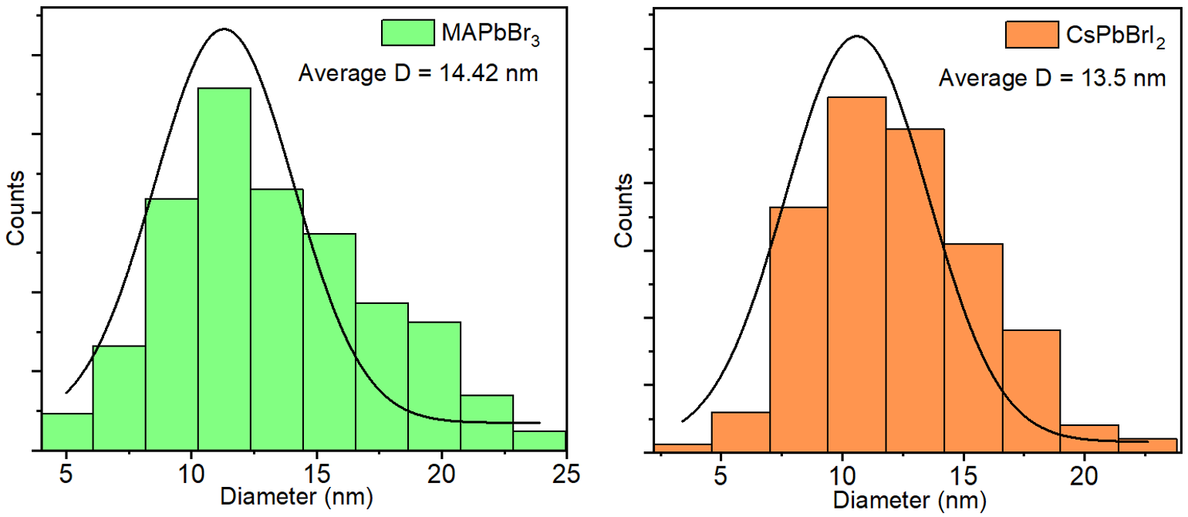
Fig. S3. Size distribution analysis of MAPbBr₃ QDs and CsPbBrI₂ QDs in PMMA matrix.

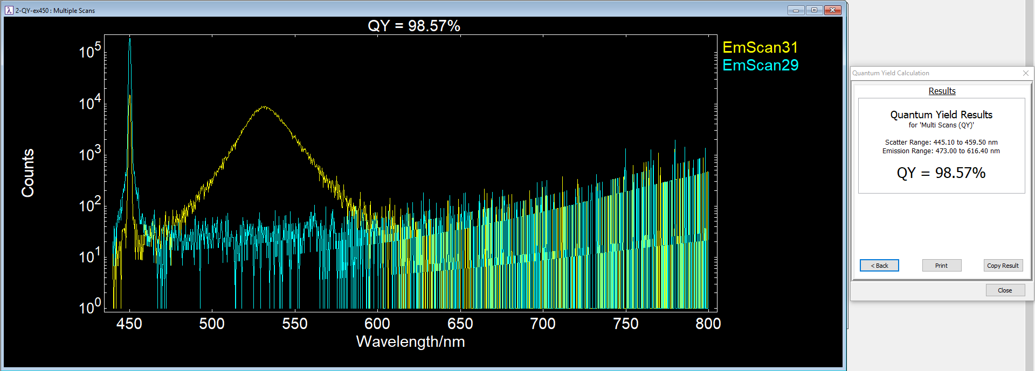
Fig. S4. PLQY measurement of MAPbBr₃/PMMA PQDs microspheres.

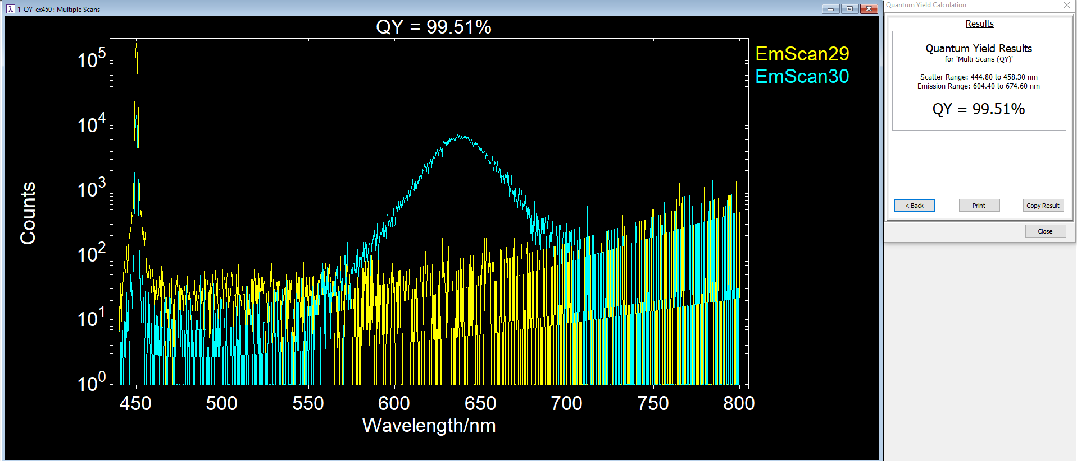
Fig. S5. PLQY measurement of CsPbBrI₂/PMMA PQDs microspheres.

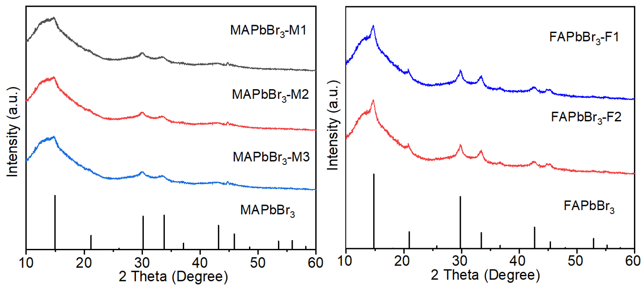
Fig. S6. XRD patterns of a series of MAPbBr₃/PMMA and FAPbBr₃/PMMA PQDs microspheres.

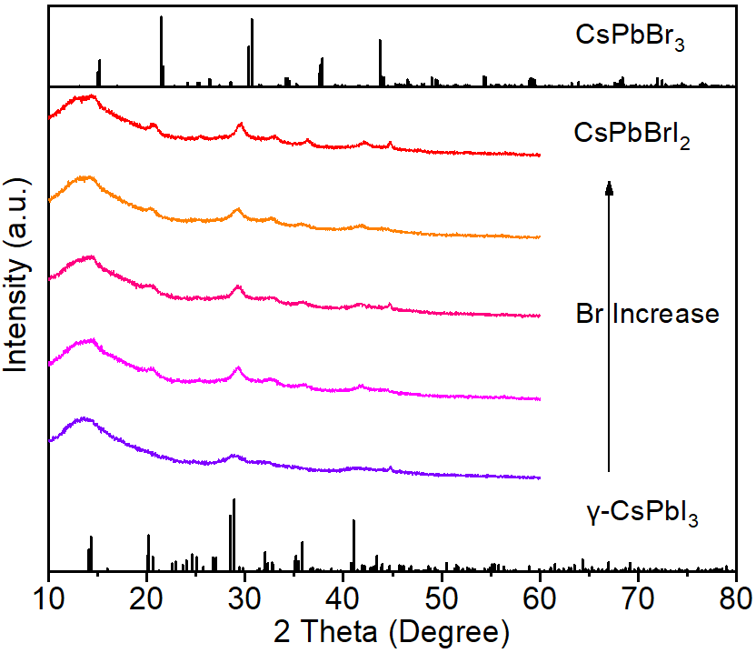
Fig. S7. XRD patterns of a series of CsPbBr_{x}I_{3−x}/PMMA PQDs microspheres.

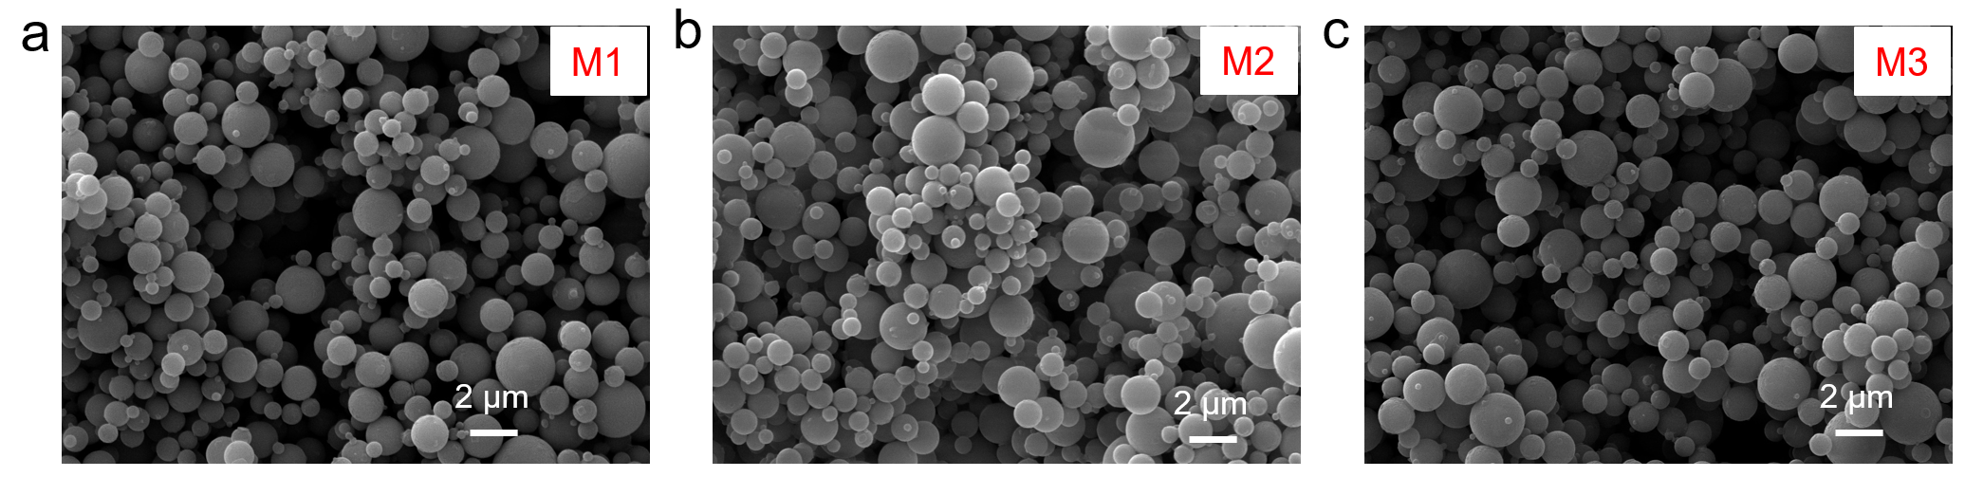
Fig. S8. SEM images of a series of MAPbBr₃/PMMA PQDs microspheres: (a) M1; (b) M2; and (3) M3.

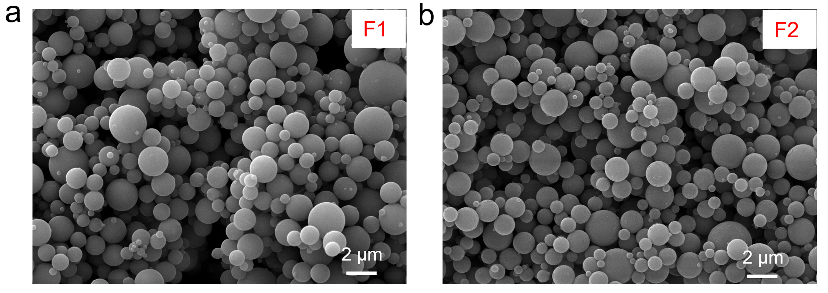
Fig. S9. SEM images of a series of FAPbBr₃/PMMA PQDs microspheres: (a) F1 and (b) F2.
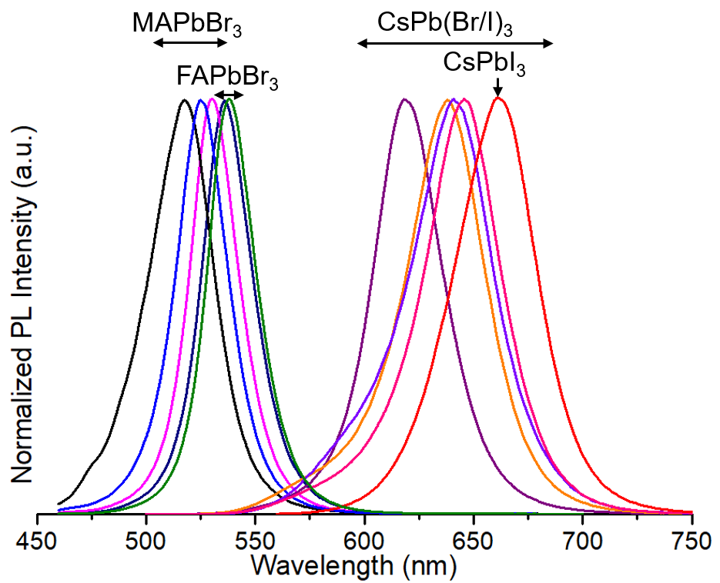
Fig. S10. PL spectra of a series of MAPbBr₃/PMMA, FAPbBr₃/PMMA, and CsPbBrI₂/PMMA PQDs microspheres.

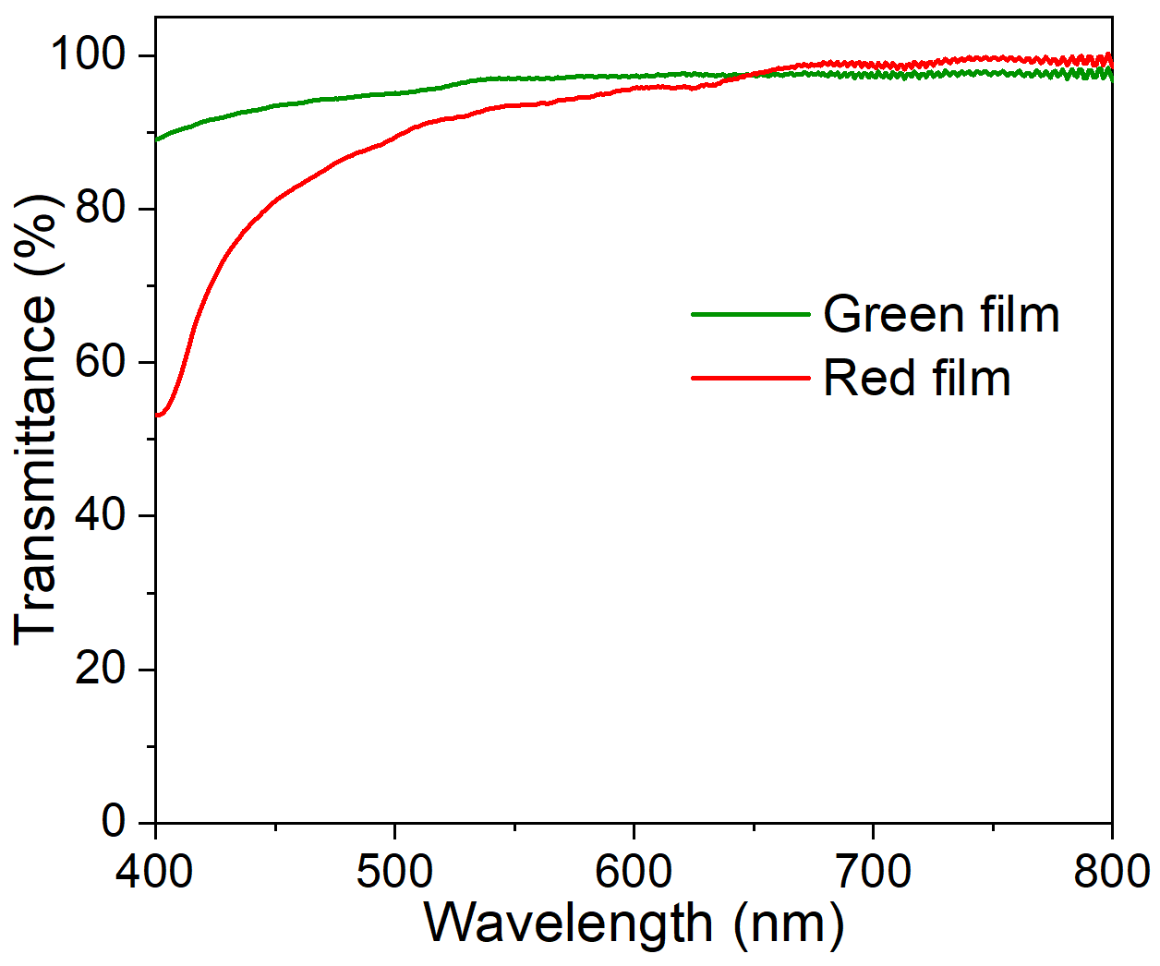
Fig. S11. Transmittance spectra of the PQDs films on the PET substrate.

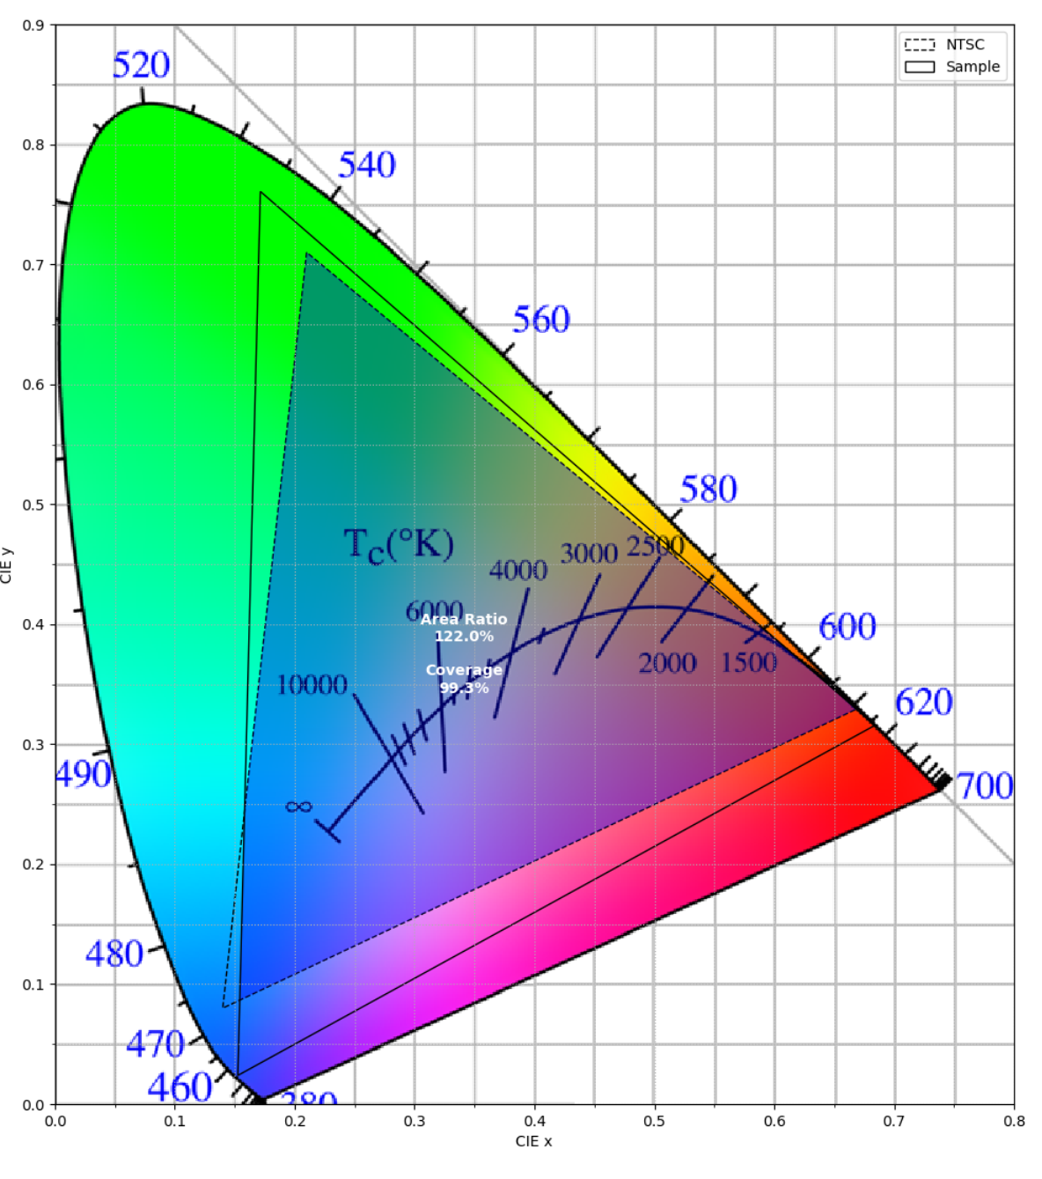
Fig. S12. Color gamut coverage of the PQDs optical films integrated LCD backlighting, compared with NTSC color gamut in CIE 1931.

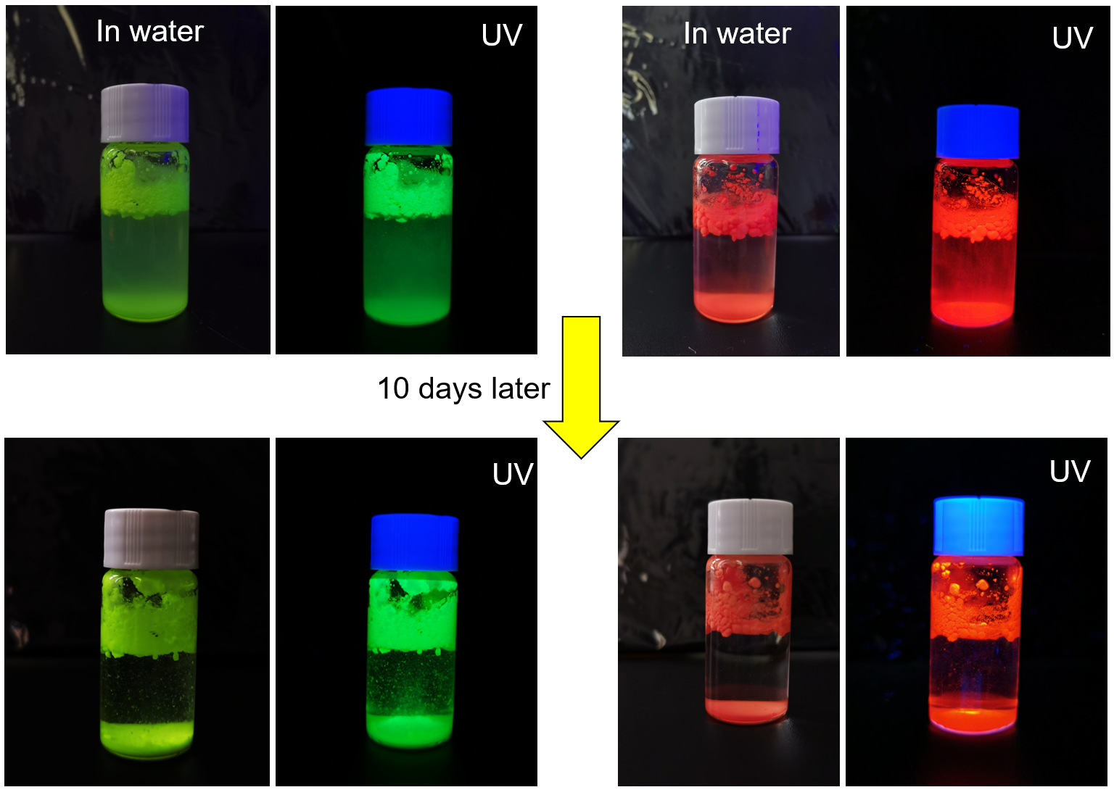
Fig. S13. Photograph of MAPbBr₃/PMMA and CsPbBrI₂/PMMA PQDs microspheres stored in water for 10 days.

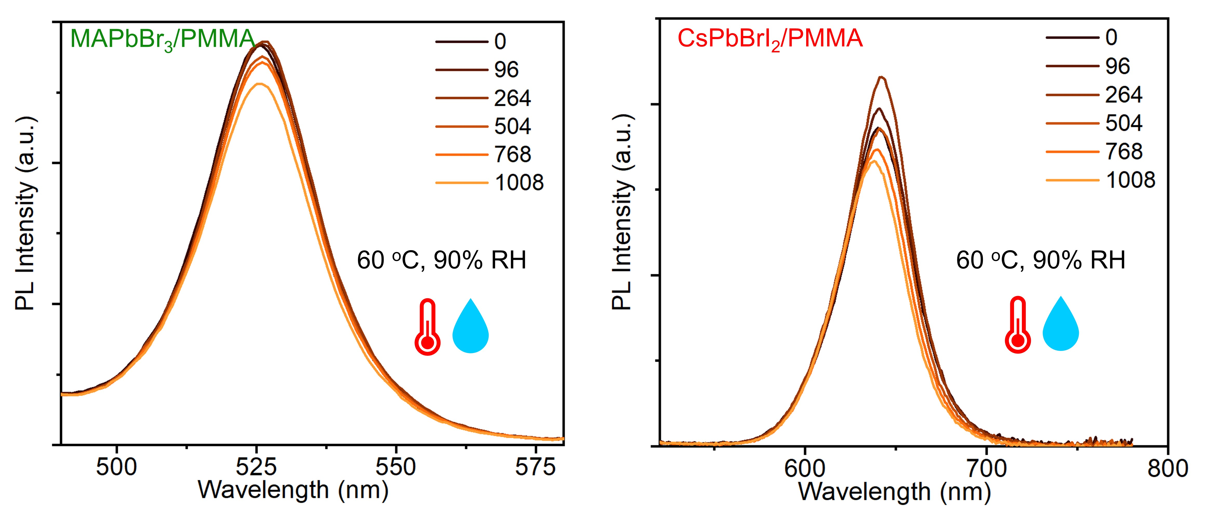
Fig. S14. PL spectra of MAPbBr₃/PMMA and CsPbBrI₂/PMMA optical films measured from 0 to 1008 hours under 60 ºC and 90% RH.

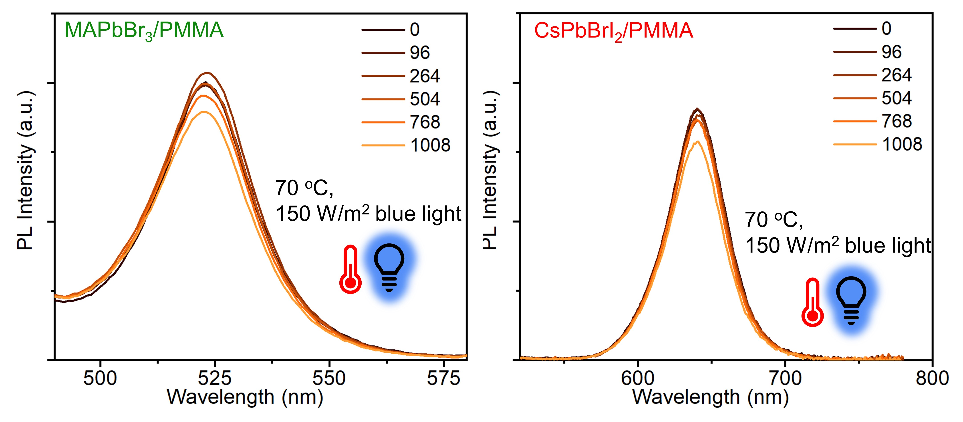
Fig. S15. PL spectra of MAPbBr₃/PMMA and CsPbBrI₂/PMMA optical films measured from 0 to 1008 h under 70 ºC and 150 W∙m⁻², 455 nm blue light irradiation.

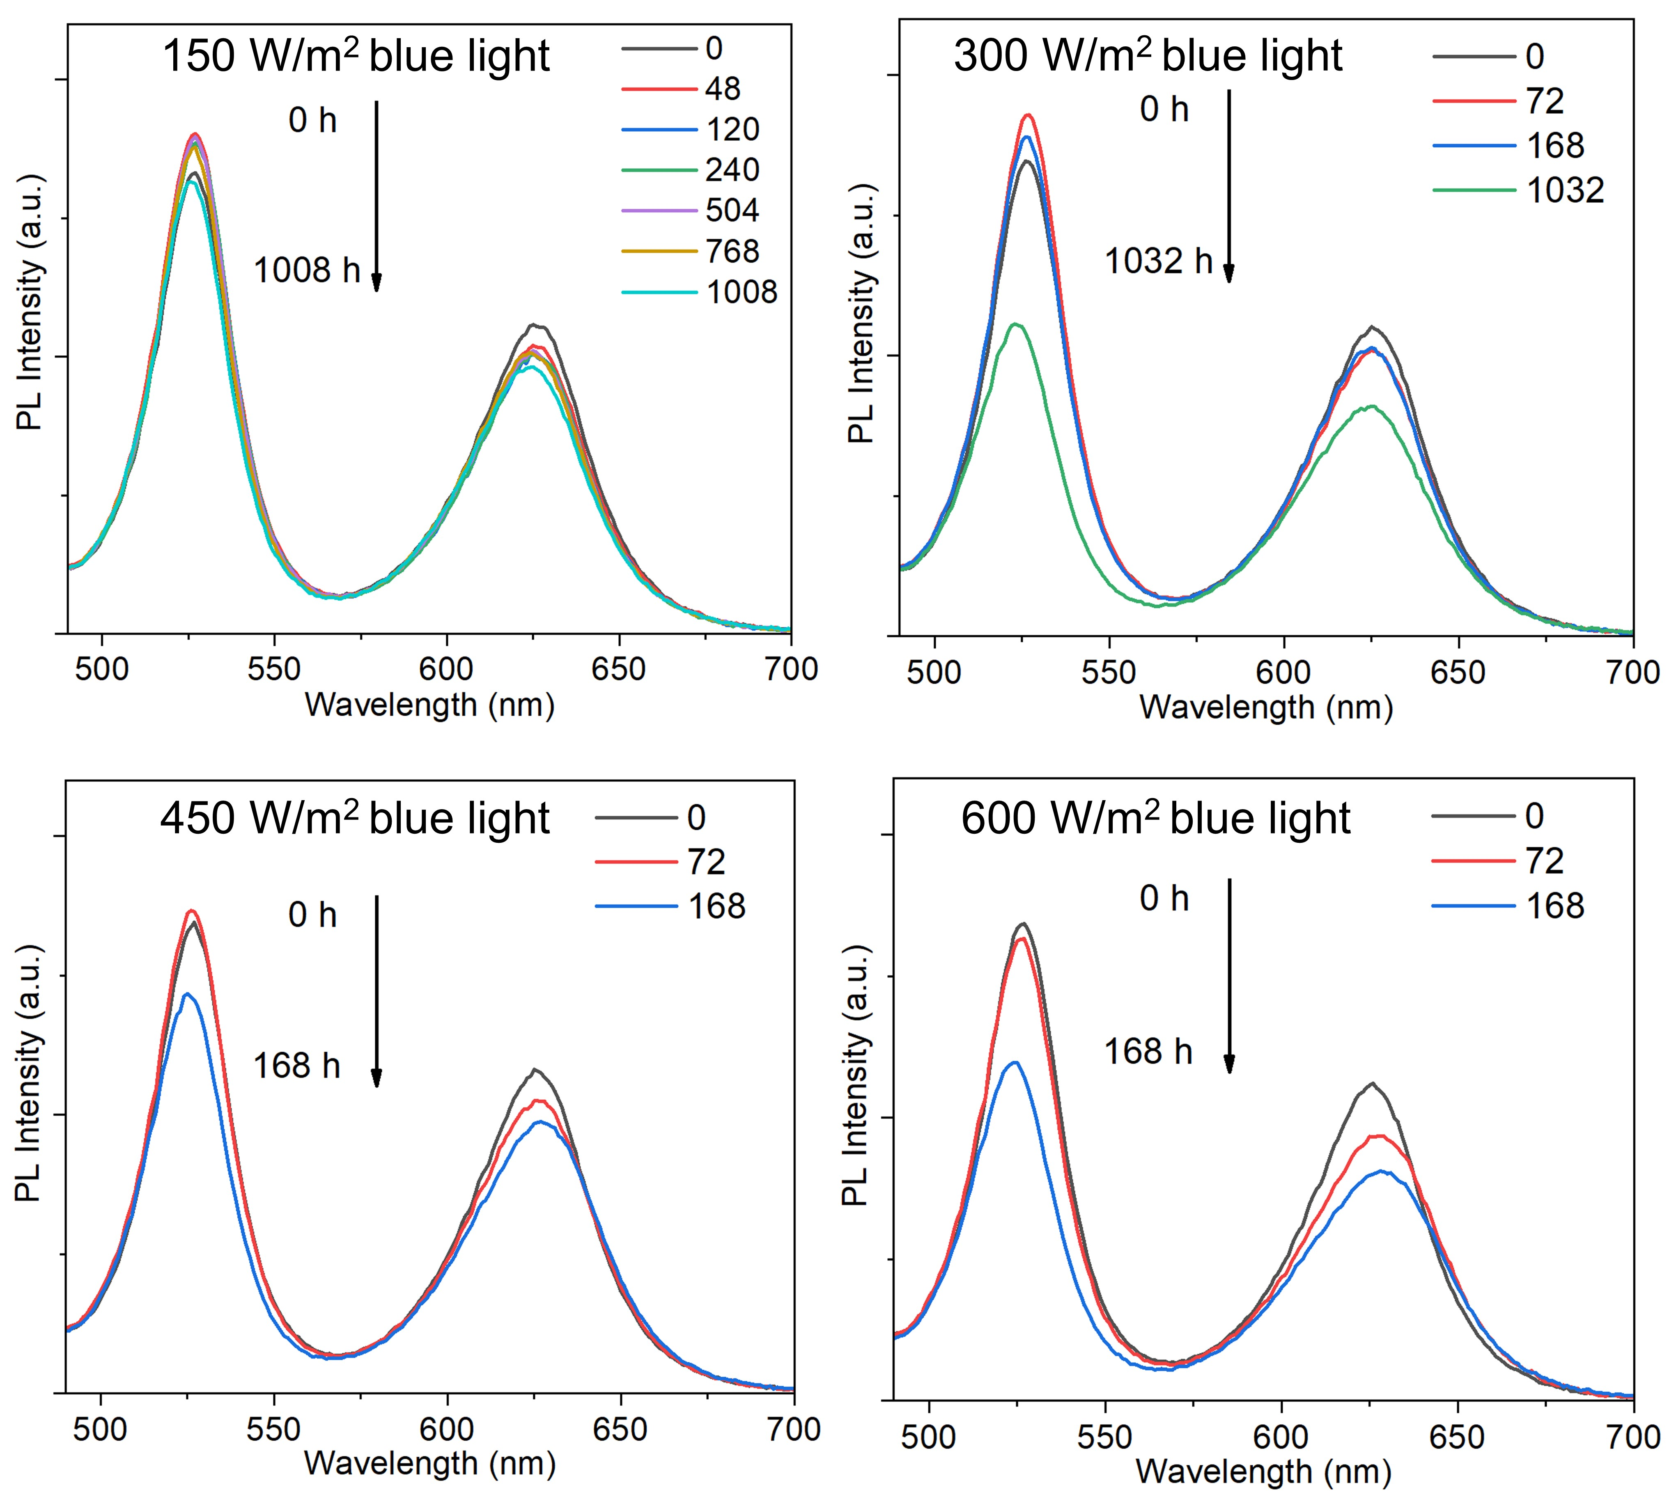
Fig. S16. PL spectra of MAPbBr₃/PMMA and CsPbBrI₂/PMMA optical films measured from 0 to 1008 h under 150, 300, 450, and 600 W∙m⁻² 455 nm blue light irradiation.

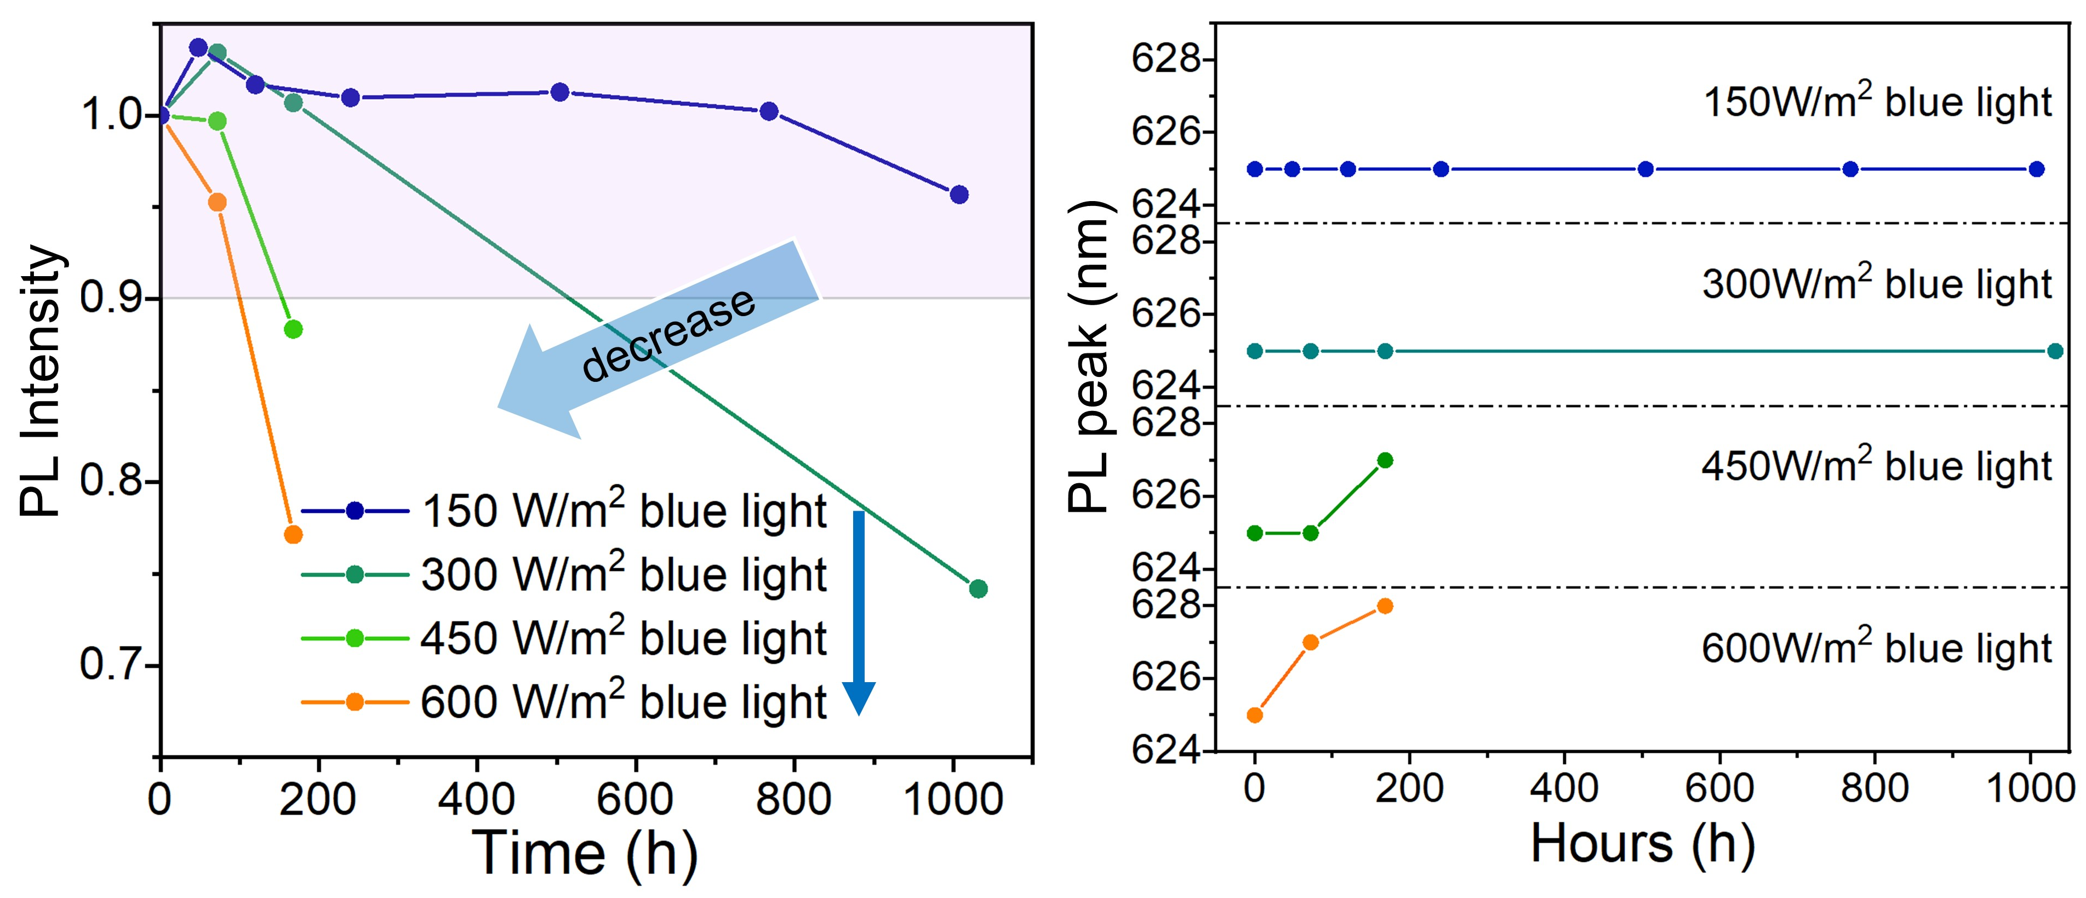
Fig. S17. PL intensity and PL peak shift of MAPbBr₃/PMMA and CsPbBrI₂/PMMA optical films measured from 0 to 1008 h under 150, 300, 450, and 600 W∙m⁻² 455 nm blue light irradiation.

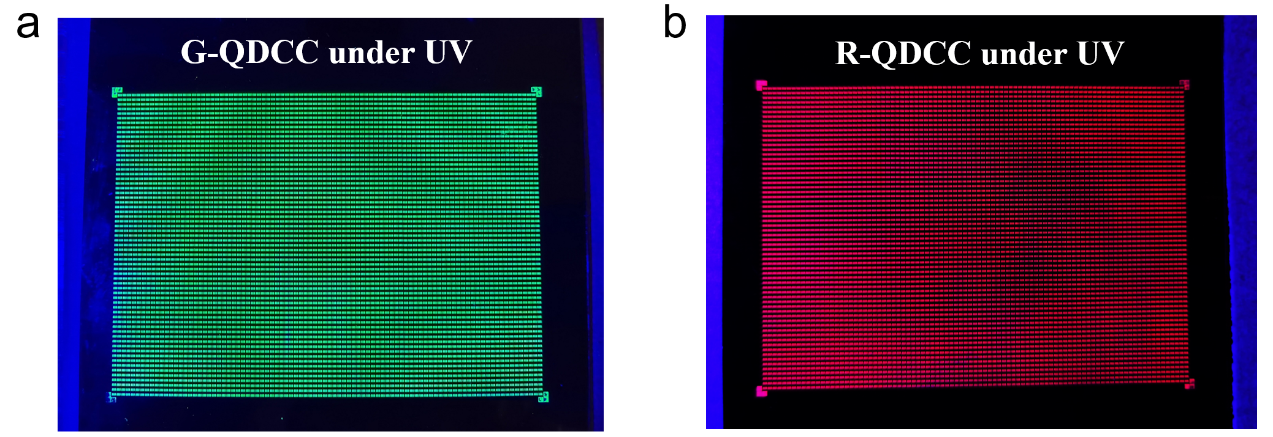
Fig. S18. The images of (a) green patterned QDCC and (b) red patterned QDCC under UV light.

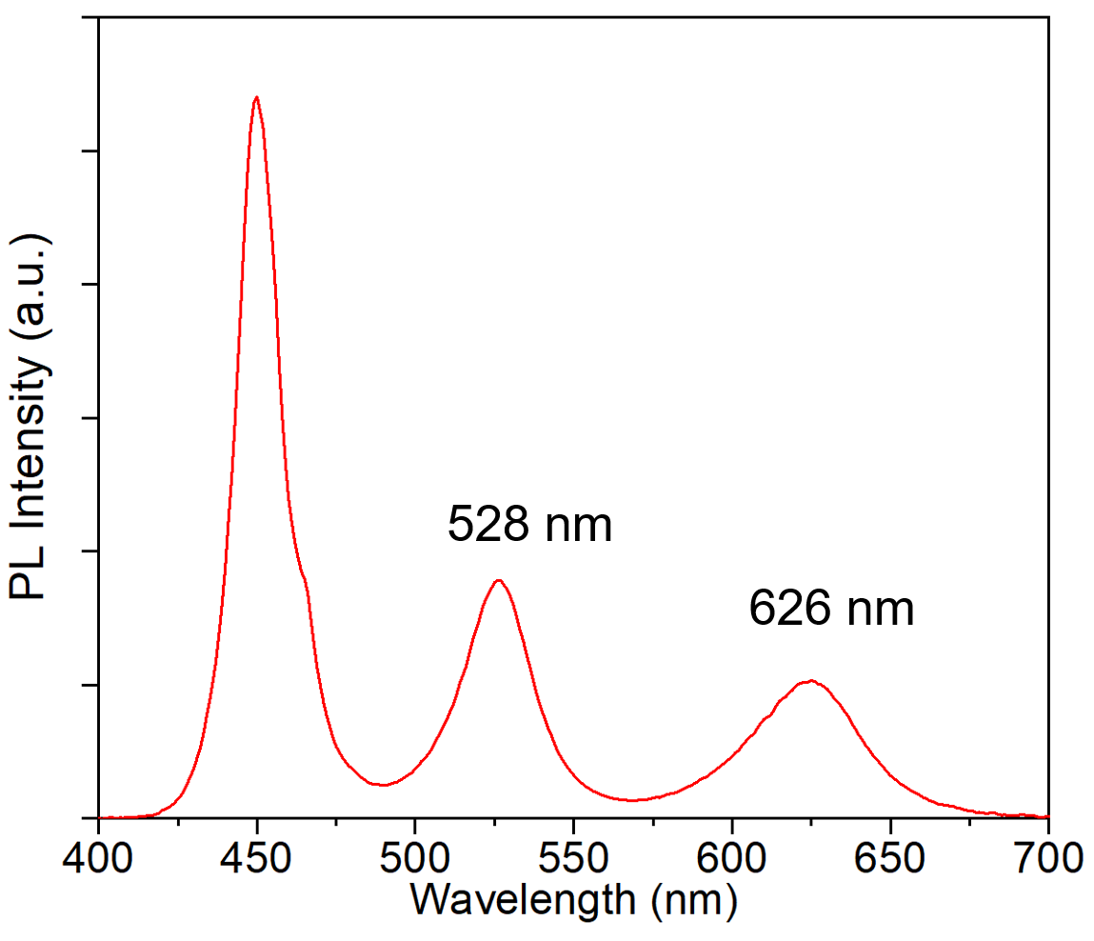
Fig. S19. PL spectra of dual-color patterned QDCC.

References
[1] Han TH, Jang KY, Dong Y, Friend RH, Sargent EH, Lee TW. A roadmap for the commercialization of perovskite light emitters. Nat Rev Mater 2022;7(10):757–77.
[2] Wu XG, Ji HL, Yan XL, Zhong HZ. Industry Outlook of Perovskite Quantum Dots for Display Applications. Nat Nanotechnol 2022;17(8):813–6.
[3] Protesescu L, Yakunin S, Bodnarchuk MI, Krieg F, Caputo R, Hendon CH, et al. Nanocrystals of cesium lead halide perovskites (CsPbX₃, X = Cl, Br, and I): novel optoelectronic materials showing bright emission with wide color gamut. Nano Lett 2015;15(6):3692–6.
[4] Zhang F, Zhong HZ, Chen C, Wu XG, Hu XM, Huang HL, et al. Brightly luminescent and color tunable colloidal CH₃NH₃PbX₃ (X = Br, I, Cl) quantum dots: potential alternatives for display technology. ACS Nano 2015;9(4):4533–42.
[5] Zhou QC, Bai ZL, Lu WG, Wang YT, Zou BS, Zhong HZ. In situ fabrication of halide perovskite nanocrystal-embedded polymer composite films with enhanced photoluminescence for display backlights. Adv Mater 2016;28(41):9163–8.
[6] Wang HC, Lin SY, Tang AC, Singh BP, Tong HC, Chen CY, et al. Mesoporous silica particles integrated with all-inorganic CsPbBr₃ perovskite quantum-dot nanocomposites (MP-PQDs) with high stability and wide color gamut used for backlight display. Angew Chem Int Ed 2016;55(28):7924–9.
[7] Wang Y, He J, Chen H, Chen J, Zhu R, Ma P, et al. Ultrastable, highly luminescent organic–inorganic perovskite–polymer composite films. Adv Mater 2016;28(48):10710–7.
[8] Xuan TT, Guo SQ, Bai WH, Zhou TL, Wang L, Xie RJ. Ultrastable and highly efficient green-emitting perovskite quantum dot composites for Mini-LED displays or backlights. Nano Energy 2022;95:107003.
[9] Li F, Huang S, Liu XY, Bai ZL, Wang ZT, Xie HD, et al. Highly stable and spectrally tunable gamma phase Rb_{x}Cs_{1–x}PbI₃ gradient‐alloyed quantum dots in PMMA matrix through a sites engineering. Adv Funct Mater 2021;31(11):2008211.
[10] Wang Z, Fu R, Li F, Xie H, He P, Sha Q, et al. One‐step polymeric melt encapsulation method to prepare CsPbBr₃ perovskite quantum dots/polymethyl methacrylate composite with high performance. Adv Funct Mater 2021;31(22):2010009.
[11] Fan M, Huang J, Turyanska L, Bian Z, Wang L, Xu C, et al. Efficient all‐perovskite white light‐emitting diodes made of in situ grown perovskite‐mesoporous silica nanocomposites. Adv Funct Mater 2023;33(19):2215032.

