Supplementary data for

Therapeutic Insights into Low-intensity Vibration for Generating Induced Tumor-Suppressive Cells and Modulating the Bone Microenvironment
Xue Xiong ^{a,b,c}, Qingji Huo ^{a,b}, Changpeng Cui ^{a,b}, Uma K. Aryal ^{d}, BonHeon Ku ^{e},
Chin-Suk Hong ^{f}, HeeChang Lim ^{e}, Jing Liu ^{c,g}, Andy Chen ^{h}, William R. Thompson ^{g,i,j},
Bai-Yan Li ª, Xue-Lian Li ^{a,k,}*, Hiroki Yokota ^{b,g,i,l,}*
ªDepartment of Pharmacology, College of Pharmacy, Harbin Medical University, Harbin 150081, China
^{b}Department of Biomedical Engineering, Purdue University in Indianapolis, Indianapolis, IN 46202, USA
^{c}Department of Physics and Astronomy, Purdue University, West Lafayette, IN 47907, USA
^{d}Department of Comparative Pathobiology, Purdue University, West Lafayette, IN 47907, USA
^{e}School of Mechanical Engineering, Pusan National University, Busan 46241, Republic of Korea
^{f}Department of Mechanical Engineering, Ulsan College, Ulsan 44022, Republic of Korea
^{g}Indiana University Simon Comprehensive Cancer Center, Indiana University School of Medicine; Indianapolis, IN 46202, USA
^{h}Department of Medical Genetics, Indiana University School of Medicine; Indianapolis, IN 46202, USA
^{i}Indiana Center for Musculoskeletal Health, Indiana University School of Medicine; Indianapolis, IN 46202, USA
^{j}Department of Physical Therapy, Indiana University, Indianapolis, IN 46202, USA
^{k}Department of Breast Surgery, Harbin Medical University Cancer Hospital, Harbin Medical University, Harbin 150086, China
^{l}Department of Anatomy, Cell Biology and Physiology, Indiana University School of Medicine, Indianapolis, IN 46202, USA

* Corresponding author.
E-mail address: lixuelian@hrbmu.edu.cn (X.-L. Li), hyokota@purdue.edu (H. Yokota)

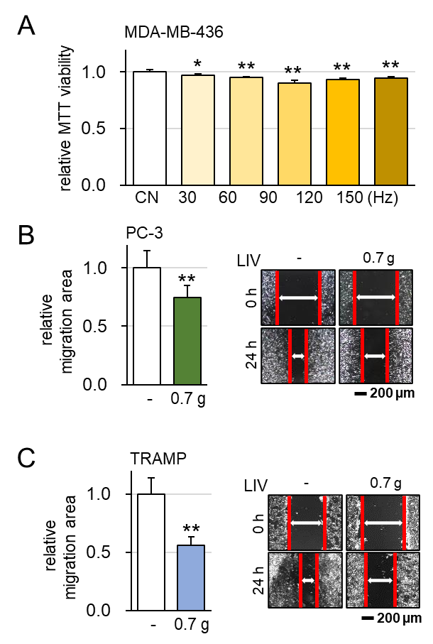
Suppl. Figure 1. Effects of LIV on the progression of breast cancer cells and the migration of prostate cancer cells. The double asterisks indicate p < 0.05 and 0.01 vs. CN, respectively. Low-intensity vibration was applied at 90 Hz with a level of 0.7 g. The double asterisk indicates p < 0.01. CN = control. (A) Frequency-dependence of MTT-based viability of MDA-MB-436 breast cancer cells in response to LIV. (B&C) Reduction in scratch-based motility of prostate cancer cells (PC-3 and TRAMP), respectively, in response to LIV.

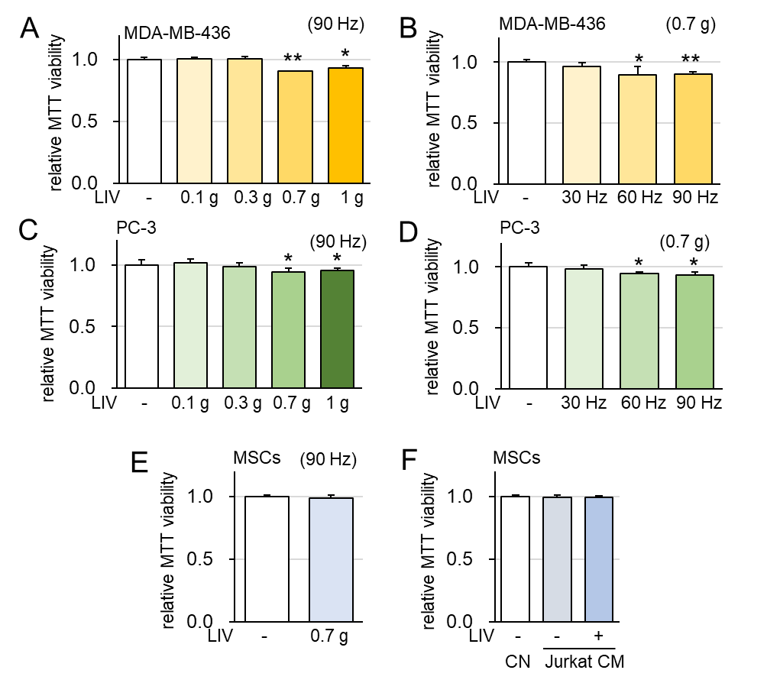
Suppl. Figure 2. Effects of LIV-treated Jurkat cell CM on the MTT-based cell viability, using varying vibration frequencies and amplitudes. The double asterisks indicate p < 0.05 and 0.01 vs. CN, respectively. (A) Alterations in MTT-based viability of MDA-MB-436 breast cancer cells in response to LIV with amplitudes of 0.1, 0.3, 0.7, and 1 g. (B) Alterations in cell viability of MDA-MB-436 breast cancer cells in response to LIV with frequencies at 30, 60, and 90 Hz. (C) Alterations in cell viability of PC-3 prostate cancer cells in response to LIV with amplitudes of 0.1, 0.3, 0.7, and 1 g. (D) Alterations in cell viability of PC-3 prostate cancer cells in response to LIV with frequencies of 30, 60, and 90 Hz. (E&F) No detectable alterations of cell viability of MSCs in response to the direct application of LIV or LIV-treated Jurkat cell-derived CM.

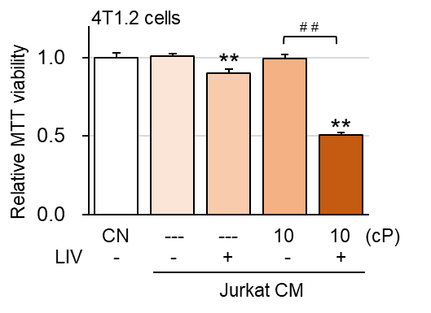
Suppl. Figure 3. The enhanced tumor-suppressing capability of shaking-treated Jurkat cell-derived CM by elevating the viscosity of the culture medium. The double asterisk indicates p < 0.01 vs. CN, while the double pound sign indicates p < 0.01 vs. Jurkat 10 cP CM. CN = control, CM = conditioned medium, and cP = centipoise (viscosity unit). Reduction in the MTT-based viability of 4T1.2 mammary tumor cells in response to LIV with standard and high-viscosity CM (0.8 and 10 cP, respectively).

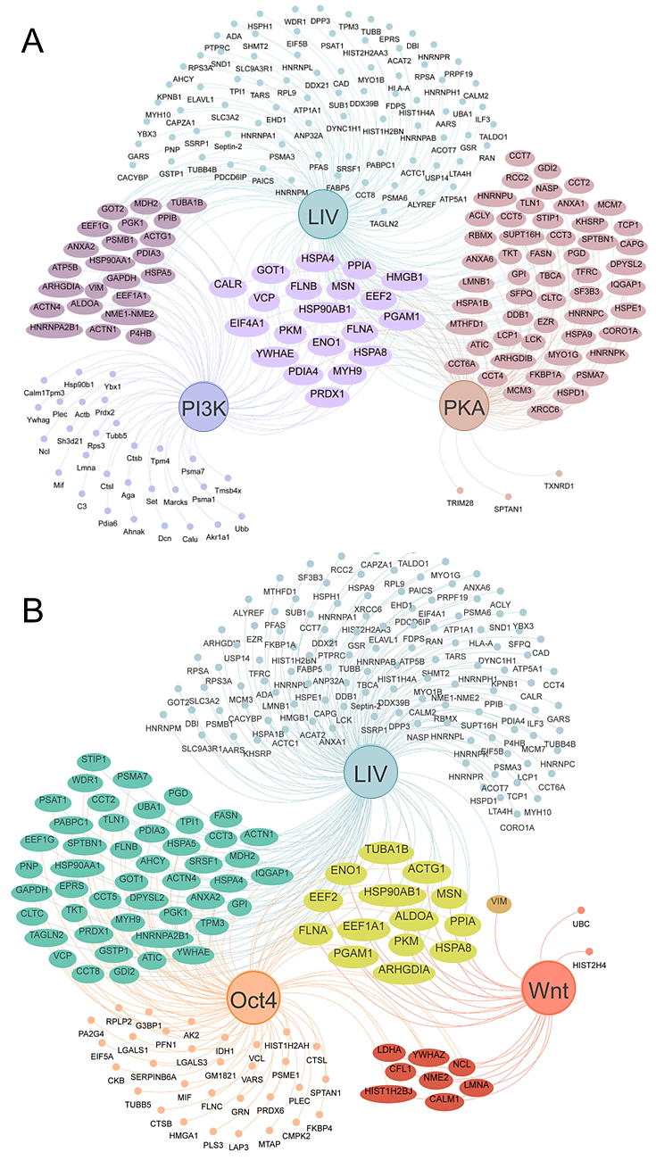
Suppl. Figure 4. Mass spectrometry-based proteomics analysis. (A) Highly enriched proteins in the three different iTSC CMs (PI3K, PKA, and LIV) and their intersection. (B) Highly enriched proteins in the three different iTSC CMs (Oct4, Wnt, and LIV) and their intersection.

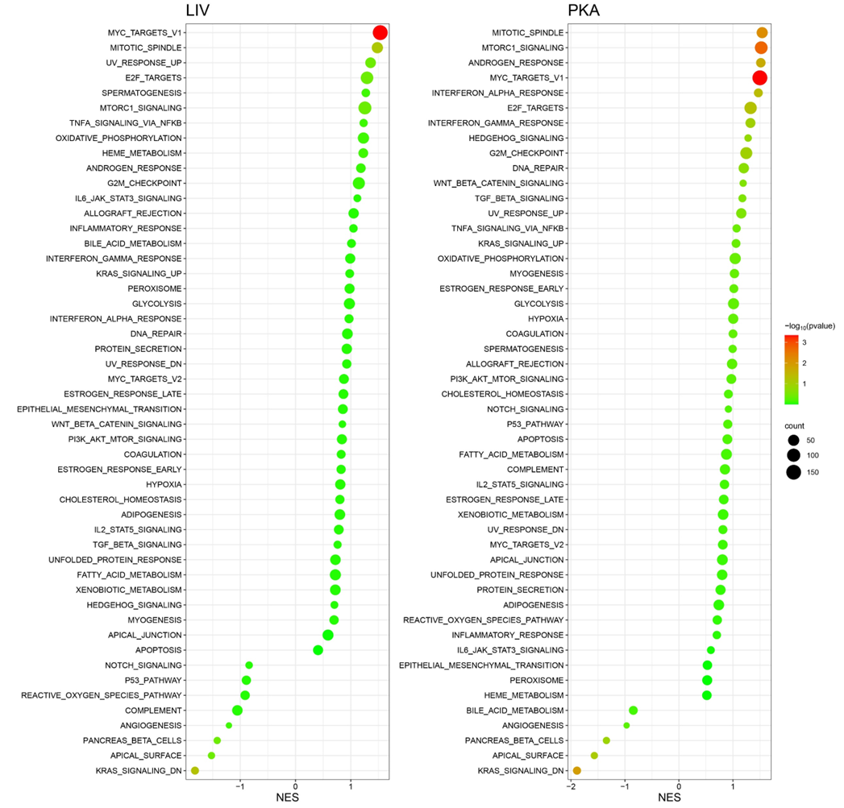
Suppl. Figure 5. Normalized enrichment score (NES) in GSEA for the signaling pathways activated in Jurkat cell-derived conditioned medium by the application of LIV (left column) and the activation of PKA (right column).

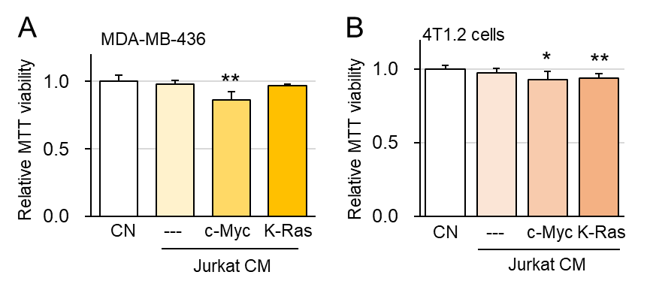
Suppl. Figure 6. Generation of tumor-suppressive conditioned medium by overexpressing c-Myc and K-Ras in Jurkat lymphocytes. CN= control and CM = conditioned medium. The single and double asterisks indicate p < 0.05 and 0.01, respectively. (A-B) Reduction in MTT-based viability and scratch-based motility of MDA-MB-436 breast cancer cells and 4T1.2 mammary tumor cells in response to c-Myc and K-Ras-overexpressing Jurkat cell-derived CM.

