Supplementary data for
Functional Metabolomics Reveals that Astragalus Polysaccharides Improve Lipids Metabolism Through Microbial Metabolite 2-Hydroxybutyric Acid in Obese Mice
Bingbing Li ^{a,#}, Ying Hong ^{a,#}, Yu Gu ª, Shengjie Ye ª, Kaili Hu ª, Jian Yao ^{b}, Kan Ding ^{b}, Aihua Zhao ^{c}, Wei Jia ^{c,d}, Houkai Li ^{a,}*
ª Institute of Interdisciplinary Integrative Medicine Research, Shanghai University of Traditional Chinese Medicine, Shanghai 201203, China
^{b} Shanghai Institute of Materia Medica, Chinese Academy of Sciences, Shanghai 201203, China
^{c} Shanghai Key Laboratory of Diabetes Mellitus and Center for Translational Medicine, Shanghai Jiao Tong University Affiliated Sixth People’s Hospital, Shanghai 200233, China
^{d} University of Hawaii Cancer Center, Honolulu, HI 96813, USA

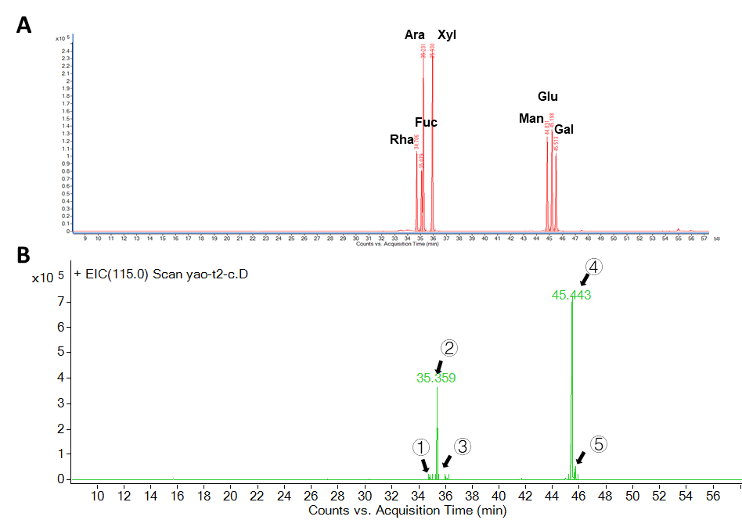
Fig. S1. Characterization of the monosaccharide composition of APS. (a) Chromatography analysis of authentic monosaccharide standards, including rhamnose, arabinose, xylose, glucose, and galactose. (b) Major monosaccharide composition and ratio in APS used in the current study, including ① rhamnose (1.6%), ② arabinose (23.39%), ③ xylose (0.84%), ④ glucose (70.55%), and ⑤ galactose (3.61%).

Table S1
Antibodies.
Antibody | Source | Identifier
FAS | Cell Singaling | 3180
ACC | Cell Singaling | 3676
SREBP | BD Pharminggen | 5570336
ATGL | Cell Singaling | 2138S
HSL | Cell Singaling | 4107
CE1 | Abcam | ab45957
p-IRS1(Y612) | Millipore | 09-432
IRS1 | Cell Singaling | 2382S
p-IR | Cell Singaling | 3023
IR | Cell Singaling | 3025
p-AKT(T308) | Cell Singaling | 4056
AKT | Cell Singaling | 9272
CPT-1 | Cell Singaling | 14670
β-Actin | Sigma-Aldrich | A5316
β-Tubulin | Cell Singaling | 2146
GAPDH | Protein Tech | 60004-1-lg
Anti-mouse IgG | Cell Singaling | 7076
Anti-rabbit IgG | Cell Singaling | 7074
FAS: fatty acid synthase; ACC: acetyl-CoA carboxylase; SREBP: sterol-regulatory element-binding proteins; ATGL: adipose triglyceride lipase; HSL: hormone-sensitive lipase; CE: carboxylesterase; IRS: insulin receptor substrate; IR: insulin receptor; AKT: Protein kinase B; CPT: carnitine palmitoyltransferase; GAPDH: glyceraldehyde-3-phosphate dehydrogenase.

Table S2
Primer sequences.
Gene | Forward/reverse | Primer
18s | F(5'to3') | CCATCCAATCGGTAGTAGCG
18s | R(3'to5') | GTAACCCGTTGAACCCCATT
TNF-α | F(5'to3') | TAGCCAGGAGGGAGAACAGA
TNF-α | R(3'to5') | TTTTCTGGAGGGAGATGTGG
FAS | F(5'to3') | CCTGGATAGCATTCCGAACCT
FAS | R(3'to5') | AGCACATCTCGAAGGCTACACA
ACC | F(5'to3') | TGACAGACTGATCGCAGAGAAAG
ACC | R(3'to5') | TGGAGAGCCCCACACACA
SREBP | F(5'to3') | GTAGGTCACCGTTTCTTTGTGGAC
SREBP | R(3'to5') | TGGGCTGAGCAATACAGTTCAAC
ChREBP | F(5'to3') | ACCTGTCTCCCCCTCAAACT
ChREBP | R(3'to5') | TGTCTTCTGAAGCGTGGTTG
CPT-1 | F(5'to3') | TGAGTGGCGTCCTCTTTGG
CPT-1 | R(3'to5') | CAGCGAGTAGCGCATAGTCATG
TNF: tumor necrosis factor; ChREBP: carbohydrate response element-binding protein.
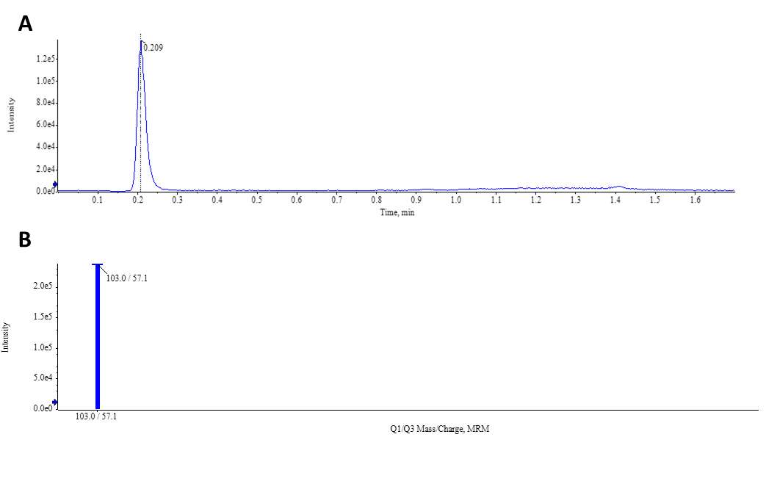
Fig. S2. Chromatographic information of the metabolites in the targeted metabolomics. (a) The total ion current (TIC) diagram of the targeted metabolomics shows the retention time of 2-HB is 0.209 min. (b) The MRM diagram shows the ion pair mass of 2-HB is 103.0/57.1.

Table S3
Literature survey of differential metabolites
Metabolite’s name | HMDB ID | Class | HFD vs Control | APS vs HFD | Functions | Reference
Linoleic acid | HMDB00673 | Fatty acids | ↓ | ↑ | Essential fatty acids, esterified to phospholipids, cholesterol esters, and triacylglycerols to power the body | [1]
2HB | HMDB00008 | Amino acid | ↓ | ↑ | 2-HB was decreased in leptin-deficient mice; the formation of obesity is related to the decrease of 2-HB in serum; increased excretion of dihydroxyisobutyrate in urine leads to typical obesity metabolism. | [2,3]
Inositol | HMDB00211 | Alcohols | ↓ | ↑ | Increase the insulin sensitivity | [4]
Oleic acid | HMDB00207 | Fatty acids | ↓ | ↑ | The product of fatty acid de novo synthesis, could promotes the formation of NAFLD | [5]
Myristic acid | HMDB00806 | Fatty acids | ↓ | ↑ | Enhancing basal glucose uptake in myotubes in a DGKδ2 expression dependent manner | [6]
Dimethylglycine | HMDB00092 | Amino acid | ↓ | ↑ | It has a protective effect on glucose metabolism | [7]
β-Alanine | HMDB00056 | Amino acid | ↓ | ↑ | Increase the content of carnosine in skeletal muscle | [8]
Citrulline | HMDB00904 | Amino acid | ↓ | ↑ | High plasma citrulline level indicates intestinal damage | [9,10]
Ketleucine | HMDB00695 | Amino acid | ↓ | ↑ | Negative correlation between ketleucine/leucine ratio and BMI index | [11]
L-lysine | HMDB00182 | Amino acid | ↓ | ↑ | Its key metabolite, carnitine, participates in fatty acid metabolism | [12]
3-Indolepropionic acid | HMDB02302 | Indoles | ↓ | ↑ | Hydroxyl radical scavenger, increased plasma IPA means lower risk of diabetes | [13,14]
β-Alanine/L-aspartic acid ratio | HMDB00056/HMDB00191 | Amino acid | ↓ | ↑ | *
Citrulline/L-arginine ratio | HMDB00904/HMDB00517 | Amino acid | ↓ | ↑ | *
Allantoic acid | HMDB01209 | Amino acid | ↓ | ↑ | Participate in the degradation of uric acid | HMDB
Urea | HMDB00294 | Amino acid | ↓ | ↑ | It is the main end product of protein catabolism and a marker of renal function | [15]
L-tyrosine/L-phenylalanine ratio | HMDB00158/HMDB00159 | Amino acid | ↑ | ↓ | *
Dodecanoic acid | HMDB00638 | Fatty acids | ↓ | ↑ | Increase serum total cholesterol | [16]
Galacturic acid | HMDB00565 | Carbohydrates | ↓ | ↑ | Access to pentose phosphate pathway | [17]
L-α-aminobutyric acid | HMDB00452 | Amino acid | ↓ | ↑ | Regulate the level of glutathione in myocardium and improve oxidative stress | [18]
Ornithine | HMDB00214 | Amino acid | ↓ | ↑ | Middle part of urea cycle | [19]
Arachidonic acid | HMDB01043 | Fatty acids | ↑ | ↓ | Precursor of enzyme metabolism, producing proinflammatory and anti-inflammatory substances | [20,21]
Arachidic acid | HMDB02212 | Fatty acids | ↑ | ↓ | Hydrogenation of arachidonic acid | HMDB
Docosahexaenoic acid | HMDB02183 | Fatty acids | ↓ | ↓ | The main fatty acids in brain phospholipid and retina have positive therapeutic effect on Alzheimer's disease | [22]
DGKδ2: diacylglycerol kinase δ 2; BMI: body mass index; IPA: 3-indolepropionic acid; HMDB: human metabolome database.
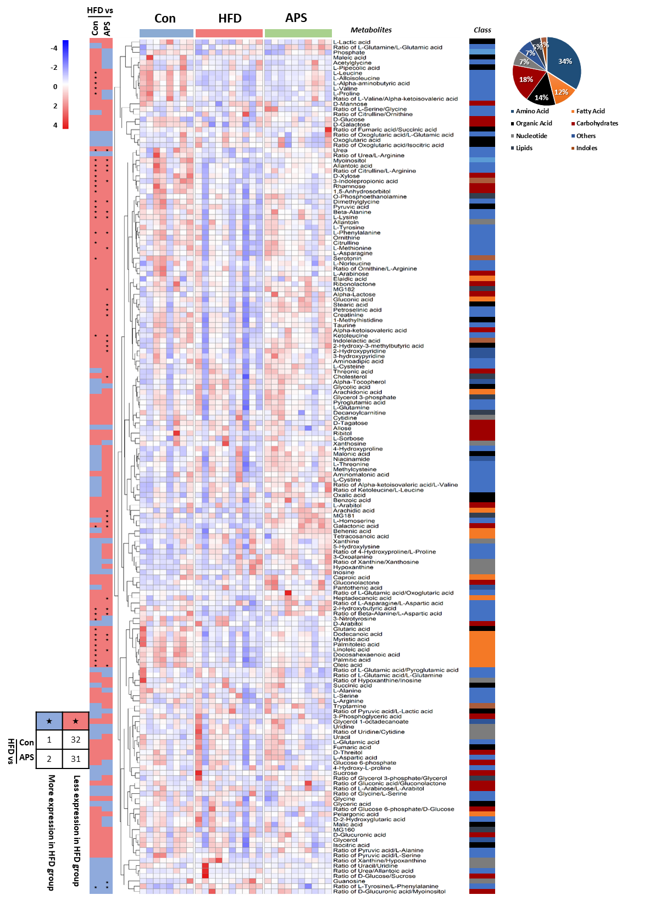
Fig. S3. Overview of the identified serum metabolites. The differences in expression among the three groups of all identified serum metabolites were visualized with a heatmap. In the heatmap, red and blue entries indicate metabolites that showed respectively more and less expression in each sample. In the graph on the left side of the heatmap, red and blue entries indicate metabolites that showed respectively more and less expression in the HFD group relative to the control or APS group. The black star represents the metabolites whose expressions were significantly altered between the groups (p < 0.05, n = 8, 10, and 10 per group). On the right side of the heatmap, the substance classes that each metabolite belongs to are shown in different colors. The proportions of different categories in the identified 166 metabolites are shown with a pie chart on the far right. Significance was measured by an unpaired two-tailed Student’s t-test.

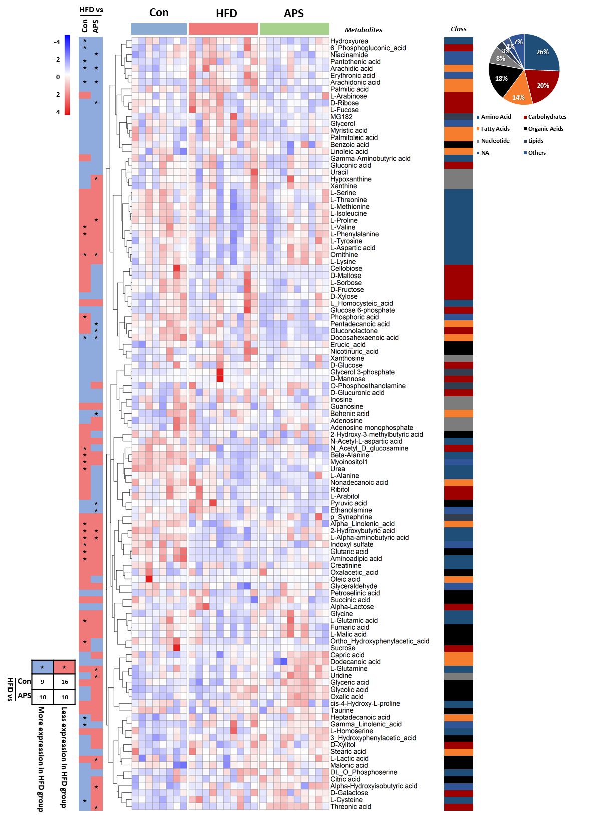
Fig. S4. Overview of the identified liver metabolites. The differences in expression among the three groups of all identified liver metabolites were visualized with a heatmap. In the heatmap, red and blue entries indicate metabolites that showed respectively more and less expression in each sample. In the graph on the left side of the heatmap, red and blue entries indicate metabolites that showed respectively more and less expression in the HFD group relative to the control or APS group. The black star represents metabolites whose expressions were significantly altered between the groups (p < 0.05, n = 8, 10, and 10 per group). On the right side of the heatmap, the substance classes that each metabolite belongs to are shown in different colors. The proportions of different categories in the identified 112 metabolites are shown with a pie chart on the far right. Significance was measured by an unpaired two-tailed Student’s t-test.

Table S4
Metabolic pathways related information
Pathway name | Total | Expected | Hits | p | –Lg (p) | FDR | Impact
Biosynthesis of unsaturated fatty acids | 42 | 0.53 | 5 | 0 | 9.064 | 0.009489 | 0
Fatty acid biosynthesis | 43 | 0.55 | 3 | 0.0001 | 4.170 | 0.4499 | 0
Arginine and proline metabolism | 44 | 0.56 | 3 | 0.0001 | 4.107 | 0.4499 | 0.082
Propanoate metabolism | 20 | 0.25 | 2 | 0.0002 | 3.677 | 0.51864 | 0.125
Lysine biosynthesis | 4 | 0.05 | 1 | 0.0010 | 2.998 | 0.81842 | 0
Biotin metabolism | 5 | 0.06 | 1 | 0.0017 | 2.781 | 0.84742 | 0
Linoleic acid metabolism | 6 | 0.08 | 1 | 0.0025 | 2.604 | 0.86644 | 0.500
Ascorbate and aldarate metabolism | 9 | 0.11 | 1 | 0.0061 | 2.217 | 1 | 0.167
Pantothenate and CoA biosynthesis | 15 | 0.19 | 1 | 0.0182 | 1.741 | 1 | 0
β-Alanine metabolism | 17 | 0.22 | 1 | 0.0236 | 1.628 | 1 | 0.077
Purine metabolism | 68 | 0.86 | 2 | 0.0282 | 1.549 | 1 | 0.022
Lysine degradation | 23 | 0.29 | 1 | 0.0436 | 1.361 | 1 | 0.059
Galactose metabolism | 26 | 0.33 | 1 | 0.0555 | 1.256 | 1 | 0
Glutathione metabolism | 26 | 0.33 | 1 | 0.0555 | 1.256 | 1 | 0.029
Inositol phosphate metabolism | 28 | 0.36 | 1 | 0.0641 | 1.193 | 1 | 0.063
Glycine, serine and threonine metabolism | 31 | 0.39 | 1 | 0.0780 | 1.108 | 1 | 0.029
Arachidonic acid metabolism | 36 | 0.46 | 1 | 0.1030 | 0.987 | 1 | 0.400
Pyrimidine metabolism | 41 | 0.52 | 1 | 0.1300 | 0.886 | 1 | 0
Aminoacyl-tRNA biosynthesis | 69 | 0.88 | 1 | 0.3027 | 0.519 | 1 | 0.020
FDR: false discovery rate.
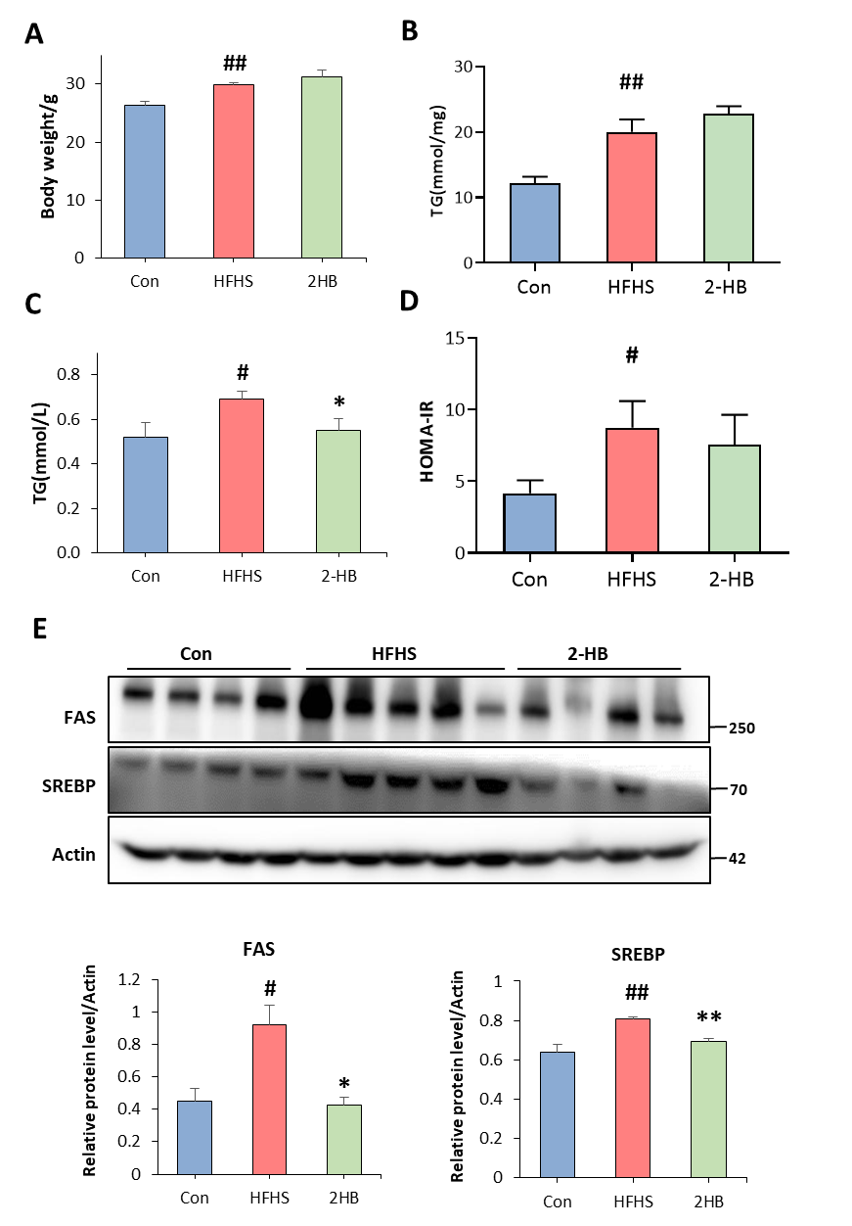
Fig. S5. 2-HB intraperitoneal injection regulates serum lipid level and liver lipid metabolism in HFHS-fed mice. Male C57BL/6J mice (four weeks old) were divided into three groups randomly. Mice in the control group were treated with a chow diet for ten weeks; mice in the HFHS group were first treated with a high-fat diet for five weeks, and then given 30% sucrose in their drinking water (g·L^{–1}) for another five weeks; mice in the 2-HB group had the same diet as the HFHS group, but were injected intraperitoneally with 25 mg·mL^{–1} 2-HB for the last two weeks. (a) Body weight at the end of the experiment (n = 8, 9, and 9 per group). (b) Liver triglyceride levels (n = 8, 9, and 9 per group). (c) Serum triglyceride levels (n = 7, 9, and 6 per group). (d) Homeostasis model assessment-insulin resistance (HOMA-IR = fasting blood glucose × fasting blood insulin ÷ 22.5, n = 7 per group). (e) Protein expression levels of SREBP and FAS in liver tissues (n = 4, 5, and 4 per group). Significance was measured by an unpaired two-tailed Student’s t-test, with # p < 0.05 and ## p < 0.01 compared with the control and * p < 0.05 and ** p < 0.01 compared with the HFHS group. Results are presented as means ± SEM.

Reference
[1] Ni Y, Su M, Qiu Y, Jia W, Du X. ADAP-GC 3.0: improved peak detection and deconvolution of co-eluting metabolites from GC/TOF-MS data for metabolomics studies. Anal Chem 2016;88(17):8802–11.
[2] Gijs Den B, Aycha B, Albert G, Karen Van E, Rick H, Theo H, et al. Short-chain fatty acids protect against high-fat diet-induced obesity via a PPARγ-dependent switch from lipogenesis to fat oxidation. Diabetes 2015;64:2398–408.
[3] Whelan J, Fritsche K. Linoleic acid. Adv Nutr 2013;4(3):311–2.
[4] Gooda Sahib Jambocus N, Saari N, Ismail A, Khatib A, Mahomoodally MF, Abdul Hamid A. An investigation into the antiobesity effects of Morinda citrifolia L. leaf extract in high fat diet induced obese rats using a 1H NMR metabolomics approach. J Diabetes Res 2016;2016:1–14.
[5] Drenick EJ, Alvarez LC, Tamasi GC, Brickman AS. Resistance to symptomatic insulin reactions after fasting. J Clin Invest 1972;51(10):2757–62.
[6] Werner E, Froehlich R. The potential role for myoinositol in the prevention of gestational diabetes mellitus. Am J Perinatol 2016;13(33):1236–41.
[7] Araya J, Rodrigo R, Videla LA, Thielemann L, Orellana M, Pettinelli P, et al. Increase in long-chain polyunsaturated fatty acid n ‒ 6/n ‒ 3 ratio in relation to hepatic steatosis in patients with non-alcoholic fatty liver disease. Clin Sci 2004;106(6):635–43.doi:10.1042/CS20030326.
[8] Wada Y, Sakiyama S, Sakai H, Sakane F. Myristic acid enhances diacylglycerol kinase δ-dependent glucose uptake in myotubes. Lipids 2016;51(8):897–903.
[9] Magnusson M, Wang TJ, Clish C, Engström G, Nilsson P, Gerszten RE, et al. Dimethylglycine deficiency and the development of diabetes. Diabetes 2015;64:3010–6.
[10] Carvalho VH, Oliveira AHS, de Oliveira LF, Da Silva RP, Di Mascio P, Gualano B, et al. Exercise and β-alanine supplementation on carnosine–acrolein adduct in skeletal muscle. Redox Biol 2018;18:222–8.
[11] Saitoh W, Takada S, Hirao J, Shirai M, Iguchi T, Tsuji M, et al. Plasma citrulline is a sensitive safety biomarker for small intestinal injury in rats. Toxicol Lett 2018;295:416–23.
[12] Wei P, Rui T, Ruilan W. Clinical application of plasma citrulline in intestinal damage. J Clin Emerg Med 2018;04(19):274–8.
[13] Elliott P, Posma JM, Chan Q, Garcia-Perez I, Wijeyesekera A, Bictash M, et al. Urinary metabolic signatures of human adiposity. Sci Transl Med 2015;7(285):285ra62.
[14] Judith LF, Peter AS, Joseph V, Mark DW, Qian G. Role of carnitine in disease. Nutr Metab 2010;7:30.
[15] Zhang LS, Davies SS. Microbial metabolism of dietary components to bioactive metabolites: opportunities for new therapeutic interventions. Genome Med 2016;8(1):46.
[16] Wikoff WR, Anfora AT, Liu J, Schultz PG, Lesley SA, Peters EC, et al. Metabolomics analysis reveals large effects of gut microflora on mammalian blood metabolites. Proc Natl Acad Sci USA 2009;106(10):3698–703.
[17] Traynor J, Mactier R, Geddes CC, Fox JG. How to measure renal function in clinical practice. BMJ 2006;333(7571):733–7.
[18] Mensink RP, Zock PL, Kester AD, Katan MB. Effects of dietary fatty acids and carbohydrates on the ratio of serum total to HDL cholesterol and on serum lipids and apolipoproteins: a meta-analysis of 60 controlled trials. Am J Clin Nutr 2003;77(5):1146–55.
[19] Mohnen D. Pectin structure and biosynthesis. Curr Opin Plant Biol 2008;11(3):266–77.
[20] Irino Y, Toh R, Nagao M, Mori T, Honjo T, Shinohara M, et al. 2-Aminobutyric acid modulates glutathione homeostasis in the myocardium. Sci Rep 2016;1(6):36749.
[21] Arthur L, Weber I, Stanley LM, Abdul Hamid A. Reasons for the occurrence of the twenty coded protein amino acid. J Mol Evol 1981;17:273–84.
[22] Nelson GJ, Schmidt PC, Bartolini G, Kelley DS, Kyle D. The effect of dietary arachidonic acid on platelet function, platelet fatty acid composition, and blood coagulation in humans. Lipids 1997;32(4):421–5.

