Supplementary Data for

Remarkable Enhancement of the Activity and Hydrothermal Stability of a CeO₂-Based NH₃-SCR Catalyst by Sn Modification
Ying Zhu ^{a,d,#}, Jingjing Liu ^{c,#}, Guangzhi He ^{c}, Shaohua Xie ^{e}, Wenpo Shan ^{a,b,}*, Zhihua Lian ª, Fudong Liu ^{e}, Hong He ^{a,c,d,}*
ª Center for Excellence in Regional Atmospheric Environment & Key Laboratory of Urban Pollutant Conversion, Institute of Urban Environment, Chinese Academy of Sciences, Xiamen 361021, China
^{b} Zhejiang Key Laboratory of Pollution Control for Port-Petrochemical Industry, Ningbo Urban Environment Observation and Research Station, Institute of Urban Environment, Chinese Academy of Sciences, Ningbo 315800, China
^{c} State Key Joint Laboratory of Environment Simulation and Pollution Control, Research Center for Eco-Environmental Sciences, Chinese Academy of Sciences, Beijing 100085, China
^{d} University of Chinese Academy of Sciences, Beijing 100049, China
^{e} Department of Civil, Environmental and Construction Engineering, Catalysis Cluster for Renewable Energy and Chemical Transformations, NanoScience Technology Center, University of Central Florida, Orlando, FL 32816, USA

# These authors contributed equally to this work.
* Corresponding authors.
E-mail addresses: wpshan@iue.ac.cn (W. Shan), honghe@rcees.ac.cn (H. He).

Catalyst preparation and hydrothermal aging treatment
The Ce–Sn–Nb mixed oxide (denoted as Ce₁Sn_{a}Nb₁O_{x}, where a = 0.5, 1.0, 1.5, 2.0, 2.5, and 3.0) was synthesized by a co-precipitation method using NH₃·H₂O as the precipitator. The required amounts of Ce(NO₃)₃∙6H₂O, SnCl₄∙5H₂O, and C₁₀H₅NbO₂₀ were firstly dissolved together in deionized water. Excessive NH₃∙H₂O was then added to the mixed slurry, dropwise, and the mixture was stirred continuously at room temperature overnight. After filtration and washing with plenty of deionized water, the resulting precipitate was dried at 100 °C for 8 h and subsequently calcined at 700 °C for 3 h in air condition. CeO₂, SnO₂, Nb₂O₅, Ce₁Sn₂O_{x}, Sn₂Nb₁O_{x}, and Ce₁Nb₁O_{x} samples were also prepared using the same method for comparison. The calcined powder catalysts were finally pressed, crushed, and sieved to 40–60 mesh for SCR activity evaluation.
Catalyst characterization
X-ray diffraction (XRD) patterns of the catalysts were collected on a computerized X’Pert PRO diffractometer with Cu Kα radiation operated at 40 kV and 40 mA. The data were recorded with 2θ ranging from 5° to 90° and scan step size of 0.02°.
In-situ high temperature XRD (HTXRD) measurements were carried out to investigate the phase evolution at high temperature using a Bruker D8 Advance diffractometer equipped with a Cu Kα X-ray tube (1.5418 Å) operated at 40 kV and 40 mA. The Ce₁Nb₁O_{x} and Ce₁Sn₂Nb₁O_{x} powder samples were placed in a crucible, heating from 600 to 1000 °C with a temperature interval of 50 °C, and then cooled down to room temperature. After the catalysts reached the target temperature and maintained stability, the XRD data collection started recording. A counting time per step of 0.6 s and a step size of 0.02° were selected for the angular range 20°–90° 2θ in the temperature programmed process.
N₂ adsorption–desorption analysis of catalysts was conducted at a liquid nitrogen temperature (−196 °C) using a physisorption analyzer (MicrotracBEL). Prior to the N₂ physisorption test, all of the samples were degassed at 300 °C for 1 h under vacuum. Specific surface area and pore volume of catalysts were measured by the Brunauer–Emmett–Teller (BET) and Barrett–Joyner–Halenda (BJH) models, respectively.
The morphologies and elements distribution of catalysts were explored by a high-resolution transmission electron microscope (HRTEM) equipped with energy-dispersive X-ray spectroscopy (EDS), which was operated on a JEOL 3200F instrument at an accelerating voltage of 300 kV.
The temperature-programmed reduction of hydrogen (H₂-TPR) and the temperature-programmed desorption of NH₃ (NH₃-TPD) experiments were performed with a Micromeritics Autochem Ⅱ 2920 automatic chemisorption analyzer. The signals were monitored by a thermal conductivity detector (TCD). Prior to H₂-TPR and NH₃-TPD analysis, all of the samples were firstly pre-treated under a flow of pure Ar (30 mL∙min⁻¹) at 400 °C for 30 min, and then cooled down to the room temperature. For H₂-TPR, the samples were heated from room temperature to 1000 °C under 10 vol% H₂/Ar mixture gas flow (50 mL∙min⁻¹) in a U-shaped quartz tube at a heating rate of 10 °C∙min⁻¹. For NH₃-TPD, the catalysts were exposed to 2500 ppm NH₃/He mixture gas flow of 30 mL∙min⁻¹ at room temperature for 1 h, followed by pure Ar (30 mL∙min⁻¹) purge for 2 h. Finally, the temperature was raised to 550 °C at a constant rate of 10 °C∙min⁻¹. All spectra were collected every second. Liquid nitrogen was added to remove the effects of water prior to collection.
X-ray photoelectron spectroscopy (XPS) measurements were collected on an AXIS Supra (Kratos Analytical Inc.) using monochromatized Al Kα radiation (λ = 1486.6 eV) as X-ray source. The binding energies of Ce 3d, Nb 3d, Sn 3d, and O 1s were calibrated by C 1s signal (binding energy (BE) = 284.8 eV) as standard.
X-ray absorption near edge structure (XANES) and extended X-ray absorption fine structure (EXAFS) of the Nb K-edge and XANES of the Ce L₃-edge, Sn K-edge, and Nb K-edge were measured in a transmission mode at room temperature at beamline 7-BM QAS of the National Synchrotron Light Source II (NSLS-II), Brookhaven National Laboratory (BNL). Data were analyzed using Athena and Artemis from the Demeter software package. The filtered k³-weighted χ(k) was Fourier transformed into R space in the k range of 3.0–13.5 Å⁻¹ for Nb K-edge.
The in-situ diffuse reflectance infrared Fourier transform spectra (DRIFTS) employing a Fourier-transform infrared spectrometer (FTIR, Nicolet IS50) equipped with a Smart Collector, an MCT/A detector using liquid nitrogen for cooling, and an in-situ DRIFTS cell including ZnSe window. An Omega programmable temperature controller was used for controlling the reaction temperature. Prior to each experiment, the catalysts were pre-treated under 20 vol% O₂/N₂ mixture gas flow at 450 °C for 30 min to remove the adsorbed impurities, and then cooled down to 200 °C. The background spectra were collected in pure N₂ (300 mL∙min⁻¹) and subtracted from the catalyst spectra. The catalysts spectra were collected ranging from 4000 to 600 cm⁻¹ when the samples were exposed to the atmospheres of 500 ppm NH₃ and balance N₂, with a total flow rate of 300 mL∙min⁻¹. For each sample, the NH₃ adsorption time was controlled at least 1 h to ensure complete adsorption. Subsequently, the catalysts were purged to eliminate the effects of physical adsorption by nitrogen for another 1 h until the FTIR spectra were stabilized. All spectra were obtained at 4 cm⁻¹ resolution with 100 accumulated scans.
Density functional theory (DFT) calculations
The projector augmented wave (PAW) method was used to describe the core–valence electron interaction [1]. DFT + U approach was applied to the Nb atom in NbO_{x} and Ce atom in CeO_{x} with the values of U_{eff} = 4.0 and 4.5 eV, respectively, to describe the on-site Coulomb interactions [2,3]. The plane wave energy cutoff was set to 400 eV for all atoms. A (4 × 2) supercell of the SnO₂(110) surface with three stoichiometric SnO₂ layers was used as the substrate. For the calculation of formation energy of NbO_{x}, CeO_{x}, and NbCeO_{x} species on SnO₂ surfaces, the bottom one stoichiometric SnO₂ layer was kept frozen at their bulk position, whereas all other atoms were fully relaxed. For the calculation of the surface energy of SnO₂ and NbO_{x}/CeO_{x}/NbCeO_{x}-loaded SnO₂, all atoms were fully relaxed. The Brillouin zone was sampled at the Γ point. A vacuum spacing of 20 Å was used to avoid the periodic image interaction normal to the surface. The convergence tolerances of energy and force were 10⁻⁵ eV and 0.02 eV∙Å⁻¹, respectively. The Gaussian smearing method with a smearing width of 0.05 eV was applied to improve the convergence for Brillouin zone integration.
Results
The NH₃-SCR activities over Ce₁Sn_{a}Nb₁O_{x} catalysts at a gas hourly space velocity (GHSV) of 100 000 h⁻¹ were shown in Fig. S1(a). The Ce₁Nb₁O_{x} catalyst already exhibited high NH₃-SCR activity over a wide temperature range. After the addition of Sn, the low temperature activity of the catalyst was gradually enhanced with the increment of Sn/Ce molar ratio. However, after further increasing the Sn/Ce molar ratio to 2.5 and 3.0, the high temperature activity above 450 °C slightly decreased, accompanying with a decrease of N₂ selectivity (Fig. S1(b)). All conditions considered, the Ce₁Sn₂Nb₁O_{x} catalyst with the Ce:Sn:Nb molar ratio of 1:2:1 was selected and tested for hydrothermal stability in this study.

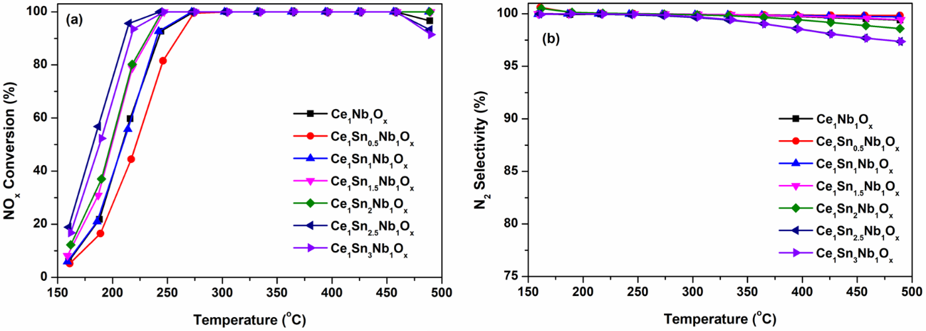
Fig. S1. The (a) NO_{x} conversion and (b) N₂ selectivity of the catalysts with various Sn/Ce molar ratios. Reaction conditions: [NO] = [NH₃] = 500 ppm, [O₂] = 5 vol%, [H₂O] = 5 vol%, balance N₂, and gas hourly space velocity (GHSV) = 100 000 h⁻¹.

Fig. S2. The N₂ selectivity of hydrothermally aged catalysts. Reaction conditions: [NO] = [NH₃] = 500 ppm, [O₂] = 5 vol%, [H₂O] = 5 vol%, balance N₂, and GHSV = 100 000 h⁻¹.

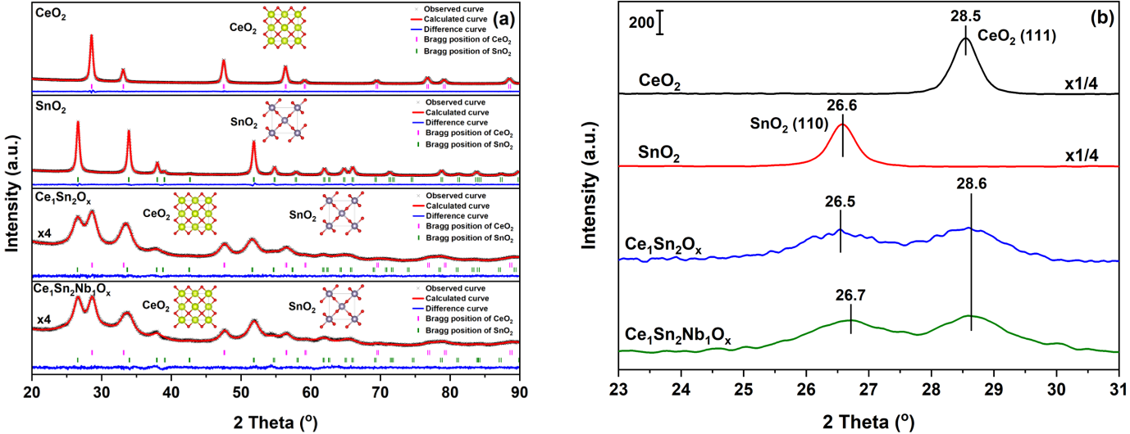
Fig. S3. (a) The Rietveld refinement profiles of CeO₂, SnO₂, Ce₁Sn₂O_{x}, and Ce₁Sn₂Nb₁O_{x}. (b) XRD patterns of SnO₂, Ce₁Sn₂O_{x}, and Ce₁Sn₂Nb₁O_{x} catalysts in the range of 23°–31°.

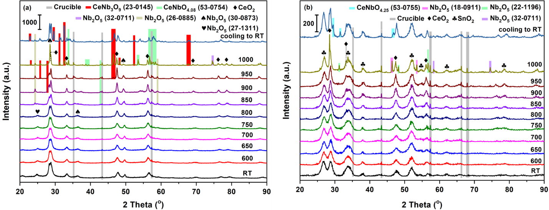
Fig. S4. In-situ HTXRD patterns of (a) Ce₁Nb₁O_{x} and (b) Ce₁Sn₂Nb₁O_{x} catalysts.
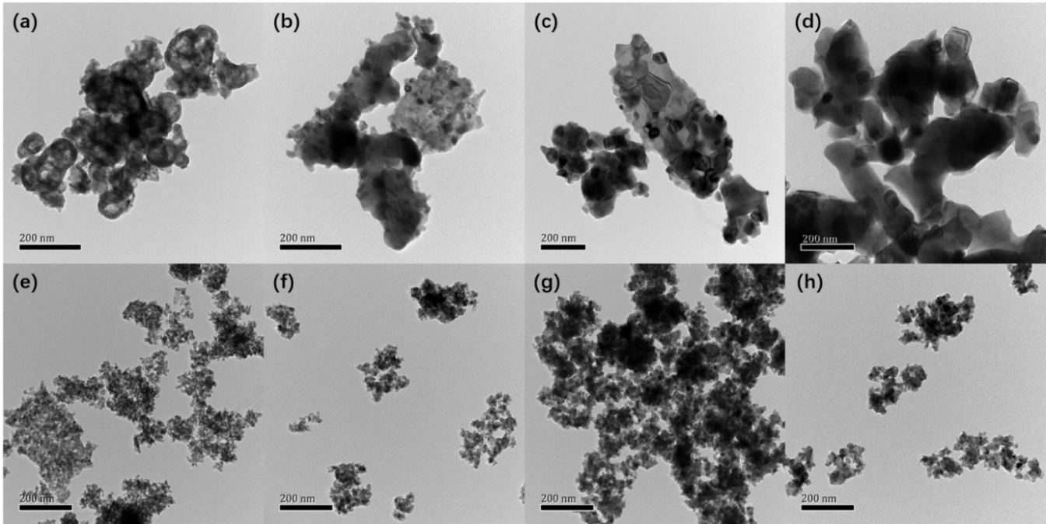
Fig. S5. The HRTEM images of (a) Ce₁Nb₁O_{x}, (b) Ce₁Nb₁O_{x}-800, (c) Ce₁Nb₁O_{x}-900, (d) Ce₁Nb₁O_{x}-1000, (e) Ce₁Sn₂Nb₁O_{x}, (f) Ce₁Sn₂Nb₁O_{x}-800, (g) Ce₁Sn₂Nb₁O_{x}-900, and (h) Ce₁Sn₂Nb₁O_{x}-1000 catalysts.

The Ce 3d spectra were decomposed into eight overlapping peaks, which were labeled as μ, μ′, μ″, μ‴, ν, ν′, ν″, and ν‴, respectively. Among them, the peaks of μ, μ″, μ‴, ν, ν″, and ν‴ are associated with 3d¹⁰4f⁰ initial electronic state of Ce⁴⁺, and the peaks of μ′ and ν′ represent the 3d¹⁰4f¹ initial electronic state of Ce³⁺ [4,5]. The results indicated that Ce species were dominated by Ce⁴⁺, along with some Ce³⁺ [6]. To compare the chemical state of Ce over different catalysts intuitively, the Ce³⁺/Ce ratios were calculated by the following equation and marked in the Figs. S6(a) and (b).
${Ce}^{3+}/Ce={Ce}^{3+}/\left({Ce}^{3+}+{Ce}^{4+}\right)=\frac{S\left(μ^{'}\right)+S(ν^{'})}{\sum{\left[S\left(μ\right)+S\left(ν\right)\right]}}×100\%$ (S1)
where S(μ′), S(ν′), S(μ), and S(ν) denote the peak areas of μ′, ν′, μ, and ν.
After the addition of Sn, the Ce 3d peaks of Ce₁Sn₂Nb₁O_{x} catalysts appeared at lower binding energies compared with Ce₁Nb₁O_{x} catalysts, while the peaks of Nb 3d shifted to higher binding energies (Fig. S6(c)). It indicates that the addition of Sn could induce the stronger interaction between Ce and Nb species, which might be an important reason for the better low-temperature activity of Ce₁Sn₂Nb₁O_{x} than Ce₁Nb₁O_{x} catalyst.

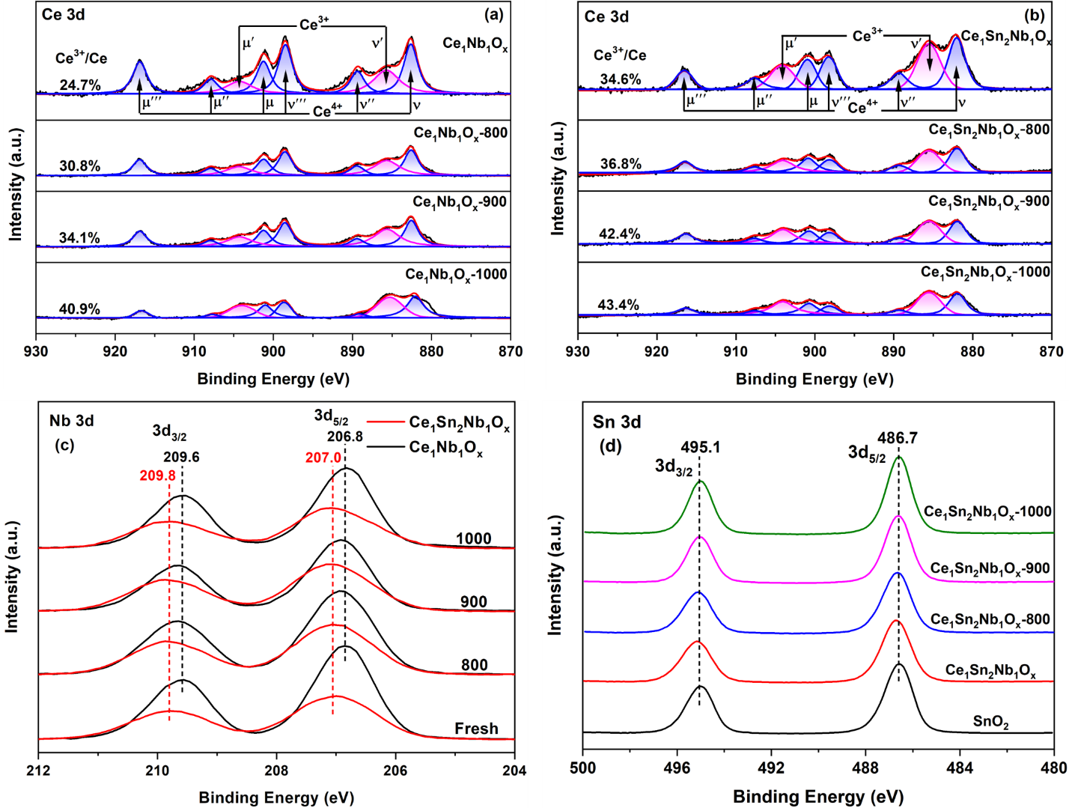
Fig. S6. XPS results of (a, b) Ce 3d, (c) Nb 3d, and (d) Sn 3d for the catalysts.

The O 1s XPS spectra were well split into two components, which were illustrated in Fig. S7. The peaks of higher binding energy (531.8 eV) were assigned to the surface chemisorbed oxygen (O₂²⁻ or O⁻, denoted as O_{α}), while the peaks of lower binding energy (529.9–530.4 eV) were ascribed to the lattice oxygen (O²⁻, denoted as O_{β}) [7,8]. The O_{α}/O ratios were calculated by the following formula and marked in the Fig. S7.
$O_{α}/O=O_{α}/\left(O_{α}+O_{β}\right)=\frac{S(O_{α})}{S\left(O_{α}\right)+S(O_{β})}×100\%$ (S2)
where S(O_{α}) and S(O_{β}) denote the peak areas of O_{α} and O_{β}.
It was found that the binding energy of O_{β} moved higher with Sn introduction. Because the electronegativity of Sn (1.96) was larger than that of Ce (1.10), it meant that the electron capture ability of Sn was stronger [9,10]. Meanwhile, the O_{α}/O ratio increased after the doping of Sn. As the O_{α} is active in oxidation reactions, the higher O_{α}/O ratio could facilitate the oxidation of NO [11]. These may account for the better low-temperature performance of Ce₁Sn₂Nb₁O_{x} than Ce₁Nb₁O_{x} catalyst.

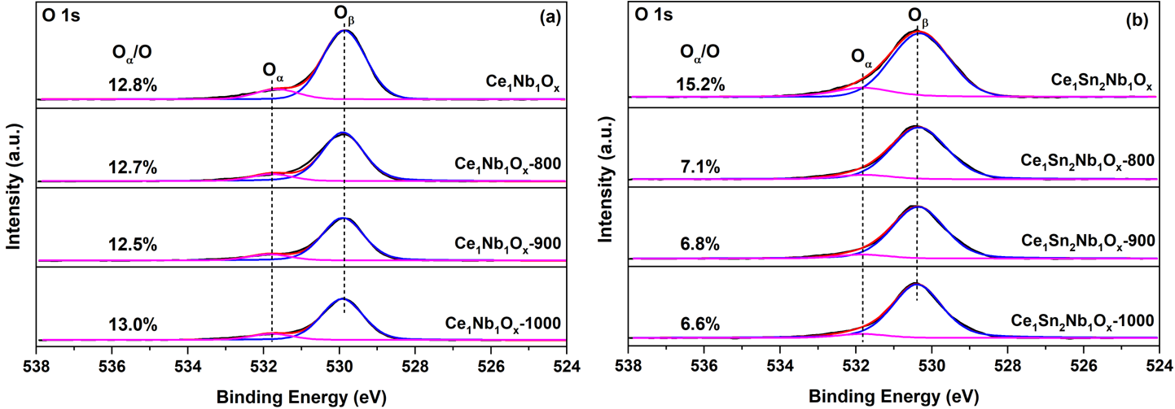
Fig. S7. XPS spectra for O 1s of fresh and hydrothermally aged (a) Ce₁SNb₁O_{x} and (b)Ce₁Sn₂Nb₁O_{x} catalysts.
The normalized Ce L₃-edge XANES spectra of catalysts were shown in Fig. S8(a), along with CeO₂, Ce(NO₃)₃, Nb₂O₅, and NbO₂ as references. For the spectrum of Ce(NO₃)₃, a strong absorption peak (C) at 5726.4 eV is due to the transition from Ce 2p to Ce 4f¹5d [12,13]. As for CeO₂, a weak pre-edge absorption peak (D) at 5720.6 eV is ascribed to the O 2p–Ce 5d hybridizations [14–16]. Two strong absorption peaks (A, B) centered at 5737.3 and 5730.7 eV are assigned to the transitions from Ce 2p_{3/2} to Ce 4f¹5dL and Ce 2p_{3/2} to Ce 4f⁰5d, respectively, where 4f¹5dL represents that Ce 4f borrowing an electron from its oxygen neighbors and leaving an O 2p hole (L) [12,17,18]. In Fig. S8(a), the XANES spectrum of Ce₁Nb₁O_{x} exhibited a peak shape similar to CeO₂. In the case of Ce₁Nb₁O_{x}-900, Ce₁Sn₂Nb₁O_{x}, and Ce₁Sn₂Nb₁O_{x}-900, the spectra showed a strong peak at 5726.4 eV, characteristic of Ce³⁺, and two peaks characteristic of Ce⁴⁺ appeared at 5737.3 and 5730.7 eV. It could be observed that Ce³⁺ and Ce⁴⁺ co-existed in the above catalysts.

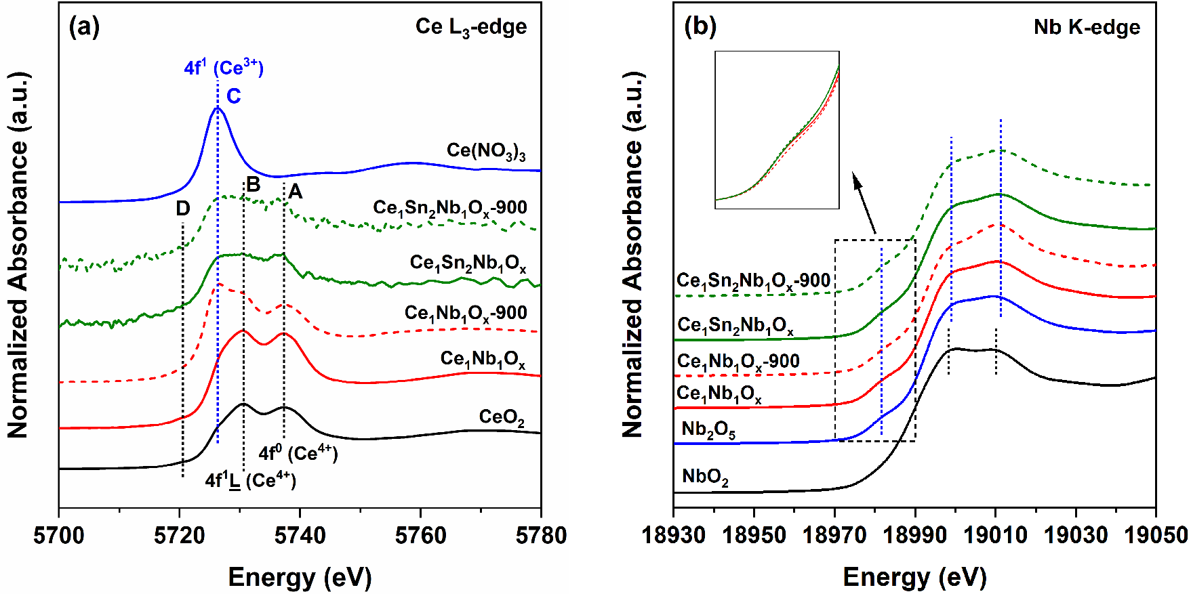
Fig. S8. XANES spectra for (a) Ce L₃-edge and (b) Nb K-edge of the catalysts.

To examine the valence states of constituent elements, the Ce L₃-edge of catalysts were fitted to four peaks (peaks A–D) by arctangent and Gaussian function (Fig. S9) [14].
${Ce}^{3+}/Ce={Ce}^{3+}/\left({Ce}^{3+}+{Ce}^{4+}\right)=\frac{S\left(C\right)}{S\left(A\right)+S\left(B\right)+S\left(C\right)}×100\%$ (3)
where S(A), S(B), and S(C) denote the peak areas of A, B, and C, respectively [19].
In Fig. S9, the peak area with the orange shade is related to an amount of Ce³⁺, and an area sum of two peaks with blue and green shades is assigned to an amount Ce⁴⁺. The percentages of Ce³⁺/Ce in Ce₁Nb₁O_{x}, Ce₁Nb₁O_{x}-900, Ce₁Sn₂Nb₁O_{x}, and Ce₁Sn₂Nb₁O_{x}-900 were calculated to be 15.6%, 38.8%, 39.3%, and 40.1%, respectively, which exhibited the same trend as the XPS results. Both of the introduction of Sn and hydrothermal aging treatment could increase the ratio of Ce³⁺/Ce due to the formation of Ce³⁺-associated new crystal phase.

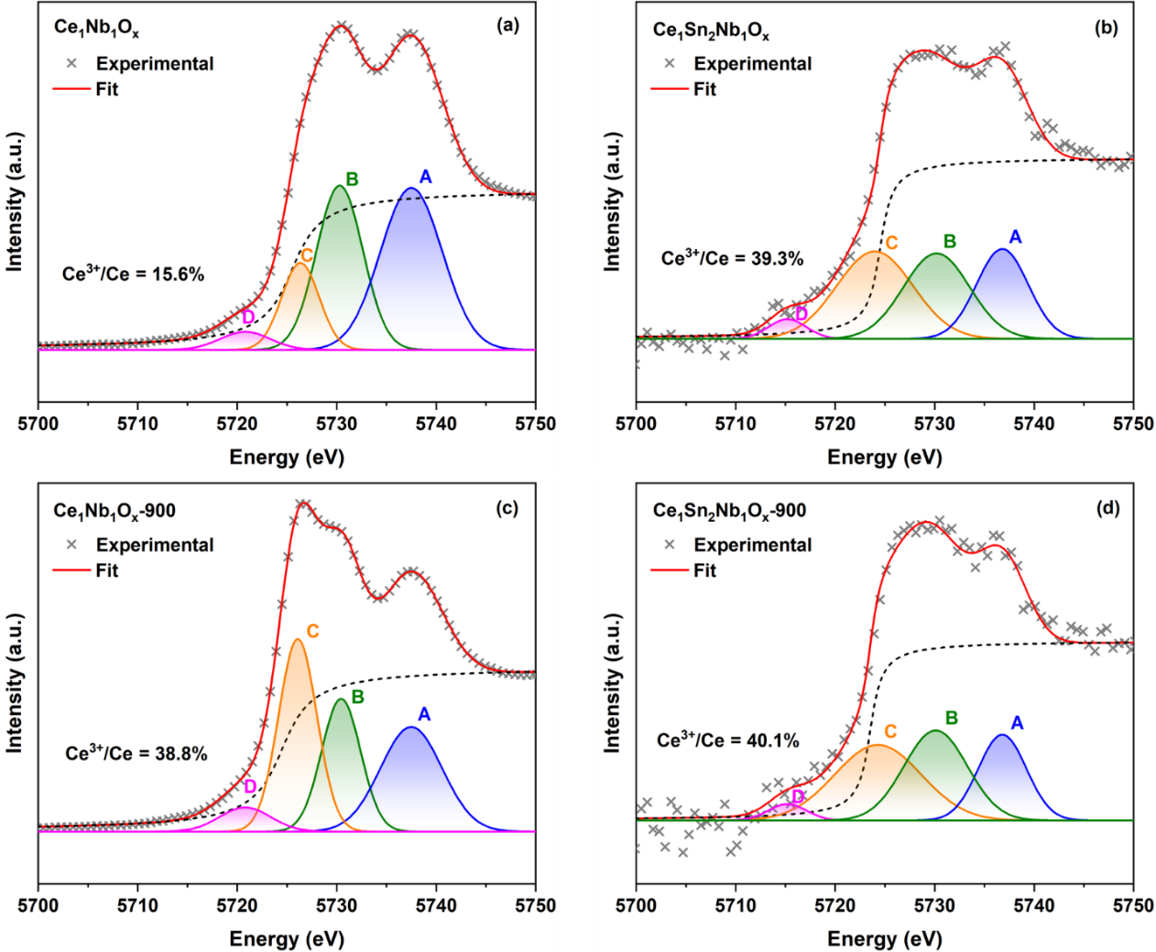
Fig. S9. XANES spectra fitting for Ce L₃-edge of the (a) Ce₁Nb₁O_{x}, (b) Ce₁Sn₂Nb₁O_{x}, (c) Ce₁Nb₁O_{x}-900, and (d) Ce₁Sn₂Nb₁O_{x}-900 catalysts.

The normalized Nb K-edge XANES spectra of catalysts were shown in Fig. S8(b). NbO₂ and Nb₂O₅ were used as references. The spectra were deconvoluted to one weak absorption peak at 18 981.7 eV in the pre-edge region and two post-edge peaks centered at 18 999.1 and 19 011.3 eV. The pre-edge peak is due to the s–d transitions and the intensity depends on the coordination [20,21]. The niobium species in the four samples and in the Nb₂O₅ reference showed very similar XANES features, which revealed that all four samples were dominated by Nb₂O₅. According to the previous study, the pre-edge peak intensity in XANES spectra was positively correlated with the structural distortion of specific element [22]. In our case, as shown in Fig. S8(b) inset, the pre-edge peak of Ce₁Nb₁O_{x} catalyst exhibited an obvious decrease in intensity with the increase of hydrothermal aging temperature, whereas there was almost no change in pre-edge peak intensity of Ce₁Sn₂Nb₁O_{x} catalyst. The XANES results indicated that the coordination structures of Nb species in Ce₁Nb₁O_{x} catalyst were transformed by severely hydrothermal aging, while that in Ce₁Sn₂Nb₁O_{x} catalyst remained stable. Therefore, the addition of Sn stabilized the coordination structures of Nb species in Ce₁Sn₂Nb₁O_{x} catalyst.
The in-situ DRIFTS experiments of fresh and hydrothermally aged catalysts were carried out, and the results are shown in Fig. S10. The negative bands at 1961 and 1966 cm⁻¹ attributed to the stretching mode of Nb=O in the overtone region [23] could be observed for Ce₁Sn₂Nb₁O_{x} and Ce₁Sn₂Nb₁O_{x}-800 catalysts, indicating that Nb=O can serve as acid site for NH₃ adsorption [24–26]. Meanwhile, the intensity of the Nb=O consumption peak of Ce₁Sn₂Nb₁O_{x}-800 was significantly weaker than that in Ce₁Sn₂Nb₁O_{x}. Although the surface Nb concentration of Ce₁Sn₂Nb₁O_{x}-800 was higher than that of Ce₁Sn₂Nb₁O_{x}, its Nb species as acid sites decreased due to the decrease of surface area during hydrothermal aging.

Fig. S10. Magnified in-situ DRIFTS results of NH₃ adsorption at 200 °C on catalysts from 2000 to 1900 cm⁻¹.

Table S1
The lattice parameters extracted from Rietveld refinement results.
Sample | c-CeO₂ (Fm-3m) |  | t-SnO₂ (P4₂/mnm) |  |  | m-CeNbO_{4.25} (I2/a)
Sample | a (Å) | V (Å³) | a (Å) | c (Å) | V (Å³) | a (Å) ^{a)} | b (Å) ^{b)} | c (Å) ^{c)} | V (Å³) ^{d)}
CeO₂ | 5.412(0) | 158.50 | — | — | — | — | — | — | —
SnO₂ | — | — | 4.738(0) | 3.187(0) | 71.55 | — | — | — | —
Ce₁Sn₂O_{x} | 5.404(1) | 157.81 | 4.749(1) | 3.213(1) | 72.47 | — | — | — | —
Ce₁Sn₂Nb₁O_{x} | 5.403(1) | 157.75 | 4.746(1) | 3.174(1) | 71.49 | — | — | — | —
Ce₁Sn₂Nb₁O_{x}-800 | 5.409(0) | 158.28 | 4.740(0) | 3.171(1) | 71.25 | — | — | — | —
Ce₁Sn₂Nb₁O_{x}-900 | 5.411(0) | 158.42 | 4.731(0) | 3.186(1) | 71.32 | 5.475(4) | 11.187(5) | 5.148(3) | 314.77
Ce₁Sn₂Nb₁O_{x}-1000 | 5.419(1) | 159.09 | 4.740(1) | 3.178(1) | 71.42 | 5.351(1) | 11.384(2) | 5.139(1) | 312.61
a, b, and c are three lattice parameters in three-dimensional space; V is cell volume.

Table S2
The surface elemental compositions of fresh and hydrothermally aged catalysts.
Sample | Element compositions (%) |  |  |  | Elemental composition ratio
Sample | Ce | Sn | Nb | O | Nb/Ce | Ce/Sn | Nb/Sn
Ce₁Nb₁O_{x} | 13.8 | — | 17.4 | 68.7 | 1.26 | — | —
Ce₁Nb₁O_{x}-800 | 13.2 | — | 17.8 | 69.0 | 1.35 | — | —
Ce₁Nb₁O_{x}-900 | 15.2 | — | 16.5 | 68.3 | 1.08 | — | —
Ce₁Nb₁O_{x}-1000 | 14.5 | — | 18.5 | 67.0 | 1.28 | — | —
Ce₁Sn₂Nb₁O_{x} | 7.8 | 16.2 | 9.8 | 66.1 | 1.26 | 0.48 | 0.61
Ce₁Sn₂Nb₁O_{x}-800 | 6.2 | 16.2 | 11.2 | 66.4 | 1.81 | 0.38 | 0.69
Ce₁Sn₂Nb₁O_{x}-900 | 5.8 | 17.2 | 10.9 | 66.1 | 1.87 | 0.34 | 0.63
Ce₁Sn₂Nb₁O_{x}-1000 | 5.5 | 19.4 | 9.7 | 65.5 | 1.77 | 0.28 | 0.50

References
[1] Kresse G, Joubert D. From ultrasoft pseudopotentials to the projector augmented-wave method. Phys Rev B 1999;59(3):1758–75.
[2] Koçer CP, Griffith KJ, Grey CP, Morris AJ. First-principles study of localized and delocalized electronic states in crystallographic shear phases of niobium oxide. Phys Rev B 2019;99(7):075151.
[3] Park JB, Graciani J, Evans J, Stacchiola D, Ma S, Liu P, et al. High catalytic activity of Au/CeO_{x}/TiO₂(110) controlled by the nature of the mixed-metal oxide at the nanometer level. Proc Natl Acad Sci USA 2009;106(13):4975–80.
[4] Liu Z, Liu Y, Chen B, Zhu T, Ma L. Novel Fe–Ce–Ti catalyst with remarkable performance for the selective catalytic reduction of NO_{x} by NH₃. Catal Sci Technol 2016;6(17):6688–96.
[5] Liu Z, Feng X, Zhou Z, Feng Y, Li J. Ce–Sn binary oxide catalyst for the selective catalytic reduction of NO_{x} by NH₃. Appl Surf Sci 2018;428:526–33.
[6] Chen L, Yao X, Cao J, Yang F, Tang C, Dong L. Effect of Ti⁴⁺ and Sn⁴⁺ co-incorporation on the catalytic performance of CeO₂–MnO_{x} catalyst for low temperature NH₃-SCR. Appl Surf Sci 2019;476:283–92.
[7] Yan L, Liu Y, Zha K, Li H, Shi L, Zhang D. Deep insight into the structure–activity relationship of Nb modified SnO₂–CeO₂ catalysts for low-temperature selective catalytic reduction of NO by NH₃. Catal Sci Technol 2017;7(2):502–14.
[8] Lian Z, Shan W, Zhang Y, Wang M, He H. Morphology-dependent catalytic performance of NbO_{x}/CeO₂ catalysts for selective catalytic reduction of NO_{x} with NH₃. Ind Eng Chem Res 2018;57(38):12736–41.
[9] Zhou L, Zhang M, Liu C, Wang H, Zhang Y, Zang Y, et al. Synergistic effect over CeSnO_{x} catalyst for the selective catalytic oxidation of NH₃. ACS Appl Energy Mater 2022;5(11):14211–21.
[10] Yao X, Xiong Y, Zou W, Zhang L, Wu S, Dong X, et al. Correlation between the physicochemical properties and catalytic performances of Ce_{x}Sn_{1–‍x}O₂ mixed oxides for NO reduction by CO. Appl Catal B 2014;144:152–65.
[11] Chang H, Chen X, Li J, Ma L, Wang C, Liu C, et al. Improvement of activity and SO₂ tolerance of Sn-modified MnO_{x}–CeO₂ catalysts for NH₃-SCR at low temperatures. Environ Sci Technol 2013;47(10):5294–301.
[12] Zhang J, Wu Z, Liu T, Hu T, Wu Z, Ju X. XANES study on the valence transitions in cerium oxide nanoparticles. J Synchrotron Radiat 2001;8(2):531–2.
[13] Bansmann J, Abdel-Mageed AM, Chen S, Fauth C, Häring T, Kučerová G, et al. Chemical and electronic changes of the CeO₂ support during CO oxidation on Au/CeO₂ catalysts: time-resolved operando XAS at the Ce L_{III} edge. Catalysts 2019;9(10):785.
[14] Zhao S, Kang D, Liu Y, Wen Y, Xie X, Yi H, et al. Spontaneous formation of asymmetric oxygen vacancies in transition-metal-doped CeO₂ nanorods with improved activity for carbonyl sulfide hydrolysis. ACS Catal 2020;10(20):11739–50.
[15] Prieur D, Bonani W, Popa K, Walter O, Kriegsman KW, Engelhard MH, et al. Size dependence of lattice parameter and electronic structure in CeO2 nanoparticles. Inorg Chem 2020;59(8):5760–7.
[16] Hu X, Chen J, Qu W, Liu R, Xu D, Ma Z, et al. Sulfur-resistant ceria-based low-temperature SCR catalysts with the non-bulk electronic states of ceria. Environ Sci Technol 2021;55(8):5435–41.
[17] Makdee A, Unwiset P, Chanapattharapol KC, Kidkhunthod P. Effects of Ce addition on the properties and photocatalytic activity of TiO₂, investigated by X-ray absorption spectroscopy. Mater Chem Phys 2018;213:431–43.
[18] Toscani LM, Zimicz MG, Martins TS, Lamas DG, Larrondo SA. In situ X-ray absorption spectroscopy study of CuO–NiO/CeO₂–ZrO₂ oxides: redox characterization and its effect in catalytic performance for partial oxidation of methane. RSC Adv 2018;8(22):12190–203.
[19] Tiwari S, Khatun N, Rajput P, Bhattacharya D, Jha SN, Tseng CM, et al. Effect of defect states and oxygen vacancies on optical transitions due to Co²⁺ substitution in CeO₂. Appl Phys A 2018;124(9):609.
[20] Francisco MSP, Landers R, Gushikem Y. Local order structure and surface acidity properties of a Nb₂O₅/SiO₂ mixed oxide prepared by the sol-gel processing method. J Solid State Chem 2004;177(7):2432–9.
[21] Yoshida H, Tanaka T, Yoshida T, Funabiki T, Yoshida S. Control of the structure of niobium oxide species on silica by the equilibrium adsorption method. Catal Today 1996;28(1–2):79–89.
[22] Liu F, Asakura K, He H, Liu Y, Shan W, Shi X, et al. Influence of calcination temperature on iron titanate catalyst for the selective catalytic reduction of NO_{x} with NH₃. Catal Today 2011;164(1):520–7.
[23] Burcham L, Datka J, Wachs I. In situ vibrational spectroscopy studies of supported niobium oxide catalysts. J Phys Chem B 1999;103(29):6015–24.
[24] Nowak I, Ziolek M. Niobium compounds: preparation, characterization, and application in heterogeneous catalysis. Chem Rev 1999;99(12):3603–24.
[25] Onfroy T, Clet G, Houalla M. Correlations between acidity, surface structure, and catalytic activity of niobium oxide supported on zirconia. J Phys Chem B 2005;109(30):14588–94.
[26] Qu R, Gao X, Cen K, Li J. Relationship between structure and performance of a novel cerium–niobium binary oxide catalyst for selective catalytic reduction of NO with NH₃. Appl Catal B 2013;142–143:290–7.

