Supplementary file for
Transcription Factors HNF1A, HNF4A, and FOXA2 Regulate Hepatic Cell Protein N-Glycosylation
Vedrana Vičić Bočkor ^{a,#}, Nika Foglar ^{a,#}, Goran Josipović ^{b}, Marija Klasić ª, Ana Vujić ª, Branimir Plavša ^{c}, Toma Keser ^{c}, Samira Smajlović ª, Aleksandar Vojta ^{a,b,}*, Vlatka Zoldoš ^{a,}*
ª Laboratory for Epigenetics, Department of Biology, Faculty of Science, University of Zagreb, Zagreb 10000, Croatia
^{b} Genos Glycoscience Research Laboratory, Borongajska cesta 83H, Zagreb 10000, Croatia
^{c} Faculty of Pharmacy and Biochemistry, University of Zagreb, Ante Kovačića 1, Zagreb 10000, Croatia
# These authors contributed equally to this work.
* Corresponding authors.
E-mail addresses: vzoldos@biol.pmf.hr (V. Zoldoš), vojta@biol.pmf.hr (A. Vojta).
Fig. S1. Changes in gene expression of the main transcription factors HNF1A, HNF4A and FOXA2 and downstream glyco-genes in HepG2 cells following (a) HNF1A downregulation, (b) FOXA2 downregulation, (c) HNF4A downregulation, (d) HNF1A/FOXA2 simultaneous downregulation, (e) HNF1A/HNF4A simultaneous downregulation, and (f) HNF4A/FOXA2 simultaneous downregulation. Error bar is ± SD (n = 9, Mann–Whitney U test *P < 0.05, **P < 0.01, ***P < 0.001). M: KRAB-dCas9 manipulation of specified gene; C: control.

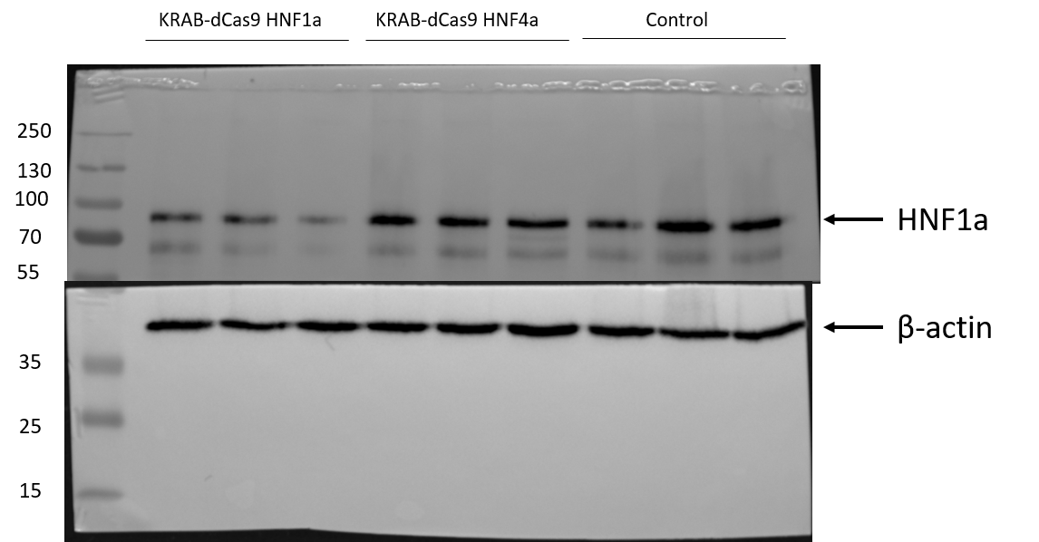
Fig. S2. Protein levels of HNF1a in HepG2 cells following silencing of HNF1A or HNF4A with KRAB-dCas9 fusion protein. 3 biological replicates of KRAB-dCas9 and control samples were pooled and separated on a 10% polyacrilamide gel. β-actin was used as loading control.

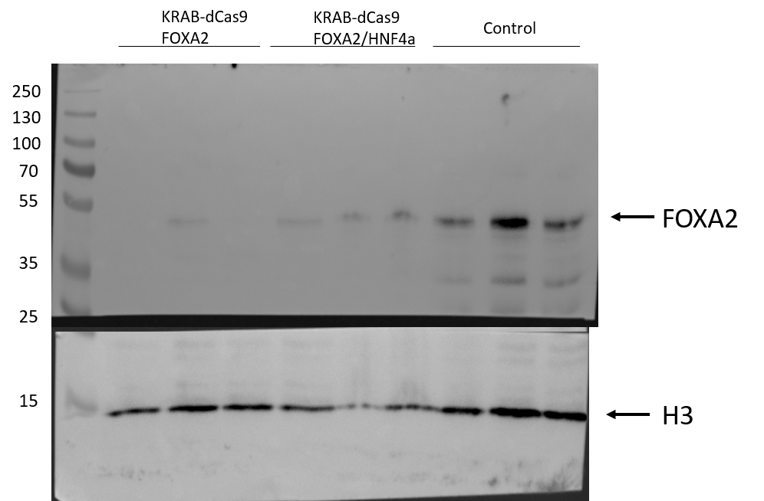
Fig. S3. Protein levels of FOXA2 in HepG2 cells following silencing of FOXA2 or simultaneous sliencing of FOXA2/HNF4A with KRAB-dCas9 fusion protein. 3 biological replicates of KRAB-dCas9 and control samples were pooled and separated on a 10% polyacrilamide gel. Histone H3 was used as loading control.

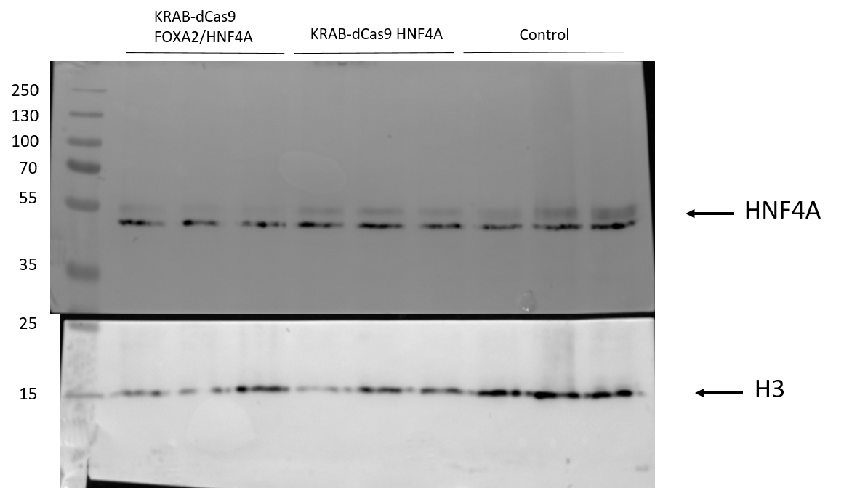
Fig. S4. Protein levels of HNF4A in HepG2 cells following silencing of HNF4A or simultaneous sliencing of FOXA2/HNF4A with KRAB-dCas9 fusion protein. 3 biological replicates of KRAB-dCas9 and control samples were pooled and separated on a 10% polyacrilamide gel. Histone H3 was used as loading control.

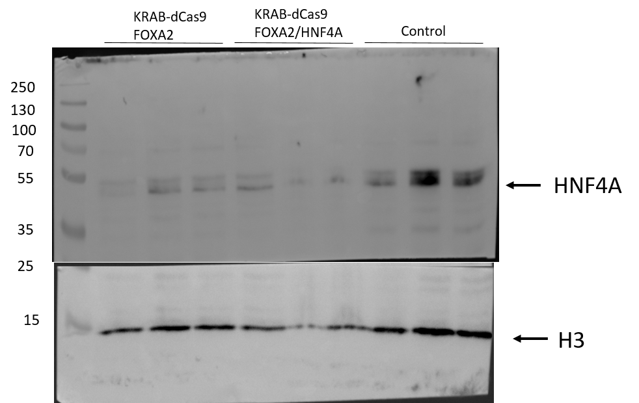
Fig. S5. Protein levels of HNF4A in HepG2 cells following silencing of FOXA2 or simultaneous sliencing of FOXA2/HNF4A with KRAB-dCas9 fusion protein. 3 biological replicates of KRAB-dCas9 and control samples were pooled and separated on a 10% polyacrilamide gel. The membrane was first probed for FOXA2, stripped and then re-probed for HNF4A. Histone H3 was used as loading control.

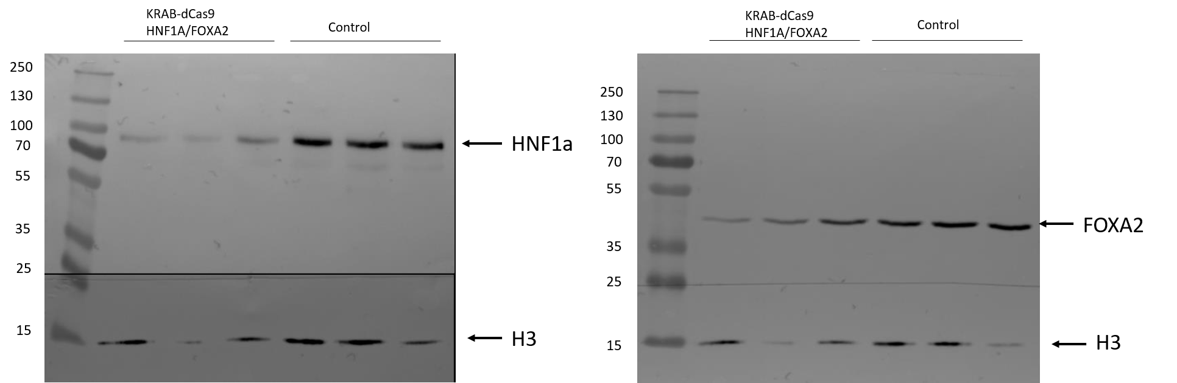
Fig. S6. Protein levels of HNF1A and FOXA2 in HepG2 cells following simultaneous silencing of HNF1A/FOXA2 with KRAB-dCas9 fusion protein. 3 biological replicates of KRAB-dCas9 and control samples were pooled and separated on a 10% polyacrilamide gel. The membrane was firstly probed for FOXA2, stripped and re-probed for HNF4A. Histone H3 was used as loading control.

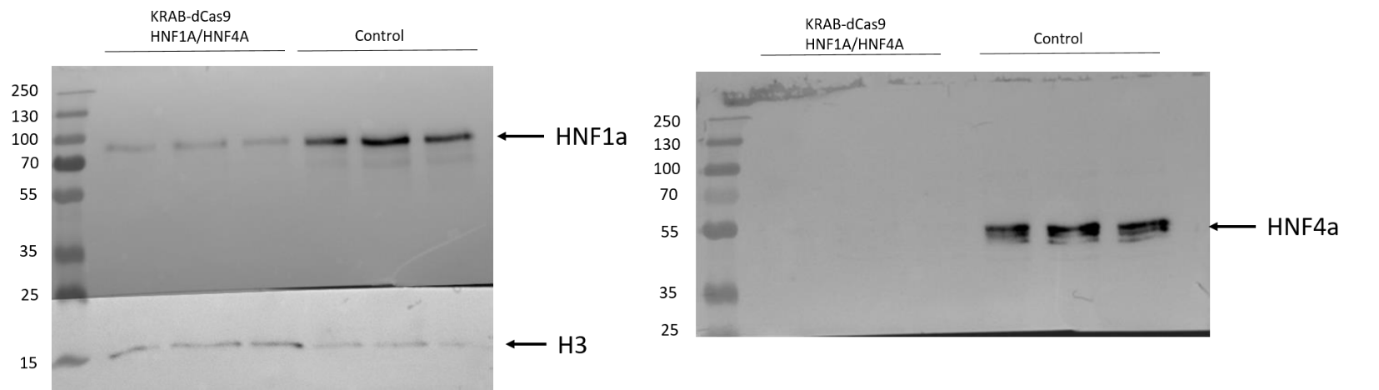
Fig. S7. Protein levels of HNF1A and HNF4A in HepG2 cells following simultaneous silencing of HNF1A/HNF4A with KRAB-dCas9 fusion protein. 3 biological replicates of KRAB-dCas9 and control samples were pooled and separated on a 10% polyacrilamide gel. Following HNF1A detection, the membrane was stripped and re-probed for HNF4A. Histone H3 was used as loading control.

Table S1
Sequences of gRNA molecules targeting the HNF1A, HNF4A and FOXA2 genes.
gRNA molecule | Target site sequence (5’→ 3’)
HNF1A-gRNA01 | AGGCAGGGGCCCTGATTCAC
FOXA2-gRNA01 | TGCATAGTAGCTGCTCCAGT
FOXA2-gRNA02 | ACCGTCGGCCGCTGCTAGAG
HNF4A-gRNA01 | GGGCGCGTTCACGCTGACCA
HNF4A-gRNA02 | AAGCGGTCACATTGCCTCCG
NT-gRNA | GTAGGCGCGCCGCTCTCTAC

Table S2
The statistical data for individual peaks and derived glycan traits following downregulation of the HNF1A, HNF4A and FOXA2 genes.
HNF1A
 | t test p-value | Wilcoxon test p-value | Absolute difference (%) | Relative difference (%)
GP1 | 0.107209 | 0.436281 | 0.189778 | 15.328009
GP2 | 0.024883 | 0.050309 | 0.841000 | 23.312184
GP3 | 0.896989 | 1.000000 | 0.034889 | 1.012283
GP4 | 0.051091 | 0.135911 | 0.899444 | 14.999351
GP5 | 0.251490 | 0.288318 | −0.074778 | −7.926973
GP6 | 0.141277 | 0.340107 | 0.139778 | 8.093155
GP7 | 0.014966 | 0.007775 | 0.020333 | 16.866359
GP8 | 0.384326 | 0.545701 | −0.092333 | −3.332264
GP9 | 0.272477 | 0.479702 | 0.261333 | 4.629010
GP10 | 0.319421 | 0.545701 | 0.060556 | 5.899545
GP11 | 0.981003 | 1.000000 | 0.000667 | 0.103681
GP12 | 0.756681 | 0.931427 | 0.011667 | 1.377591
GP13 | 0.000112 | 0.000566 | 0.752000 | 11.767979
GP14 | 0.965078 | 0.723795 | 0.000889 | 0.301773
GP15 | 0.848306 | 0.185099 | 0.013111 | 0.750732
GP16 | 0.900741 | 0.796174 | −0.014667 | −0.153753
GP17 | 0.004961 | 0.000082 | −0.165000 | −7.670851
GP18 | 0.327836 | 0.545701 | −0.437556 | −2.128614
GP19 | 0.336541 | 0.536289 | −0.071333 | −4.300643
GP20 | 0.329335 | 0.545701 | 0.356111 | 3.655046
GP21 | 0.006134 | 0.001851 | −0.481667 | −11.724138
GP22 | 0.687394 | 0.545701 | 0.060556 | 1.834708
GP23 | 0.008125 | 0.005387 | −0.251667 | −16.653187
GP24 | 0.003477 | 0.005636 | −0.347444 | −21.513588
GP25 | 0.003264 | 0.001851 | −0.294444 | −19.458110
GP26 | 0.043570 | 0.010613 | −0.210000 | −15.577351
GP27 | 0.010768 | 0.005636 | −0.453222 | −21.073569
GP28 | 0.038381 | 0.010613 | −0.274889 | −20.303652
GP29 | 0.056422 | 0.039984 | −0.354333 | −19.435641
GP30 | 0.074959 | 0.063416 | −0.113444 | −17.530907
GP31 | 0.930036 | 0.666475 | −0.005667 | −1.053284
PM | 0.092921 | 0.340107 | 1.965111 | 13.752829
OM | 0.149397 | 0.093912 | 0.842444 | 1.595022
LB | 0.003042 | 0.000288 | −0.717111 | −8.731887
HB | 0.019743 | 0.007775 | −2.305111 | −18.440397
G0 | 0.453035 | 0.545701 | 0.072222 | 3.855279
G2 | 0.003042 | 0.000288 | −0.717111 | −8.731887
G3 | 0.123916 | 0.077005 | −0.473444 | −15.738347
GN | 0.009409 | 0.003990 | −3.022222 | −14.591022
S0 | 0.481406 | 0.666475 | 0.073111 | 3.372457
S1 | 0.004597 | 0.002756 | −0.590667 | −10.486241
S2 | 0.005150 | 0.001851 | −0.733333 | −13.049668
S3 | 0.038381 | 0.010613 | −0.274889 | −20.303652
SN | 0.009922 | 0.003990 | −3.023111 | −14.805866
FC | 0.287838 | 0.062526 | −0.564222 | −2.044045
FA | 0.054856 | 0.062526 | −0.926667 | −17.962524
SR | 0.045661 | 0.039984 | −1.608239 | −16.898494
GR | 0.049261 | 0.062526 | −1.884765 | −16.870488
entropy | 0.007871 | 0.014192 | −0.046235 | −1.097307
grade | 0.865981 | 0.190251 | 0.024771 | 0.266931
HNF4A
 | t test p-value | Wilcoxon test p-value | Absolute difference (%) | Relative difference (%)
GP1 | 0.215831 | 0.161497 | −0.043667 | −3.526878
GP2 | 0.054244 | 0.084928 | −0.165667 | −4.592214
GP3 | 0.009309 | 0.014192 | −0.486444 | −14.113930
GP4 | 0.005071 | 0.007775 | −0.344889 | −5.751450
GP5 | 0.011716 | 0.017061 | −0.159667 | −16.925795
GP6 | 0.067128 | 0.077005 | −0.068778 | −3.982244
GP7 | 0.003296 | 0.011632 | −0.007000 | −5.806452
GP8 | 0.660908 | 0.436281 | −0.042222 | −1.523779
GP9 | 0.000489 | 0.000494 | −0.419333 | −7.427672
GP10 | 0.554798 | 0.604813 | 0.025889 | 2.522191
GP11 | 0.039079 | 0.057502 | −0.055444 | −8.622775
GP12 | 0.636077 | 0.489428 | 0.016000 | 1.889268
GP13 | 0.211440 | 0.250754 | −0.117000 | −1.830922
GP14 | 0.346779 | 0.452679 | −0.020444 | −6.940777
GP15 | 0.029755 | 0.027196 | −0.089889 | −5.146965
GP16 | 0.123930 | 0.077005 | 0.188444 | 1.975493
GP17 | 0.596484 | 0.436281 | 0.065556 | 3.047678
GP18 | 0.020213 | 0.018758 | 0.903667 | 4.396145
GP19 | 0.230013 | 0.185099 | 0.256444 | 15.460879
GP20 | 0.000123 | 0.000165 | 0.710333 | 7.290704
GP21 | 0.712281 | 0.135911 | −0.037000 | −0.900609
GP22 | 0.211011 | 0.297326 | 0.071778 | 2.174718
GP23 | 0.038036 | 0.018758 | −0.093889 | −6.212778
GP24 | 0.089256 | 0.093912 | −0.158667 | −9.824561
GP25 | 0.282515 | 0.062526 | −0.059778 | −3.950363
GP26 | 0.562821 | 0.222419 | −0.037000 | −2.744581
GP27 | 0.596648 | 0.077083 | −0.059556 | −2.769167
GP28 | 0.750229 | 0.161497 | 0.027667 | 2.043496
GP29 | 0.457154 | 0.723521 | 0.093778 | 5.143832
GP30 | 0.421694 | 0.859676 | 0.031222 | 4.824863
GP31 | 0.107637 | 0.161497 | 0.074889 | 13.919868
PM | 0.009851 | 0.014192 | −1.040667 | −7.283105
OM | 0.073628 | 0.077005 | 1.106444 | 2.094860
LB | 0.432845 | 0.790976 | 0.264556 | 3.221355
HB | 0.767205 | 0.077005 | −0.181333 | −1.450628
G0 | 0.585590 | 0.545701 | 0.041889 | 2.236062
G2 | 0.432845 | 0.790976 | 0.264556 | 3.221355
G3 | 0.334002 | 0.964766 | 0.199889 | 6.644751
GN | 0.915457 | 0.258083 | 0.083222 | 0.401790
S0 | 0.791406 | 0.604813 | 0.021444 | 0.989186
S1 | 0.241388 | 0.604813 | 0.415778 | 7.381399
S2 | 0.356053 | 0.024434 | −0.130889 | −2.329168
S3 | 0.750229 | 0.161497 | 0.027667 | 2.043496
SN | 0.895805 | 0.258083 | 0.103667 | 0.507714
FC | 0.553569 | 0.113492 | −0.310111 | −1.123460
FA | 0.652920 | 0.604813 | 0.140333 | 2.720224
SR | 0.841220 | 0.489428 | −0.110288 | −1.158848
GR | 0.694078 | 0.340107 | −0.258985 | −2.318172
entropy | 0.056927 | 0.062526 | −0.035703 | −0.847360
grade | 0.453070 | 0.666475 | −0.073463 | −0.791644
FOXA2
 | t test p-value | Wilcoxon test p-value | Absolute difference (%) | Relative difference (%)
GP1 | 0.099357 | 0.170877 | 0.082333 | 6.649915
GP2 | 0.246314 | 0.386508 | 0.191778 | 5.316003
GP3 | 0.695749 | 0.796174 | 0.127222 | 3.691286
GP4 | 0.208370 | 0.489428 | 0.263000 | 4.385851
GP5 | 0.821571 | 0.596052 | 0.026889 | 2.850412
GP6 | 0.347994 | 0.222419 | 0.049222 | 2.849974
GP7 | 0.165379 | 0.170877 | 0.005667 | 4.700461
GP8 | 0.262232 | 0.093912 | 0.154333 | 5.569813
GP9 | 0.590638 | 0.863307 | −0.065667 | −1.163157
GP10 | 0.036033 | 0.050309 | 0.115111 | 11.214549
GP11 | 0.490621 | 0.565792 | 0.026889 | 4.181787
GP12 | 0.226407 | 0.340107 | 0.056667 | 6.691157
GP13 | 0.001744 | 0.006167 | 0.496222 | 7.765336
GP14 | 0.104451 | 0.093912 | 0.058222 | 19.766126
GP15 | 0.649790 | 0.536289 | 0.023667 | 1.355134
GP16 | 0.213624 | 0.604813 | −0.175889 | −1.843871
GP17 | 0.572717 | 0.077005 | 0.183111 | 8.512836
GP18 | 0.055034 | 0.050309 | −1.070000 | −5.205321
GP19 | 0.442194 | 0.051938 | 0.358889 | 21.637192
GP20 | 0.298441 | 0.666475 | 0.230222 | 2.362950
GP21 | 0.022612 | 0.010613 | −0.286889 | −6.983097
GP22 | 0.846826 | 0.931427 | 0.019333 | 0.585760
GP23 | 0.532918 | 0.340107 | −0.041333 | −2.735093
GP24 | 0.353928 | 0.062526 | −0.142556 | −8.826969
GP25 | 0.034461 | 0.004697 | −0.140000 | −9.251781
GP26 | 0.515065 | 0.161497 | −0.053556 | −3.972637
GP27 | 0.072884 | 0.013371 | −0.231222 | −10.751188
GP28 | 0.767040 | 0.093912 | −0.027333 | −2.018876
GP29 | 0.277979 | 0.039984 | −0.150889 | −8.276451
GP30 | 0.430519 | 0.157490 | −0.034556 | −5.339973
GP31 | 0.356872 | 0.340107 | −0.050000 | −9.293680
PM | 0.320100 | 0.489428 | 0.664333 | 4.649336
OM | 0.513724 | 1.000000 | −0.558222 | −1.056897
LB | 0.709190 | 0.077005 | 0.313333 | 3.815296
HB | 0.214282 | 0.050309 | −0.871444 | −6.971370
G0 | 0.088095 | 0.135911 | 0.171778 | 9.169632
G2 | 0.709190 | 0.077005 | 0.313333 | 3.815296
G3 | 0.308422 | 0.093912 | −0.235444 | −7.826697
GN | 0.651438 | 0.093912 | −0.558111 | −2.694511
S0 | 0.024366 | 0.024434 | 0.230000 | 10.609400
S1 | 0.608332 | 0.077005 | 0.391111 | 6.943486
S2 | 0.072827 | 0.113492 | −0.328222 | −5.840715
S3 | 0.767040 | 0.093912 | −0.027333 | −2.018876
SN | 0.615826 | 0.093912 | −0.616333 | −3.018529
FC | 0.987942 | 0.297326 | 0.009889 | 0.035825
FA | 0.185048 | 0.050309 | −0.466667 | −9.045876
SR | 0.164143 | 0.050309 | −1.145121 | −12.032301
GR | 0.345063 | 0.062526 | −1.070593 | −9.582851
entropy | 0.441400 | 0.863307 | 0.014285 | 0.339033
grade | 0.815362 | 0.436281 | −0.023343 | −0.251545
FOXA2 / HNF4A
 | t test p-value | Wilcoxon test p-value | Absolute difference (%) | Relative difference (%)
GP1 | 0.223895 | 0.258083 | 0.064111 | 5.178139
GP2 | 0.176393 | 0.161497 | 0.161667 | 4.481335
GP3 | 0.931335 | 1.000000 | 0.017222 | 0.499694
GP4 | 0.004925 | 0.005636 | 0.427111 | 7.122607
GP5 | 0.867618 | 0.929600 | −0.012111 | −1.283863
GP6 | 0.227003 | 0.258083 | 0.048000 | 2.779207
GP7 | 0.000084 | 0.000401 | 0.011778 | 9.769585
GP8 | 0.123905 | 0.093912 | 0.135556 | 4.892132
GP9 | 0.006631 | 0.007775 | −0.295556 | −5.235190
GP10 | 0.670930 | 0.658678 | 0.015333 | 1.493830
GP11 | 0.204867 | 0.161497 | 0.034333 | 5.339554
GP12 | 0.133317 | 0.222419 | −0.041556 | −4.906849
GP13 | 0.000108 | 0.001080 | 0.423222 | 6.622966
GP14 | 0.964504 | 0.730440 | 0.000889 | 0.301773
GP15 | 0.104041 | 0.033977 | 0.071111 | 4.071765
GP16 | 0.557688 | 0.258083 | 0.064000 | 0.670922
GP17 | 0.767908 | 0.545701 | 0.011222 | 0.521721
GP18 | 0.886897 | 0.931427 | −0.049889 | −0.242699
GP19 | 0.367428 | 1.000000 | 0.048778 | 2.940782
GP20 | 0.654003 | 0.796174 | −0.087778 | −0.900932
GP21 | 0.267274 | 0.050309 | −0.117778 | −2.866802
GP22 | 0.048586 | 0.062526 | −0.122111 | −3.699714
GP23 | 0.767709 | 0.258083 | −0.012222 | −0.808764
GP24 | 0.002568 | 0.008006 | −0.285889 | −17.702098
GP25 | 0.096069 | 0.010613 | −0.098111 | −6.483589
GP26 | 0.122401 | 0.050309 | −0.097000 | −7.195253
GP27 | 0.044986 | 0.008039 | −0.251333 | −11.686299
GP28 | 0.863411 | 0.185099 | 0.014889 | 1.099713
GP29 | 0.686224 | 0.077005 | −0.050667 | −2.779132
GP30 | 0.868294 | 0.401056 | 0.006444 | 0.995879
GP31 | 0.457698 | 0.222419 | −0.034111 | −6.340355
PM | 0.153696 | 0.113492 | 0.670111 | 4.689772
OM | 0.939304 | 0.931427 | 0.041889 | 0.079309
LB | 0.624468 | 0.666475 | −0.056889 | −0.692706
HB | 0.203372 | 0.050309 | −0.808000 | −6.463828
G0 | 0.673101 | 0.730440 | −0.026222 | −1.399763
G2 | 0.624468 | 0.666475 | −0.056889 | −0.692706
G3 | 0.700724 | 0.297326 | −0.078333 | −2.603974
GN | 0.217129 | 0.031469 | −0.864889 | −4.175607
S0 | 0.709435 | 0.931427 | −0.025333 | −1.168572
S1 | 0.939233 | 0.790976 | 0.009333 | 0.165697
S2 | 0.370152 | 0.077005 | −0.130000 | −2.313350
S3 | 0.863411 | 0.185099 | 0.014889 | 1.099713
SN | 0.223415 | 0.039984 | −0.865778 | −4.240198
FC | 0.963349 | 0.436281 | −0.023222 | −0.084129
FA | 0.304169 | 0.039984 | −0.329667 | −6.390265
SR | 0.465641 | 0.135911 | −0.377699 | −3.968655
GR | 0.505505 | 0.190251 | −0.404497 | −3.620640
entropy | 0.612433 | 0.545701 | −0.008028 | −0.190521
grade | 0.834951 | 0.258083 | −0.019697 | −0.212254

