Supplementary file for
X-Ray-Sensitizers: Organic Pharmaceutical Drug Intermediates Activated Directly by X-Rays to Efficiently Populate Triplet Excitons for Cancer Treatment
Nuo Lin ^{a,b,#}, Han Xu ^{a,b,#}, Haichao Liu ^{c,#}, Xiaoqian Ma ^{a,b}, Qunying Shi ^{a,b}, Qing Yang ^{a,b}, Yating Wen ^{c}, Huanglei Wei ^{a,b}, Ke Hu ^{a,b}, Bing Yang ^{c}, Hongmin Chen ^{a,b,}*
ª State Key Laboratory of Vaccines for Infectious Diseases, Center for Molecular Imaging and Translational Medicine, Xiang An Biomedicine Laboratory, School of Public Health, Xiamen University, Xiamen, 361102, China
^{b} State Key Laboratory of Molecular Vaccinology and Molecular Diagnostics, National Innovation Platform for Industry-Education Integration in Vaccine Research, Xiamen University, Xiamen, 361102, China
^{c} State Key Laboratory of Supramolecular Structure and Materials, College of Chemistry, Jilin University, Changchun 130012, China

# These authors contributed equally to this work.

* Corresponding author.
E-mail address: hchen@xmu.edu.cn (H. Chen)

Materials and methods
Characterizations
Transmission electron microscopy (TEM) was taken on a JEM-2100 transmission electron microscope at 200 kV (JEOL Ltd., Japan). Fourier transform infrared (FT-IR) spectroscopy was conducted on a Nicolet iS10 FTIR spectrometer, scanning from 4000 to 500 cm⁻¹.The zeta potential and size distribution measurements were carried out using a Zetasizer Nano particle analyser series (Malvern Ltd., UK). The UV-Vis absorbance spectra were obtained on a UV-2100 spectrophotometer (Shimadzu, Co., Japan). PL emission and excitation spectra were acquired on a F-7000 fluorescence spectrophotometer (Hitachi, Ltd., Japan) under ambient conditions. X-ray excited optical luminescence (XEOL) was measured on an Ocean Optics QE Pro optical bench. The mini-X X-ray tube (Amptek Inc., USA) was set at 50 kV and 70 µA. The fluorescence images of cells were performed on an Olympus FV1200 laser scanning confocal microscopy (Olympus, Japan). The in vivo and ex vivo fluorescence imaging was conducted by a Carestream In-Vivo FX PRO imaging system (Carestream Health, Inc., USA). The instrument used for internal treatment is RS-2000 X-ray Irradiator (Rad Source, USA), setting at 160 kV and 25 mA.
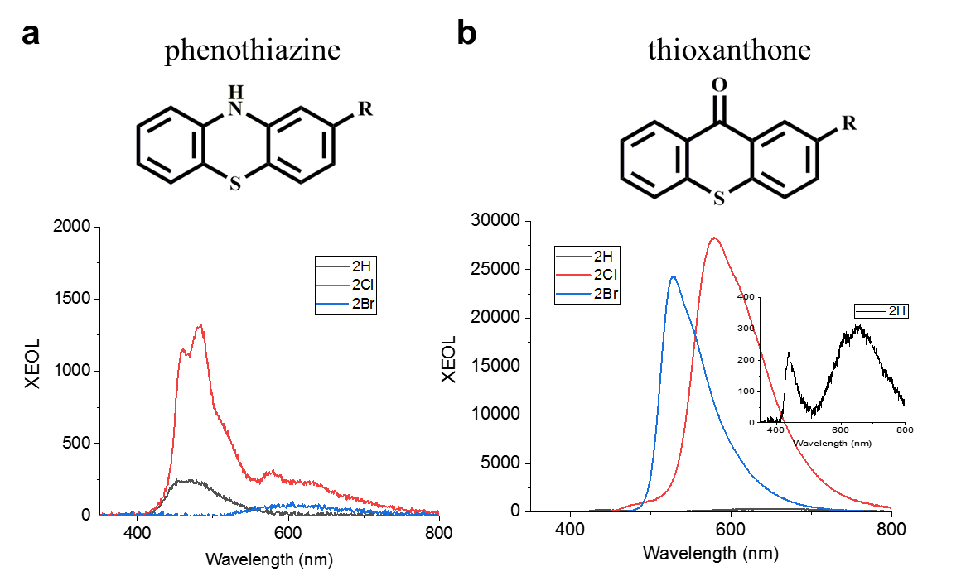
Fig. S1. Molecular structures and luminescence of (a) phenothiazine and (b) thioxanthone (R = H, Cl, Br) under X-ray irradiation (50 kV).

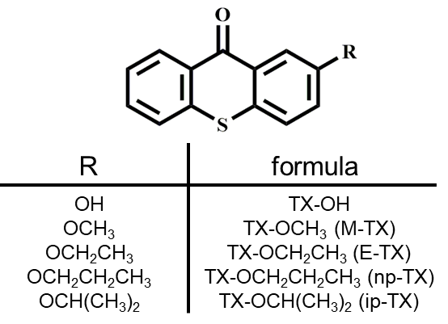
Fig. S2. A series of TX molecules were tailored with 2-positioned alkoxy substituents.
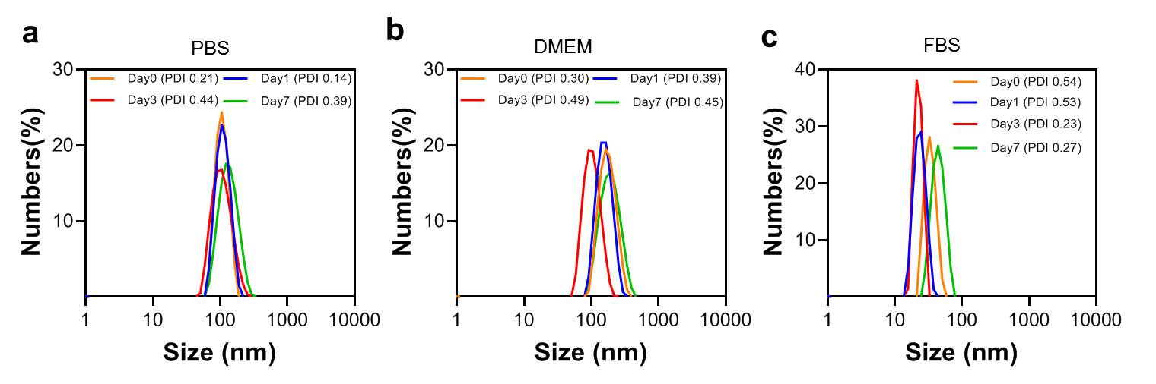
Fig. S3. The particle size distribution of Vip-TX in different media, including (a) PBS, (b) DMEM, and (c) FBS.
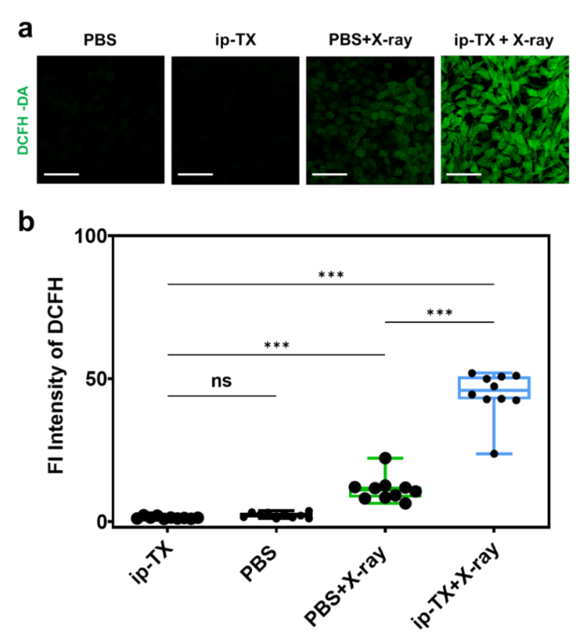
Fig. S4. Cellular ROS production detected by DCFH-DA probe. (a) Confocal laser scanning microscope (CLSM) images of 4T1 cells stained with DCFH-DA after incubation with PBS or ip-TX (15 μg ip-TX∙mL^{–1}) with or without X-ray irradiation (2 Gy). Scale bars: 50 µm. (b) Corresponding quantitative analysis of the fluorescence of DCFH-DA probes. SPSS Statistics 2 was used to calculate P values using one-way ANOVA as indicated. ns: no significant difference; ***P < 0.001.

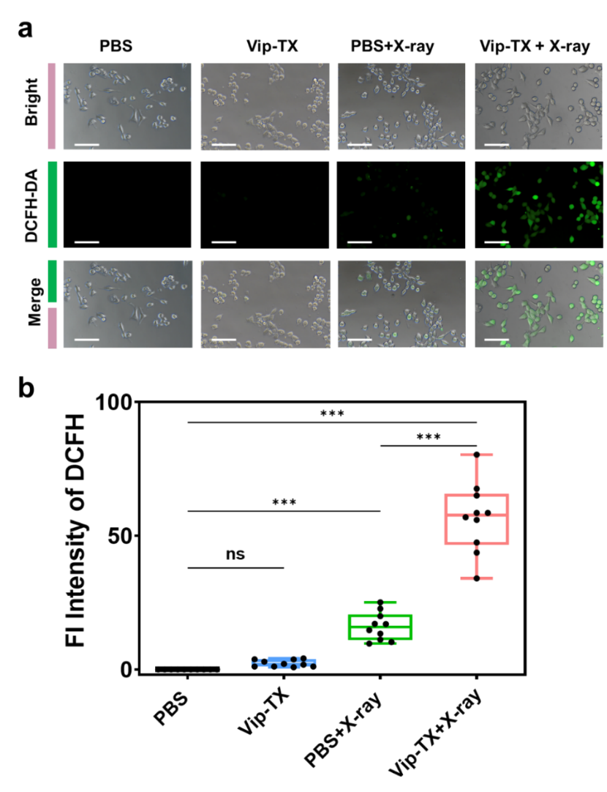
Fig. S5. (a) CLSM images of 4T1 cells stained by DCFH-DA after incubating with PBS and Vip-TX (15 μg ip-TX∙mL^{–1}) nanoparticles with or without X-ray irradiation (2 Gy). Scale bars: 50 µm. (b) Corresponding quantitative analysis. SPSS Statistics 2 was used to calculate P values using one-way ANOVA as indicated. ns: no significant difference; ***P < 0.001.
Fig. S6. (a) CLSM images of 4T1 cells stained by DCFH-DA after incubating with PBS and VP nanoparticles with or without X-ray irradiation (2 Gy). Scale bars: 50 µm. (b) Corresponding quantitative analysis. SPSS Statistics 2 was used to calculate P values using one-way ANOVA as indicated. ns: no significant difference; **P < 0.01; ***P < 0.001.

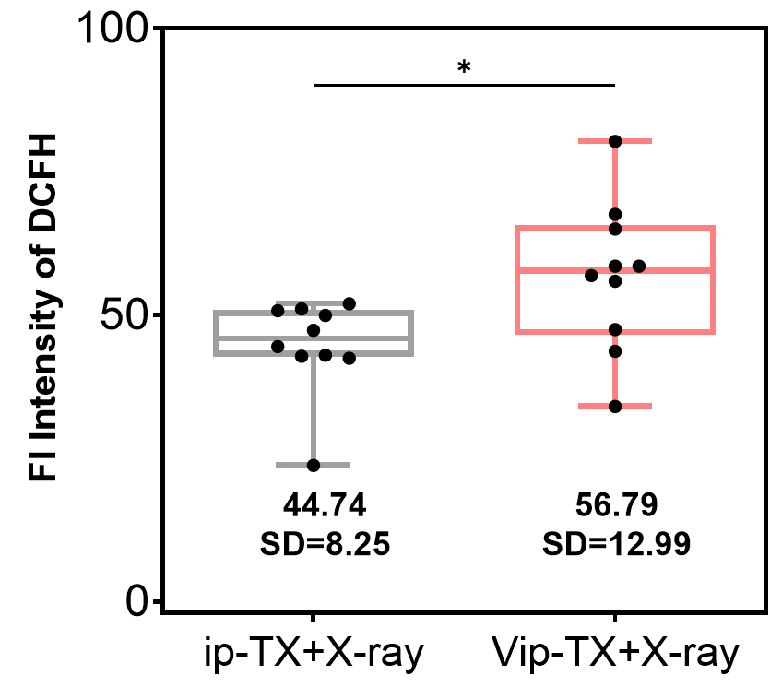
Fig. S7. Comparison of fluorescence intensity of DCFH in group of ip-TX + X-ray and Vip-TX + X-ray. SPSS Statistics 2 was used to calculate P values using one-way ANOVA as indicated. *P < 0.05.

Fig. S8. (a) Assessment and analysis of lipid peroxidation levels after treatments. Scale bars: 50 µm. (b) SPSS Statistics 2 was used to calculate P values using one-way ANOVA as indicated. ns: no significant difference; ***P < 0.001.

Fig. S9. (a) Immunofluorescence for γH2AX in 4T1 cells treated with various treatments. Images were taken 24 h after transfection by confocal microscopy. Scale bars: 50 µm. (b) SPSS Statistics 2 was used to calculate P values using one-way ANOVA as indicated. ns: no significant difference; **P < 0.01; ***P < 0.001.

Fig. S10. (a) CLSM images of the changes in the mitochondrial membrane potential of 4T1 cells irradiated with or without X-rays (2 Gy). Scale bars: 50 µm. Red fluorescence indicates positive membrane potential, whereas green fluorescence indicates decreased membrane potential. (b) SPSS Statistics 2 was used to calculate P values using one-way ANOVA as indicated. ns: no significant difference; ***P < 0.001.

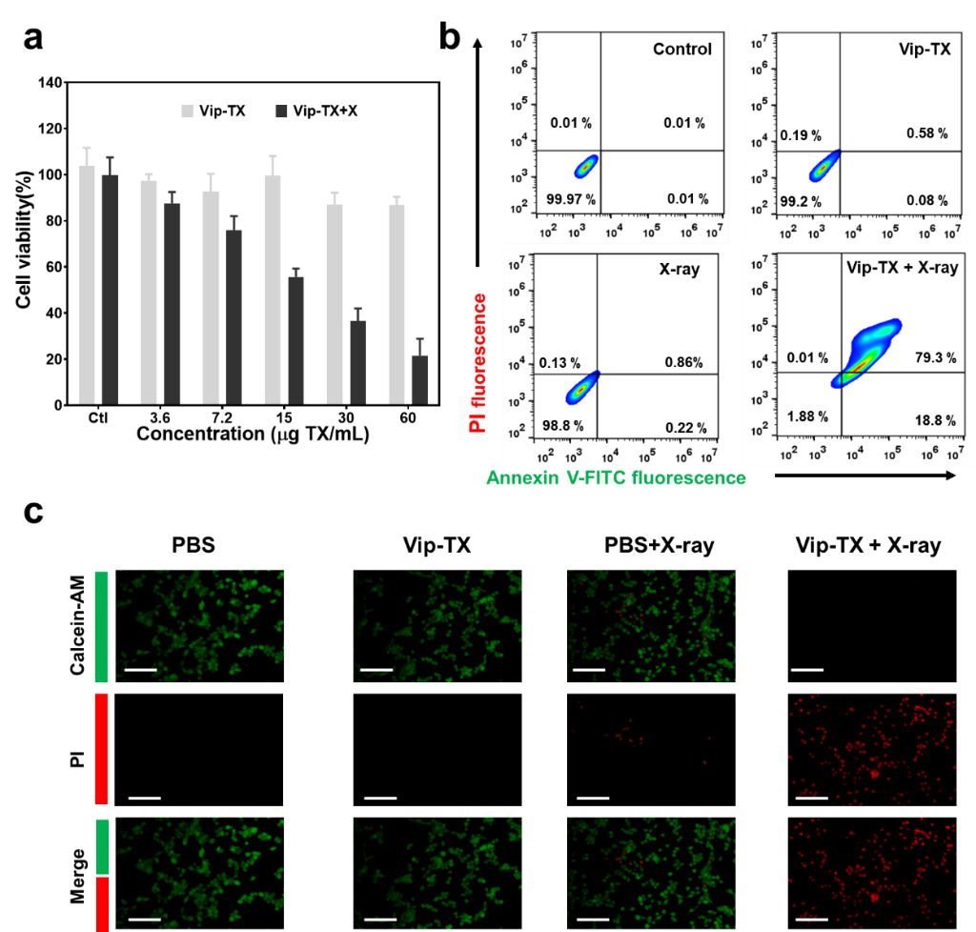
Fig. S11. (a) Cell viabilities of 4T1 cells measured by MTT assays, after incubating with different concentration of Vip-TX with or without X-ray irradiation (2 Gy). (b) Flow cytometry analysis of 4T1 cells that were stained with Annexin V-FITC and PI for cell apoptosis and late apoptosis/necrosis, respectively, after 4 h treatment of PBS, Vip-TX (15 μg ip-TX∙mL^{–1}) with or without X-ray irradiation (2 Gy). (c) Fluorescence images of Calcein-AM (live cells, green fluorescence) and PI (dead cells, red fluorescence) co-stained 4T1 cells with different treatments. Scale bars: 100 µm.

Table S1
Biosafety evaluation of Vip-TX.
Entry | Unit | Vip-TX (n = 3)
Entry | Unit | Day 0 | Day 3 | Day 7 | Day 14
WBC | 10⁹ L^{–1} | 2.66 ± 0.29 | 2.80 ± 0.22 | 4.23 ± 1.02 | 6.83 ± 1.81
HGB | g∙L^{–1} | 144.0 ± 1.41 | 148.33 ± 5.79 | 131.67 ± 5.31 | 158.67 ± 6.94
RBC | 10¹² L^{–1} | 8.72 ± 0.09 | 8.99 ± 0.19 | 7.99 ± 0.40 | 9.45 ± 0.52
HCT | % | 45.90 ± 0.36 | 47.33 ± 0.97 | 42.30 ± 2.29 | 49.97 ± 2.96
MCV | fL | 52.70 ± 0.78 | 52.70 ± 0.37 | 53.03 ± 0.34 | 52.93 ± 0.47
MCH | pg | 16.50 ± 0.14 | 16.43 ± 0.29 | 16.43 ± 0.19 | 16.73 ± 0.25
MCHC | g∙L^{–1} | 313.33 ± 2.62 | 312.67 ± 6.60 | 311.00 ± 4.55 | 317.33 ± 5.44
RDW-SD | fL | 28.60 ± 1.04 | 28.57 ± 0.75 | 35.17 ± 3.08 | 38.10 ± 1.45
PLT | 10¹⁹ L^{–1} | 584.00 ± 37.16 | 534.00 ± 35.19 | 883.00 ± 90.03 | 667.67 ± 21.75
MPV | fL | 6.33 ± 1.32 | 5.56 ± 0.34 | 7.23 ± 0.84 | 5.87 ± 0.19
ALT | U∙L^{–1} | 8.77 ± 2.95 | 17.47 ± 3.15 | 11.17 ± 2.32 | 14.57 ± 2.79
AST | U∙L^{–1} | 26.63 ± 2.76 | 34.63 ± 4.98 | 28.33 ± 1.47 | 36.07 ± 7.08
ALP | U∙L^{–1} | 61.00 ± 1.53 | 55.73 ± 9.77 | 60.07 ± 5.07 | 69.80 ± 5.30
ALB | g∙L^{–1} | 8.37 ± 0.31 | 8.87 ± 0.79 | 9.53 ± 0.45 | 10.00 ± 1.42
UREA | mmol∙L^{–1} | 0.52 ± 0.19 | 0.42 ± 0.29 | 0.78 ± 0.23 | 0.56 ± 0.22
CK | U∙L^{–1} | 47.73 ± 5.49 | 48.30 ± 14.14 | 41.57 ± 10.66 | 56.00 ± 19.70
LDH | U∙L^{–1} | 146.07 ± 28.79 | 270.50 ± 52.34 | 126.43 ± 8.30 | 255.30 ± 8.39
CREA | mmol∙L^{–1} | 875.90 ± 66.68 | 741.27 ± 107.56 | 877.63 ± 110.36 | 814.50 ± 97.29
CK-MB | U∙L^{–1} | 42.87 ± 8.29 | 56.03 ± 13.90 | 34.73 ± 3.12 | 61.43 ± 14.47

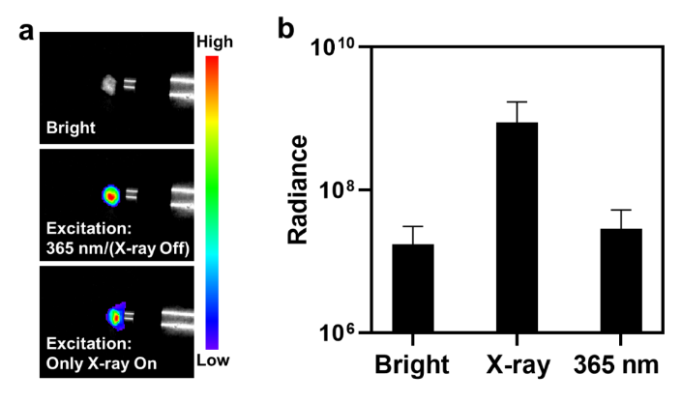
Fig. S12. (a) The fluorescent images of the extracted tumors under different irradiations. (b) Corresponding radiance intensities of tumors at 24 h post-injection. The statistical data are expressed as mean values ± SD (n = 3 independent animals).
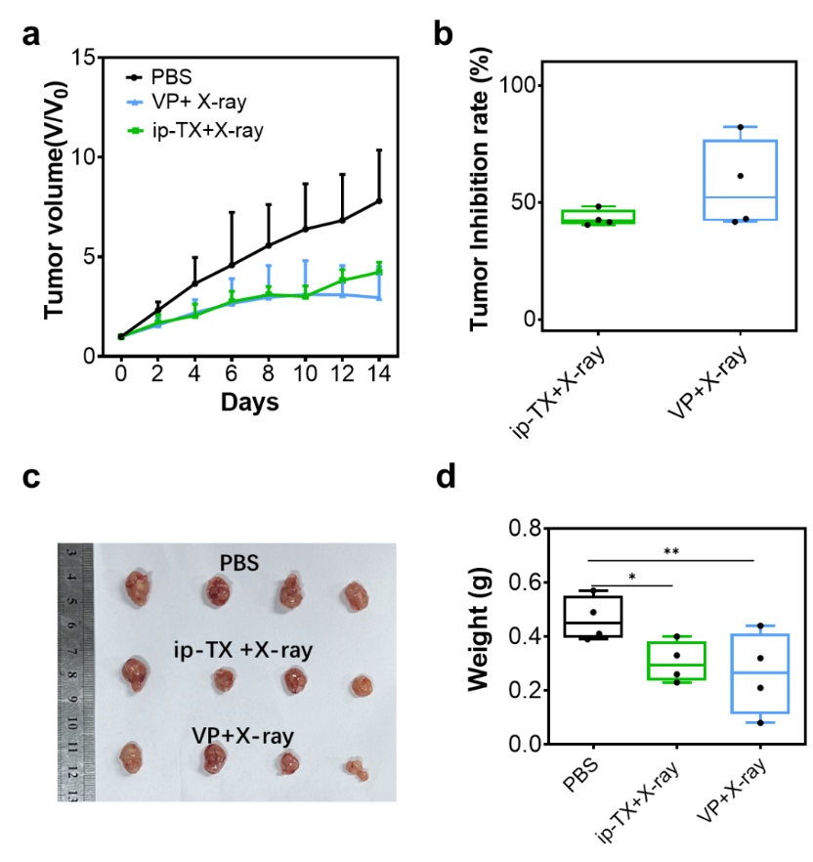
Fig. S13. (a) Quantification of tumor growth curves in each group (n = 5 biologically independent samples). (b) Quantification of tumor inhibition based on tumor volumes. (c) Photographs of tumors in each group at the end time point. (d) Tumor weights after different treatments from (c). SPSS Statistics 2 was used to calculate P values using one-way ANOVA as indicated. *P < 0.05, **P < 0.01.

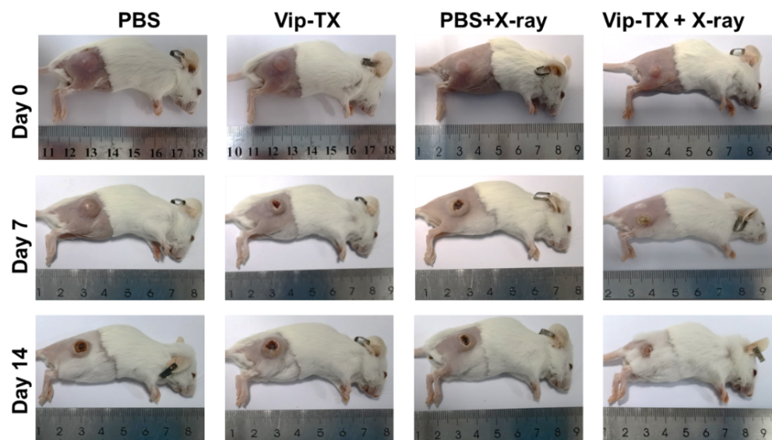
Fig. S14. Representative photographs of mice bearing 4T1 tumors on days 0, 7, and 14 after treatments.

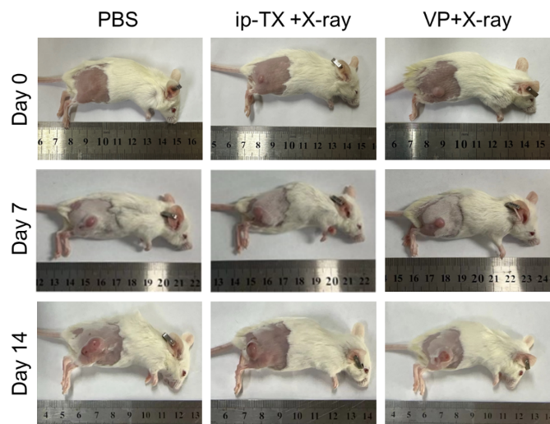
Fig. S15. Representative photographs of mice bearing 4T1 tumors on days 0, 7, and 14 after treatments.

Fig. S16. Body weights of tumor-bearing mice after various treatments.

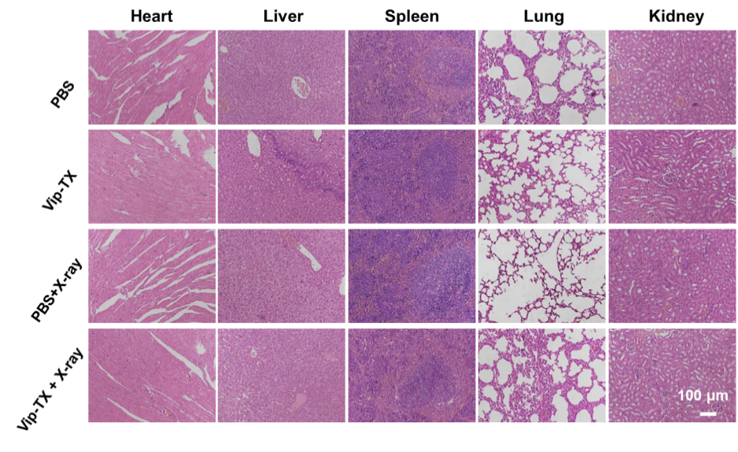
Fig. S17. Hematoxylin and eosin-stained slice images of the main organs, including heart, liver, spleen, lung, and kidney of tumor-bearing mice after various treatment for 15 d.

