Supplementary Information for

Investigation on Mixed Reflection Behavior of Cool Pavement Coating and Its Impact on Safety of Road Light Environment
Hui Li ^{a,b,}*, Ning Xie ^{c,a}, Xue Zhang ª, Lijun Sun ^{a,}*, John T. Harvey ^{d}, Lei Wang ª
ª Key Laboratory of Road and Traffic Engineering of the Ministry of Education, College of Transportation Engineering, Tongji University, Shanghai 201804, China
^{b} Urban Mobility Institute, College of Transportation Engineering, Tongji University, Shanghai 201804, China
^{c} Key Laboratory of Internet of Vehicle Technical Innovation and Testing (China Academy of Information and Communications Technology), Ministry of Industry and Information Technology of the People’s Republic of China, Beijing 100191, China
^{d} University of California Pavement Research Center, University of California, Davis, CA95616, USA

* Corresponding authors.
E-mail addresses: hli@tongji.edu.cn (H. Li), ljsun@tongji.edu.cn (L. Sun).

Section S1: Design gradation of asphalt concrete used in the study
Table S1
Design gradation of asphalt concrete
Gradation types | Gradation of AC |  | OGFC-1 |  | OGFC-2
Sieve size/mm | Passing Percent /% | Percentage Retained/% | Passing Percent /% | Percentage Retained/% | Passing Percent /% | Percentage Retained/%
13.2 | 100 | 0 | 100 | 0 | 100 | 0
9.5 | 76.5 | 23.5 | 68 | 32 | 60 | 40
4.75 | 53 | 23.5 | 28 | 40 | 22 | 38
2.36 | 37 | 16 | 16 | 12 | 13 | 9
1.18 | 26.5 | 10.5 | 12 | 4 | 9 | 4
0.6 | 19 | 7.5 | 8 | 4 | 7 | 2
0.3 | 10 | 9 | 6 | 2 | 5 | 2
0.15 | 5 | 5 | 6 | 0 | 5 | 0
0.075 | 5 | 0 | 6 | 0 | 5 | 0
<0.075 | 0 | 5 | 0 | 6 | 0 | 5
Asphalt-stone ratio (%) | 5.0 |  | 5.1 |  | 4.3
Void ratio (%) | 7.3 |  | 17.1 |  | 24.4

Section S2: Detailed description of the mixed reflection test platform
An automated mixed reflection test platform was independently designed and constructed for this study. The test platform consists of a light source (1), a sample rotation table (2), a rotating motor component (3), an external frame (4), a luminance meter (5), an optical anti-vibration platform (6), and a data acquisition and control system (7), etc., as shown in Supplementary Fig. S1(a). The light source (1) and the sample rotation table (2) are mounted on the rotation motor component (3), which realizes the rotation and change of incident angle (γ) in the hemispherical space. The rotation motor component (3) adopts a servo motor with an accuracy of 0.01° to realize the rotation angle control of β within 180° angle. The luminance meter (5) is mounted on the external frame (4) and can be adjusted up and down, forward and backward by the external frame (4) to realize adjustment of different receiving angles. In this study, the imaging luminance meter was adopted, which is equipped with the optical lenses of 28mm and 50mm to realize the measurement. All components are installed on an anti-vibration platform (6), and a light shield is used to achieve darkroom testing conditions. In addition, the automatic data collection can be conducted based on acquisition control system (7) and computer software.
According to the standard format of simplified luminance coefficient table for pavement recommended by CIE, the β angle was adjusted to 20 different angles, including 2°, 5°, 10°, 15°, 20°…180°, by the specimen rotating platform, and the γ angle was adjusted to 29 different angles, including 0°, 14.036°, 26.565°, 36.87°, 45°, 51.34°…85.24°, by the light source rotating arm. And the imaging luminance test was performed at each position determined by β and γ. Therefore, each measured luminance coefficient table contained 580 data points. The imaging luminance meter measured the luminance distribution of the sample under the illumination of the light source at a fixed observation angle 𝛼 and obtained the average plane luminance. The test case is shown in Fig.S1(c), and the whole testing process needs to be carried out in a dark room to avoid interference from external light sources.
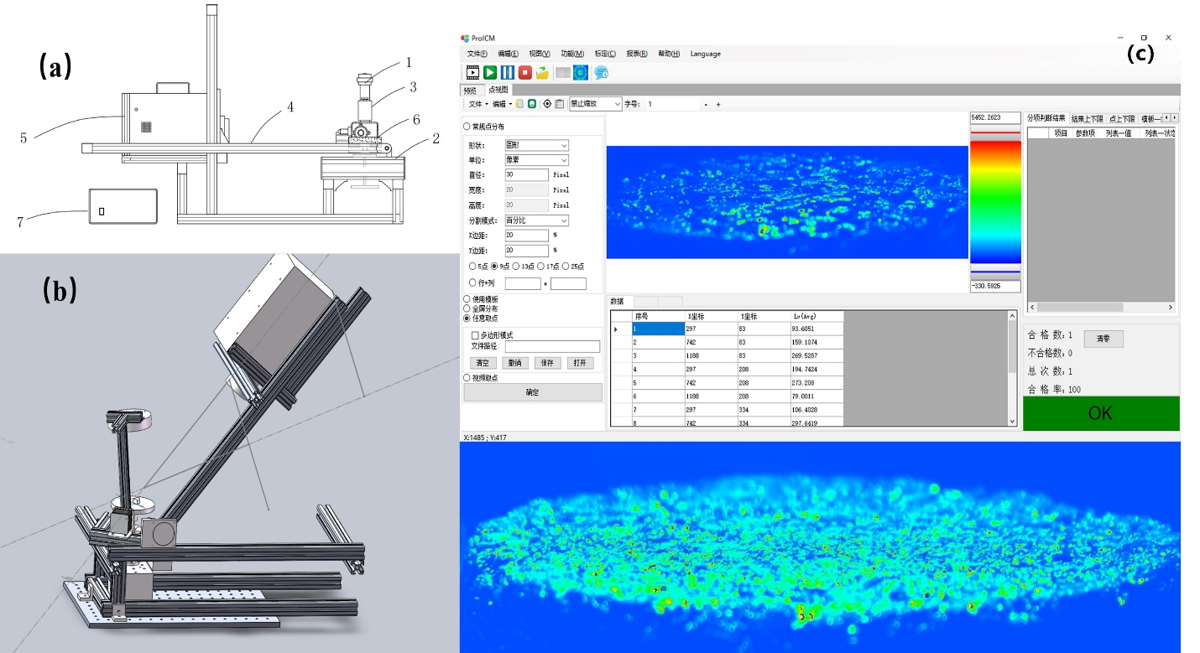
Fig. S1. Automated test platform for mixed reflection properties (a) (b) and testing software interface (c).

Section S3: Average luminance, overall uniformity, longitudinal uniformity, and TI of different pavement
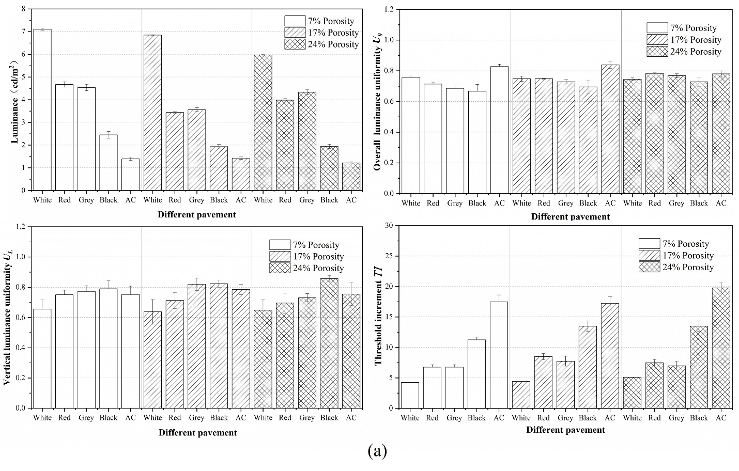
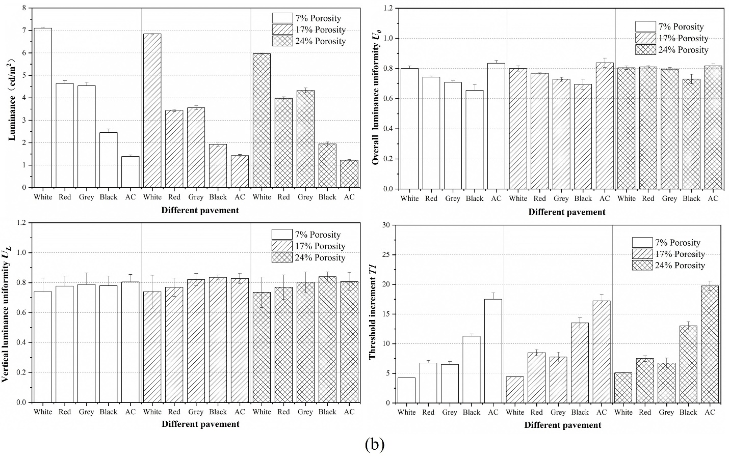
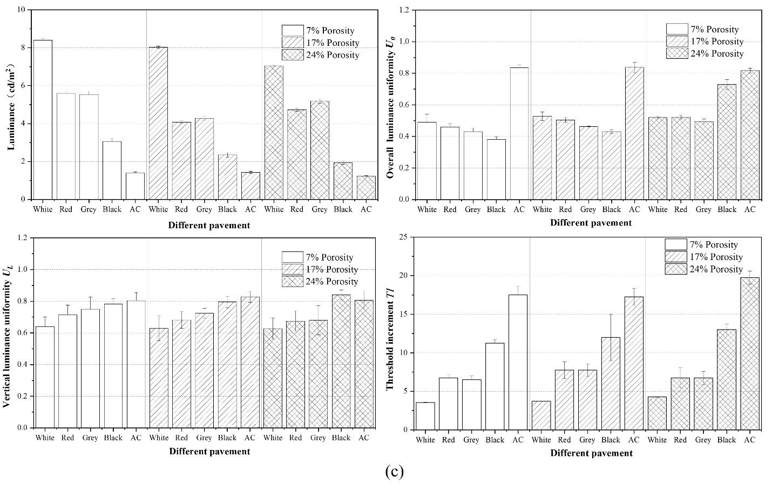
Fig. S3. Average luminance, overall uniformity, longitudinal uniformity, and TI of different pavement: (a) bidirectional symmetrical lighting arrangement, (b) bidirectional cross lighting arrangement, and (c) middle median strip lighting arrangement.

Section S4: Provisions on average luminance, overall uniformity, longitudinal uniformity, and TI
Table S4
Provisions on average luminance, overall uniformity, longitudinal uniformity, and TI in Chinese and European lighting standard.
No. | Standard | Grade | L_{av} (cd·m⁻²) | U₀ | U_{L} | TI (%)
1 | CJJ45–2015 | Expressway, trunk road | 1.50/2.00 | 0.4 | 0.7 | 10
2 | CJJ45–2015 | Secondary trunk road | 1.00/1.50 | 0.4 | 0.5 | 10
3 | CJJ45–2015 | By-pass | 0.50/0.75 | 0.4 | — | 15
4 | EN 13201-2: 2015 | M1 | 2.00 | 0.40 | 0.70 | 10
5 | EN 13201-2: 2015 | M2 | 1.50 | 0.40 | 0.70 | 10
6 | EN 13201-2: 2015 | M3 | 1.00 | 0.40 | 0.60 | 15
7 | EN 13201-2: 2015 | M4 | 0.75 | 0.40 | 0.60 | 15
8 | EN 13201-2: 2015 | M5 | 0.50 | 0.35 | 0.40 | 15
9 | EN 13201-2: 2015 | M6 | 0.30 | 0.35 | 0.40 | 20
The Chinese lighting industry standard “CJJ45–2015: Standard for lighting design of urban road” provides two standard values for the average luminance of each road grade. The value on the left side of the “/” represents the low-grade standard, while the value on the right side represents the high-grade standard. This study adopts the high-grade values.

