Supplementary Information for

Amplified Risks of the Yarlung Tsangpo–Brahmaputra River to Glacier Hazard Chains due to Multi-Hazard Transformation
Ruochen Jiang ª, Limin Zhang ^{a,b,}*, Ming Peng ^{c,d}, Wenjun Lu ^{e}, Dalei Peng ^{f}, Shihao Xiao ª, Xin He ª
ª Department of Civil and Environmental Engineering, The Hong Kong University of Science and Technology, Hong Kong 999077, China
^{b} HKUST Shenzhen-Hong Kong Collaborative Innovation Research Institute, Shenzhen 518000, China
^{c} Key Laboratory of Geotechnical & Underground Engineering of Ministry of Education, Tongji University, Shanghai 200092, China
^{d} Department of Geotechnical Engineering, College of Civil Engineering, Tongji University, Shanghai 200092, China
^{e} School of Intelligent Civil and Ocean Engineering, Harbin Institute of Technology (Shenzhen), Shenzhen 518055, China
^{f} State Key Laboratory of Geohazard Prevention and Geoenvironment Protection, Chengdu University of Technology, Chengdu 610000, China

* Corresponding author.
E-mail address: cezhangl@ust.hk (L. Zhang).

S1. DEM production and uncertainty estimation for the 2018 Sedongpu hazard
The 2018 Sedongpu hazard model is used to calibrate and validate the physical parameters in the simulation model. The ground elevations prior to and after the hazard are produced based on ZY-3 stereo data (2.5 resolution) collected on November11, 2017, and November30, 2018, respectively. The derived DEM data are used to compute the volume of detached glacial masses and deposition depths. First, the stereo satellite images are imported into ENVI (https://www.nv5geospatialsoftware.com/Products/ENVI) to produce geocoded point clouds using tools from the photogrammetry module. The ALOS DEM was used to achieve stereo image matching and co-registration. CloudCompare (https://www.cloudcompare.org/) was used to clean abnormal points using the filter tool, after which the residual abnormal points were manually eliminated. Finally, the processed point clouds are imported into ArcGIS to produce a DEM using the LAS toolbox, in which the projected coordinate system of the DEM is set as UTM Zone-46 N.
The two stable areas, namely, Regions c and d in Fig. S1, are taken to estimate the uncertainties in the pre- and post-DEM maps. The histogram results are shown in Fig. S1(b) and S1(c). We assume that the differences in the selected areas satisfy the Gaussian distribution and fit the DEM differences in Fig. S1 (the red curves). The mean values in region c and region d in Fig. S1 are 0.71 m and 0.53 m, respectively. The standard deviations are 1.798 m and 1.465 m, and the two-sigma DEM differencing uncertainties are 3.596 m and 2.930 m, respectively. Finally, we take the average as the DEM error and differencing uncertainty: mean error = (0.71+0.53)/2=0.62 m and differencing uncertainty = (3.596+2.930)/2=3.263 m. The final estimates of the volume of detached glaciers are presented in Fig. S1. The total volume of detached debris‒ice mixtures is approximately (150 ± 0.63) × 10⁶ m³ (95% confidence), distributed at elevations ranging from 3100 to 4100 m. The formed scar has a width of up to 550 m, a vertical difference of up to (190 ± 3.1) m (located in Region a in Fig. S1) and an average thickness of approximately (150 ± 3.1) m.
S2. Error estimation for glacier surface velocity and glacier thickness in the research area
To assess the accuracy of the glacier surface velocity and thickness of glacial deposits obtained through remote sensing inversion, a comparison is made between the results obtained from the study area and the data available in publicly accessible glacier databases [1]. The glacier velocity and glacier thickness in this published database were resampled with the same grid size as the results obtained in this study, namely, 30 m. Herein, we propose two indicators to quantify the error between the obtained results and those in the published databases:
$R_VG=\frac{V_{o}-V_{p}}{V_{p}}$ (S1)
$R_TG=\frac{T_{o}-T_{p}}{T_{p}}$ (S2)
where R_VG and R_TG represent the relative errors between the obtained glacier surface velocities and glacier thickness values and those found in the published databases, respectively. The histograms are shown in Fig. 3. We assume that the differences satisfy the Gaussian distribution and fit the relative errors in Fig. S3 (the red curves). The mean differences for the obtained velocities and sediment thicknesses are 0.0998 and 0.1291, respectively.
S3. Multi-scenario simulation of the detached glacier mass
In this section, we take Peilong Glacier (Glacier No. 14) as an example to explain the multi-scenario simulation analysis. First, we determine four scenarios: (1) Scenario 1, with a low-magnitude detachment of L_{D} =1 km; (2) Scenario 2, with a moderate-magnitude detachment, L_{D} =2 km; (3) Scenario 3, with a high-magnitude detachment, L_{D} =3 km; (blue part in Fig. S4); and (4) Scenario 4, with an extreme scenario with the destabilization of all sediments from each valley glacier. Second, on the basis of the derived glacier thickness in Section 2 and Fig. 5, we can obtain the detached volumes under different scenarios, which are then used as the initial hazard volume in the EDDA simulation analysis.
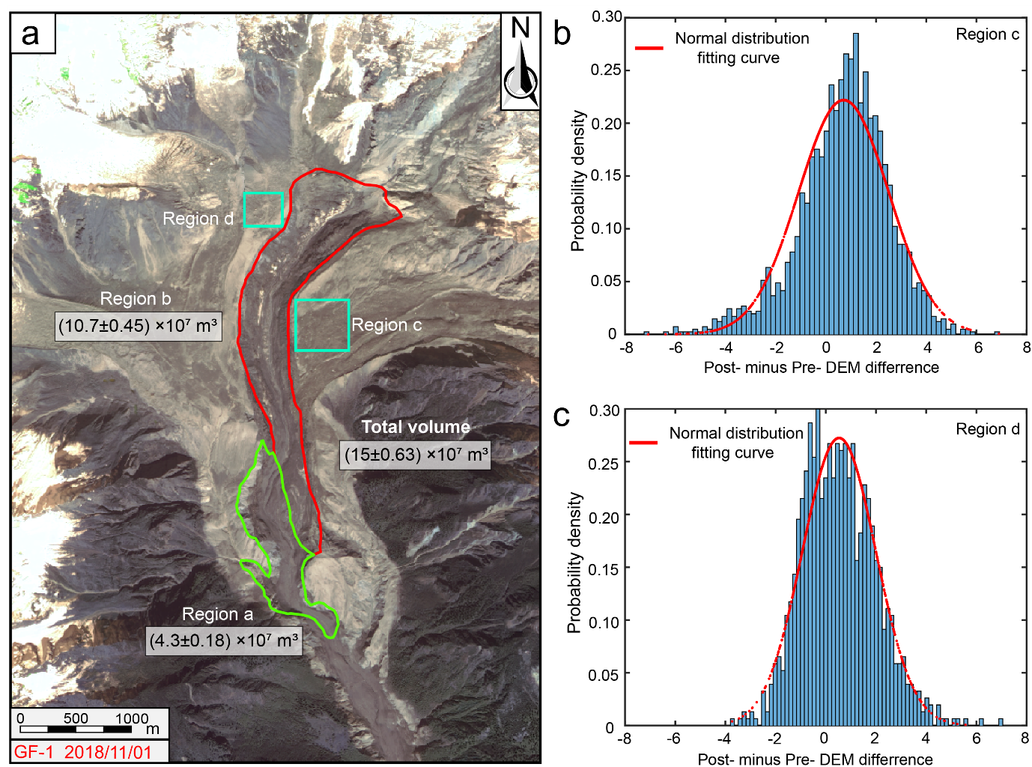

Fig. S1. The detached sub-regions and histogram of stable ground DEM difference analysis. (a) The detached volume in different sub-regions and the locations of stable ground taken for DEM difference analysis; (b) the histogram of stable ground DEM differences in region c; (c) histogram of stable ground DEM differences in region d.
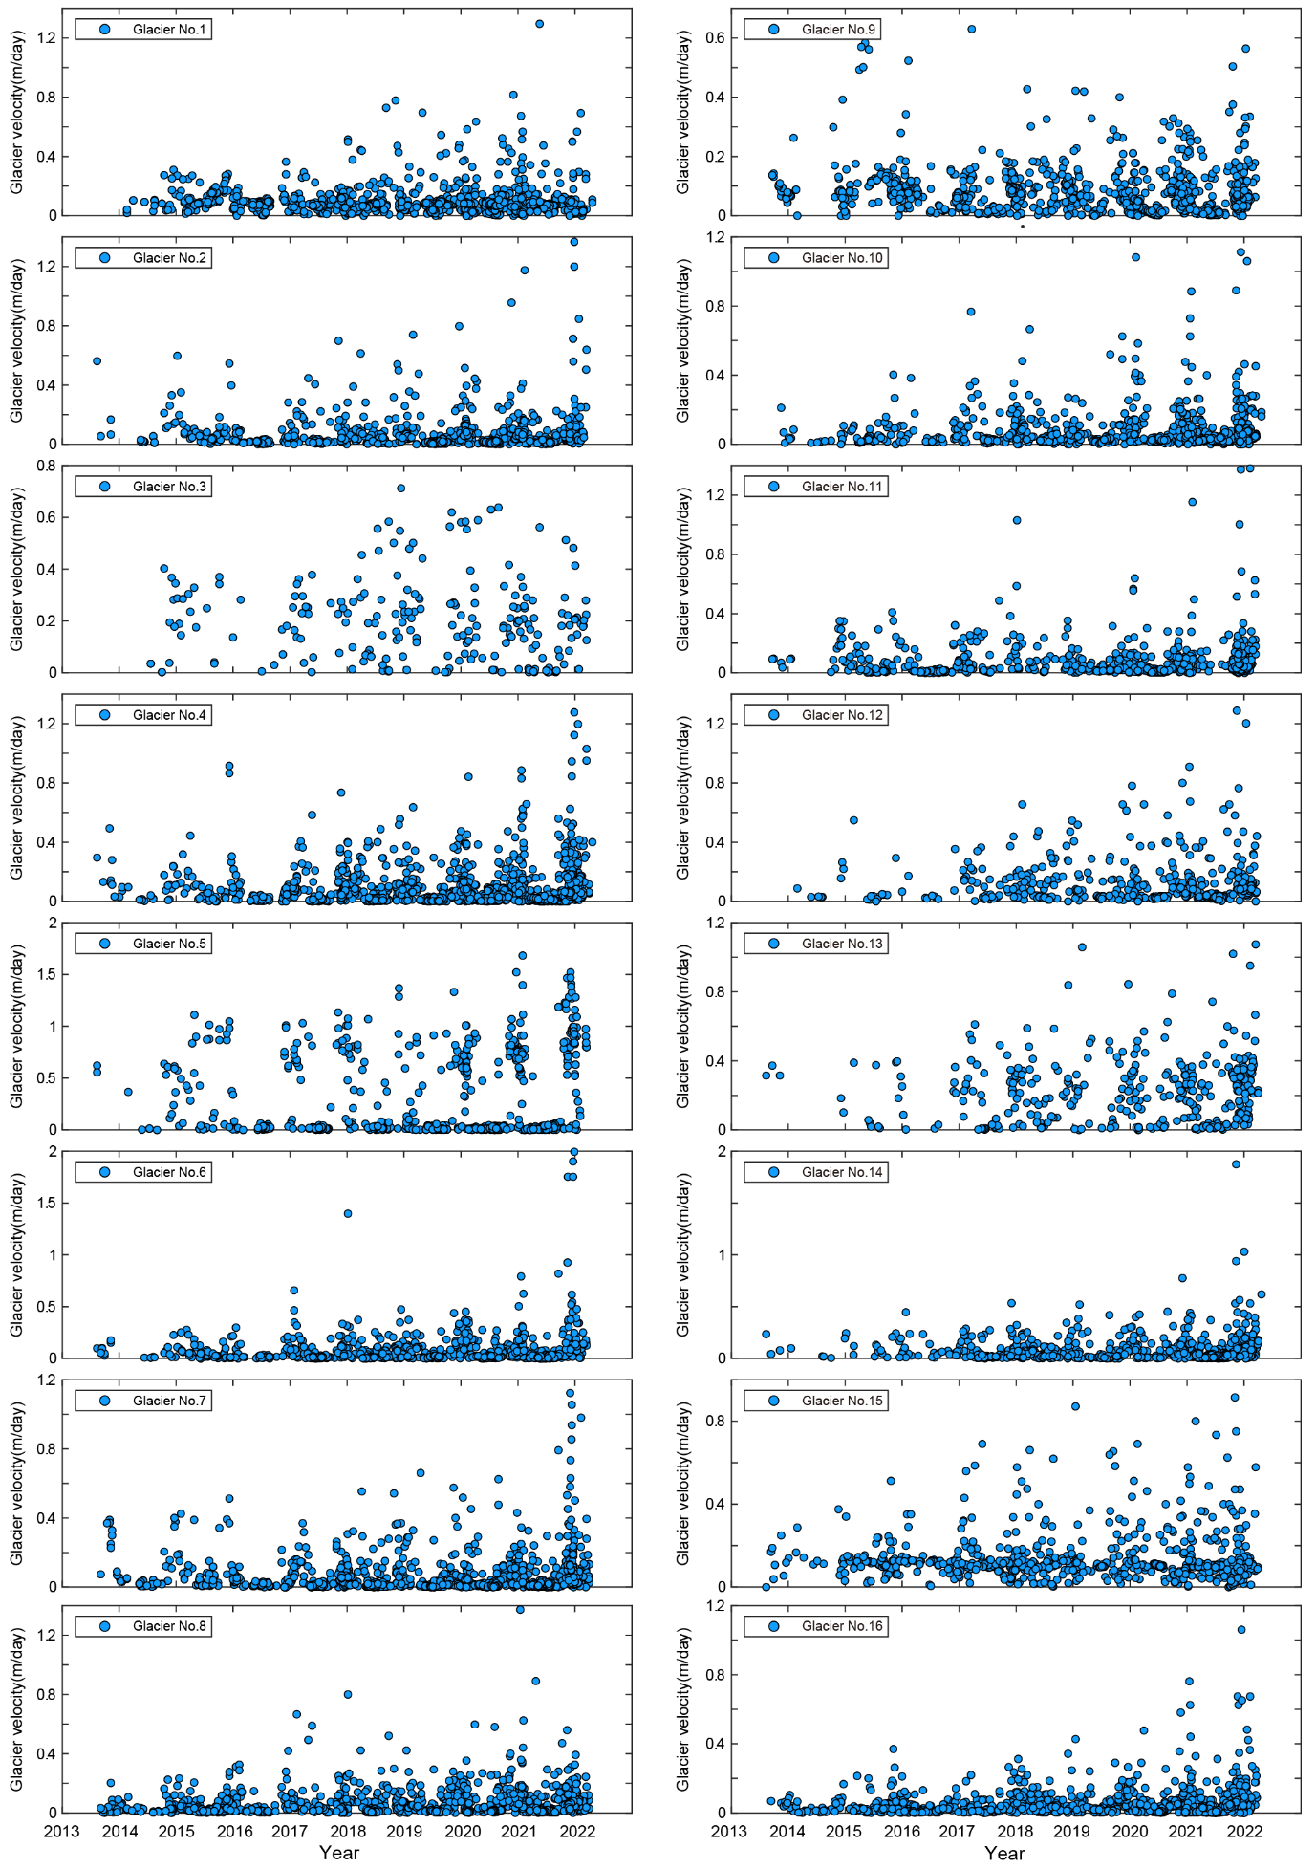
Fig. S2. Glacier surface velocities in YTGC.

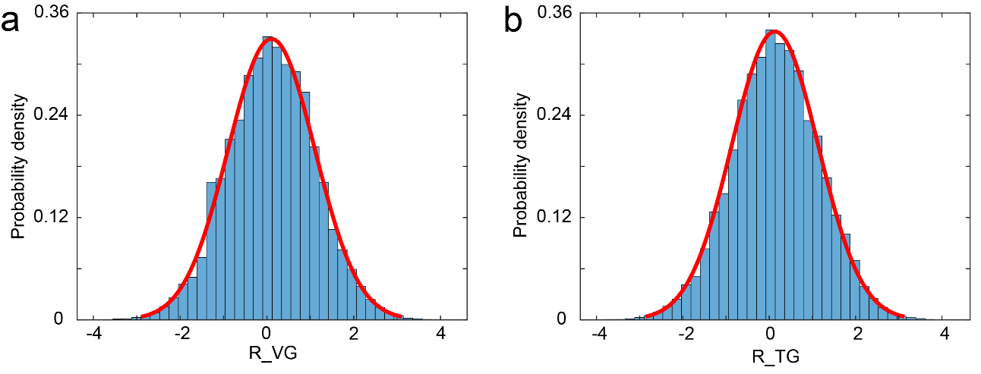

Fig. S3. (a) Histogram of relative errors of glacier surface velocity; (b) Histogram of relative errors of glacier thickness.

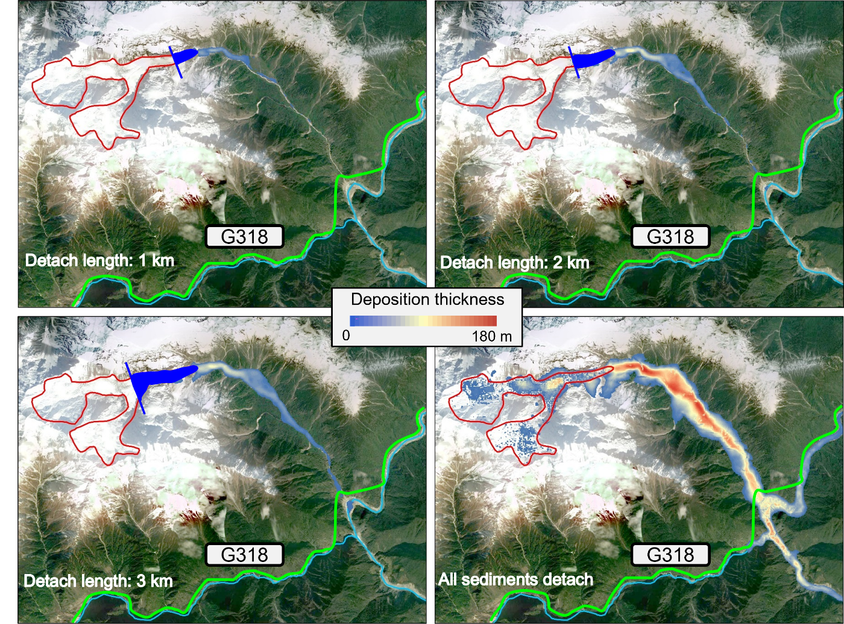
Fig. S4. Multiple simulation scenarios and simulated deposition thickness caused by mass flows in Peilong Glacier (Glacier ID: 14).

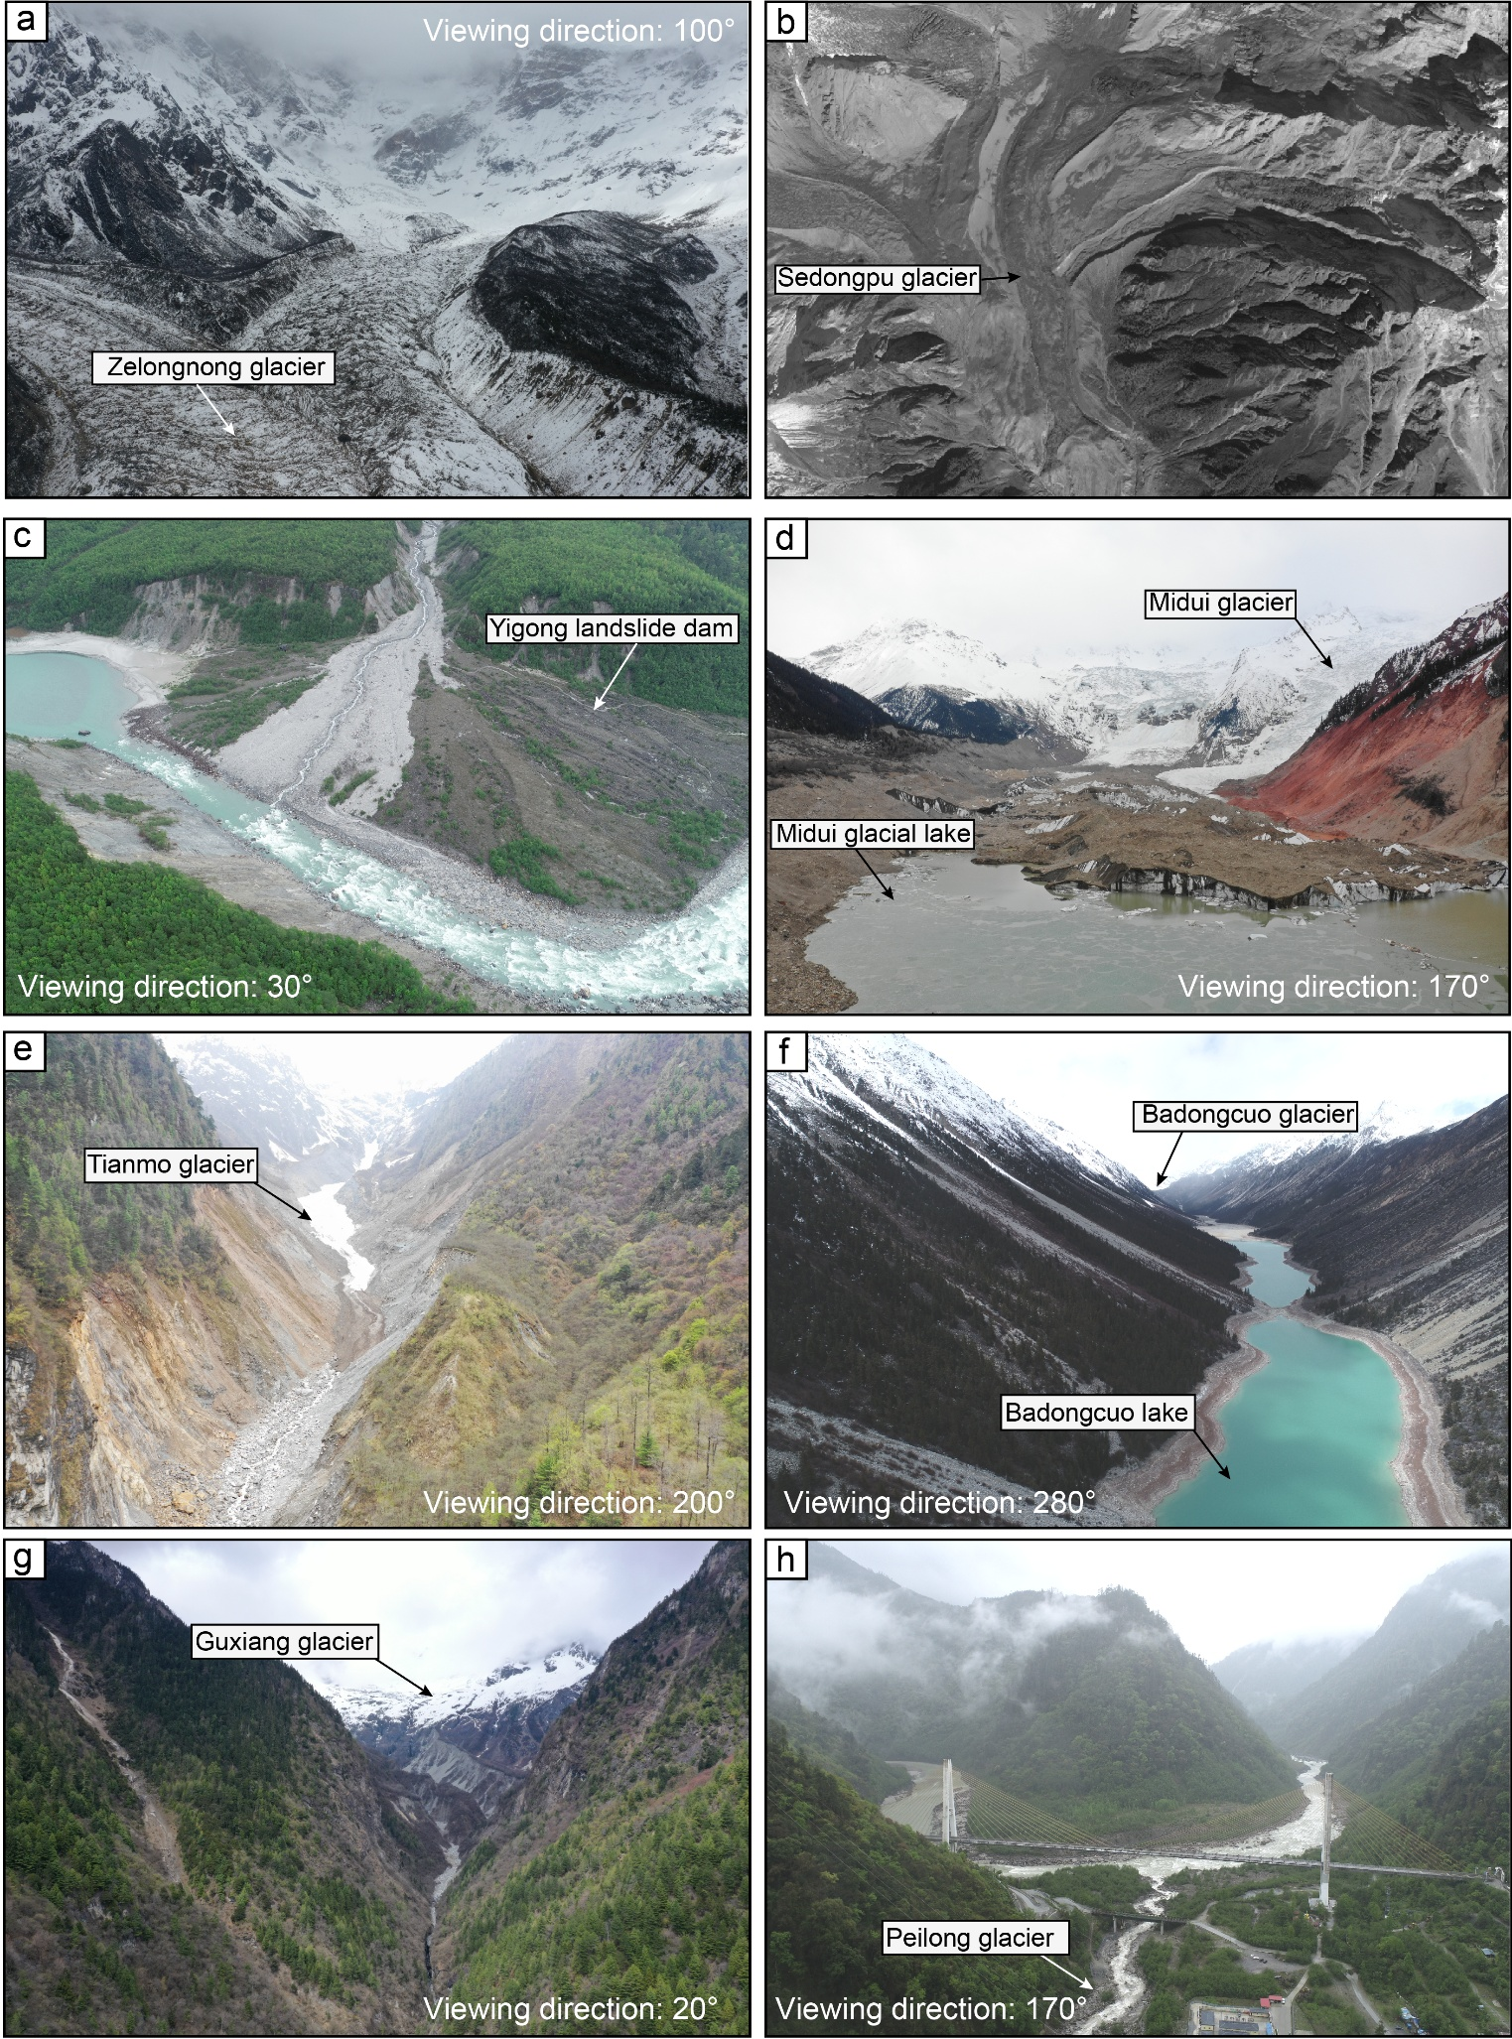
Fig. S5. Photos of barrier dams and mountain valley glaciers in Southeastern Tibet. (a) Zelongnong Glacier (29.62$°$N, 94.99$°$E) 100; (b) Sedongpu glacier (ZY-3 satellite image from 2017); (c) The Yigong landslide dam formed in 2000 (30.18$°$N, 94.94$°$E); (d) Midui Glacier (29.47$°$N, 96.50$°$E); (e) Tianmo Glacier (29.97$°$N, 95.30$°$E); (f) Badongcuo Glacier and Badongcuo Lake (30.31$°$N, 96.07$°$E); (g) Guxiang Glacier (29.93$°$N, 95.45$°$E); (h) Peilong Glacier (30.05$°$N, 95.01$°$E). All images were taken by a DJI Phantom 4 Pro RTK UAV and a DJI Mavic 2 Pro UAV. (Photo credits: Limin Zhang (corresponding author)).
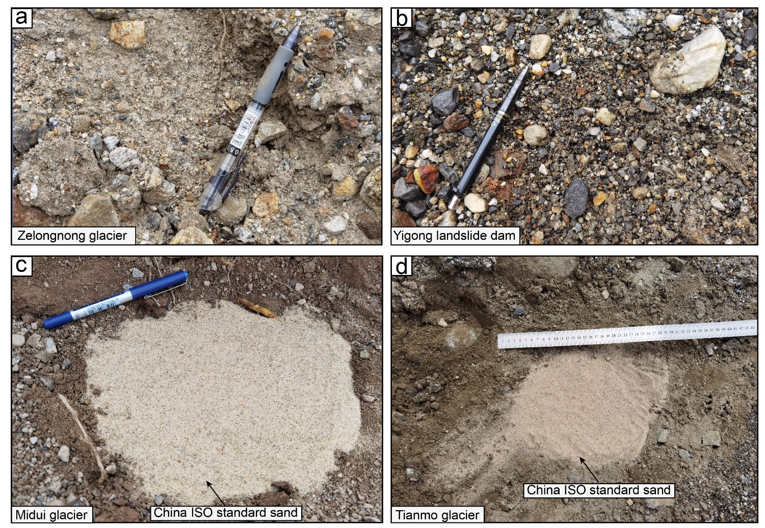
Fig. S6. (a–d) Soil samples from Zelongnong Glacier (29.61$°$N, 94.94$°$E), the Yigong landslide dam (30.17$°$N, 94.94$°$E), Midui Glacier (29.47$°$N, 96.50$°$E), and Tianmo Glacier (29.98$°$N, 95.31$°$E).

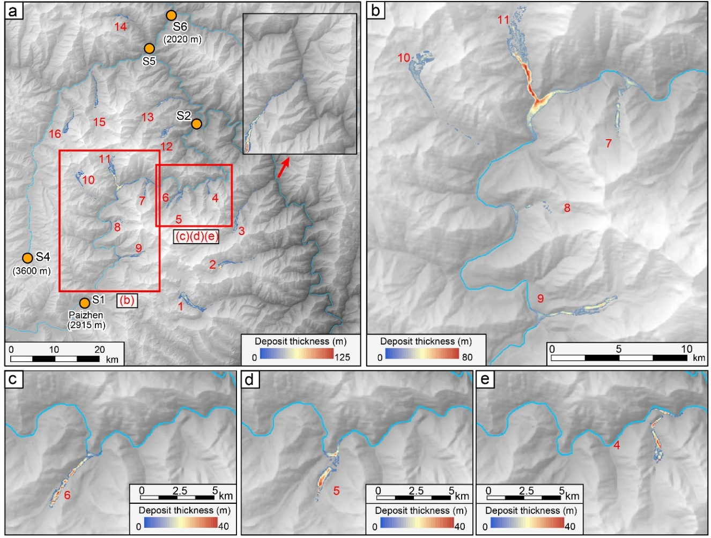
Fig. S7. Barrier dams caused by 1 km-length valley glacier detachments.

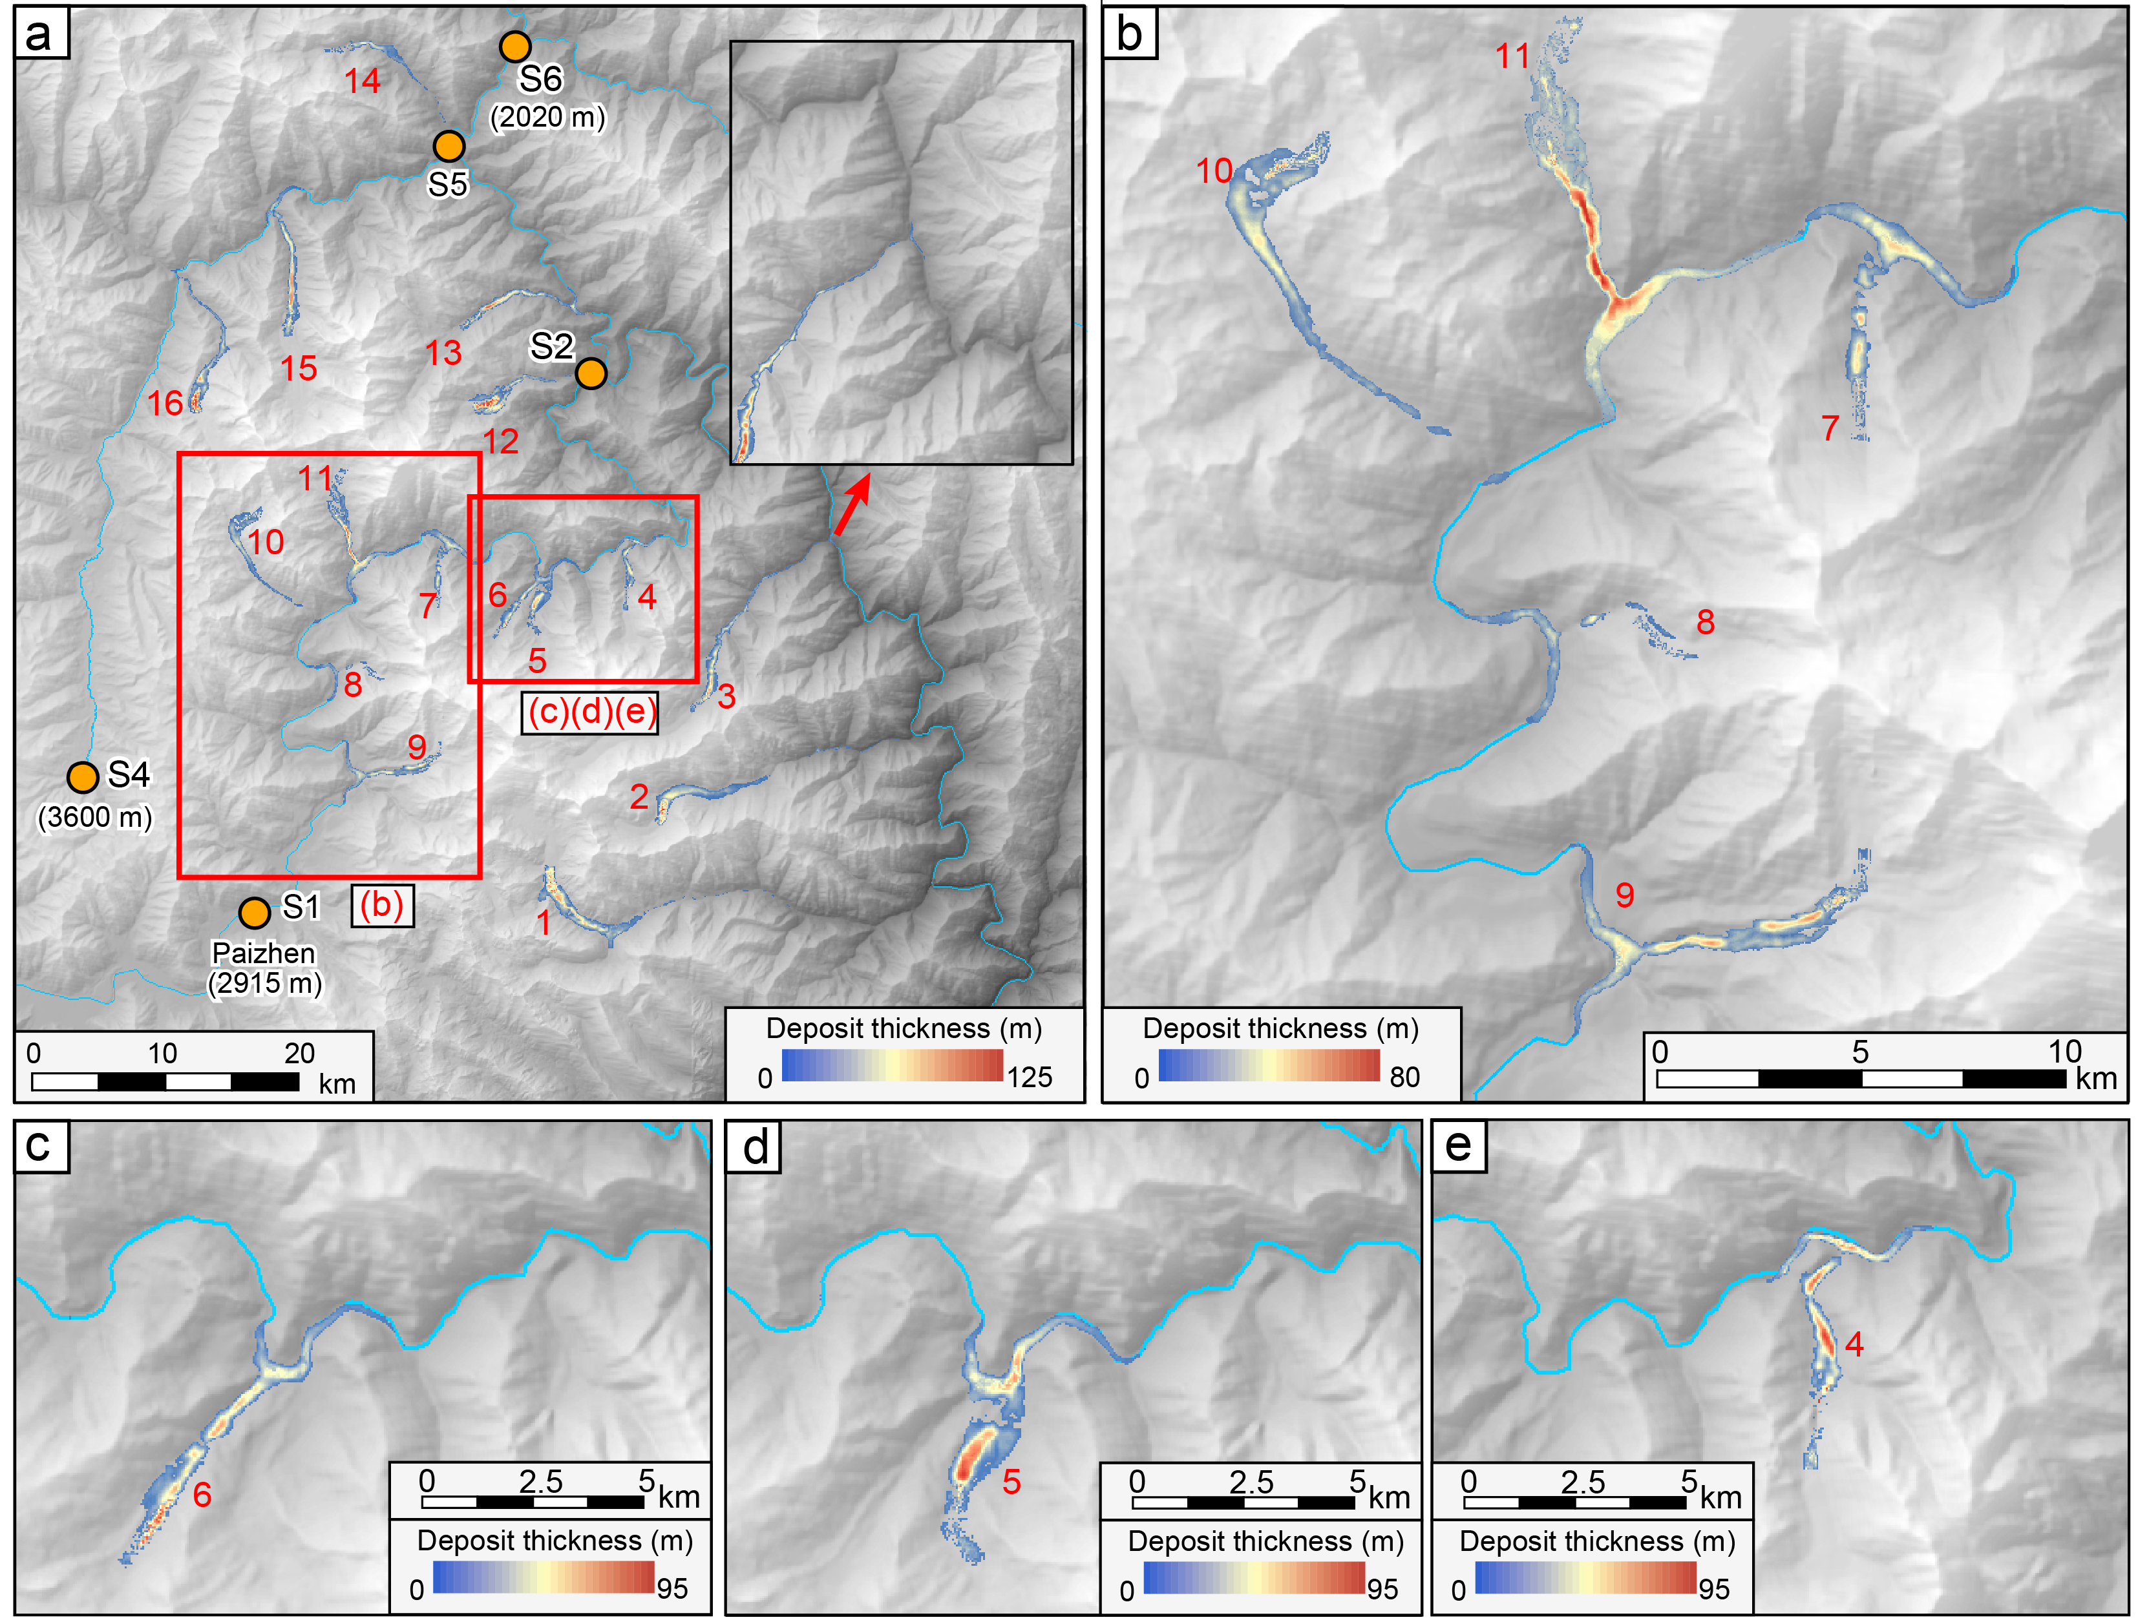
Fig. S8. Barrier dams caused by 2 km-length valley glacier detachments.

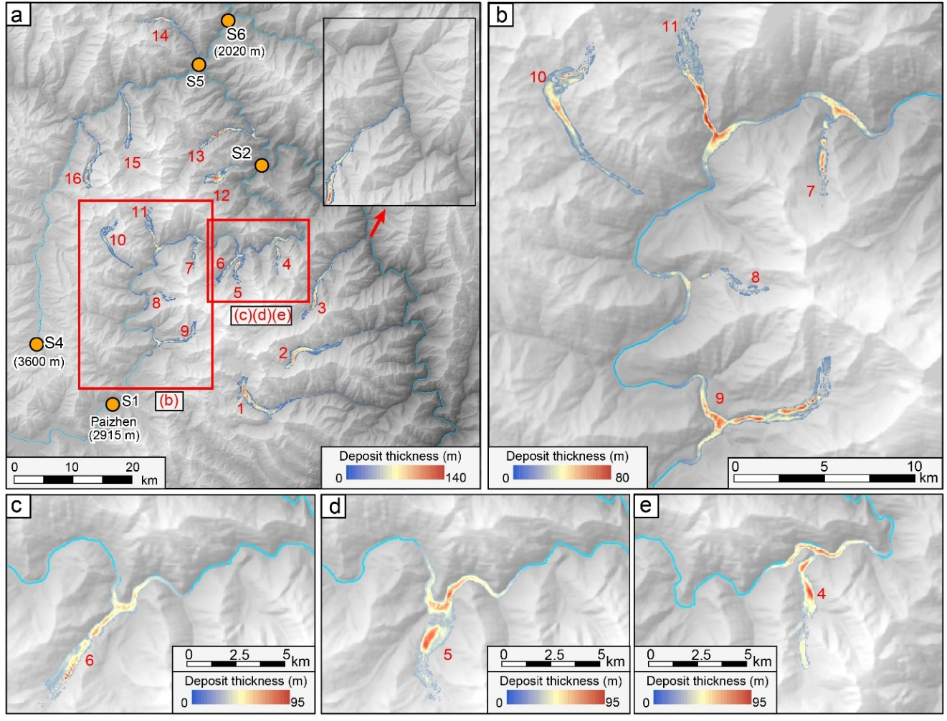
Fig. S9. Barrier dams caused by 3 km-length valley glacier detachments.
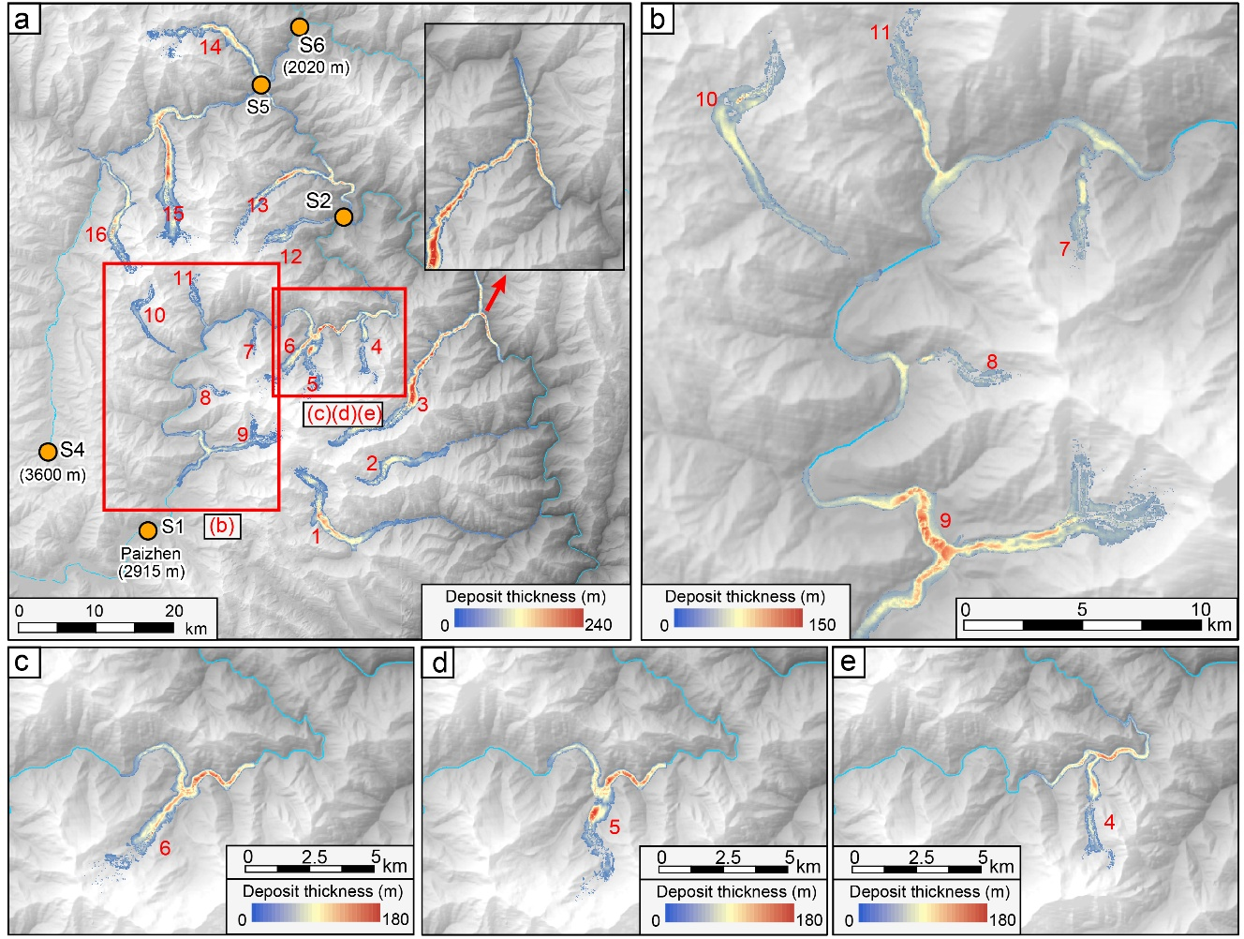
Fig. S10. Barrier dams caused by detachments of all valley sediments.

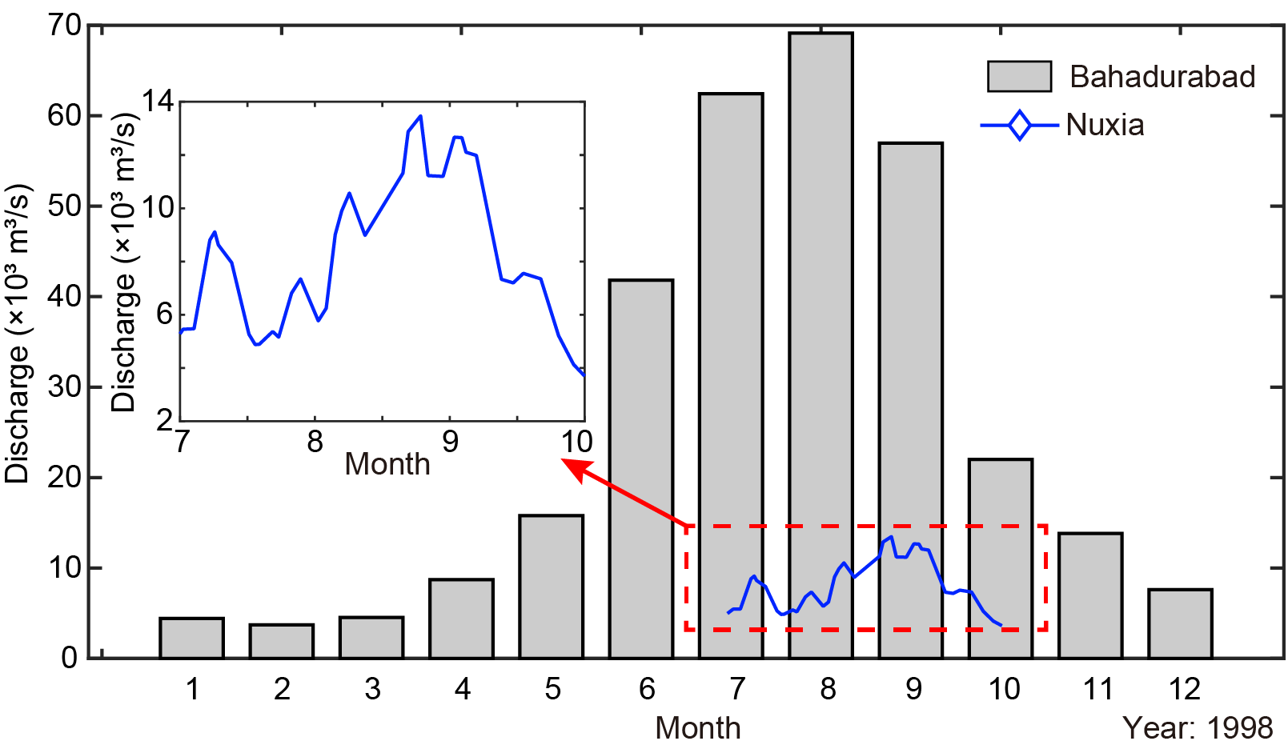
Fig. S11. River discharges in the 1998 flood at Nuxia and Bahadurabad. The data were obtained from Refs. [2,3].
References
- Millan R, Mouginot J, Rabatel A, Morlighem M. Ice velocity and thickness of the world’s glaciers. Nat Geosci 2022;15:124–9.
- Chen C, Zhang LM, Xiao T, He J. Barrier lake bursting and flood routing in the Yarlung Tsangpo Grand Canyon in October 2018. J Hydrol 2020;583:124603.
- Rao MP, Cook ER, Cook BI, D’Arrigo RD, Palmer JG, Lall U, et al. Seven centuries of reconstructed Brahmaputra River discharge demonstrate underestimated high discharge and flood hazard frequency. Nat Commun 2020;11:6017.

