Supplementary data for

Improvement of the Yangtze River’s Water Quality with Substantial Implementation of Wastewater Services Infrastructure since 2013
Weixiao Qi ª, Xu Wang ^{b,c,}*, Jin Kang ^{d}, Yaohui Bai ^{e}, Rui Bian ª, Hongtao Xue ª, Li Chen ª, Aomei Guan ^{e}, Yi-Rong Pan ^{e}, Huijuan Liu ª, Jiuhui Qu ^{a,e,}*
ª Center for Water and Ecology, State Key Joint Laboratory of Environment Simulation and Pollution Control, School of Environment, Tsinghua University, Beijing 100084, China
^{b} State Key Laboratory of Urban Water Resources and Environment, School of Civil and Environmental Engineering, Harbin Institute of Technology, Shenzhen, Shenzhen 518055, China
^{c} Centre for Water Systems, College of Engineering, Mathematics and Physical Sciences, University of Exeter, Exeter, EX4 4QF, UK
^{d} Hubei Provincial Research Institute of Environmental Science, Wuhan 430072, China
^{e} Research Center for Eco-Environmental Sciences, Chinese Academy of Sciences, Beijing 100085, China
*Corresponding authors.
E-mail addresses: wangxu2021@hit.edu.cn (X. Wang), jhqu@mail.tsinghua.edu.cn (J. Qu)
Fig. S1. Temporal variation of annual wastewater treatment amount in the YRB and sub-basins.
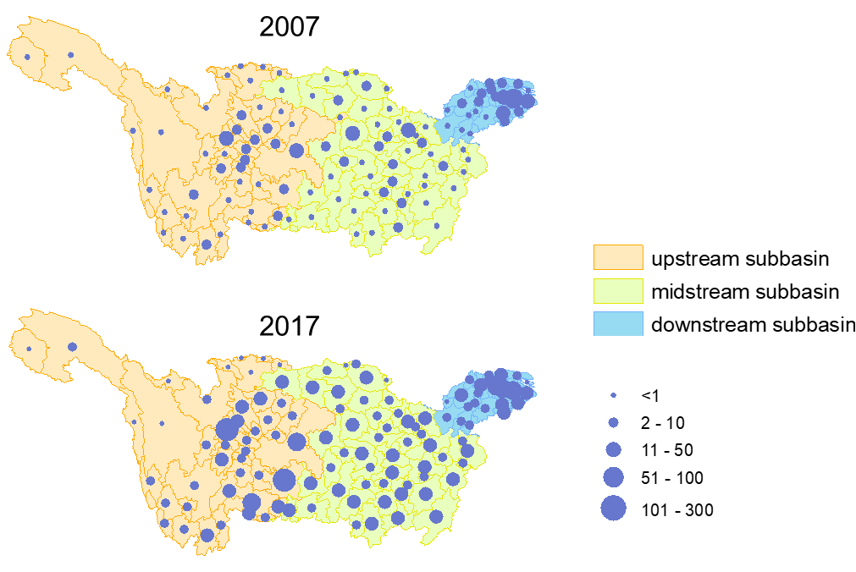
Fig. S2. Numbers of WWTPs in YRB cities in 2007 and 2017.

Table S1
Socioeconomic and sewage emission factors of three YRB sub-basins.
 | population (million) | GDP (billion yuan) | area (km²) | town-constructed area (km²) | sewage emission factor (L/capita·day)
 | 2007
upstream | 170 | 2189 | 97 | 2806 | 127±13
midstream | 218 | 3067 | 70 | 2967 | 153±20
downstream | 106 | 4662 | 12 | 3436 | 168±14
 | 2017
upstream | 179 | 8462 | 97 | 6120 | -
midstream | 221 | 11105 | 70 | 5337 | -
downstream | 120 | 13640 | 12 | 5539 | -
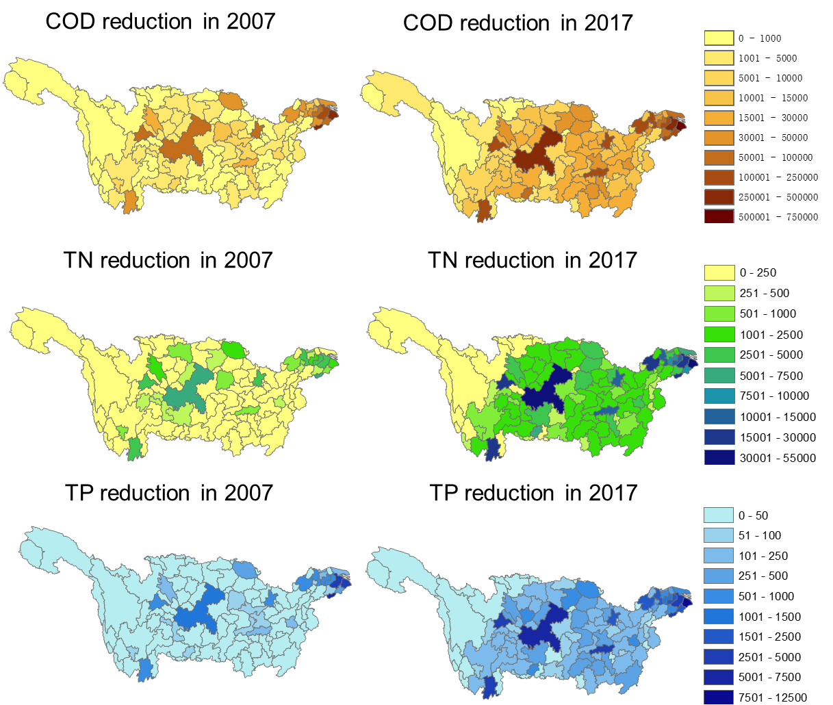
Fig. S3. Pollutant reduction (t) from WWTPs in YRB cities.
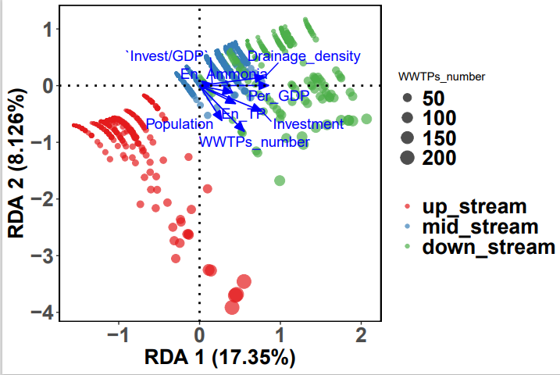
Fig. S4. The RDA results showing the influences of constrained variables on pollutants flux in the Yangtze River
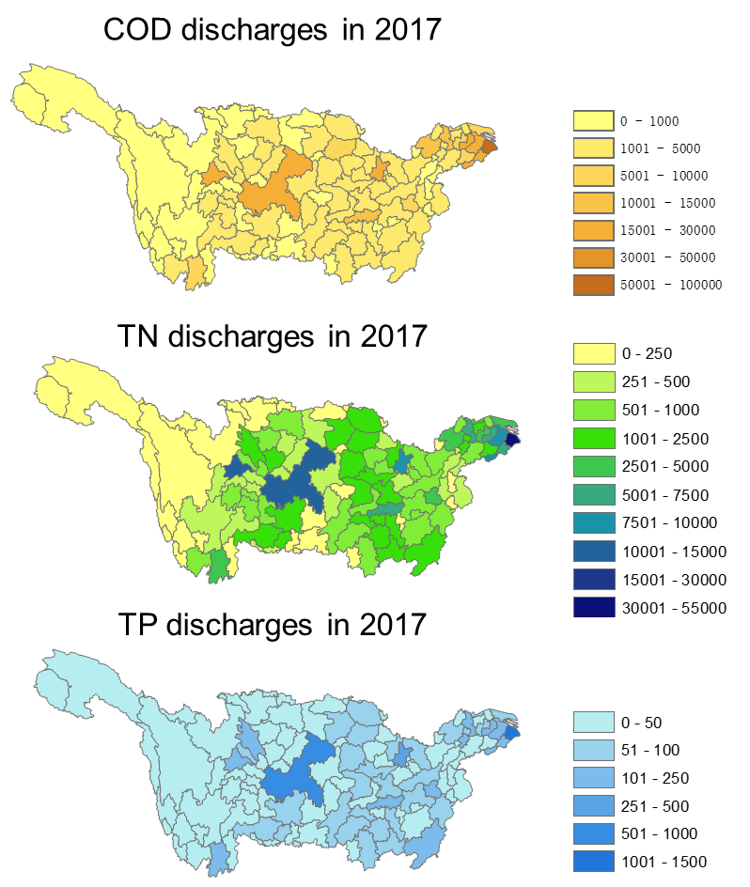
Fig. S5. Pollutant discharges (t) from WWTPs in YRB cities.
Fig. S6. Phosphorous concentrations in effluent.

Table S2
Pollutants collected and discharged from WWTPs in the Yangtze Basin in 2007, 2017 and future 2035 simulating with assumption of density of drainage pipelines reaching 30 km km⁻².
Year | Ammonia (Gg N yr⁻¹) |  | Total nitrogen (Gg N yr⁻¹) |  | Organic matter (Gg COD yr⁻¹)
Year | Collected | Discharged | Collected | Discharged | Collected | Discharged
2007 | 155 | 59 | 191 | 100 | 1931 | 350
2017 | 415 | 32 | 574 | 192 | 4500 | 442
2035 | 1495±513 | 284±98 | 2077±719 | 837±289 | 15139±5043 | 1621±539

