Supplementary Data for

Synergistic Enhancement of Mechanical Properties and Electrical Conductivity of Immiscible Bimetal: A Case Study on W–Cu
Qixiang Duan, Chao Hou *, Tielong Han, Yurong Li, Haibin Wang, Xiaoyan Song *, Zuoren Nie
Key Laboratory of Advanced Functional Materials, Ministry of Education, College of Materials Science and Engineering, Beijing University of Technology, Beijing 100124, China

* Corresponding authors.
E-mail addresses: houchao@bjut.edu.cn (C. Hou), xysong@bjut.edu.cn (X. Song).

The morphology and particle size distribution of the raw W powder are shown in Fig. S1. Compared with the microstructure of the sintered UFG-CW-Cu bimetal, it is found that the W grain size in the sintered bimetal is very close to the initial W particle size. This indicates that the ultrafine grain size in the W islands was remained from the ultrafine W particles, and the grain growth was well controlled in the process of rapid low-temperature sintering.

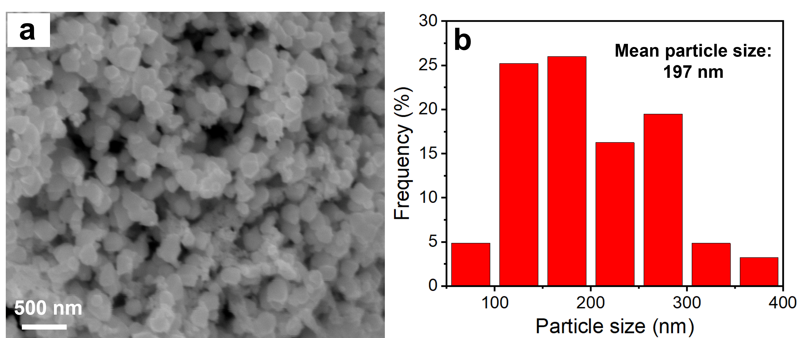
Fig. S1. (a) Morphology and (b) particle size distribution of the ultrafine W powder.

Fig. S2 shows the microstructure and grain size distribution of W phase in the CG W–Cu bimetal. The mean W grain size in the CG W–Cu bimetal is 8.36 µm. From the measurements, the hardness of the CG W–Cu bimetal is (210.0 ± 2.7) kgf⋅mm⁻², which is about half that of the UFG-CW-Cu bimetal.

Fig. S2. (a) Microstructure and (b) grain size distribution of W phase in the CG W–Cu bimetal.

