Supplementary data for

Membrane Fouling Alleviation by Chemically Enhanced Backwashing in Treating Algae-Containing Surface Water: From Bench-Scale to Full-Scale Application
Xiaobin Tang ª, Tiecheng Guo ª, Haiqing Chang ^{b}, Xiao Yue ^{c}, Jinlong Wang ª, Haikuan Yu ^{c}, Binghan Xie ^{d}, Xuewu Zhu ª, Guibai Li ª, Heng Liang ª*
ª State Key Laboratory of Urban Water Resource and Environment (SKLUWRE), School of Environment, Harbin Institute of Technology, Harbin 150090, China
^{b} College of Architecture and Environment, Sichuan University, Chengdu 610207, China
^{c} College of Architecture and Civil Engineering, Beijing University of Technology, Beijing 100124, China
^{d} School of Marine Science and Technology, Harbin Institute of Technology at Weihai, Weihai 264209, China

* Corresponding author.
E-mail address: hitliangheng@163.com (H. Liang)

1. Process of flow diagram of DWTPs
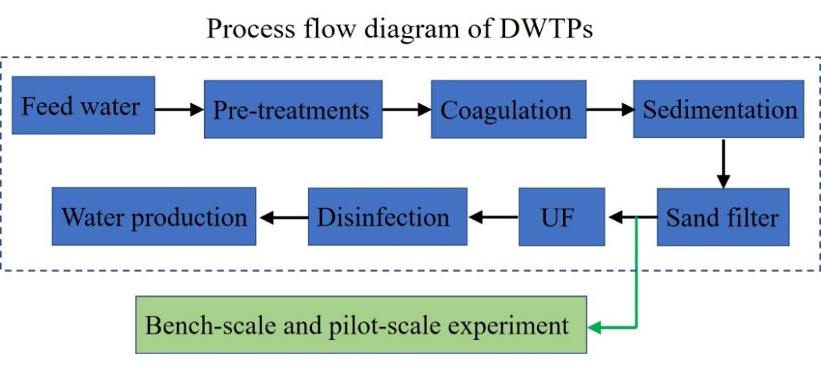
Fig. S1. Process flow diagram of DWTPs (see the black arrow) and the experiment setup location (see the green arrow).

2. Characteristics of organic foulants in the feed water
Fig. S2. Characteristics of organic foulants in the feed water prior to UF process based on the 3D-EEM measurements.
3. Algae cell counting method
In this study, microtechnique was used to determine the algae contents in the water. The water sample (1000 mL) was obtained from the sampling location of raw water pipe of the DWTPs and poured into a sedimentator. The fixation was proceed immediately using the working Lugol solution (10 mL). After that, static settlement was processed for 48 h. Subsequently, the supernatant was siphoned off without stirring the precipitated algae on the bottom. Then, the residual precipitated algae solution (approximately 30 mL) was transferred into a 50 mL volumetric flask. The sedimentator was rinsed 3 times using the supernatant and the water was added into the volumetric flask. Afterwards, the volumetric flask was filled to 50 mL using the supernatant. Finally, optical microscope was employed to observe and count the algae cells, and the algae concentrations can be obtained using a standard carve as shown below.
(S1)
where N is the algae concentration (cell·L⁻¹); A is the area of counting grid (mm²); A_{c} is the counting area (mm²); V_{s} is the water sample after sedimentation per liter (10 mL); V_{a} is the volume of counting grid (mL); n is the total cell counts.

