Supplementary data for

Achieving 12.0% Solar-to-Hydrogen Efficiency with a Trimetallic-Layer-Protected and Catalyzed Silicon Photoanode Coupled with an Inexpensive Silicon Solar Cell
Lingyun He, Xin Hong, Yiqing Wang, Zhonghang Xing, Jiafeng Geng, Penghui Guo, Jinzhan Su, Shaohua Shen *
International Research Center for Renewable Energy, State Key Laboratory of Multiphase Flow in Power Engineering, Xi’an Jiaotong University, Xi’an 710049, China

* Corresponding author.
E-mail address: shshen_xjtu@mail.xjtu.edu.cn (S. Shen)

Materials and methods

1. Fabrication of p⁺n-Si and p⁺-Si wafers
Commercial p⁺n-Si pyramids wafers were purchased from YingLi Co., Ltd. (China). The Si wafers were etched by the thermal diffusion of B₂H₆ to form a p–n buried junction. The p⁺ region is about 200 nm, and thereby the boron concentration is about 10²⁰ atoms per cubic centimeter. The original 6 inch × 6 inch (1 inch = 2.54 cm) p⁺n-Si wafer was cut into 0.5 cm × 0.5 cm slices. All these slices were ultrasonically cleaned in acetone, ethanol, and deionized water (18.25 MΩ∙cm) for 10 min each at room temperature, and then dipped in 5% HF solution for 3 min. The p⁺-Si (< 0.005 Ω∙cm) wafers purchased from Suzhou Research Materials Microtech Co., Ltd. (China), were treated by the same cleaning step, and then immersed in 70 mL of mixed NH₄OH and H₂O₂ aqueous solution (V_{NH4OH}:V_{H2O2}:V_{H2O} = 1:1:5) at 70 °C for 1 h. Next, the washed p⁺-Si wafers were boiled in a 100 mL of mixed aqueous solution of KOH (5 wt%) and isopropanol (5 vol%) at 80 °C for 30 min to fabricate random Si pyramids. The textured Si pyramids were finally immersed in 1.0 mol∙L⁻¹ HNO₃ for 10 min and 5% HF for 3 min to remove any residue KOH and SiO₂.

2. Preparation of electrodes
To form ohmic contact, GaIn eutectic alloy was coated on the back side of p⁺n-Si and p⁺-Si wafers, and then the conductive silver glue was used to connect copper wire to the p⁺n-Si and p⁺-Si wafers.

3. Preparation of precursor solution for underpotential deposition (UPD)
Deionized water was used to prepare the UPD solutions. Specifically, desired amounts of NiSO₄·6H₂O and CoSO₄·7H₂O were added into 100 mL water with continuous stirring under the protection of N₂ to obtain the Ni²⁺/Co²⁺ mixed solutions. Then, a required amount of FeSO₄·7H₂O was added into the above mixed solution with continuous stirring under the protection of N₂. The obtained mixed solution was used as precursor for the following UPD process.

4. Fabrication of NiFeCo/p⁺n-Si and Ni_{0.9}Fe_{0.05}Co_{0.05}/p⁺-Si electrodes
The trimetallic NiFeCo protective layer were deposited on the p⁺n-Si and p⁺-Si wafers by UPD in a mixture solution of Ni(SO₄)₂, Fe(SO₄)₂, and Co(SO₄)₂ under the protection of nitrogen, with UPD times adjusted from 750 to 1250 s. The molar ratios of Ni:Fe:Co in the precursor solutions were tuned from 2:4:4 to 9:0.5:0.5, with the obtained NiFeCo/p⁺n-Si photoanodes named as Ni_{0.2}Fe_{0.4}Co_{0.4}/p⁺n-Si, Ni_{0.33}Fe_{0.33}Co_{0.33}/p⁺n-Si, Ni_{0.8}Fe_{0.1}Co_{0.1}/p⁺n-Si and Ni_{0.9}Fe_{0.05}Co_{0.05}/p⁺n-Si, respectively.
As reference, monometallic Ni and bimetallic Ni_{0.9}Fe_{0.1} protective layers were deposited onto the p⁺n-Si wafers via the similar UPD process in 0.1 mol∙L⁻¹ Ni(SO₄)₂ aqueous solution and 0.09 mol∙L⁻¹ Ni(SO₄)₂/0.01 mol∙L⁻¹ Fe(SO₄)₂ mixed solution, respectively, with the obtained photoanodes named as Ni/p⁺n-Si and Ni_{0.9}Fe_{0.1}/p⁺n-Si.

5. Si solar cell
Commercial Si solar cell were purchased from Nantong Along Abundant New Energy Co., Ltd. (China). A single Si solar cell piece is 0.35 cm × 2 cm in size ($ 0.01 USD). However, a single Si solar cell piece could provide an open circuit voltage (V_{oc}) of only 500–600 mV under simulated solar illumination. Therefore, different series-connected (SC) Si solar cells, including 2-SC Si solar cell of 1.26 cm², 3-SC Si solar cell of 1 cm², and 3-SC Si solar cell of 1.89 cm², were prepared by welding with tin bars.

6. Characterizations
The sample morphology and crystal structure were observed on JEOL JSM-7800FE scanning electron microscope (SEM) and FEI Tecnai G2 F30 S-Twin transmission electron microscope (TEM), respectively. The chemical compositions and states of the deposited metallic layers were recorded by X-ray photoelectron spectroscopy (XPS) with mono Aluminum Kα radiation (Axis UltraDLD, Kratos). The charge calibration was done by correcting C 1s line of adventitious carbon setting to 284.8 eV to compensate the charge effect. The fabricated photoanodes were explored by X-ray diffraction (XRD) on a PANalytical X’pert MPD Pro diffractometer (Netherlands) equipped with a Cu-Kα radiation source operated at 40 kV and 40 mA.

7. Photoelectrochemical (PEC) and electrochemical measurements
PEC measurements were carried out using in a standard three-electrode cell under simulated solar illumination (100 mW∙cm⁻²). The as-prepared p⁺n-Si-based photoanode, a platinum plate and an Ag/AgCl electrode were employed as working electrode, counter electrode and reference electrode, respectively. 1.0 mol∙L⁻¹ NaOH electrolyte (pH = 13.6) was purged using O₂ for 10 min before PEC measurements. A 300 W Xenon lamp with adjustable power settings through an AM 1.5G filter (Oriel) was utilized as the light source to get simulated solar illumination. The gas products were analyzed via gas chromatograph equipped with thermal conductivity detector (TCD) and NaX zeolite column with Ar as carrier gas. The cyclic voltammetry (CV) and linear scanning voltammetry (LSV) measurements of the p⁺n-Si photoanodes were conducted under simulated solar illumination in 1.0 mol∙L⁻¹ NaOH solution. The CV measurements of the Ni_{0.9}Fe_{0.05}Co_{0.05}/p⁺-Si electrode were conducted in 1.0 mol∙L⁻¹ NaOH solution in the dark. The scan rates of CV and LSV measurements are set to be 10 mV∙s⁻¹. The conversion of the potential of Ag/AgCl electrode to RHE is calculated by the following equation:
(S1)
where E_{RHE} is the potential versus RHE, E_{Ag/AgCl} is the potential versus the Ag/AgCl electrode, and is the standard potential of Ag/AgCl electrode (0.1976 V, the saturated KCl solution, 25 °C).
The faradaic efficiency (η_{F}) for the Ni_{0.9}Fe_{0.05}Co_{0.05}/p⁺n-Si photoanode was calculated by the following equation:
(S2)
where, V (L) is the volume of gas products, V_{m} (22.4 L∙mol⁻¹) is the molar volume of gas, Q (C) is the utilized charge, N_{A} (6.022 × 10²³ mol⁻¹) is Avogadro constant, q (1.6 × 10⁻¹⁹ C) is the elementary charge, and n is 2 and 4 for H₂ and O₂, respectively.
Herein, the applied bias photon-to-current efficiency (ABPE) of Ni_{0.9}Fe_{0.05}Co_{0.05}/p⁺n-Si photoanode was calculated by the following equation:
(S3)
where, J (mA∙cm⁻²) is the photocurrent density, 1.23 (V) is the standard thermodynamic potential difference between hydrogen evolution and oxygen evolution half-reactions, E_{bias} (V vs RHE) is the applied bias, and P_{in} (100 mW∙cm⁻²) is the power density of the simulated solar illumination. Note that the ABPE of Ni/p⁺n-Si and Ni_{0.9}Fe_{0.1}/p⁺n-Si photoanodes was calculated for comparison, with 100% Faradaic efficiency assumed for the oxidation of water to O₂.
Given the favorable thermodynamics of triethanolamine (TEOA) oxidation, photocurrent densities of the p⁺n-Si photoanodes were measured in 1.0 mol∙L⁻¹ NaOH aqueous solution (pH = 13.6) containing 5 vol% TEOA as hole scavenger to calculate charge injection efficiency (φ_{inj}) and charge separation efficiency (φ_{sep}) by following equations:
(S4)
(S5)
(S6)
where, is the photocurrent density of photoanode in 1.0 mol∙L⁻¹ NaOH (pH = 13.6) electrolyte, J_{TEOA} is the photocurrent density of photoanode in 1.0 mol∙L⁻¹ NaOH electrolyte containing 5 vol% TEOA (pH = 13.6), and J_{abs} (43.7 mA cm⁻²) is the maximum theoretical photocurrent density.
Electrochemical impedance spectroscopy (EIS) tests were carried out in 1.0 mol∙L⁻¹ NaOH solution at 1 V versus RHE under simulated solar irradiation. The frequency varied from 100 kHz to 0.1 Hz.
Mott–Schottky (M–S) plots were acquired at a frequency of 1 kHz in the range of −0.3 to 0.9 V versus RHE in the dark. The flat-band potentials (E_{fb}) can be determined by the x-intercept of the linear region of the M−S plots.
Electrochemical surface areas (ECSAs) of the electrodes were determined by the double-layer capacitance via CVs at various scan rates (5 to 200 mV∙s⁻¹) in 1 mol∙L⁻¹ NaOH solution. The selected potential range is in a non-Faradaic region (from 0.9 to 1.1 V vs RHE). ECSAs of the electrodes were calculated by the following equations:
(S7)
(S8)
where i_{C} is the double-layer charging current, which was measured from CV measurements at various scan rates; ν is the CV scanning rate; C_{S} (0.04 mF∙cm⁻² in 1.0 mol∙L⁻¹ NaOH) is the specific capacitance of the sample or the capacitance of an atomically smooth planar surface of the materials per unit area under identical electrolyte conditions [1]; C_{DL} is calculated from absolute average of slopes of lines in the plot of current density versus CV scanning rates.
For the PV/PEC device, the solar-to-hydrogen (STH) conversion efficiency is defined as
(S9)
where I_{OP} is the operating current of the PV/PEC device, and A is the illuminated area (PEC + PV: 1.51 cm²)

8. Computational methods
In molecular dynamics (MD) simulations, 48 H₂O molecules were distributed on the surface of Ni, Ni_{0.9}Fe_{0.1}, and Ni_{0.9}Fe_{0.05}Co_{0.05} layers. The supercell dimensions are a = b = c = 9.8Å, γ = 120º. Nose–Hoover thermostat was used to keep temperature (statistically) constant at 298.15 K. Our works started from random H₂O structure and run ReaxFF force-field MD using large-scale molecular massively parallel simulator (LAMMPS) for 10 pic-second to simulate the water dissociation and adsorption on the catalytic surface.
First-principles density functional theory (DFT) calculations were performed using the Vienna ab initio simulation package (VASP) [2–4] and the projector augmented wave (PAW) method [5]. The exchange-correlation effects were treated in generalized gradient approximation (GGA) with the Perdew–Burke–Ernzerhof (PBE) potential [6]. The kinetic energy cutoff was chosen to be 400 eV. Brillouin zone integration was sampled with 2 × 2 × 1, 2 × 2 × 1, and 2 × 2 × 1 Monkhorst–Pack mesh k-points for Ni, Ni_{0.9}Fe_{0.1}, and Ni_{0.9}Fe_{0.05}Co_{0.05}. The slabs were set by a vacuum region of 15 Å. The adsorbates and the top layers of the surfaces are allowed to fully relaxed and optimized until convergence to 10⁻⁵ eV in total energy and 0.01 eV∙Å⁻¹ in the forces. The structural parameters of the models were set as follows: a = 9.7590 Å, b = 9.8434 Å, c = 22.1066 Å, α = 90.0008º, β = 95.2772º, γ = 120.6627º.
Gibbs free energy difference (ΔG) in the water oxidation process is calculated according to the approach proposed by Nørskov et al. [7] The formula at pH = 0 without solar irradiation can be defined in the following equation:
(S10)
where ΔE is the system energy, ΔZPE is the difference in zero-point energies due to the reaction, and ΔS is the change in entropy [7].
There are four steps to transform H₂O into O₂ molecule in the water oxidation reaction, which can be written as the following processes:
* + H₂O → *OH + H⁺ + e⁻ (S11)
*OH → *O + H⁺ + e⁻ (S12)
*O + H₂O → *OOH + H⁺ + e⁻ (S13)
*OOH → * + O₂ + H⁺ + e⁻ (S14)
where * represents the active sites, *O, *OH, and *OOH represent the adsorbed intermediates.
For each oxidation production reaction, the free energy difference under an extra potential bias at any pH values can be written as the following equations:
(S15)
(S16)
(S17)
(S18)
(S19)
(S20)
where ΔG_{U} (ΔG_{U} = −neU) denotes the extra potential bias provided by an electron in the electrode, where U is the electrode potential relative to the standard hydrogen electrode (SHE), n is the number of transferred charges; , , , and are the ground state electronic energies of a clean surface and surfaces adsorbed with *, *O, *OH, and *OOH, respectively; , and are the calculated DFT energies of H₂, O₂, and H₂O molecules in the gas phase, respectively; ΔG₁, ΔG₂, ΔG₃, and ΔG₄ are the free energy changes corresponding to the each OER steps (listed in Eqs. (S11)–(S14)), respectively; ΔG_{pH} is the correction of the free energy at any pH value; k is the Boltzmann constant; T is the temperature (298.15 K); and η is the theoretical overpotential [8].
Generally, for the UPD of metallic layer on substrate, only when the work function of metal is smaller than that of substrate, the metal could be possibly deposited on the substrate at a potential more positive than its thermodynamically reversible potential. As shown in Fig. S1(a), the reduction peak starts at about −1.05 V versus Ag/AgCl in the 1st CV scan. In the following CV scans, the reduction potentials are gradually negatively shifted. That is to say, the applied voltage must be more positive than −1.05 V versus Ag/AgCl for the UPD of trimetallic NiFeCo layer on the p⁺n-Si substrate. As shown in Fig. S1(b), the deposition voltage is always more positive than −1.05 V versus Ag/AgCl during the UPD of the NiFeCo protective layer on the p⁺n-Si substrate.

Fig. S1. (a) Cyclic voltammetry (CV) curves of the p⁺n-Si substrate in the mixture solution of Ni(SO₄)₂, Fe(SO₄)₂, and Co(SO₄)₂ under nitrogen atmosphere. (b) UPD voltage–time curve of p⁺n-Si sample (1000 s) with the electrodeposition current density of 1.0 mA∙cm⁻² in the mixture solution under nitrogen atmosphere.

Fig. S2. (a) CV curves of the Ni_{0.9}Fe_{0.05}Co_{0.05}/p⁺n-Si photoanodes obtained with different UPD times under simulated solar light (100 mW∙cm⁻²). (b) The stability test of the Ni_{0.9}Fe_{0.05}Co_{0.05}/p⁺n-Si photoanodes obtained with UPD times under simulated solar light (100 mW∙cm⁻²). Measurement conditions: 1.0 mol∙L⁻¹ NaOH electrolyte (pH = 13.6).

As shown in Fig. S3, by tuning the Ni:Fe:Co ratios in the UPD precursor solutions, the optimized PEC performance was obtained over the Ni_{0.9}Fe_{0.05}Co_{0.05}/p⁺n-Si photoanode, with the onset potential (V_{on}) as low as 0.938 V versus RHE and the saturation current density (J_{S}) as high as ~36 mA∙cm⁻².

Fig. S3. CV curves of the NiFeCo/p⁺n-Si photoanodes obtained with different Ni:Fe:Co ratios in the UPD precursor solutions under simulated solar light. Measurement conditions: 1.0 mol∙L⁻¹ NaOH electrolyte (pH = 13.6).

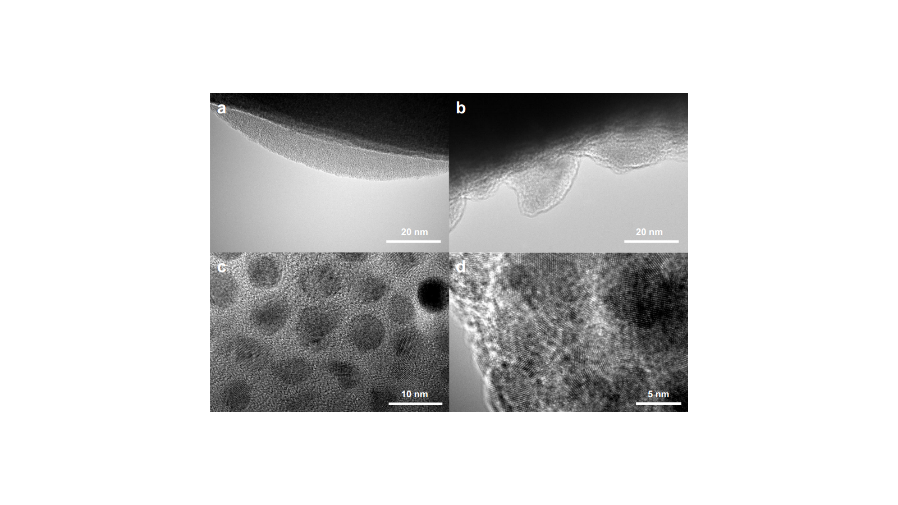

Fig. S4. High resolution TEM (HRTEM) images of the Ni_{0.9}Fe_{0.05}Co_{0.05}/p⁺n-Si photoanode.
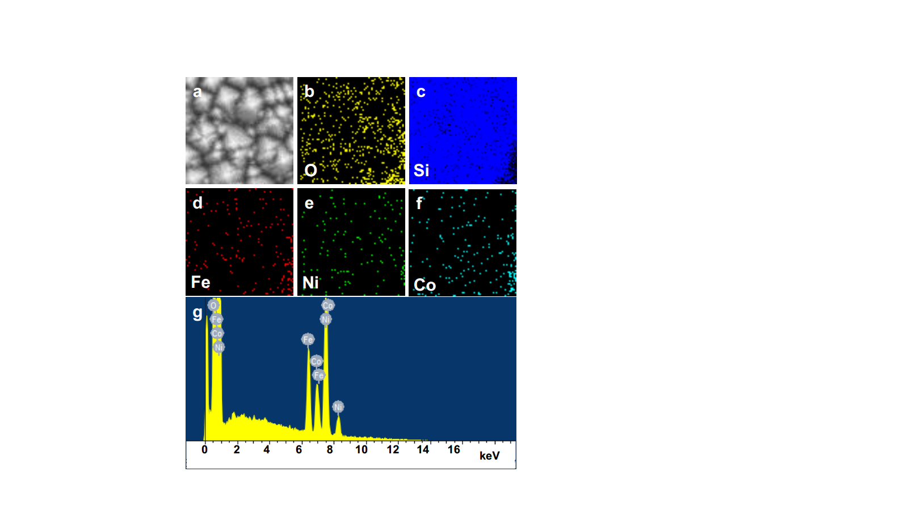

Fig. S5. SEM elemental distribution spectrum (SEM-EDS) of the Ni_{0.9}Fe_{0.05}Co_{0.05} protective layer deposited on the p⁺n-Si substrate. (a) SEM image of the selected area; (b–f) O, Si, Fe, Ni, and Co element map of (a); (g) energy-dispersive X-ray spectrum of (a).

Fig. S6. X-ray diffraction (XRD) pattern of the Ni_{0.9}Fe_{0.05}Co_{0.05}/p⁺n-Si photoanode.
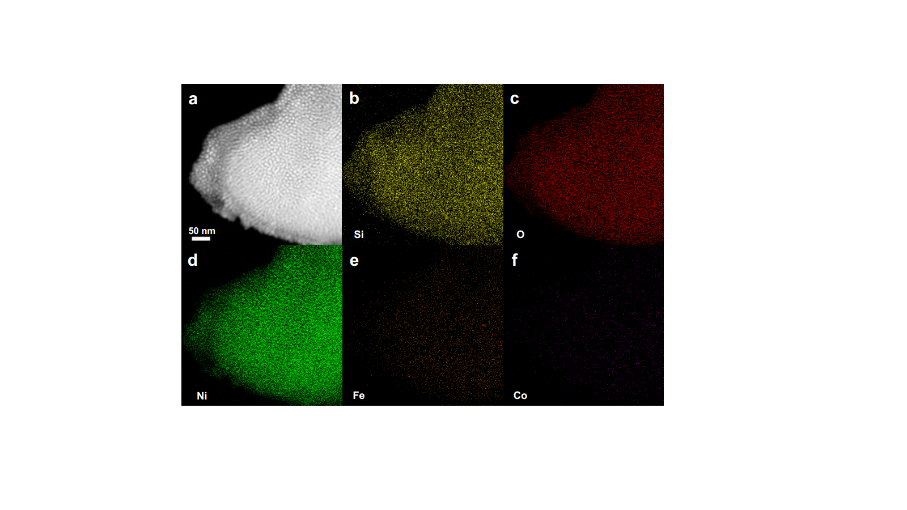

Fig. S7. TEM elemental distribution spectrum (TEM-EDS) mapping of the Ni_{0.9}Fe_{0.05}Co_{0.05} protective layer deposited on the p⁺n-Si substrate. (a) STEM image of the selected area; (b–f) Si, O, Ni, Fe, and Co element map of (a).

Table S1. The calculated and the measured amounts of O₂ and H₂ gas products during PEC reaction.
PEC reaction | Charge (C) | Calculated amounts (μmol) |  | Measured amounts (μmol)
 |  | H₂(g) | O₂(g) | H₂(g) | O₂(g)
0 min | 0 | 0 | 0 | 0 | 0
15 min | 8.11 | 42.084 | 21.042 | 40.094 | 20.503
30 min | 16.21 | 84.116 | 42.058 | 80.031 | 40.297
45 min | 24.30 | 126.097 | 63.048 | 124.933 | 62.507
60 min | 32.392 | 168.088 | 84.043 | 163.032 | 80.361
75 min | 40.47 | 210.006 | 105.002 | 196.909 | 101.798
90 min | 48.63 | 252.35 | 126.174 | 238.97 | 122.768
105 min | 56.823 | 294.865 | 147.431 | 278.229 | 145.596
120 min | 65.032 | 337.463 | 168.73 | 324.076 | 165.507

Table S2. PEC performances of the Si-based photoanodes deposited with Ni-based layers reported in previous literatures. The onset potential is defined as the potential reaching an anodic photocurrent density of 1 mA∙cm⁻².
Photoanode | V_{on} (V vs RHE) | J_{ph} (mA∙cm⁻²) | Stability (h) | ABPE (%) | Electrolyte | Ref.
Ni_{0.9}Fe_{0.05}Co_{0.05}/p⁺n-Si | 0.938 | 33.1 | 41 h | 3.2 | 1.0 mol∙L⁻¹ NaOH | This work
n-Si/Ni/NiOOH/NiFe | 1.0 | 25.2 | — | 1.42^{b} | 1.0 mol∙L⁻¹ KOH | [9]
n-Si/Ni/NiOOH/NiFe | — | — | 20 h (~90%) | — | 1.0 mol∙L⁻¹ K-borate | [9]
n-Si/Ni/Fe:NiOOH | 1.01 | 19.2 | — | 0.81^{b} | 1.0 mol∙L⁻¹ KOH | [10]
n-Si/Ni/Fe:NiOOH | — | — | 30 h | — | 1.0 mol∙L⁻¹ K-borate | [10]
n-Si/SiO_{x}/Ni@Co | 1.02 | 10.65 | — | — | 1.0 mol∙L⁻¹ NaOH | [11]
n-Si/SiO_{x}/Ni@Co | — | — | 100 h | — | 1.0 mol∙L⁻¹ K-borate | [11]
n-Si/NiFe (1 nm) | 1.06 | 25.4 | 24 h (~60%) | 1.08^{b} | 1.0 mol∙L⁻¹ NaOH | [12]
n-Si/NiFe (2 nm) | 1.09 | 25.2 | 50 h | 0.85^{b} | 1.0 mol∙L⁻¹ NaOH | [12]
NiO_{x}/Ni/n-Si | 1.08 | 14.7 | — | — | 1.0 mol∙L⁻¹ NaOH | [13]
NiO_{x}/Ni/n-Si | — | — | 80 h | — | 1.0 mol∙L⁻¹ K-borate | [13]
n-Si/Ni | 1.1 | 3.5 | 10 h | — | 1.0 mol∙L⁻¹ NaOH | [14]
p⁺n-Si/NiFe | 0.94 | 31.2 | 11 h | 2.7^{b} | 1.0 mol∙L⁻¹ KOH | [15]
np⁺-Si/SiO_{x}/NiFeª | 0.92* | 30.7 | 14 h (rapid decay) | 3.3^{b} | 1.0 mol∙L⁻¹ KOH | [16]
np⁺-Si/SiO_{x}/NiFeª | 1.03* | ~12 | 100 h | — | 1.0 mol∙L⁻¹ K-borate | [16]
np⁺-Si/NiCo₂O₄/NiFe | 0.99* | 26 | 72 h | — | 1.0 mol∙L⁻¹ KOH | [17]
ª The PEC performance of photoanode was measured with IR correction in the literature.
^{b} The Faradaic efficiency was not measured and assumed to be 100% in the literature.
* The onset potential of photoanode was extracted from the corresponding literature.

Fig. S8. CV curves of the Ni_{0.9}Fe_{0.05}Co_{0.05}/p⁺n-Si photoanode before and after stored in atmosphere for 6 months.

Fig. S9. XPS valence band (VB) spectra of the Ni, Ni_{0.9}Fe_{0.1}, and Ni_{0.9}Fe_{0.05}Co_{0.05} layers.

Fig. S10. CV curves collected in 1.0 mol∙L⁻¹ NaOH in a non-Faradaic region at different scan rates varying from 5 to 200 mV∙s⁻¹. (a) Ni/p⁺-Si; (b) Ni_{0.9}Fe_{0.1}/p⁺-Si; (c) Ni_{0.9}Fe_{0.05}Co_{0.05}/p⁺-Si.

Table S3. The fitting data of EIS plots for different p⁺n-Si-based photoanodes (0.25 cm²) at 1.0 V versus RHE under simulated solar illumination.
Photoanode | R_{S} (Ω) | R_{SC1} (Ω) | R_{SC2} (Ω)
Ni/p⁺n-Si | 7.8 | 12 | 1592
Ni_{0.9}Fe_{0.1}/p⁺n-Si | 8.2 | 6.7 | 91
Ni_{0.9}Fe_{0.05}Co_{0.05}/p⁺n-Si | 7.9 | 6.8 | 11.6
R_{S}: the resistance of the external circuits, including the electrolyte resistance, the circuit wire resistance, and the contact resistance between the work photoanode and the wire; R_{SC1}: the resistance of charge transfer at the metallic layer/p⁺n-Si interface; R_{SC2}: the resistance of interfacial charge transfer at the metallic layer/electrolyte interface.

Fig. S11. LSV curves of the Ni/p⁺n-Si, Ni_{0.9}Fe_{0.1}/p⁺n-Si and Ni_{0.9}Fe_{0.05}Co_{0.05}/p⁺n-Si photoanode in 1.0 mol∙L⁻¹ NaOH (pH = 13.6) and NaOH/TEOA (pH = 13.6) electrolyte, respectively. J_{H2O}: photocurrent density of photoanode (solid line) in 1.0 mol∙L⁻¹ NaOH (pH = 13.6) electrolyte. J_{TEOA}: photocurrent density of photoanode (dash line) in 1.0 mol∙L⁻¹ NaOH electrolyte containing 5 vol% TEOA (pH = 13.6).

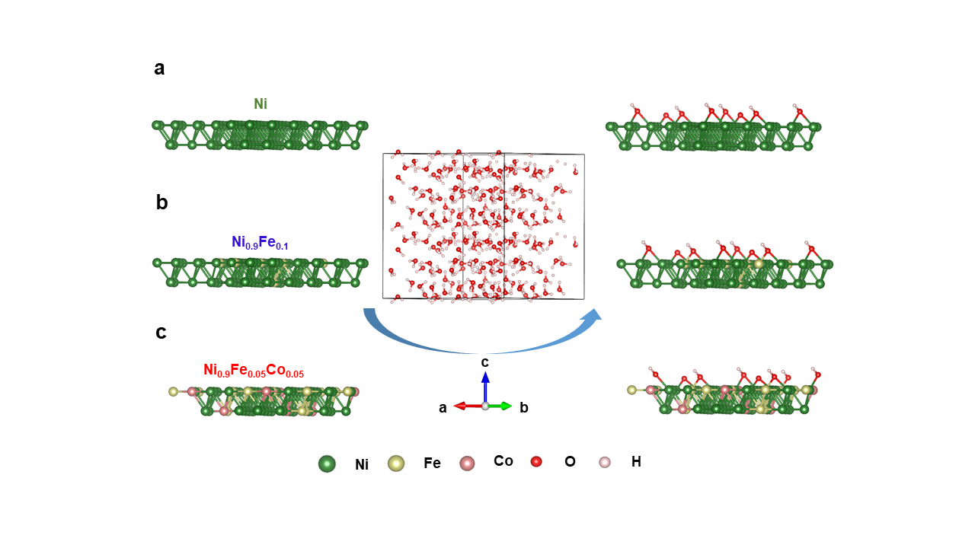

Fig. S12. Reactive force field MD (ReaxFF MD) simulations of the interaction between water and catalytic surface in aqueous solution for (a) Ni, (b) Ni_{0.9}Fe_{0.1}, and (c) Ni_{0.9}Fe_{0.05}Co_{0.05}.

Table S4. ΔG of each step (eV) and η (V) of the OER process (U = 0 V, pH = 0).
Reactions | Ni |  | Ni_{0.9}Fe_{0.1} |  | Ni_{0.9}Fe_{0.05}Co_{0.05}
Reactions | ΔG (eV) | η (V) | ΔG (eV) | η (V) | ΔG (eV) | η (V)
* + H₂O → *OH + H⁺ + e⁻ | 0.92 | 0.99 | 0.87 | 0.78 | 0.75 | 0.58
*OH → *O + H⁺ + e⁻ | 1.35 | 0.99 | 0.90 | 0.78 | 0.93 | 0.58
*O + H₂O → *OOH + H⁺ + e⁻ | 2.22 | 0.99 | 2.01 | 0.78 | 1.43 | 0.58
*OOH → * + O₂ + H⁺ + e⁻ | 0.43 | 0.99 | 1.14 | 0.78 | 1.81 | 0.58

Fig. S13. LSV curve of Ni_{0.9}Fe_{0.05}Co_{0.05}/p⁺n-Si photoanode under simulated solar illumination in 1.0 mol∙L⁻¹ NaOH in a two-electrode system.

As shown in Fig. S14, 2-SC Si solar cell (1.26 cm²) exhibits a small open circuit voltage (V_{oc}) of 1.15 V (Fig. S14(a)), although the solar-to-electric power conversion efficiency reaches ~22% at 0.852 V (Fig. S14(b)). Due to the small V_{oc}, the 2-SC Si solar cell (1.26 cm²) is not able to drive water splitting with a two-electrode device consisting of the Ni_{0.9}Fe_{0.05}Co_{0.05}/p⁺n-Si photoanode and the Pt cathode. The 3-SC Si solar cell (1.89 cm²) could produce a V_{oc} of 1.75 V, large enough to drive the two-electrode water splitting device, however, the solar-to-electric power conversion efficiency is only ~15% at 1.41 V. By reducing the area of the 3-SC Si solar cell to be 1 cm², the solar-to-electric power conversion efficiency could reach as high as ~20% at 1.38 V, with V_{oc} maintained at ~1.71 V. Thus, the 3-SC Si solar cell (1 cm²) was selected to couple with the Ni_{0.9}Fe_{0.05}Co_{0.05}/p⁺n-Si photoanode to fabricate a PV/PEC device for unassisted solar-driven water splitting.

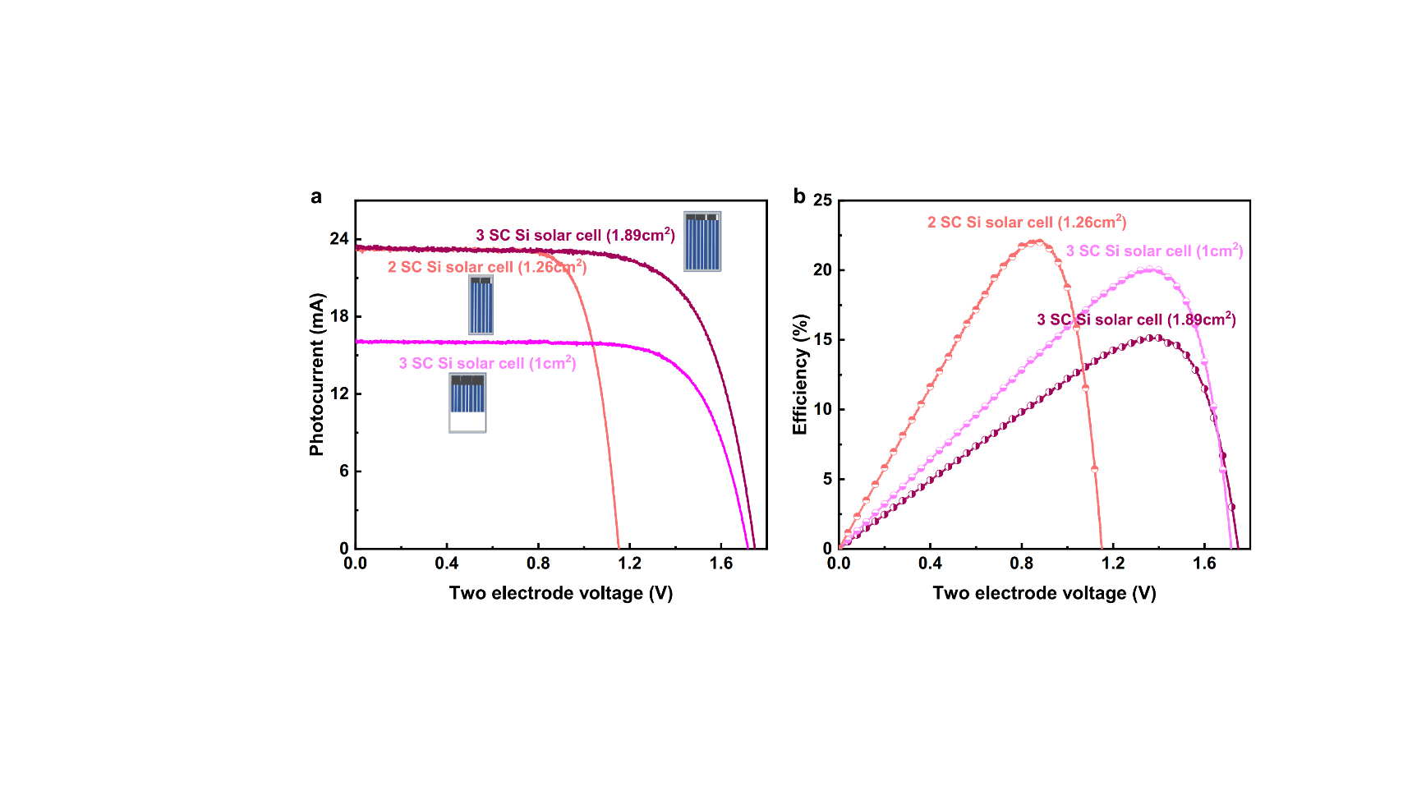

Fig. S14. (a) LSV curves and (b) solar-to-electric power conversion efficiency of different series-connected (SC) Si solar cells under simulated solar illumination.

As shown in Fig. S15(a), the current of the commercial RuIr/Ti mesh electrode at 1.69 V versus RHE could reach 100 mA in three-electrode electrochemical system. However, to achieve 100 mA in two-electrode electrochemical system, the RuIr/Ti mesh electrode requires an external bias of 1.75 V (Fig. S15(b)).

Fig. S15. (a) LSV curve of RuIr/Ti mesh electrode in three-electrode electrochemical system in 1.0 mol∙L⁻¹ H₂SO₄. (b) LSV curve of RuIr/Ti mesh electrode in two-electrode electrochemical system in 1.0 mol∙L⁻¹ H₂SO₄.

Fig. S16. Current–potential (J–V) curves of the Ni₉Fe_{0.5}Co_{0.5}/p⁺n-Si photoanode, RuIr/Ti mesh electrode, and Si PV tested using a two-electrode configuration.

Table S5. Si-based PV/PEC devices for unassisted solar water splitting.
Photoanode | Cathode | PV | STH (%) | Stability (h) | Electrolyte | Ref.
Ni_{0.9}Fe_{0.05}Co_{0.05}/p⁺n-Si  (0.51 cm²) | Pt | Si (1 cm²) | 12.0 | 20 | 1.0 mol∙L⁻¹ NaOH | This work
Ni-Mo/Ni/p⁺pn⁺-Si  (0.25 cm²) | Ni-Mo/Ni/n⁺np⁺-Si  (0.25 cm²) | Si (0.5 cm²) | 9.8 | 100 | 1.0 mol∙L⁻¹ KOH | [18]
H,Mo:BiVO₄/CoP  (0.32 cm²) | CoP/Ni | Si | 5.3 | 2 | 0.5 mol∙L⁻¹ KPi | [19]
Mo:BiVO₄/Ti:Fe₂O₃  (0.24 cm²) | Pt | Si (0.25 cm²) | 7.7 | 8 | 1.0 mol∙L⁻¹ KCi | [20]
W:BiVO₄/CoPi  (0.283 cm²) | Pt | Si | 5.2 | — | 0.1 mol∙L⁻¹ KPi | [21]

References
[1] Gao J, Sahli F, Liu C, Ren D, Guo X, Werner J, et al. Solar water splitting with perovskite/silicon tandem cell and TiC-supported Pt nanocluster electrocatalyst. Joule 2019;3(12):2930–41.
[2] Kresse G, Furthmüller J. Efficiency of ab-initio total energy calculations for metals and semiconductors using a plane-wave basis set. Comput Mater Sci 1996;6(1):15–50.
[3] Kresse G, Hafner J. Ab initio molecular dynamics for open-shell transition metals. Phys Rev B 1993;48(17):13115–8.
[4] Kresse G, Hafner J. Ab initio molecular-dynamics simulation of the liquid-metal–amorphous-semiconductor transition in germanium. Phys Rev B 1994;49(20):14251–69.
[5] Kresse G, Joubert D. From ultrasoft pseudopotentials to the projector augmented-wave method. Phys Rev B 1999;59(3):1758–75.
[6] Perdew JP, Burke K, Ernzerhof M. Generalized gradient approximation made simple. Phys Rev Lett 1996;77(18):3865–8.
[7] Nørskov JK, Rossmeisl J, Logadottir A, Lindqvist L, Kitchin JR, Bligaard T, et al. Origin of the overpotential for oxygen reduction at a fuel-cell cathode. J Phys Chem B 2004;108(46):17886–92.
[8] Zhao X, Liu X, Huang B, Wang P, Pei Y. Hydroxyl group modification improves the electrocatalytic ORR and OER activity of graphene supported single and bi-metal atomic catalysts (Ni, Co, and Fe). J Mater Chem A 2019;7(42):24583–93.
[9] Cai Q, Hong W, Jian C, Liu W. A high-performance silicon photoanode enabled by oxygen vacancy modulation on NiOOH electrocatalyst for water oxidation. Nanoscale 2020;12(14):7550–6.
[10] Cai Q, Hong W, Jian C, Liu W. Ultrafast hot ion-exchange triggered electrocatalyst modification and interface engineering on silicon photoanodes. Nano Energy 2020;70:104485.
[11] Chen J, Xu G, Wang C, Zhu K, Wang H, Yan S, et al. High-performance and stable silicon photoanode modified by crystalline Ni@amorphous Co core–shell nanoparticles. ChemCatChem 2018;10(21):5025–31.
[12] Li C, Huang M, Zhong Y, Zhang L, Xiao Y, Zhu H. Highly efficient NiFe nanoparticle decorated Si photoanode for photoelectrochemical water oxidation. Chem Mater 2019;31(1):171–8.
[13] Lee SA, Lee TH, Kim C, Lee MG, Choi MJ, Park H, et al. Tailored NiO_{x}/Ni cocatalysts on silicon for highly efficient water splitting photoanodes via pulsed electrodeposition. ACS Catal 2018;8(8):7261–9.
[14] Loget G, Fabre B, Fryars S, Mériadec C, Ababou-Girard S. Dispersed Ni nanoparticles stabilize silicon photoanodes for efficient and inexpensive sunlight-assisted water oxidation. ACS Energy Lett 2017;2(3):569–73.
[15] Oh S, Song H, Oh J. An optically and electrochemically decoupled monolithic photoelectrochemical cell for high-performance solar-driven water splitting. Nano Lett 2017;17(9):5416–22.
[16] Yu X, Yang P, Chen S, Zhang M, Shi G. NiFe alloy protected silicon photoanode for efficient water splitting. Adv Energy Mater 2017;7(6):1601805.
[17] Chen L, Yang J, Klaus S, Lee LJ, Woods-Robinson R, Ma J, et al. p-Type transparent conducting oxide/n-type semiconductor heterojunctions for efficient and stable solar water oxidation. J Am Chem Soc 2015;137(30):9595–603.
[18] Fan R, Cheng S, Huang G, Wang Y, Zhang Y, Vanka S, et al. Unassisted solar water splitting with 9.8% efficiency and over 100 h stability based on Si solar cells and photoelectrodes catalyzed by bifunctional Ni–Mo/Ni. J Mater Chem A 2019;7(5):2200–9.
[19] Kim JH, Han S, Jo YH, Bak Y, Lee JS. A precious metal-free solar water splitting cell with a bifunctional cobalt phosphide electrocatalyst and doubly promoted bismuth vanadate photoanode. J Mater Chem A 2018;6(3):1266–74.
[20] Kim JH, Jang JW, Jo YH, Abdi FF, Lee YH, van de Krol R, et al. Hetero-type dual photoanodes for unbiased solar water splitting with extended light harvesting. Nat Commun 2016;7(1):13380.
[21] Han L, Abdi FF, van de Krol R, Liu R, Huang Z, Lewerenz HJ, et al. Efficient water-splitting device based on a bismuth vanadate photoanode and thin-film silicon solar cells. ChemSusChem 2014;7(10):2832–8.

