Supplementary file for
TRPML1 Controls Mitochondrial Homeostasis and Alleviates Cardiac Hypertrophy by Inhibiting VDAC1 Oligomerization
Xiuye Zhao^{a,#}, Mingxiu Zhang^{a,#}, Changling Lv^{a,#}, Chunlei Duanª, Zhen Chenª, Yan Haoª, Zhen Liangª, Yiping Taoª, Hongda Liª, Zhenru Wangª, Haonan Duª, Jiapan Wangª, Wenjie Liaoª, Peifeng Liª, Jia Wangª, Xueqi Heª, Yu Zhangª, Xinyuan Haoª, Hongyu Jiª, Yan Zhangª, Xingda Liª, Ye Yuan^{a,}*, Zhimin Du^{a,b,}*
ª Institute of Clinical Pharmacology, the Second Affiliated Hospital of Harbin Medical University & State Key Laboratory of Frigid Zone Cardiovascular Disease, Harbin Medical University, Harbin 150081, China
^{b} State Key Laboratory of Mechanism and Quality of Chinese Medicine, Macau University of Science and Technology, Macao 999078, China

# These authors contributed equally to this work.

* Corresponding authors.
E-mail addresses: dzm1956@126.com (Z. Du), yuanye_hmu@126.com (Y. Yuan).

1. Supplementary figures
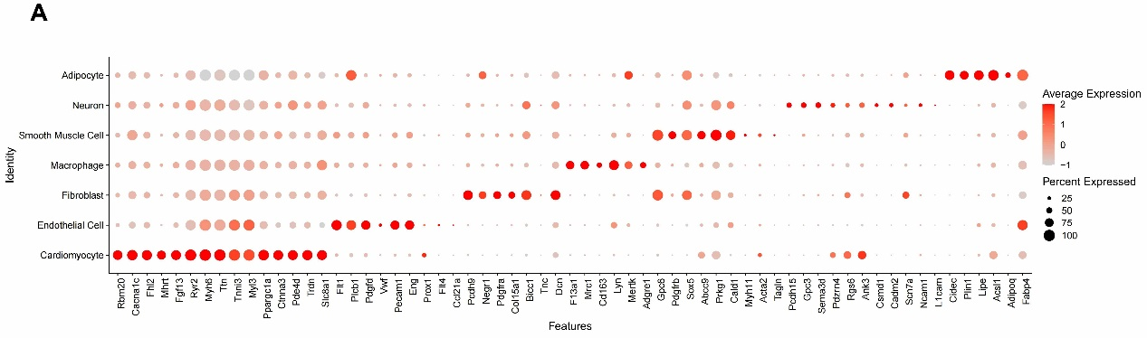
Fig. S1. Expression of cell markers for each cell type in single cell sequencing data. Dot map showing differentially expressed cell marker genes in each cell type in GSE255054.

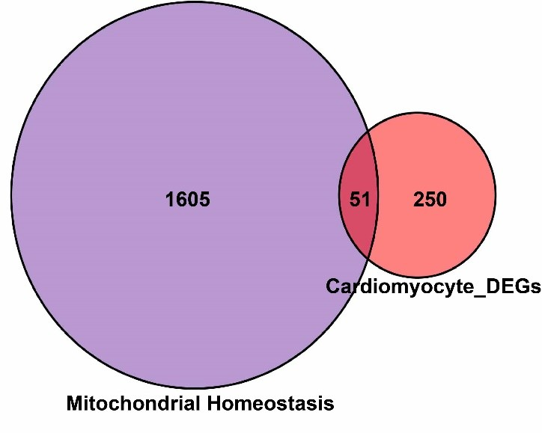
Fig. S2. Identification of mitochondrial homeostatic differential genes. Mitochondrial homeostasis and cardiac cell differential Venn profiles.

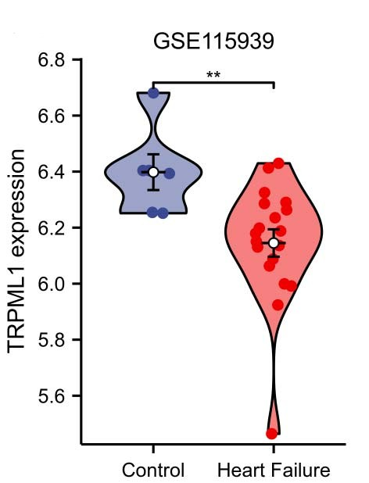
Fig. S3. TRPML1 expression is downregulated in HF patients. Expression analysis of TRPML1 by bulk RNA-seq in healthy individuals and patients with HF. **P < 0.01 vs Control. Data are represented as mean ± SEM.
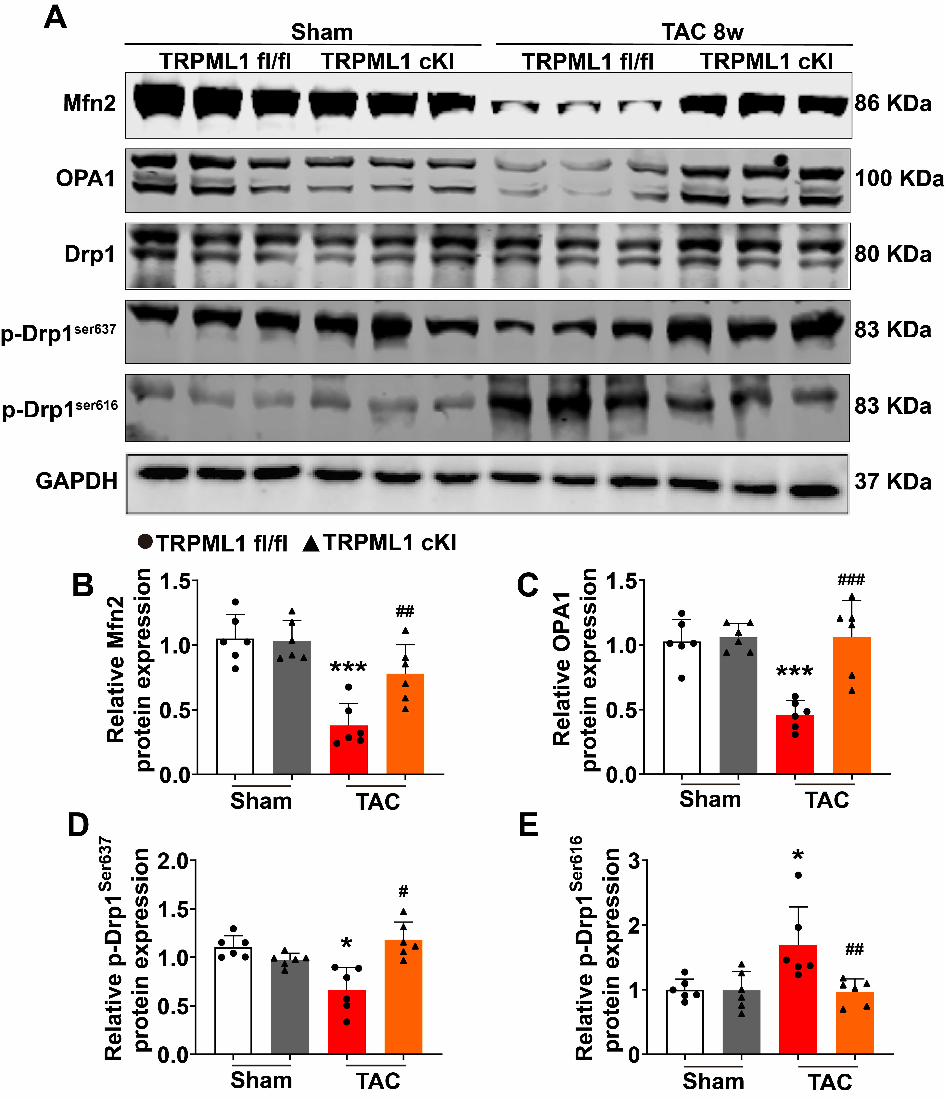
Fig. S4. TRPML1 cardiac-specific knock-in increased the protein expression of mitochondrial fusion but decreased the protein expression of mitochondrial fission. (a) Representative images of western blot analysis of Mfn2, OPA1, T-Drp1, p-Drp1^{Ser637}, and p-Drp1^{Ser616} protein expression after sham or TAC surgery in TRPML1^{fl/fl} and TRPML1 cKI mice. (b) Statistical data of Mfn2 protein expression level (n = 6). ***P < 0.001 vs sham + TRPML1^{fl/fl}; ##P < 0.01 vs TAC + TRPML1^{fl/fl}. (c) Statistical data of OPA1 protein expression level (n = 6). ***P < 0.001 vs sham + TRPML1^{fl/fl}; ###P < 0.001 vs TAC + TRPML1^{fl/fl}. (d). Statistical data of p-Drp1^{Ser637} protein expression level (n = 6). *P < 0.05 vs sham + TRPML1^{fl/fl}; #P < 0.05 vs TAC + TRPML1^{fl/fl}. (e) Statistical data of p-Drp1^{Ser616} protein expression level (n = 6). *P < 0.05 vs sham + TRPML1^{fl/fl}; ##P < 0.01 vs TAC + TRPML1^{fl/fl}. Data are represented as mean ± SEM.

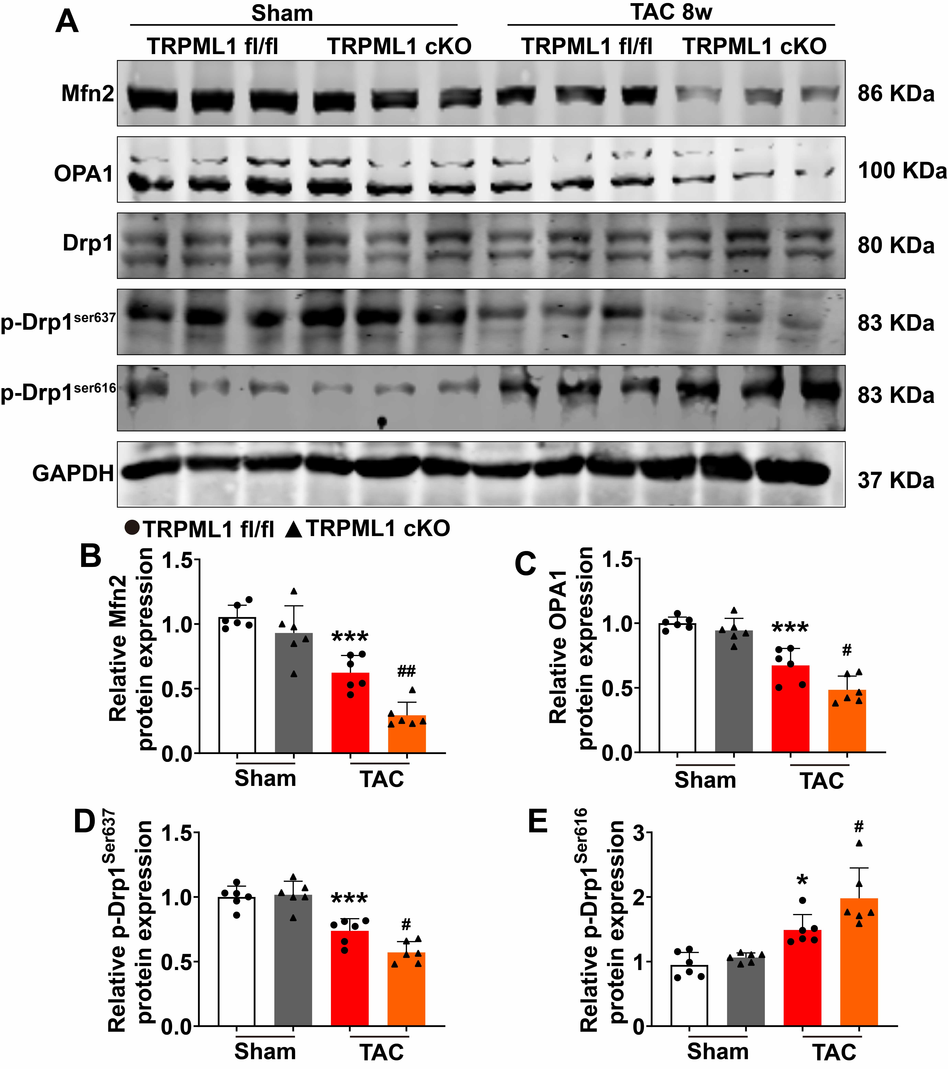
Fig. S5. TRPML1 cardiac-specific knockout decreased the protein expression of mitochondrial fusion but increased the protein expression of mitochondrial fission. (a) Representative images of western blot analysis of Mfn2, OPA1, T-Drp1, p-Drp1^{Ser637}, and p-Drp1^{Ser616} protein expression after sham or TAC surgery in TRPML1^{fl/fl} and TRPML1 cKO mice. (b) Statistical data of Mfn2 protein expression level (n = 6). ***P < 0.001 vs sham + TRPML1^{fl/fl}; ##P < 0.01 vs TAC + TRPML1^{fl/fl}. (c) Statistical data of OPA1 protein expression level (n = 6). ***P < 0.001 vs Sham + TRPML1^{fl/fl}; #P < 0.05 vs TAC + TRPML1^{fl/fl}. (d) Statistical data of p-Drp1^{ser637} protein expression level (n = 6). ***P < 0.001 vs sham + TRPML1^{fl/fl}; #P < 0.05 vs TAC + TRPML1^{fl/fl}. (e) Statistical data of p-Drp1^{ser616} protein expression level (n = 6). *P < 0.05 vs sham + TRPML1^{fl/fl}; #P < 0.05 vs TAC + TRPML1^{fl/fl}. Data are represented as mean ± SEM.

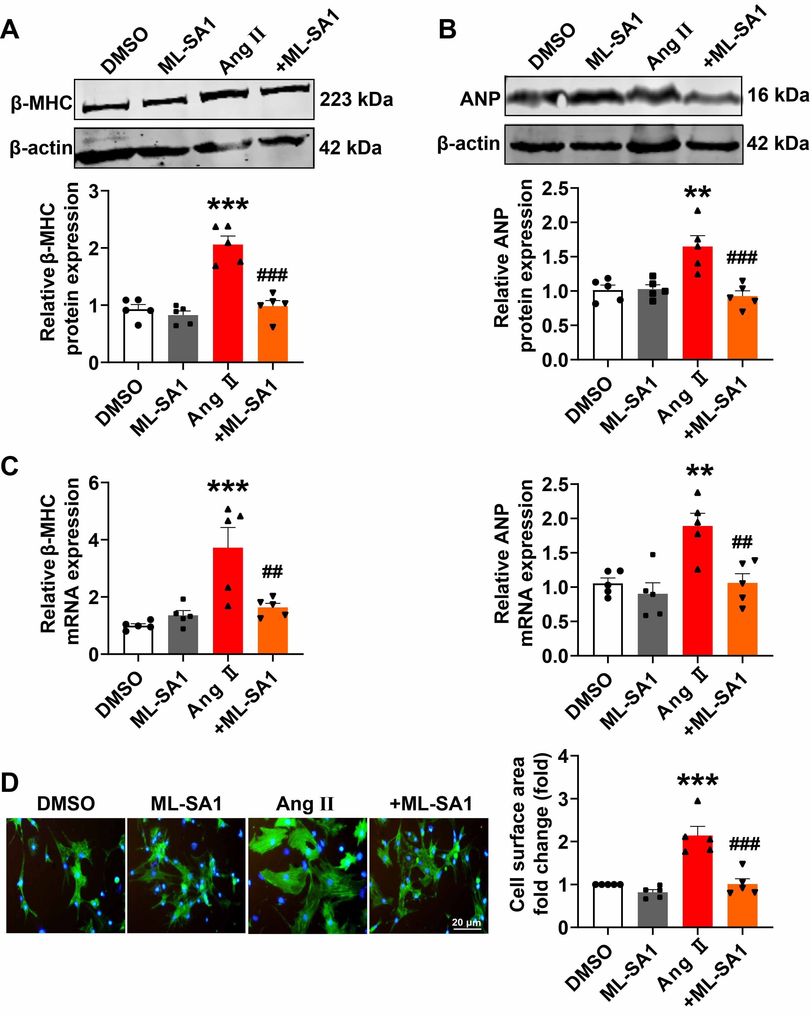
Fig. S6. Increased TRPML1 activity inhibits cardiac hypertrophy. (a) Western blot analysis of β-MHC protein expression in hypertrophic cardiomyocytes after ML-SA1 stimulation (n = 5). ***P < 0.001 vs DMSO; ###P < 0.001 vs Ang II. (b) Western blot analysis of ANP protein expression in hypertrophic cardiomyocytes after ML-SA1 stimulation (n = 5). **P < 0.01 vs DMSO; ###P < 0.001 vs Ang II. (c) qRT-PCR analysis of β-MHC and ANP mRNA expression in hypertrophic cardiomyocytes after ML-SA1 stimulation (n = 5). **P < 0.01 and ***P < 0.001 vs DMSO; ##P < 0.01 vs Ang II. (d) Immunofluorescence analysis of cell surface area in hypertrophic cardiomyocytes after ML-SA1 stimulation (n = 5; scale bar = 20 μm). ***P < 0.001 vs DMSO; ###P < 0.001 vs Ang II. Data are represented as mean ± SEM.

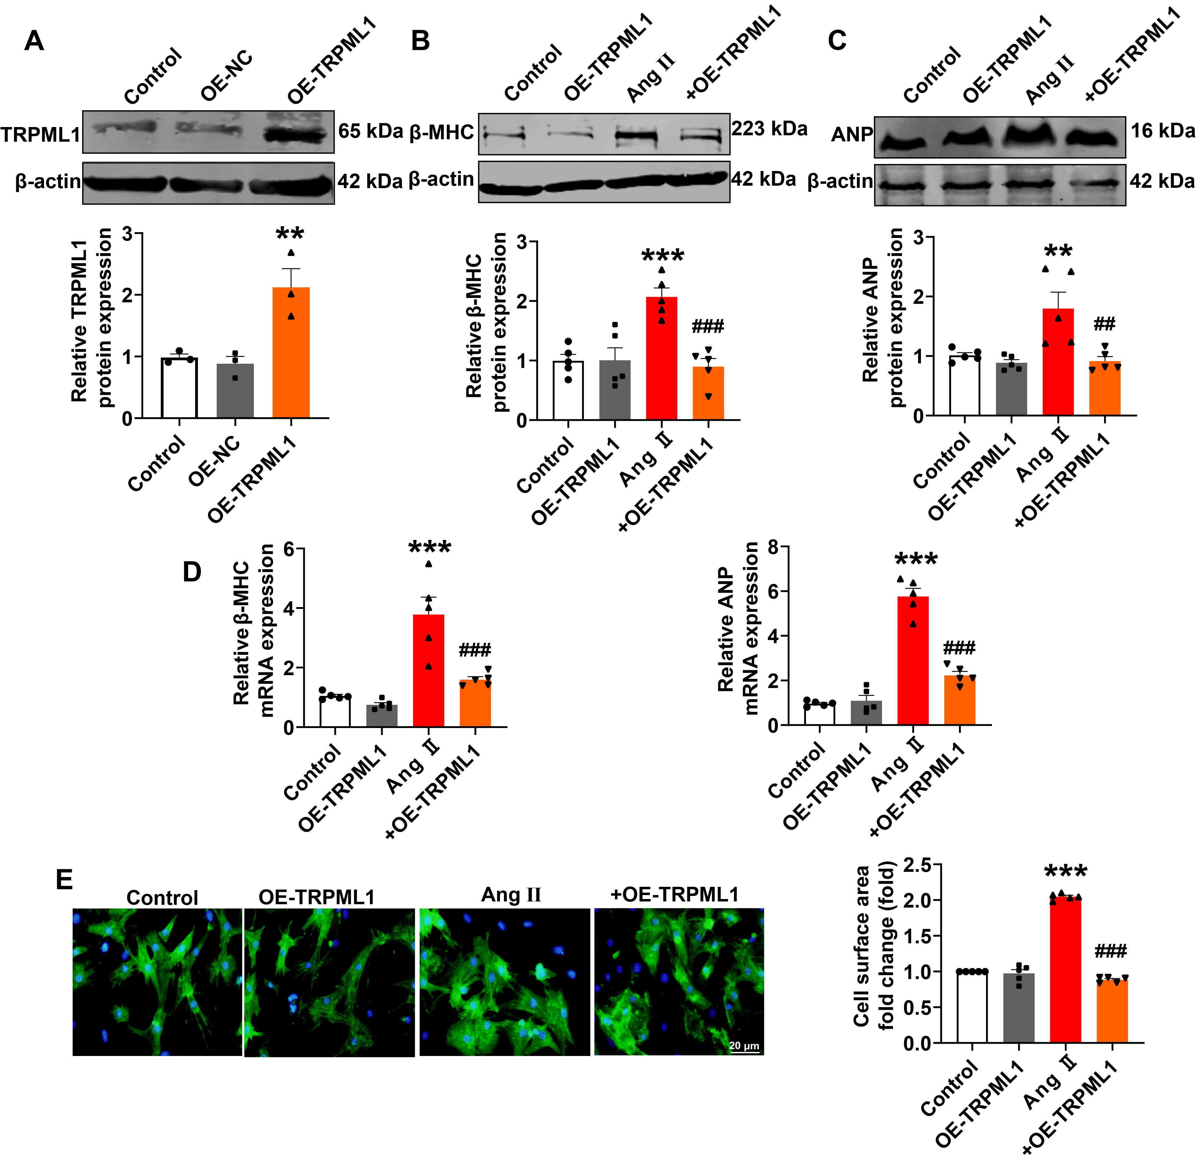
Fig. S7. Overexpression of TRPML1 (OE-TRPML1) inhibits cardiac hypertrophy. (a) Western blot analysis of TRPML1 protein expression after transfection with pcDNA3.1-TRPML1 or pcDNA3.1-NC (n = 3). **P < 0.01 vs OE-NC. (b) Western blot analysis of β-MHC protein expression after transfection with pcDNA3.1-TRPML1 in hypertrophic cardiomyocytes (n = 5). ***P < 0.001 vs control; ###P < 0.001 vs Ang II. (c) Western blot analysis of ANP protein expression after transfection with pcDNA3.1-TRPML1 in hypertrophic cardiomyocytes (n = 5). **P < 0.01 vs control; ##P < 0.01 vs Ang II. (d) qRT-PCR analysis of β-MHC and ANP mRNA expression after transfection with pcDNA3.1-TRPML1 in hypertrophic cardiomyocytes (n = 5). ***P < 0.001 vs control; ###P < 0.001 vs Ang II. (e) Immunofluorescence analysis of cell surface area after transfection with pcDNA3.1-TRPML1 in hypertrophic cardiomyocytes (n = 5). ***P < 0.001 vs control; ###P < 0.001 vs Ang II. Data are represented as mean ± SEM.

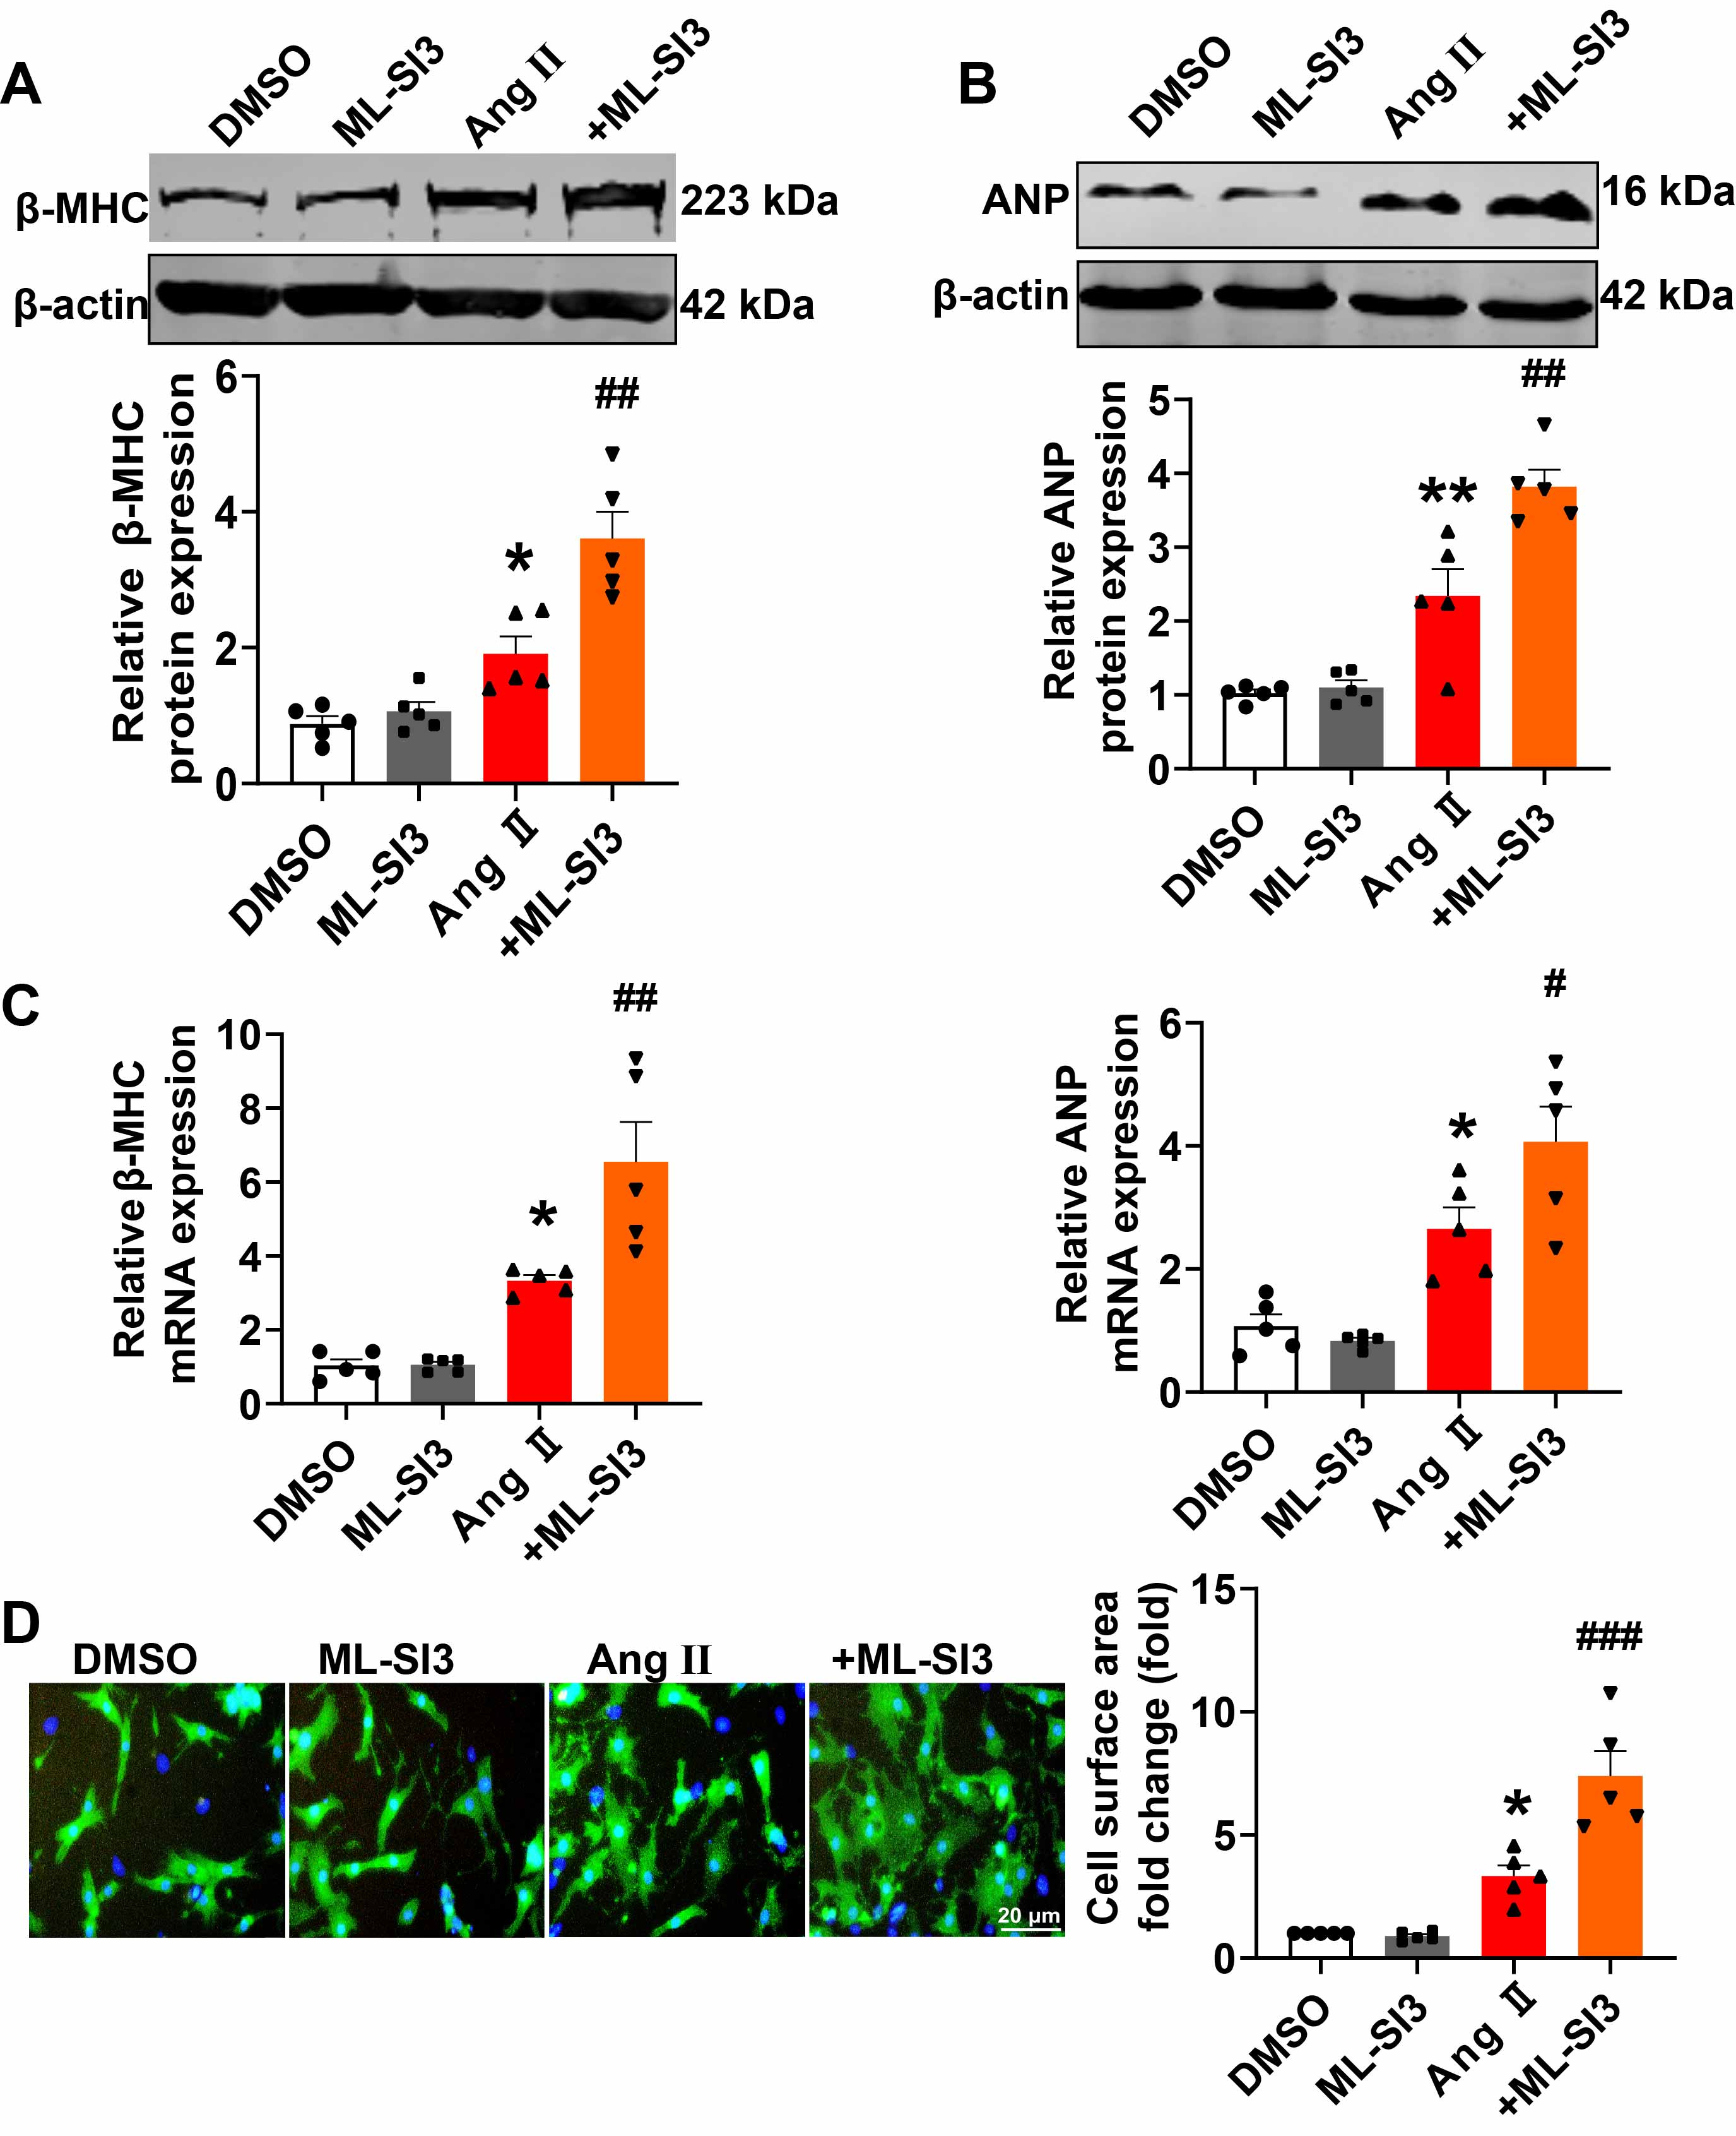
Fig. S8. Decreased TRPML1 activity promotes cardiac hypertrophy. (a) Western blot analysis of β-MHC protein expression after stimulation with ML-SI3 in hypertrophic cardiomyocytes (n = 5). *P < 0.05 vs DMSO; ##P < 0.01 vs Ang II. (b) Western blot analysis of ANP protein expression after stimulation with ML-SI3 in hypertrophic cardiomyocytes (n = 5). **P < 0.01 vs DMSO; ##P < 0.01 vs Ang II. (c) qRT-PCR analysis of β-MHC and ANP mRNA expression after stimulation with ML-SI3 in hypertrophic cardiomyocytes (n = 5). *P < 0.05 vs DMSO; #P < 0.05 and ##P < 0.01 vs Ang II. (d) Immunofluorescence analysis of cell surface area after stimulation with ML-SI3 in hypertrophic cardiomyocytes (n = 5). *P < 0.05 vs DMSO; ###P < 0.001 vs Ang II. Data are represented as mean ± SEM.

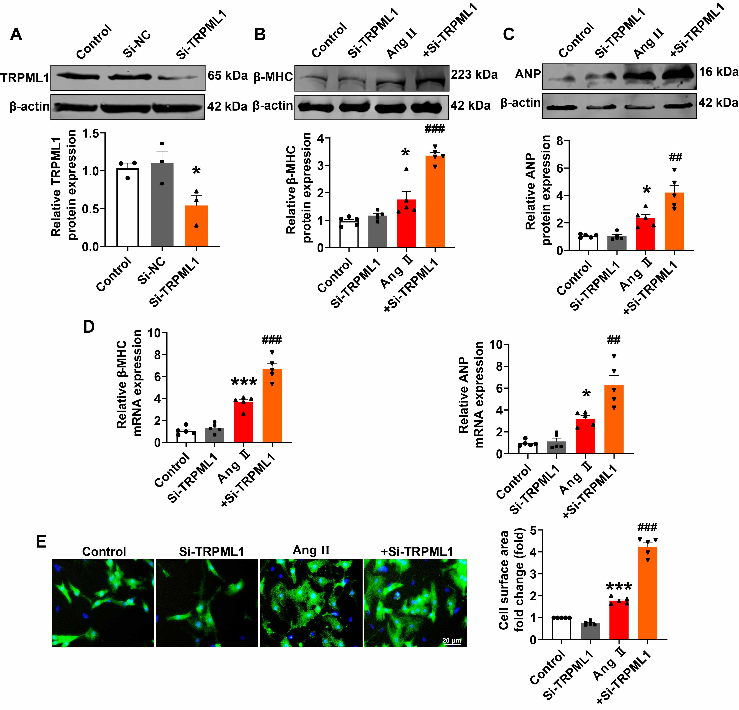
Fig. S9. Knockdown of TRPML1 promotes cardiac hypertrophy. (a) Western blot analysis of TRPML1 protein expression after transfection with si-TRPML1 or si-NC (n = 3). *P < 0.05 vs si-NC. (b) Western blot analysis of β-MHC protein expression after transfection with si-TRPML1 in hypertrophic cardiomyocytes (n = 5). *P < 0.05 vs control; ###P < 0.001 vs Ang II. (c) Western blot analysis of ANP protein expression after transfection with si-TRPML1 in hypertrophic cardiomyocytes (n = 5). *P < 0.05 vs control; ##P < 0.01 vs Ang II. (d) qRT-PCR analysis of β-MHC and ANP mRNA expression after transfection with si-TRPML1 in hypertrophic cardiomyocytes (n = 5). *P < 0.05 and ***P < 0.001 vs control; ##P < 0.01 and ###P < 0.001 vs Ang II. (e) Immunofluorescence analysis of cell surface area after transfection with si-TRPML1 in hypertrophic cardiomyocytes (n = 5). ***P < 0.001 vs control; ###P < 0.001 vs Ang II. Data are represented as mean ± SEM.

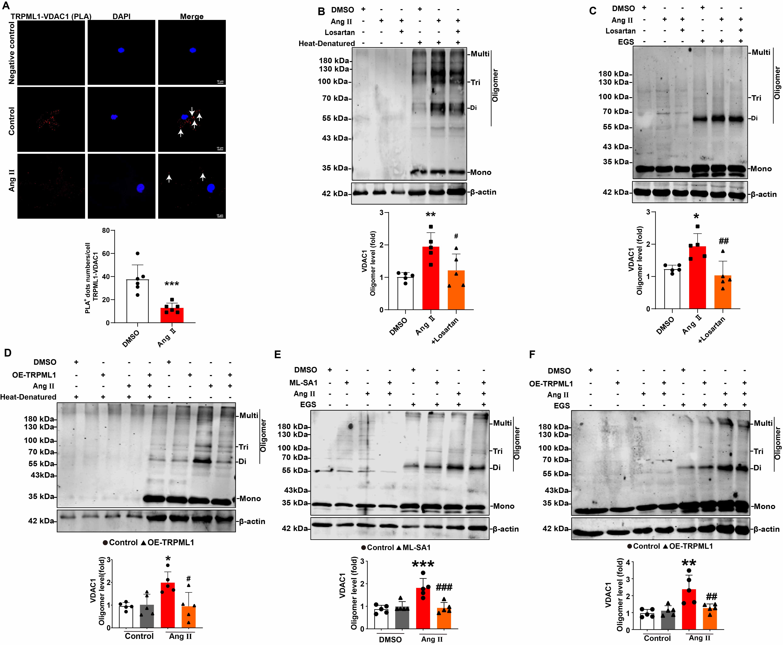
Fig. S10. TRPML1 interacts with VDAC1. (a) The interaction between TRPML1 and VDAC1 was detected by proximity ligation assay in NMCMs after treatment with Ang II for 24 hours (n = 5; scale bar, 10 μm). ***P < 0.001 vs. DMSO. Arrows showing proximity. (b) Western blot analysis of VDAC1 oligomerization after treatment with Ang II and AT1R (n = 5). *P < 0.05 vs. DMSO; ##P < 0.01 vs. Ang II. (c) Western blot analysis of VDAC1 oligomerization after treatment with Ang II and AT1R (n = 5). *P < 0.05 vs. DMSO; ##P < 0.01 vs. Ang II. (d) Western blot analysis of VDAC1 oligomerization after treatment with Ang II and OE-TRPML1 (n = 5). **P < 0.01 vs. Control; ##P < 0.01 vs. Ang II. (e) Western blot analysis of VDAC1 oligomerization after treatment with Ang II and ML-SA1 (n = 5). ***P < 0.001 vs. DMSO; ###P < 0.001 vs. Ang II. (f) Western blot analysis of VDAC1 oligomerization after treatment with Ang II and OE-TRPML1 (n = 5). **P < 0.01 vs. Control; ##P < 0.01 vs. Ang II. Data are represented as mean ± SEM.

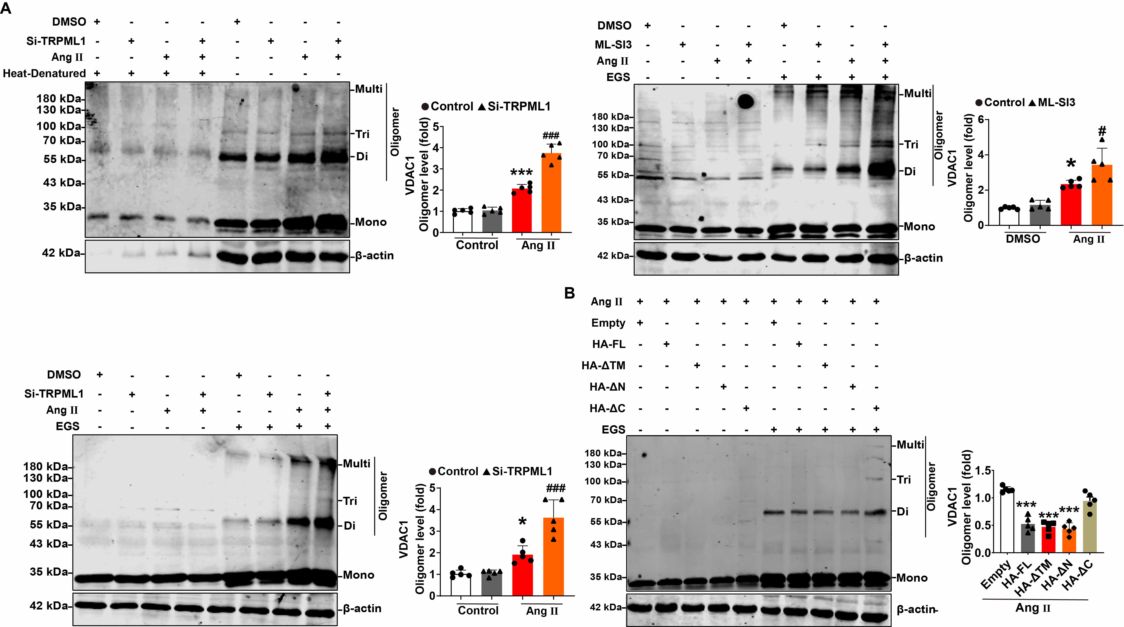
Fig. S11. TRPML1 affects VDAC1 oligomerization. (a) Western blot assay for analyzing the impact of si-TRPML1 (n = 5) and ML-SI3 (n = 5) on Ang II-induced VDAC1 oligomerization. *P < 0.05 vs. DMSO; ***P < 0.001 vs. DMSO; #P < 0.05 vs. Ang II; ###P < 0.001 vs. Ang II. (b) NMCMs were transfected with full-length TRPML1 or its truncated mutant as indicated. Cell lysates were collected and analyzed using a crosslinking assay to identify the functional region of TRPML1 responsible for inhibiting VDAC1 oligomerization (n = 5). ***P < 0.001 vs. Empty. Data are represented as mean ± SEM.

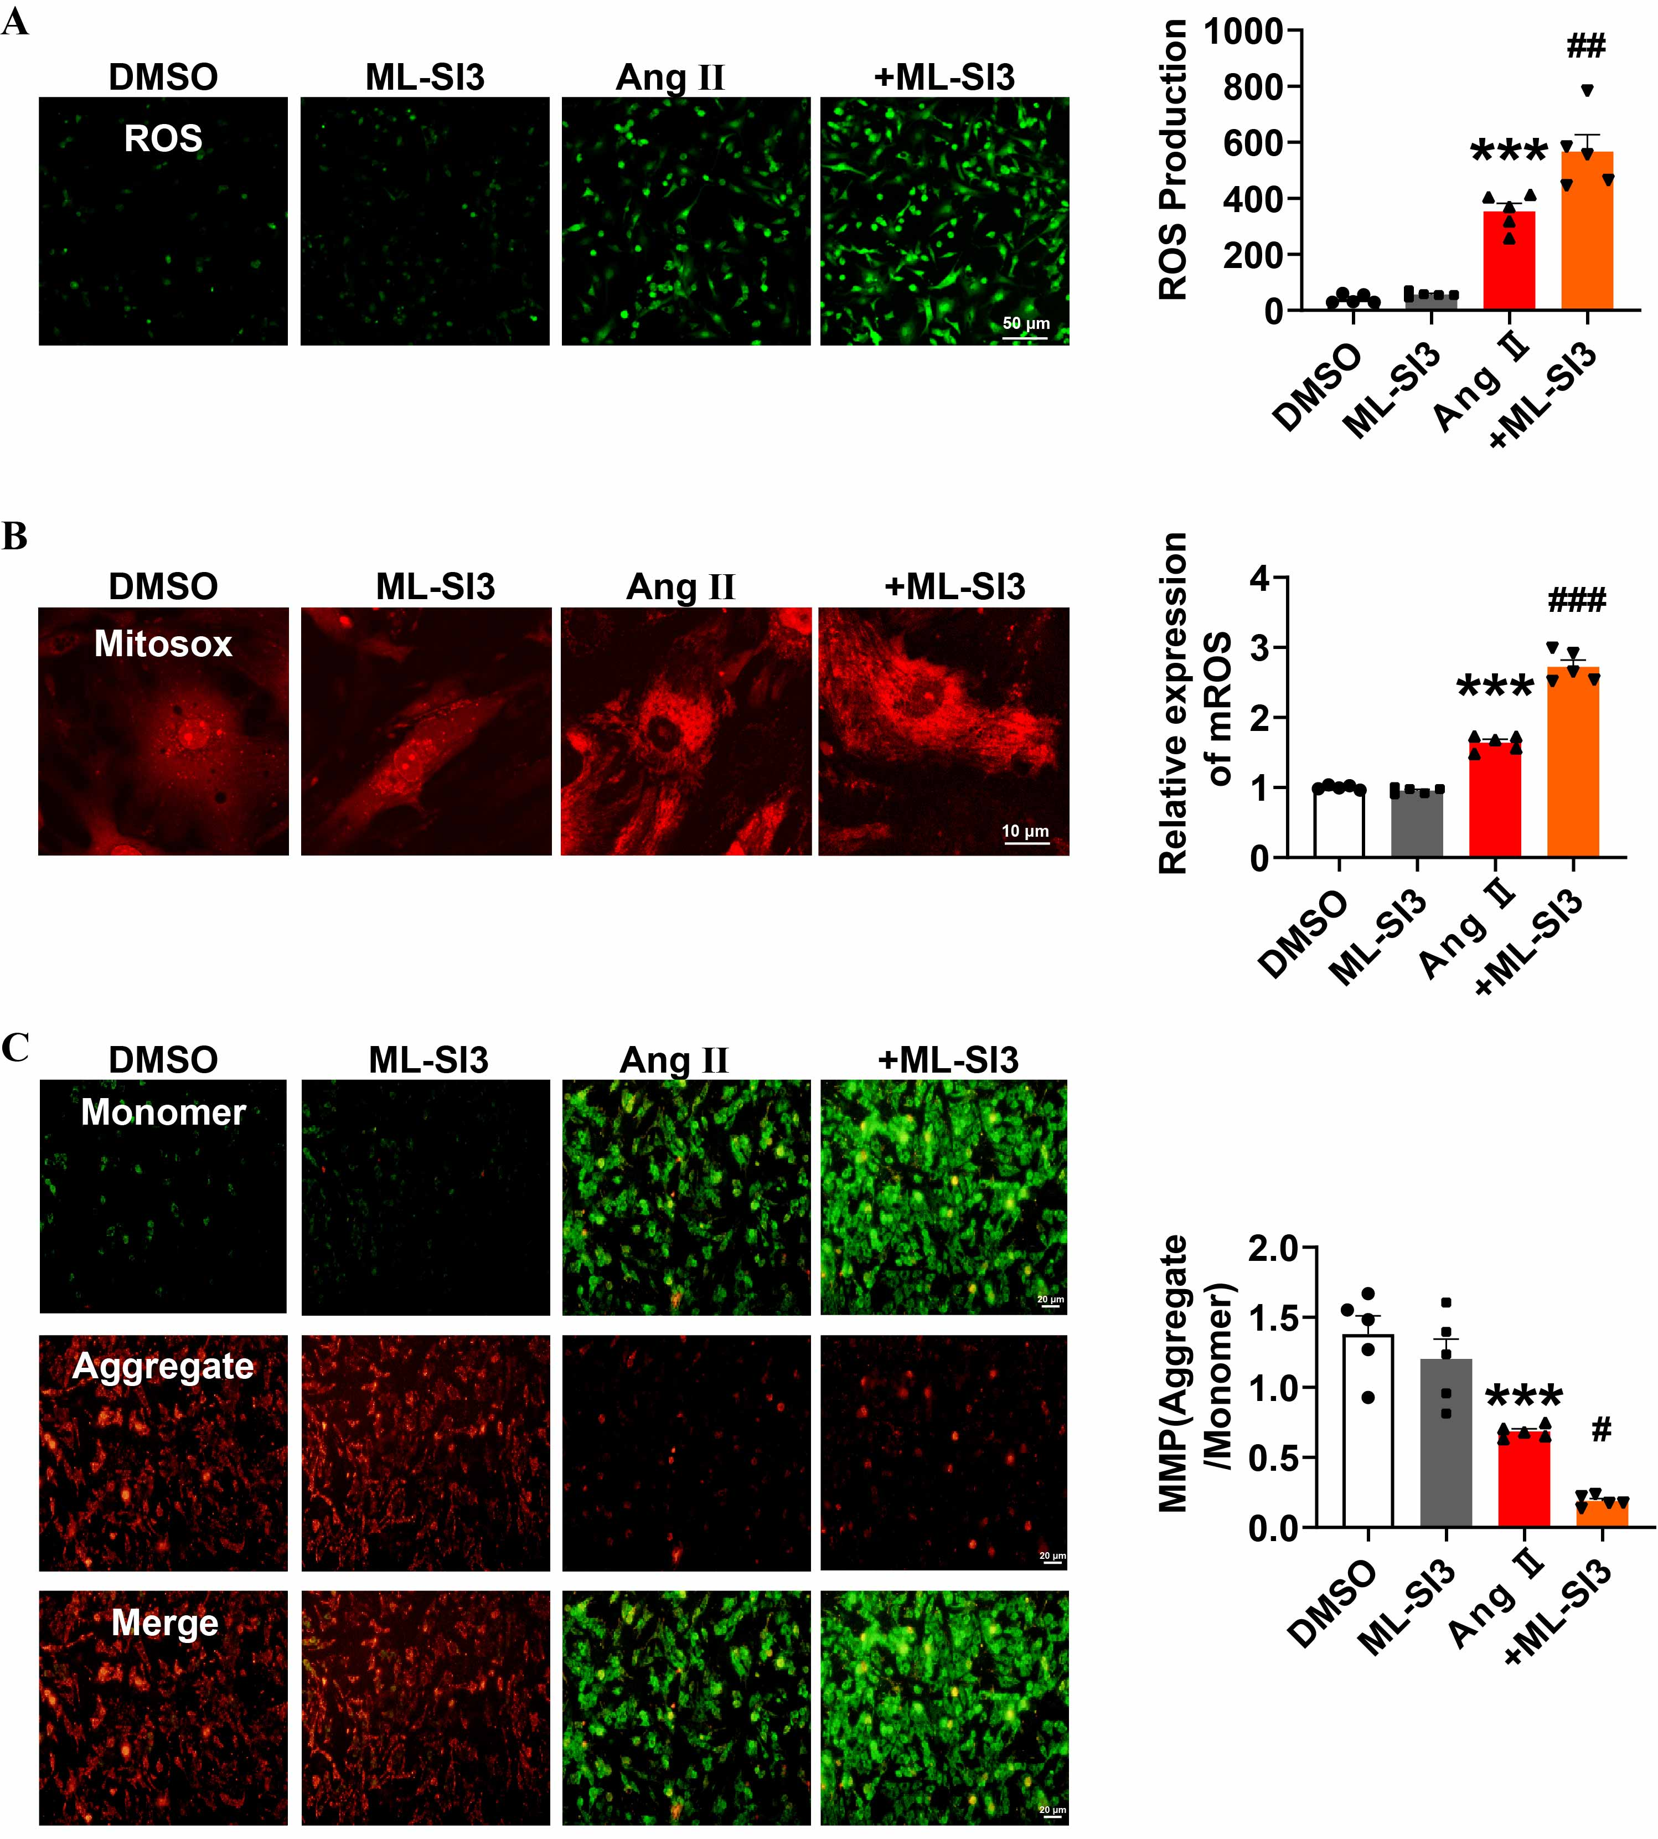
Fig. S12. Reduced TRPML1 activity promotes oxidative stress in hypertrophic cardiomyocytes. (a) DCFH-DA staining images measuring ROS levels in NMCMs after treatment with Ang II and ML-SI3 for 24 h (n = 5). ***P < 0.001 vs DMSO; ##P < 0.01 vs Ang II. (b) MitoSOX staining measuring mitochondrial ROS levels in NMCMs after treatment with Ang II and ML-SI3 for 24 h (n = 5). ***P < 0.001 vs DMSO; ###P < 0.001 vs Ang II. (c) JC-1 staining images measuring MMP in NMCMs after treatment with Ang II and ML-SI3 for 24 h (n = 5; scale bar, 20 μm). ***P < 0.001 vs DMSO; #P < 0.05 vs Ang II. Data are represented as mean ± SEM.

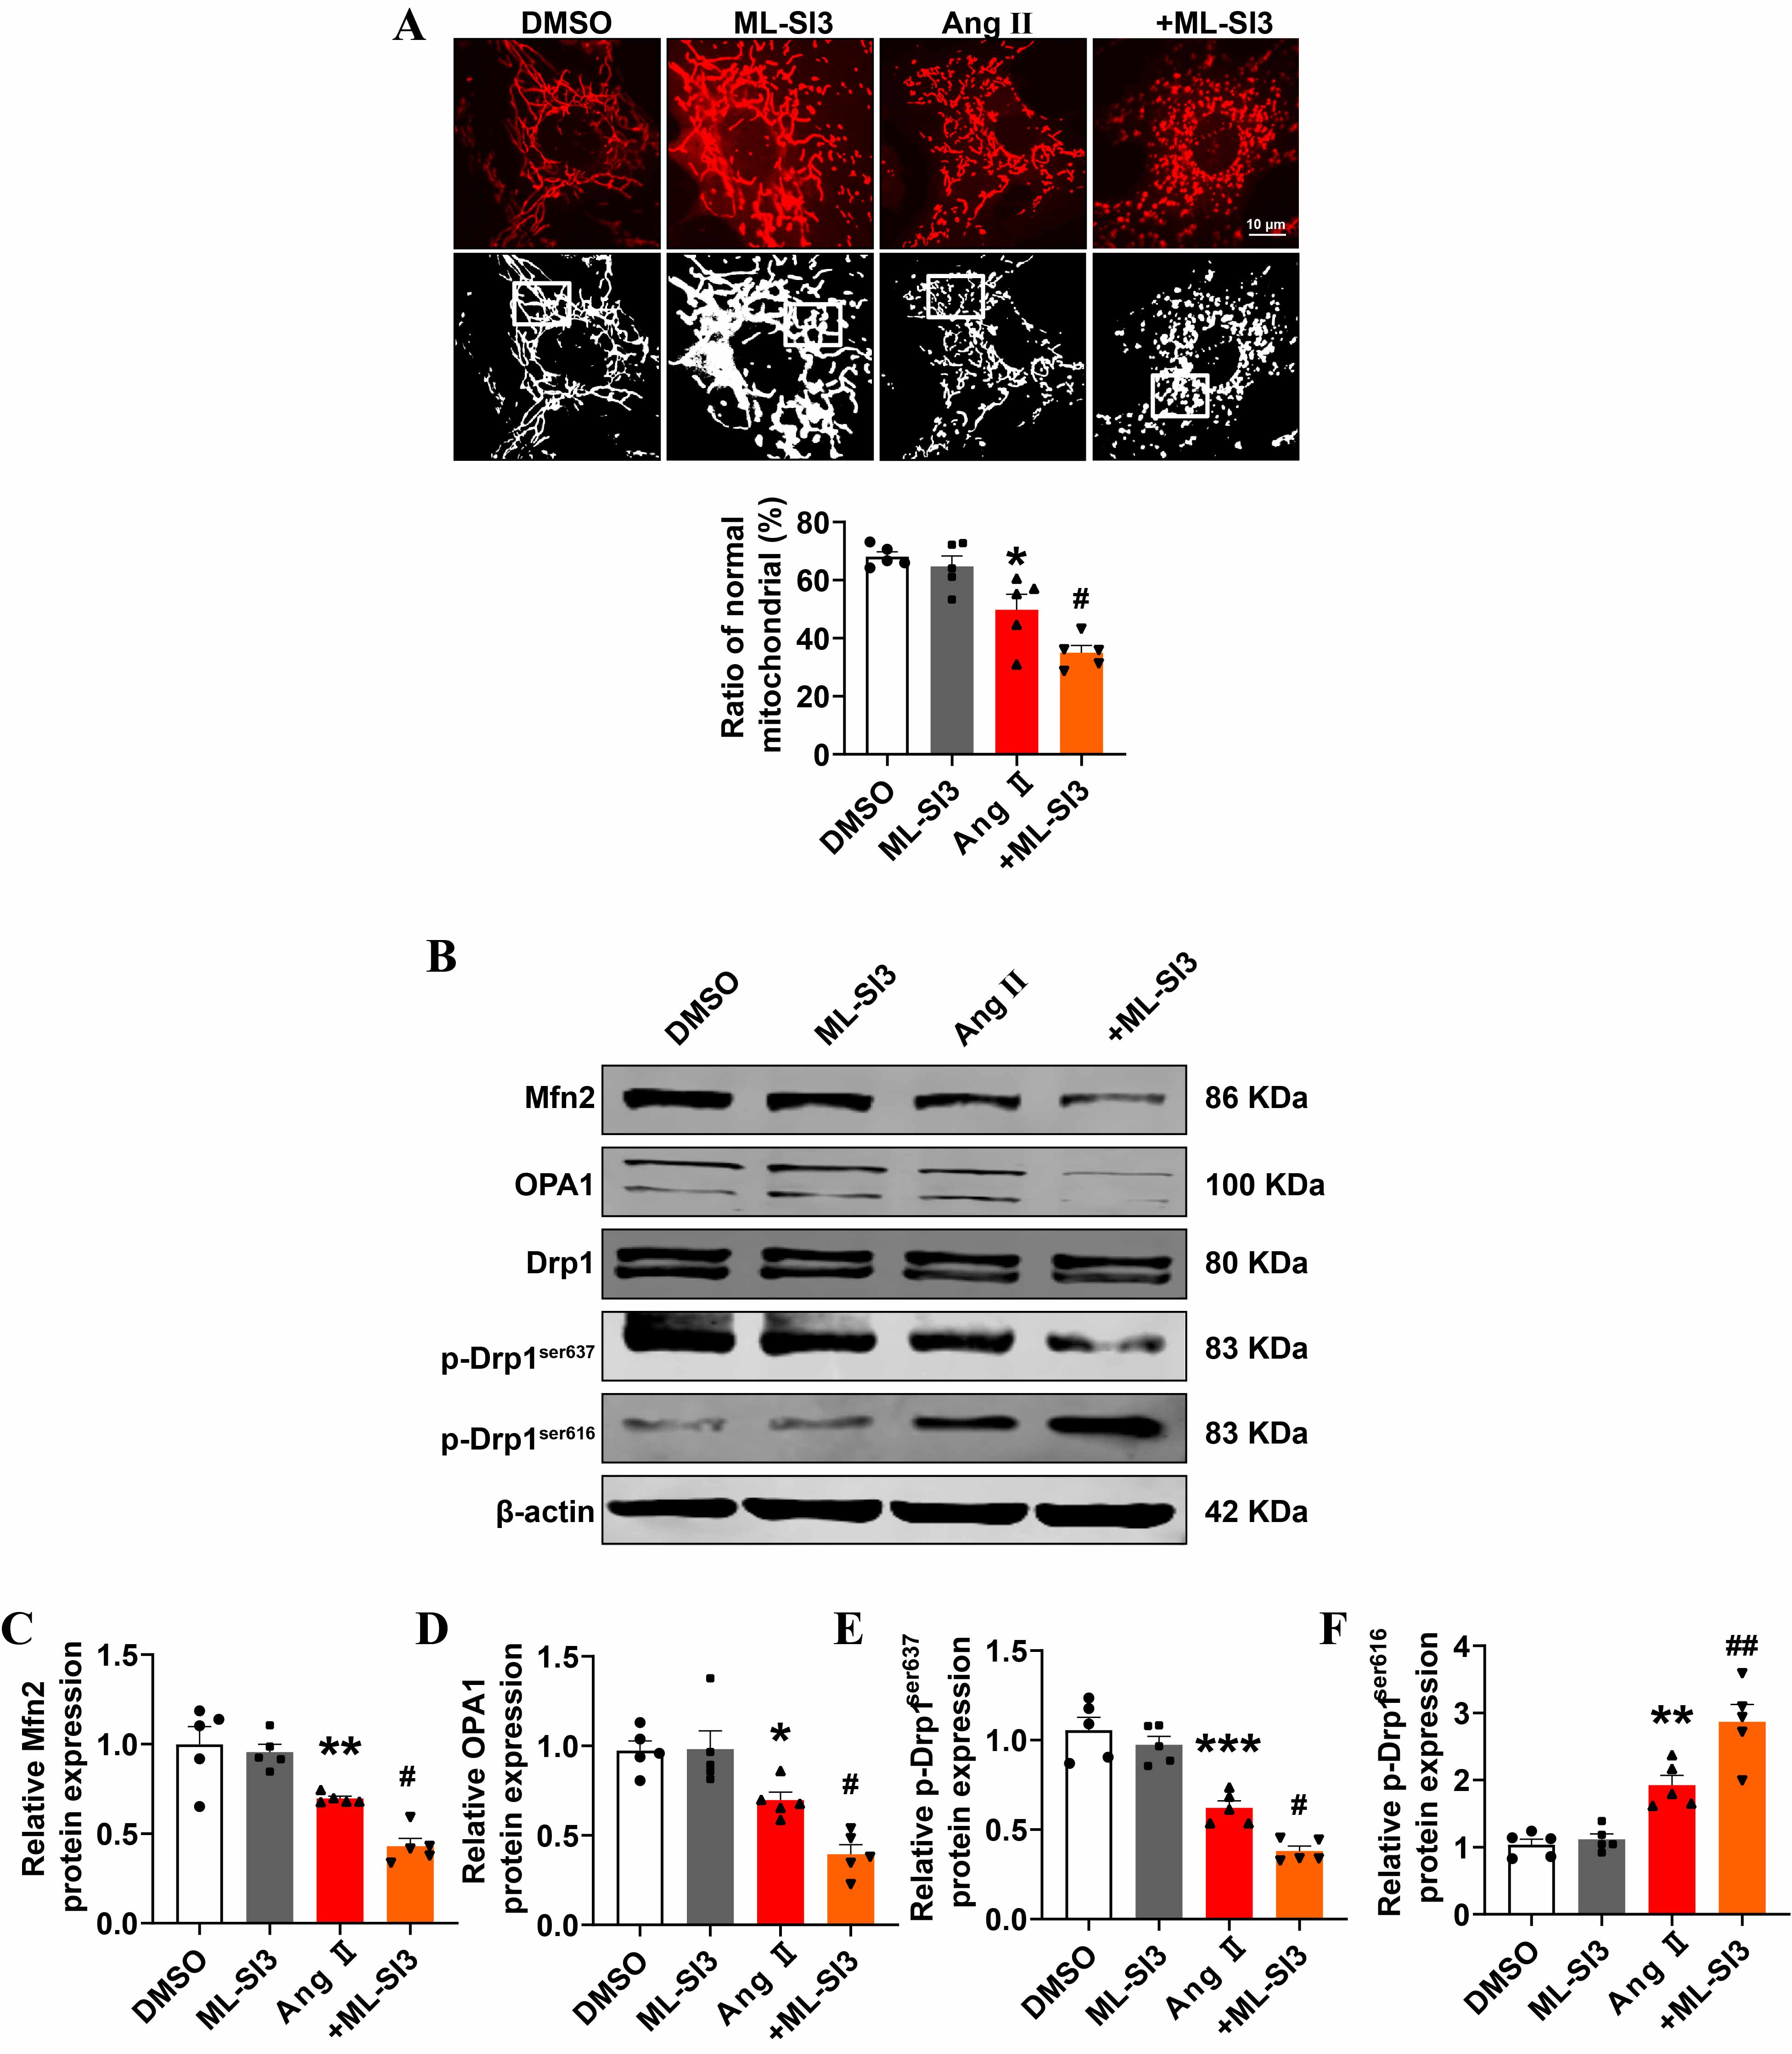
Fig. S13. Reduced TRPML1 activity promotes mitochondrial injury in hypertrophic cardiomyocytes. (a) MitoTracker staining to assess mitochondrial morphology in NMCMs after treatment with Ang II and ML-SI3 for 24 h (n = 5). *P < 0.05 vs DMSO; #P < 0.05 vs Ang II. (b) Representative western blotting images showing the protein expression of Mfn2, OPA1, T-Drp1, p-Drp1^{Ser637}, and p-Drp1^{Ser616} in NMCMs after treatment with Ang II and ML-SI3 for 24 h. (c) Statistical analysis of the protein expression of Mfn2 (n = 5). **P < 0.01 vs DMSO; #P < 0.05 vs Ang II. (d) Statistical analysis of the protein expression of OPA1 (n = 5). *P < 0.05 vs DMSO; #P < 0.05 vs Ang II. (e) Statistical analysis of the protein expression of p-Drp1^{Ser637} (n = 5). ***P < 0.001 vs DMSO; #P < 0.05 vs Ang II. (f) Statistical analysis of the protein expression of p-Drp1^{Ser616} (n = 5). **P < 0.01 vs DMSO; ##P < 0.01 vs Ang II. Data are represented as mean ± SEM.

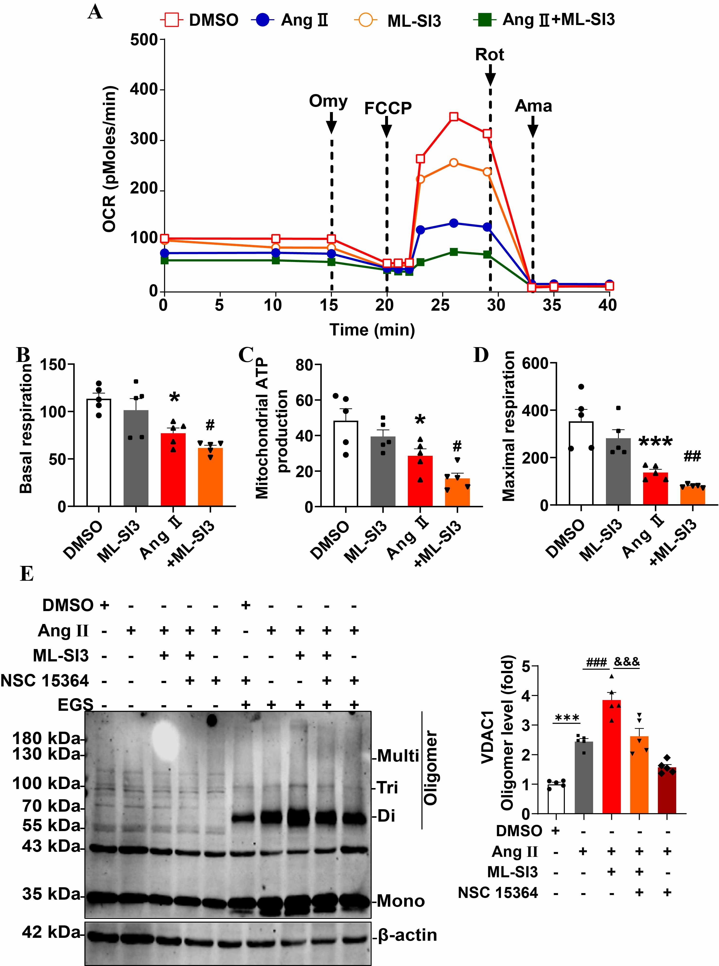
Fig. S14. Reduced TRPML1 activity inhibits mitochondrial O₂ consumption in hypertrophic cardiomyocytes. (a) Analysis of O₂ consumption in NMCMs treated with Ang II and ML-SI3 for 24 hours (n = 5). (b) Statistical analysis of basal respiration (n = 5). *P < 0.05 vs. DMSO; #P < 0.05 vs. Ang II. (c) Statistical analysis of mitochondrial ATP production (n = 5). ***P < 0.001 vs. DMSO; ##P < 0.01 vs. Ang II. (d) Statistical analysis of maximal respiration (n = 5). *P < 0.05 vs. DMSO; #P < 0.05 vs. Ang II. (e) Western blot analysis of VDAC1 oligomerization after treatment with Ang II, ML-SI3, and NSC 15364 (20 μmol∙L^{–1}) for 24 h (n = 5). ***P < 0.001 vs DMSO; ###P < 0.001 vs Ang II; &&&P < 0.001 vs Ang II + ML-SI3. Data are represented as mean ± SEM.

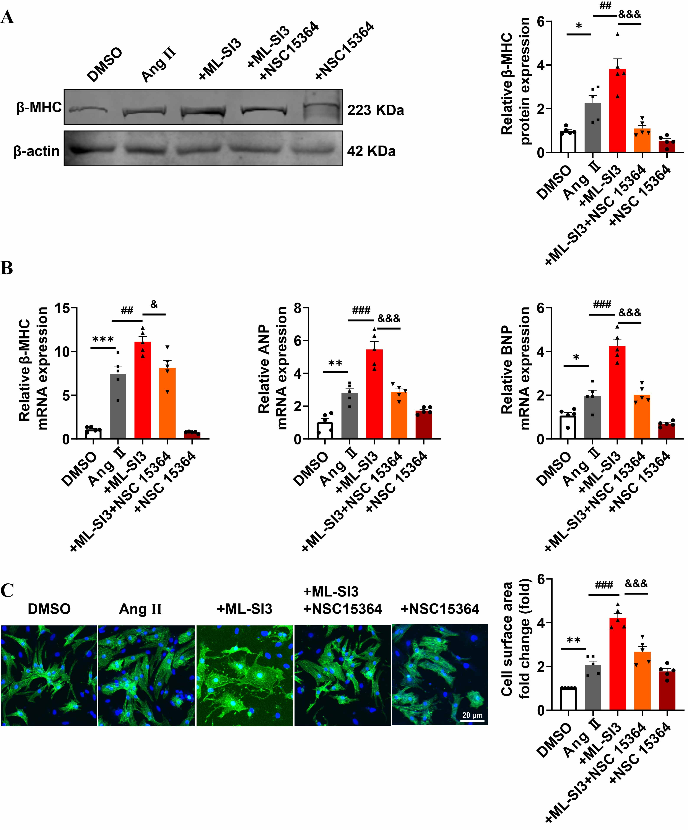
Fig. S15. Inhibition of VDAC1 oligomerization attenuates cardiac hypertrophy after treatment with NSC 15364. (a) Western blotting analysis of β-MHC protein expression after being treated with Ang II, ML-SI3, and NSC 15364 for 24 h (n = 5). *P < 0.05 vs DMSO; ##P < 0.01 vs Ang II; &&&P < 0.001 vs Ang II + ML-SI3. (b) qRT-PCR analysis of mRNA expression of β-MHC, ANP, and BNP after treatment with Ang II, ML-SI3, and NSC 15364 for 24 h (n = 5). *P < 0.05, **P < 0.01, and ***P < 0.001 vs DMSO; ##P < 0.01 and ###P < 0.001 vs Ang II; &P < 0.05 and &&&P < 0.001 vs Ang II + ML-SI3. (c) Immunofluorescence analysis of cell surface area after treatment with Ang II, ML-SI3, and NSC 15364 for 24 h (n = 5; scale bar = 20 μm). **P < 0.01 vs DMSO; ###P < 0.001 vs Ang II; &&&P < 0.001 vs Ang II + ML-SI3. Data are represented as mean ± SEM.

2. Supplementary tables
Table S1
Target allele primers in knock-in mice and tool mice.
Primers | Forward | Reverse
TRPML1- knock-in | 5′-AGTCATAGCTGTCCCTCTTCTCT-3′ | 5′-CCATTTAAGCCATGGGAAGTTAGT-3′
TRPML1-WT | 5′-GTCTGCAGCCATTACTAAACATGAA-3′ | 5′-AAAGGTAGACGGATTTAGCCACA-3′
myh6-Cre | 5′-AGTCATAGCTGTCCCTCTTCTCT-3′ | 5′-CCATTTAAGCCATGGGAAGTTAGT-3′

Table S2
Target allele primers in knockout mice.
Primers | Forward | Reverse
TRPML1- knockout | 5′-CTCCGTTGTATACCCAAAATGTCC-3′ | 5′-ACTGATTGATAGGGTGTGTGCTAA-3′

Table S3
The primary antibodies were used as follows.
Immunogen | Catalog No. | Manufacturer | Country | Host species
TRPML1 | ACC-081 | Alomone Labs | Israel | Rabbit
VDAC1/Porin+ VDAC3 | ab14734 | Abcam | UK | Mouse
β-MHC | M-8421 | Sigma, St. Louis, MO | USA | Mouse
Mfn2 | A19678 | ABclonal | USA | Rabbit
OPA1 | 27733-1-AP | Proteintech | China | Rabbit
Drp1 | sc-271583 | Santa Cruz | USA | Mouse
P-Drp1ser637 | #6319 | Cell Signaling Technology | USA | Rabbit
P-Drp1ser616 | #3455 | Cell Signaling Technology | USA | Rabbit
Stat5b | PTM-5318 | PTM Bio | China | Mouse
GAPDH | TA-08 | ZSGB-Bio | China | Mouse
β-actin | TA-09 | ZSGB-Bio | China | Mouse
Anti-Flag | 66008-4-Ig | Proteintech | China | Rabbit
Anti-HA | 51064-2-AP | Proteintech | China | Rabbit
Anti-IgG | B900620 | Proteintech | China | Rabbit

Table S4
All primers used in qRT-PCR were as follow.
Primers | Forward | Reverse
TRPML1 | 5’-GCTGGGTTACTCTGATGGGTC-3’ | 5’-CCACCACGGACATAGGCATAC-3’
ANP | 5’-GTGCGGTGTCCAACACAGAT-3’ | 5’-TCCAATCCTGTCAATCCTACCC-3’
BNP | 5’-GAGGTCACTCCTATCCTCTGG-3’ | 5’-GCCATTTCCTCCGACTTTTCTC-3’
β-MHC | 5’-GTGAAGGGCATGAGGAAGAGT-3’ | 5’-AGGCCTTCACCTTCAGCTGC-3’
Stat5b | 5’- CCCTTCATCAGATGCAATCC-3’ | 5’- ATCAGACCATCCAGCAGAC-3’
GAPDH | 5’- ACCACAGTCCATGCCATCAC-3’ | 5’- TCCACCACCCTGTTGCTGTA-3’

Table S5
The sequences of siRNAs.
siRNAs | Forward | Reverse
TRPML1 | 5’-GCAGAACGAGUUUGUUGUA-3’ | 5’-UACAACAAACUCGUUCUGC-3’
Stat5b | 5′–CGGCCAAAGGAUGAAGUAUAU–3′ | 5′–AUAUACUUCAUCCUUUGGCCG–3′
siNC | 5’-UUCUCCGAACGUGUCACGU-3’ | 5’-ACGUGACACGUUCGGAGAA-3’

