Supplementary data for

Evaluation of the Impact of Multi-Source Uncertainties on Meteorological and Hydrological Ensemble Forecasting
Zhangkang Shu ^{a,b,c,d}, Jianyun Zhang ^{b,c,d}, Lin Wang ^{b,c,d}, Junliang Jin ^{b,c,d,*}, Ningbo Cui ª, Guoqing Wang ^{b,c,d}, Zhouliang Sun ^{b,d,e}, Yanli Liu ^{b,c,d}, Zhenxin Bao ^{b,c,d}, Cuishan Liu ^{b,c,d}
ª State Key Laboratory of Hydraulics and Mountain River Engineering, College of Water Resource and Hydropower, Sichuan University, Chengdu, 610065, China
^{b} State Key Laboratory of Hydrology–Water Resources and Hydraulic Engineering, Nanjing Hydraulic Research Institute, Nanjing 210029, China
^{c} Yangtze River Protection and Green Development Research Institute, Nanjing 210098, China
^{d} Research Center for Climate Change of Ministry of Water Resources, Nanjing 210029, China
^{e} School of Water Resources and Hydropower Engineering, Wuhan University, Wuhan 430072, China
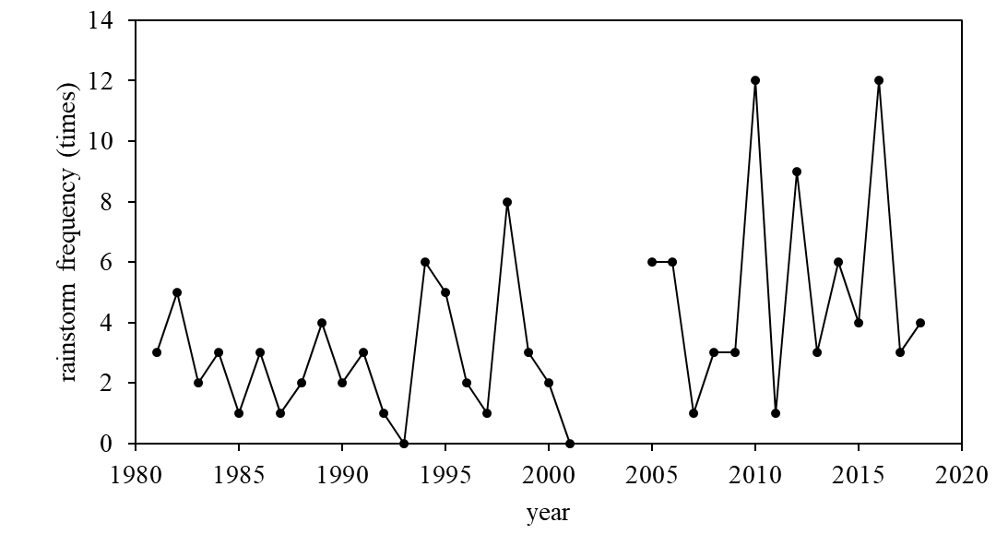
Fig. S1. The frequency of rainstorm (daily precipitation > 50mm) in Chitan basin from 1981 to 2017. Lack of Data for 2002-2004.
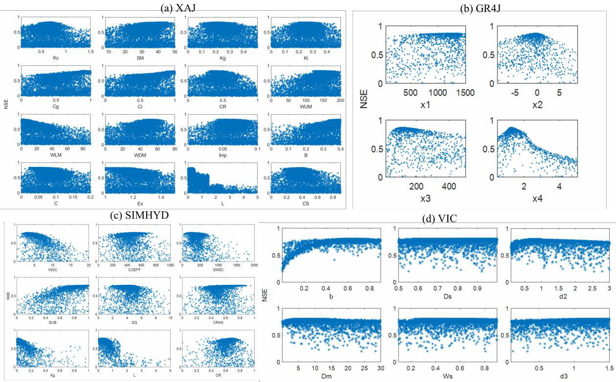
Fig. S2. Scatter diagram of parameter distribution of XAJ, GR4J, SIMHYD, and VIC hydrological models.

