Supplementary file for
Rapid In-Vitro Inactivation of Various SARS-CoV-2 Strains Using Ionizing Radiation: New Inactivation Patterns And Mechanistic Insights
Wei Wang ^{a,#}, Xiaodi Zhang ^{b,#}, Jiageng Yu ^{a,#}, Tianhao Weng ^{b,#}, Zhiyang Yu ª, Zhigang Wu ^{b}, Danrong Shi ^{b}, Sufen Zhang ª, Xiangyun Lu ^{b}, Osama Alam ª, Dahang Shen ª, Qian Bao ª, Qingfu Ye ^{a,}*, Lanjuan Li ^{b,}*, Hangping Yao ^{b,}*
ª Institute of Nuclear Agricultural Sciences, Key Laboratory of Nuclear Agricultural Sciences of Ministry of Agriculture of the People’s Republic of China, Zhejiang University, Hangzhou 310058, China
^{b} State Key Laboratory for Diagnosis and Treatment of Infectious Diseases, National Clinical Research Center for Infectious Diseases, The First Affiliated Hospital, Zhejiang University School of Medicine, Hangzhou 310009, China

# These authors contributed equally to this work.

* Corresponding authors.
E-mail addresses: qfye@zju.edu.cn (Q. Ye), ljli@zju.edu.cn (L. Li), yaohangping@zju.edu.cn (H. Yao).

Table S1
Information on eleven WT strains used in this study and the inactivation insights under 2.0 kGy E-beam irradiation. “+” represents significant cytopathic effects, “–” represents no observable cytopathic effects.
ID | Sample | Sampling date | Inhibition rate (%) | CPE
 |  |  |  | Before | Irradiated
hCoV-19/Hangzhou/ZJU-01/2020 | Sputum | 2020.1.25 | 99.99 ± 0.01 | + | –
hCoV-19/Hangzhou/ZJU-02/2020 | Sputum | 2020.1.26 | 99.97 ± 0.01 | + | –
hCoV-19/Hangzhou/ZJU-03/2020 | Sputum | 2020.1.25 | 99.99 ± 0.00 | + | –
hCoV-19/Hangzhou/ZJU-04/2020 | Sputum | 2020.1.24 | 99.99 ± 0.00 | + | –
hCoV-19/Hangzhou/ZJU-05/2020 | Sputum | 2020.1.22 | 99.96 ± 0.01 | + | –
hCoV-19/Hangzhou/ZJU-06/2020 | Sputum | 2020.2.2 | 99.99 ± 0.00 | + | –
hCoV-19/Hangzhou/ZJU-07/2020 | Nasopharyngeal swab | 2020.2.3 | 99.98 ± 0.00 | + | –
hCoV-19/Hangzhou/ZJU-08/2020 | Sputum | 2020.1.26 | 99.96 ± 0.01 | + | –
hCoV-19/Hangzhou/ZJU-09/2020 | Stool | 2020.1.28 | 99.98 ± 0.02 | + | –
hCoV-19/Hangzhou/ZJU-10/2020 | Stool | 2020.2.3 | 99.99 ± 0.01 | + | –
hCoV-19/Hangzhou/ZJU-11/2020 | Stool | 2020.2.4 | 99.98 ± 0.00 | + | –
Table S2
Effect of different irradiation dose rates on SARS-CoV-2 inactivation, the total absorbed dose is 2.0 kGy. “+” represents significant cytopathic effects, “–” represents no observable cytopathic effects. All experiments were repeated three times with consistent results.
Dose rate (kGy∙s^{–1}) | Log₁₀(N_{i}/N₀) | Inhibition rate (%) | CPE
2.442 | −4.05 ± 0.02 | 99.99 ± 0.00 | –
4.506 | −4.13 ± 0.00 | 99.99 ± 0.00 | –
9.580 | −4.12 ± 0.00 | 99.99 ± 0.00 | –
Table S3
Effect of different thickness of 2 and 4 cm ice plates on inactivation of SARS-CoV-2 by 2.0 kGy irradiation. “+” represents significant cytopathic effects, “–” represents no observable cytopathic effects. All experiments were repeated three times with consistent results.
Thickness (cm) | Log₁₀(N_{i}/N₀) | Inhibition rate (%) | CPE
0 | −4.37 ± 0.17 | 99.99 ± 0.00 | –
2 | −4.30 ± 0.09 | 99.99 ± 0.00 | –
4 | −4.21 ± 0.03 | 99.99 ± 0.00 | –

Table S4
Information on nine VOC used in this study.
ID | Sample | Sampling date | Strain type
hCoV-19/Hangzhou/ZJU-012/2021 | Sputum | 2021.5.4 | Delta
hCoV-19/Zhejiang/ZJU-20/2023 | Sputum | 2023.1.5 | Omicron BA.5.2
hCoV-19/Zhejiang/ZJU-22/2022 | BLAF | 2022.12.27 | Omicron BA.7
SKLID_ZJU-35_hCoV-19/2023 | Oropharyngeal swab | 2023.5.3 | Omicron XBB.1.16
SKLID_ZJU-30_hCoV-19/2023 | Oropharyngeal swab | 2023.4.28 | Omicron XBB.1.9.1
SKLID_ZJU-S148_hCoV-19/2023 | Sputum | 2023.8.23 | Omicron EG5.1
SKLID_ZJU-167_hCoV-19/2024 | Sputum | 2024.1.22 | Omicron HK.13
SKLID_ZJU-169_hCoV-19/2024 | Sputum | 2024.1.22 | Omicron JN.1
SKLID_ZJU-187_hCoV-19/2024 | Sputum | 2024.3.13 | Omicron JN.1.16

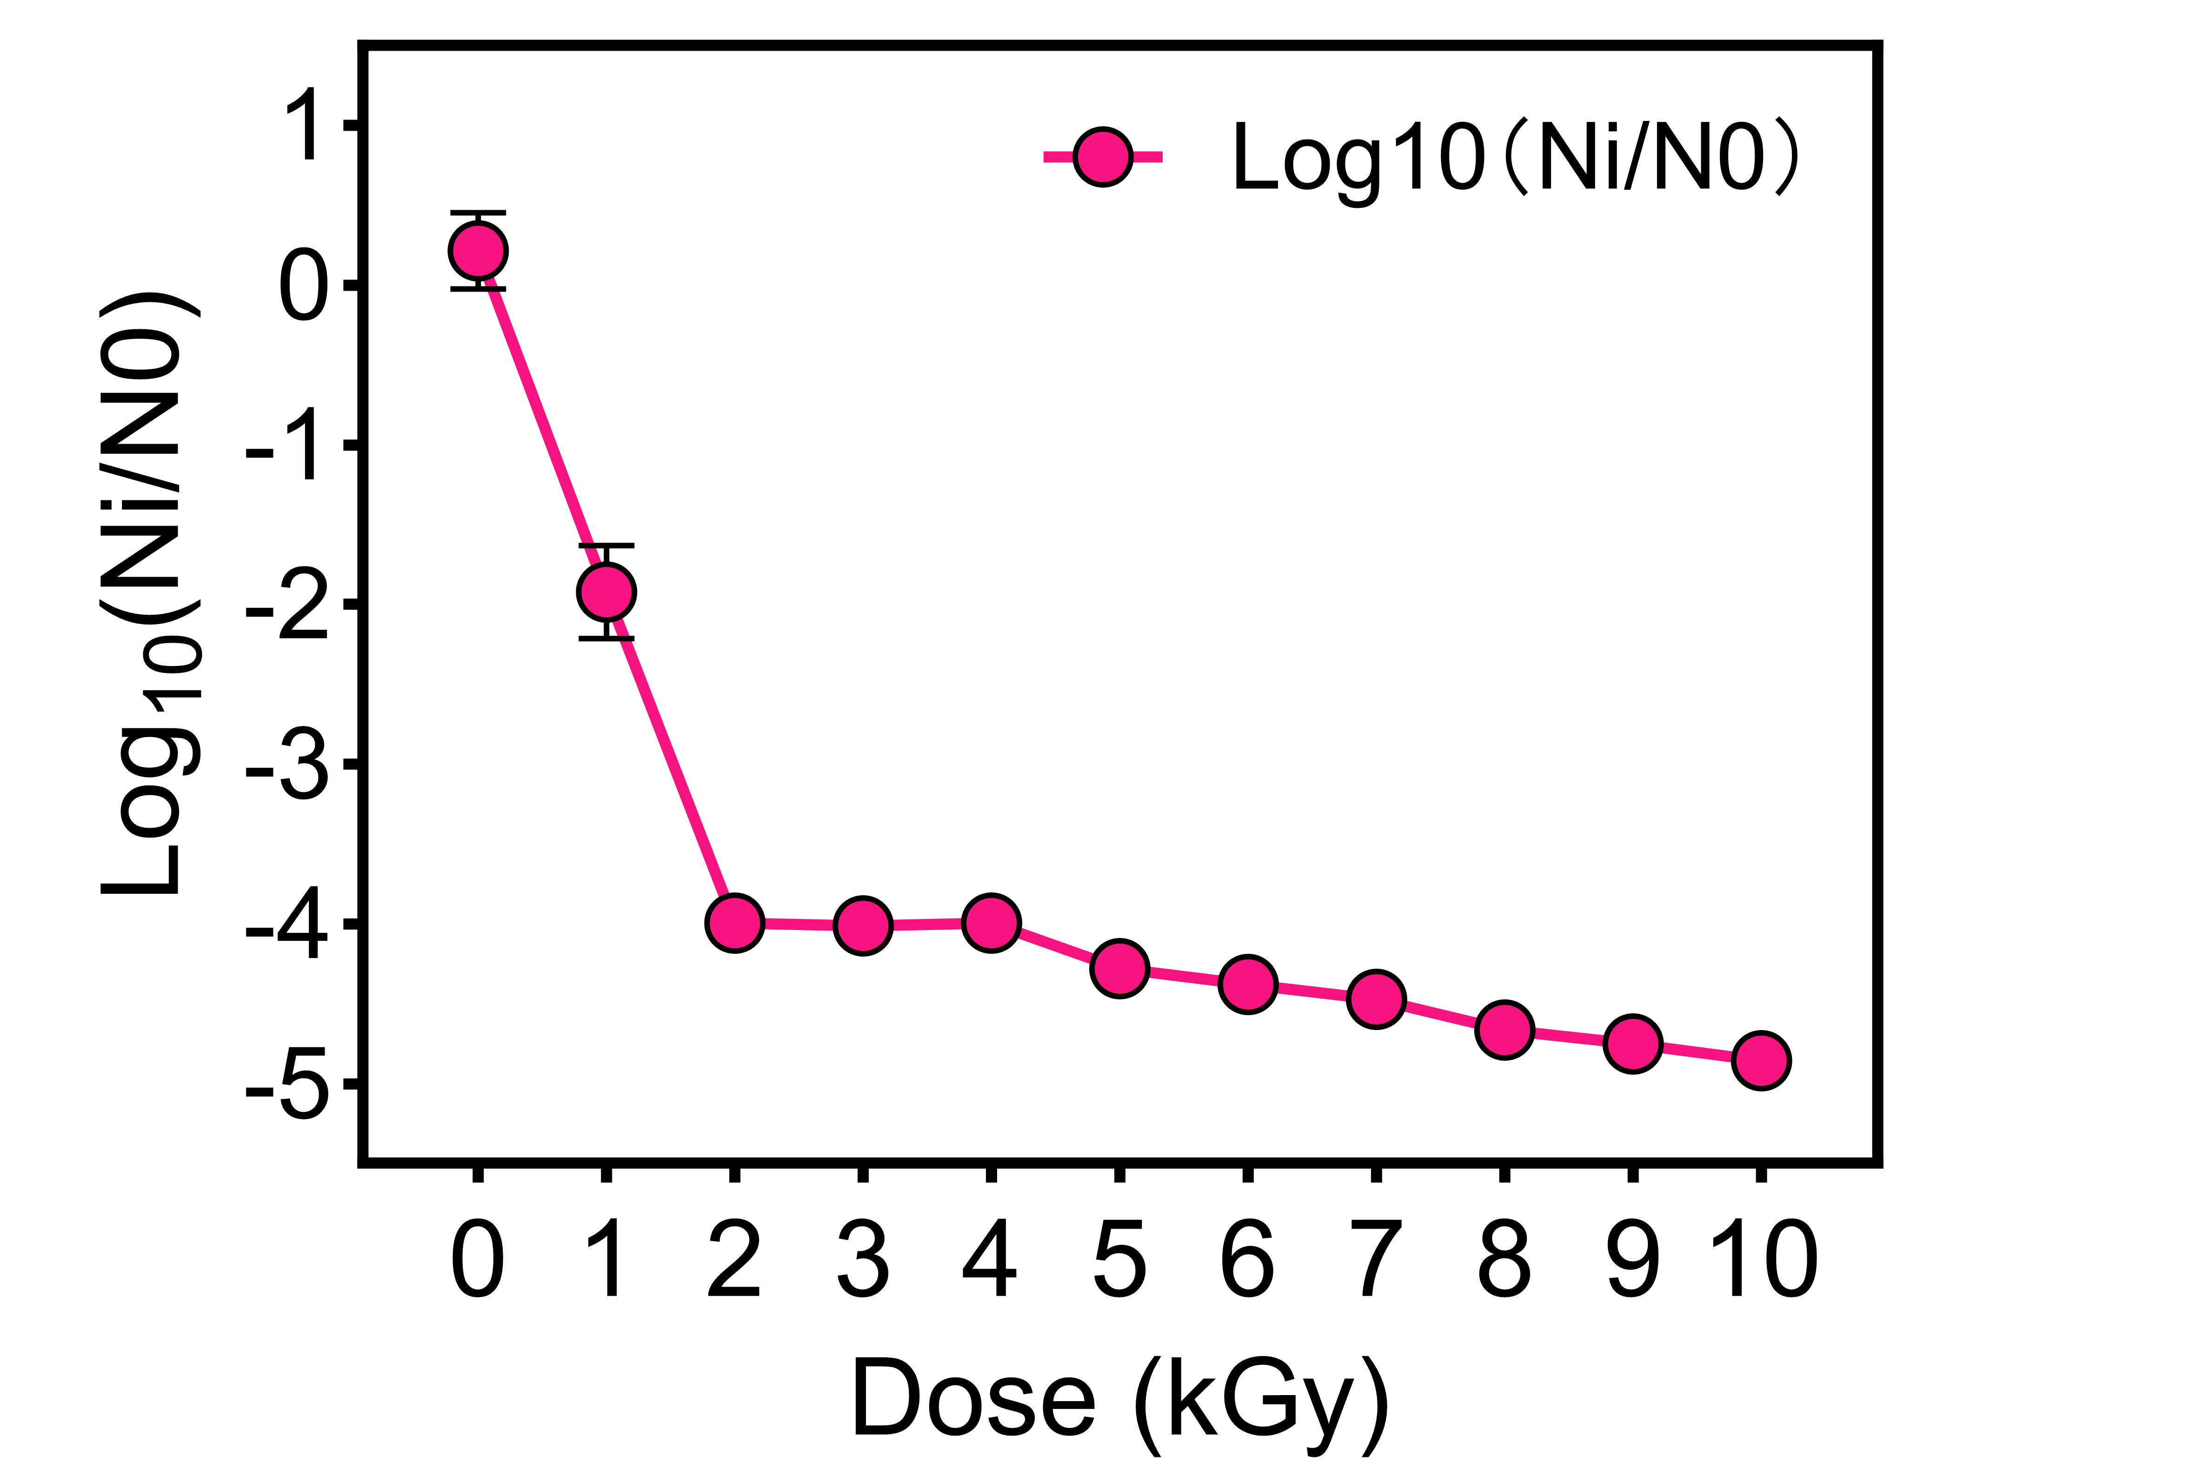
Fig. S1. The relationship between irradiation dose and the logarithmic reduction in virus load.
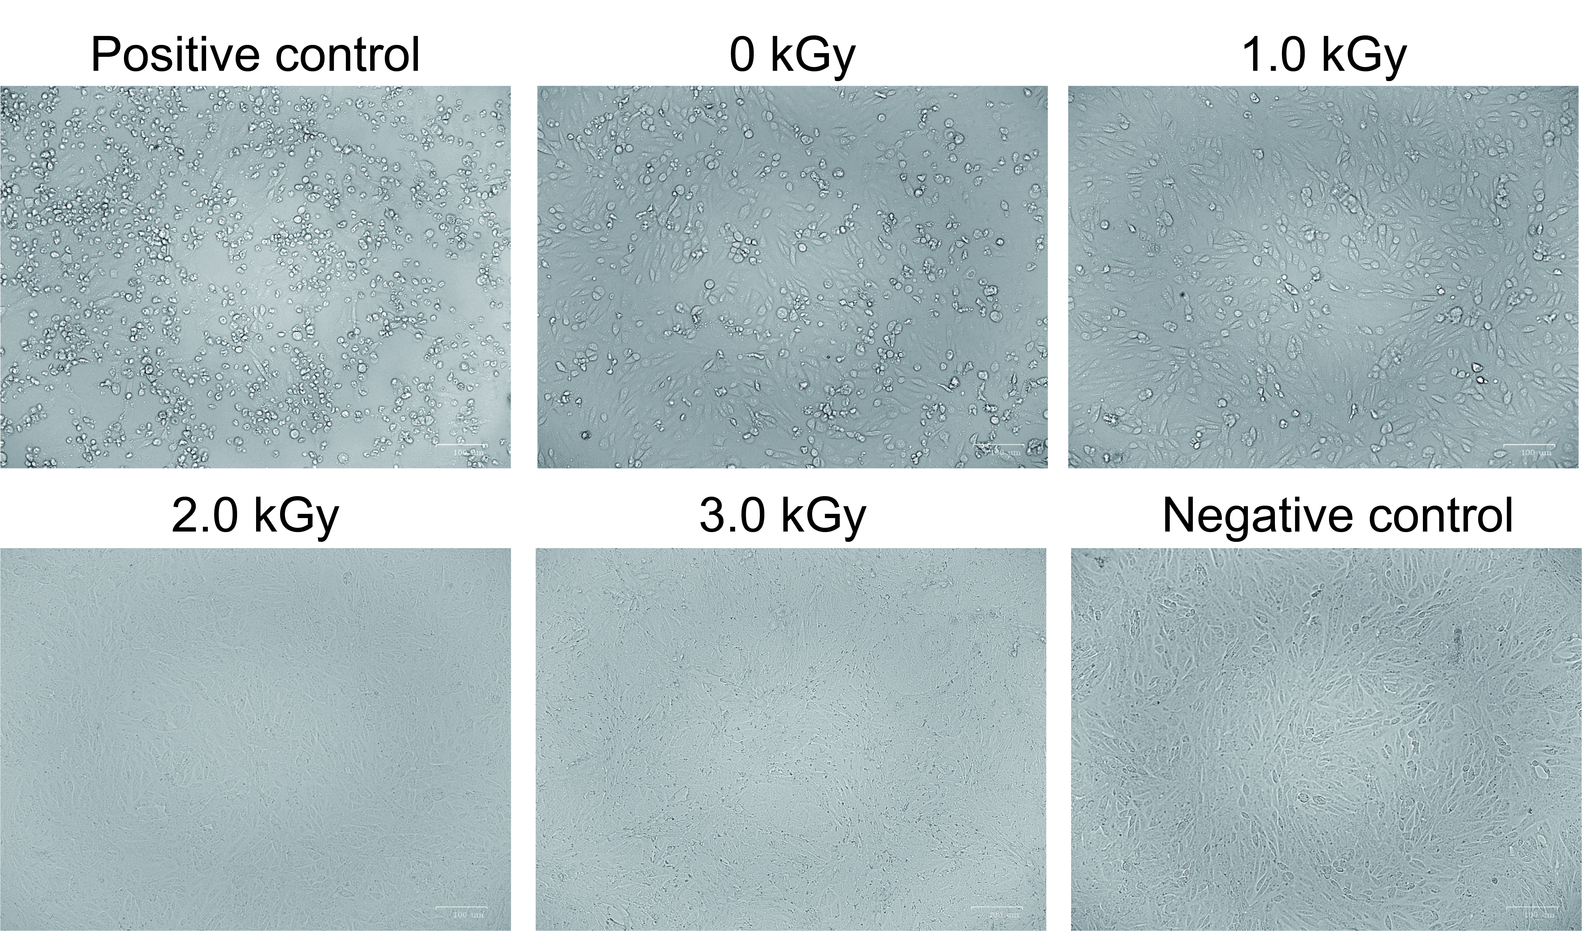
Fig. S2. Representative photomicrographs of Vero cells infected with SARS-CoV-2 following E-beam irradiation. All experiments were performed in triplicate with consistent results. Scale bars: 100 μm.
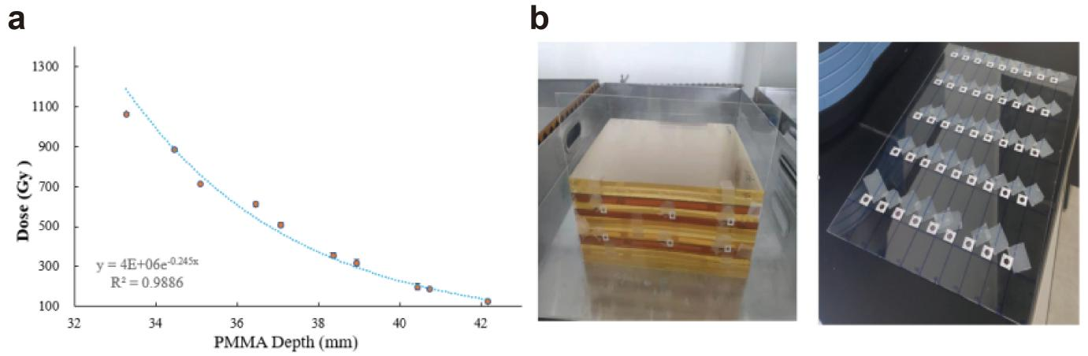
Fig. S3. (a) Correlation between mass attenuation and absorbed radiation dose for PMMA with varying thicknesses. (b) Schematic diagram of PMMA obstruction.

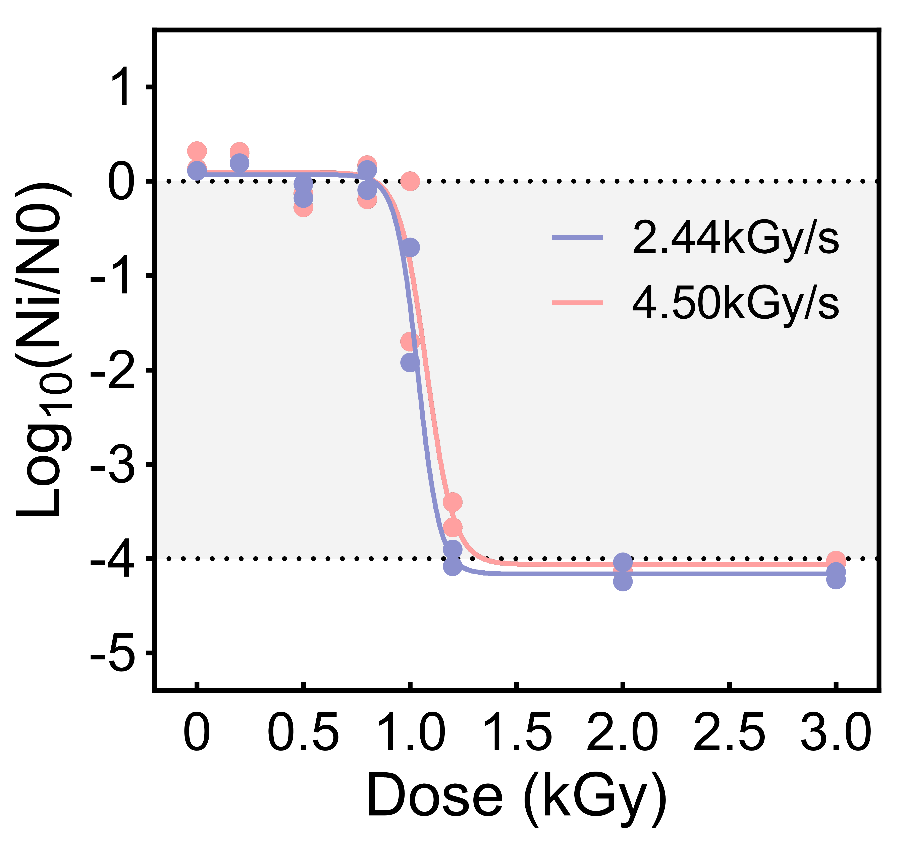
Fig. S4. SARS-CoV-2 dose-response curves under different E-beam irradiation dose rates. N_{i} represents virus copies after irradiation, while N₀ represents the initial viral copies.

