Supplementary Data for

Investigating the Spectroscopic Performance of Y₃Al₅O₁₂:Mn⁴⁺ Phosphors Co-Doped with Divalent Metal Ions and the Use of Phosphor Film for “Green” Plant Cultivation
Fen Wang ^{a,b}, Hirohisa Miyata ^{b}, Jingyi Liang ª, Yingying Song ^{c}, Guangyuan Xu ^{c}, Jumpei Ueda ^{b,}*, Dan Wang ^{a,}*
ª State Key Laboratory of Organic-Inorganic Composites, College of Chemical Engineering, Beijing University of Chemical Technology, Beijing 100029, China
^{b} Graduate School of Advanced Science and Technology, Japan Advanced Institute of Science and Technology, Nomi 923-1292, Japan
^{c} State Key Laboratory of Agricultural and Forestry Biosecurity, MOA Key Lab of Pest Monitoring and Green Management, College of Plant Protection, China Agricultural University, Beijing 100193, China

* Corresponding authors.
E-mail addresses: ueda-j@jaist.ac.jp (J. Ueda), wangdan@mail.buct.edu.cn (D. Wang).

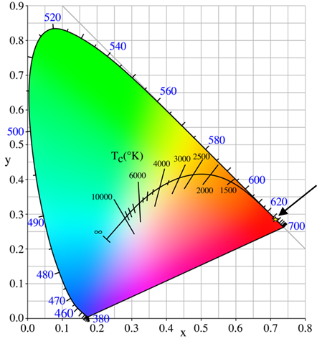
Fig. S1. CIE diagram of YAG:Mn.

Table S1. The effective ionic radius of the cation.
Ion | Charge | Effective ionic radius (Å)
Ion | Charge | CN = 4 | CN = 6 | CN = 8
Y | 3 | — | 0.900 | 1.019
Al | 3 | 0.39 | 0.535 | —
Mn | 4 | 0.39 | 0.530 | —
Mg | 2 | 0.57 | 0.720 | 0.890
Zn | 2 | 0.60 | 0.740 | 0.900
Ca | 2 | — | 1.000 | 1.120
Ba | 2 | — | 1.350 | 1.420

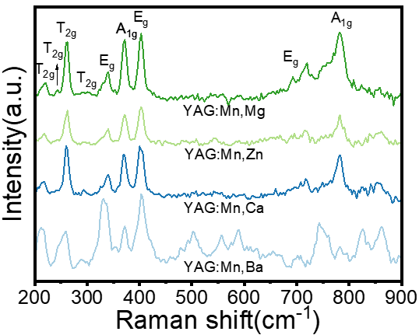
Fig. S2. Raman spectra of YAG:0.2%Mn⁴⁺–4%M²⁺.

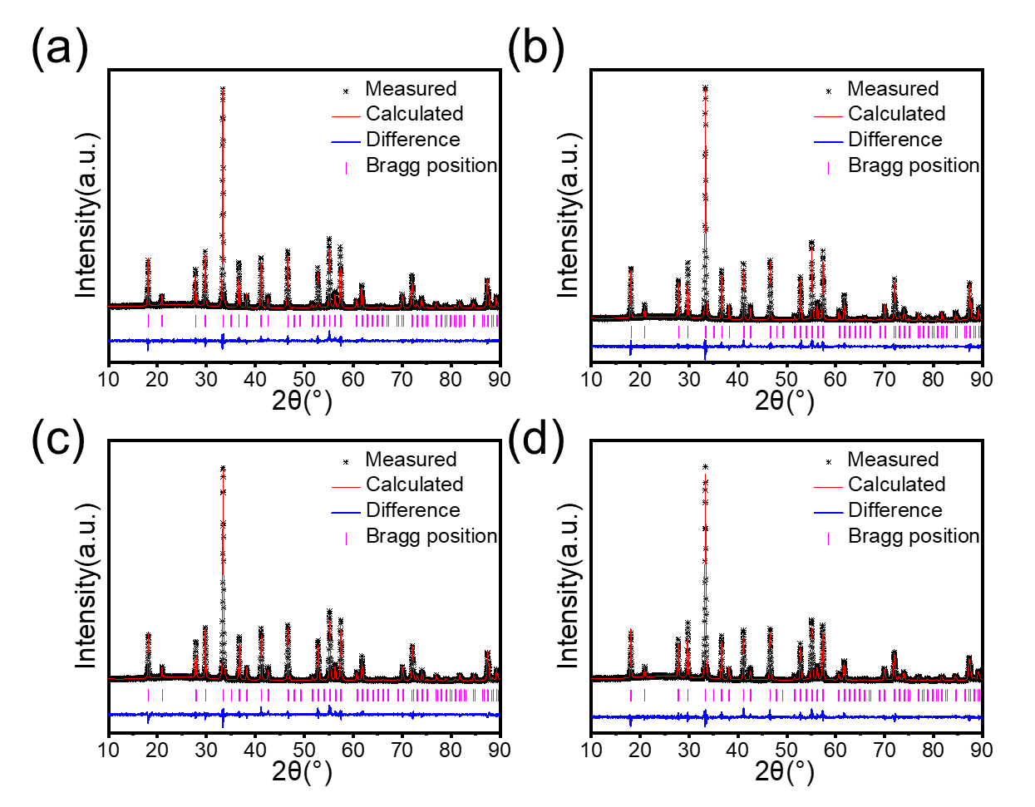
Fig. S3. XRD Rietveld refinement patterns of (a) YAG:0.2%Mn⁴⁺–4%Mg²⁺, (b) YAG:0.2%Mn⁴⁺–4%Zn²⁺, (c) YAG:0.2%Mn⁴⁺–4%Ca²⁺, and (d) YAG:0.2%Mn⁴⁺–4%Ba²⁺ phosphors.

Table S2. Crystallographic parameters from XRD Rietveld refinement of YAG:0.2%Mn⁴⁺–4%M²⁺ (M = Mg, Zn, Ca, or Ba).
Parameter | Mn⁴⁺(CN=6)/Mg²⁺(CN=6) | Mn⁴⁺(CN=6)/Zn²⁺(CN=6) | Mn⁴⁺(CN=6)/Ca²⁺(CN=8) | Mn⁴⁺(CN=6)/Ba²⁺(CN=8)
Space group | Ia–3d | Ia–3d | Ia–3d | Ia–3d
Lattice parameter  a = b = c | 12.016 | 12.014 | 12.016 | 12.021
Al1–O (CN = 6) (Å) | 1.937(1) | 1.939(1) | 1.943(1) | 1.934(1)
Y–O (CN = 8) (Å) | 2.349(1) | 2.343(1) | 2.350(1) | 2.354(2)
Y–O (CN = 8) (Å) | 2.460(2) | 2.442(1) | 2.463(2) | 2.462(2)
χ² | 1.459 | 1.624 | 1.456 | 1.633

Section S1. Lifetime fitting of YAG:Mn⁴⁺–M²⁺
Because there are noise and scattered light in the experimental result. Background subtraction is essential. According to the raw lifetime curve, subtract 2 from all signal values to make the curve approach zero at long times. And then, the biexponential decay model was used for fitting. In particular, the value of y₀ should be set to 0 during the fitting process.

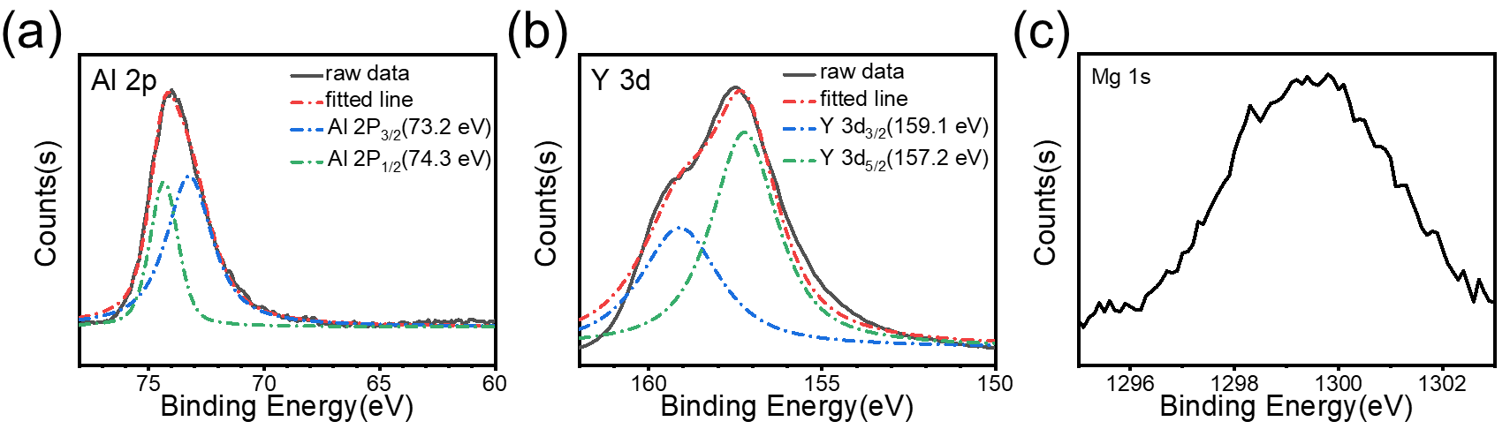
Fig. S4. High-resolution, (a) Al 2p, (b) Y 3d, and (c) Mg 1s peaks of the XPS spectra of YAG:0.2%Mn²⁺,4%Mg²⁺.

Table S3. The ratio of elements of XPS and the theoretical ratio.
Composition | Y | Al | Mg | O
Results of XPS | 0.148 | 0.267 | 0.025 | 0.560
Theoretical ratio | 0.15 | 0.246 | 0.004 | 0.600

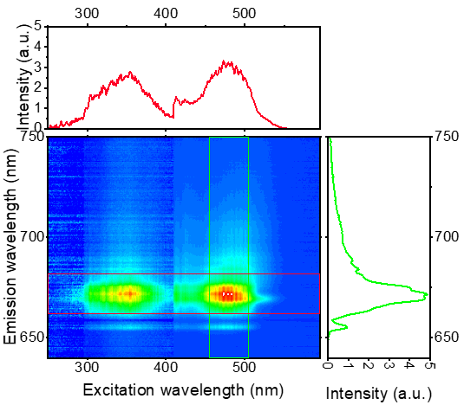
Fig. S5. Excitation–emission 2D contour mapping at 5 K.

Section S2. Density functional theory (DFT) calculations of YAG and YAG:Mn⁴⁺–Mg²⁺
Density functional theory (DFT) calculations were performed using the CASTEP code (version 2023). The Perdew–Burke–Ernzerhof (PBE) generalized gradient approximation (GGA) functional for solids (PBEsol) was employed to describe exchange–correlation interactions. Ultrasoft pseudopotentials were used for all elements (O, Mg, Al, Mn, and Y). A plane-wave basis set cutoff energy of 489.8 eV was applied. The system was treated as spin-polarized, with an initial fixed spin of 5.0 μB​ set for the Mn atom. The electronic minimization was performed with a convergence tolerance of 2.0 × 10⁻⁶ eV per atom.
The DOS for the YAG:Mn⁴⁺–Mg²⁺ exhibits additional spin-polarized states within the bandgap compared to undoped YAG (Fig. S6(c)). These states originate from the crystal field-split 3d orbitals of Mn⁴⁺ in an octahedral environment. And the Mn⁴⁺ split into the lower 3-fold degenerate t_{2g} and the higher 2-fold degenerate e_{g} orbitals in each spin direction. To further investigate the properties of Mn⁴⁺, the spin-polarized PDOS of Mn⁴⁺ was shown in the Fig. S6(d). Due to spin splitting, the degenerate states of spin-up and spin-down are created and have different energies. The splitting generates localized impurity states within the host bandgap. Since there are three electrons in the 3d orbitals of Mn⁴⁺, the up spin t_{2g} can be correlated with the ground state (⁴A₂) of Mn⁴⁺. When the electron is excited to the up spin e_{g}, it is equivalent to a spin-allowed transition, ⁴A₂ → ⁴T₁ and ⁴A₂ → ⁴T₂. And then, the electrons on the up spin e_{g} undergo relaxation to the down spin t_{2g}. Finally, electrons come back to the up spin t_{2g}. The process is equivalent to the non-radiative transition of the ⁴T₁ and ⁴T₂ excited states of Mn⁴⁺ to the ²E_{g} level, followed by a spin-blocking transition from ²E_{g} to ⁴A₂.

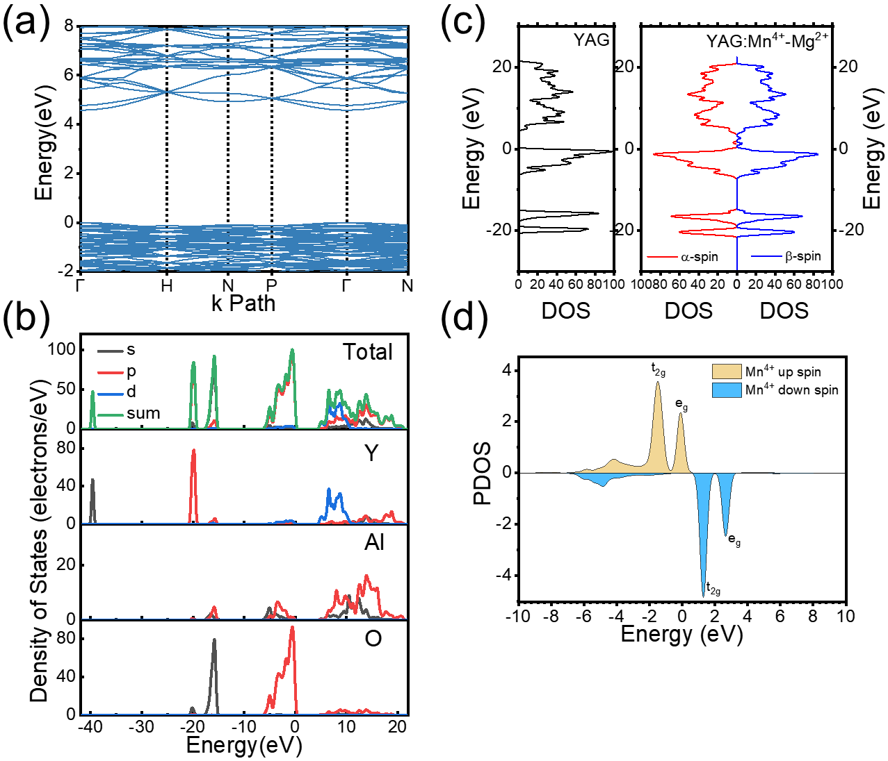
Fig. S6. (a) Band gap structure of YAG; (b) DOS and PDOS of YAG; (c) DOS comparison between YAG and YAG:Mn⁴⁺–Mg²⁺; (d) spin-polarized PDOS of Mn⁴⁺.

Section S3. Energies analysis of the Stokes PSBs
The PL of YAG:Mn⁴⁺–Mg²⁺ shows a complex structure, and there are 11 peaks in the spectrum. The peak 1 located at the higher wavenumber is ZPL. Other peaks below ZPL are PSBs generated by the coupling of ZPL and phonons. The characteristic phonon energies are listed in the E_{phonon} column (Table S4). The several vibrational modes at approximately 131, 175, 380, and 576 cm⁻¹ closely correspond to the characteristic phonon energies of the YAG lattice as reported in reference [1]. The 131 and 175 cm⁻¹ feature closely with the T_{2g} mode (110–150 cm⁻¹) was attributed to coupled Y³⁺/AlO₆ translational or low-frequency bending vibrations. The 380 cm⁻¹ feature corresponds to the A_{1g}/T_{2g} symmetric stretching vibrations of the AlO₆ octahedra (310–350 cm⁻¹), consistent with the dominant Raman-active modes of the host lattice.

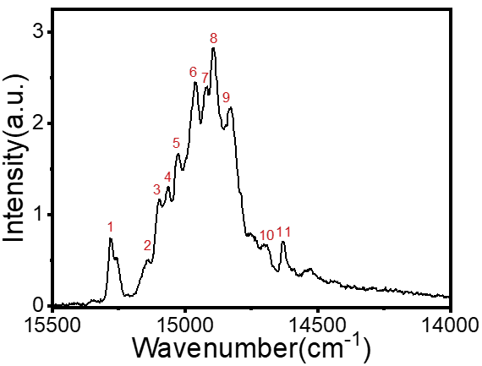
Fig. S7. Detailed PL spectrum of YAG:Mn,Mg at 10 K.

Table S4. PL peak information of YAG:Mn,Mg.
No. | Wavelength (nm) | Wavenumber (cm⁻¹) | E_{phonon} (cm⁻¹)
1 | 655 | 15 271 | 0
2 | 661 | 15 140 | 131
3 | 662 | 15 096 | 175
4 | 664 | 15 063 | 208
5 | 666 | 15 025 | 246
6 | 668 | 14 960 | 311
7 | 670 | 14 919 | 352
8 | 672 (main peak) | 14 891 | 380
9 | 674 | 14 827 | 444
10 | 681 | 14 695 | 576
11 | 684 | 14 629 | 642

Table S5. Quenching temperature T_{1/2} (K) and ⁴A₂ → ⁴T₂ energy (cm⁻¹) for Mn⁴⁺-doped oxides phosphors [2].
No. | Host lattice | ⁴A₂ → ⁴T₂ energy (cm⁻¹) | T_{1/2} (K)
1 | Mg₄GeO₆ | 23 697 | 730
2 | Mg₂₈Ge_{7.5}O₃₈F₁₀ | 23 923 | 700
3 | K₂Ge₄O₉ | 21 739 | 373
4 | La₃GaGe₅O₁₆ | 21 413 | 420
5 | La₂ZnTiO₆ | 19 608 | 230
6 | La₂MgTiO₆ | 20 000 | 250
7 | CaZrO₃ | 18 500 | 300
8 | Mg₆As₂O₁₁ | 23 810 | 680
9 | Sr₄Al₁₄O₂₅ | 22 222 | 423
10 | SrLaAlO₄ | 19 231 | 300
11 | LiGa₅O₈ | 20 000 | 350
This work | Y₃Al₅O₁₂ | 20 794 | 254

Section S4. Analysis of relationship between quenching temperature and ⁴A₂ → ⁴T₂ transition energy
The overall trend aligns well with the linear relationship,
$y=-1484.83+-0.090x$
where y is the quenching temperature T_{1/2}, and x is the ⁴A₂ → ⁴T₂ transition energy. It is can be seen that T_{1/2} increases with the energy of the ⁴A₂ → ⁴T₂ transition. And YAG:Mn,Mg obtained in this work represents a relatively low T_{1/2​}, yet still falls within the prediction interval, confirming consistency with the observed trend.

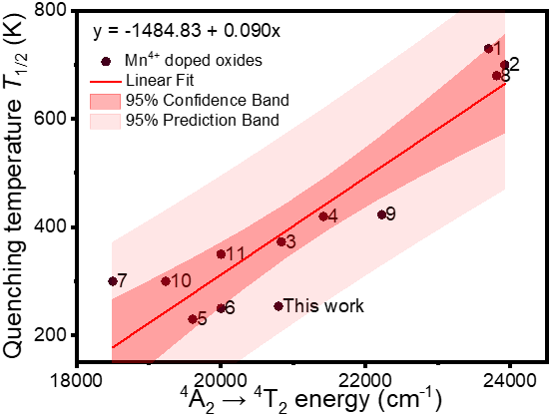
Fig. S8. Quenching temperature T_{1/2} of Mn⁴⁺-doped oxides phosphors as a function of the ⁴A₂ → ⁴T₂ transition energy.

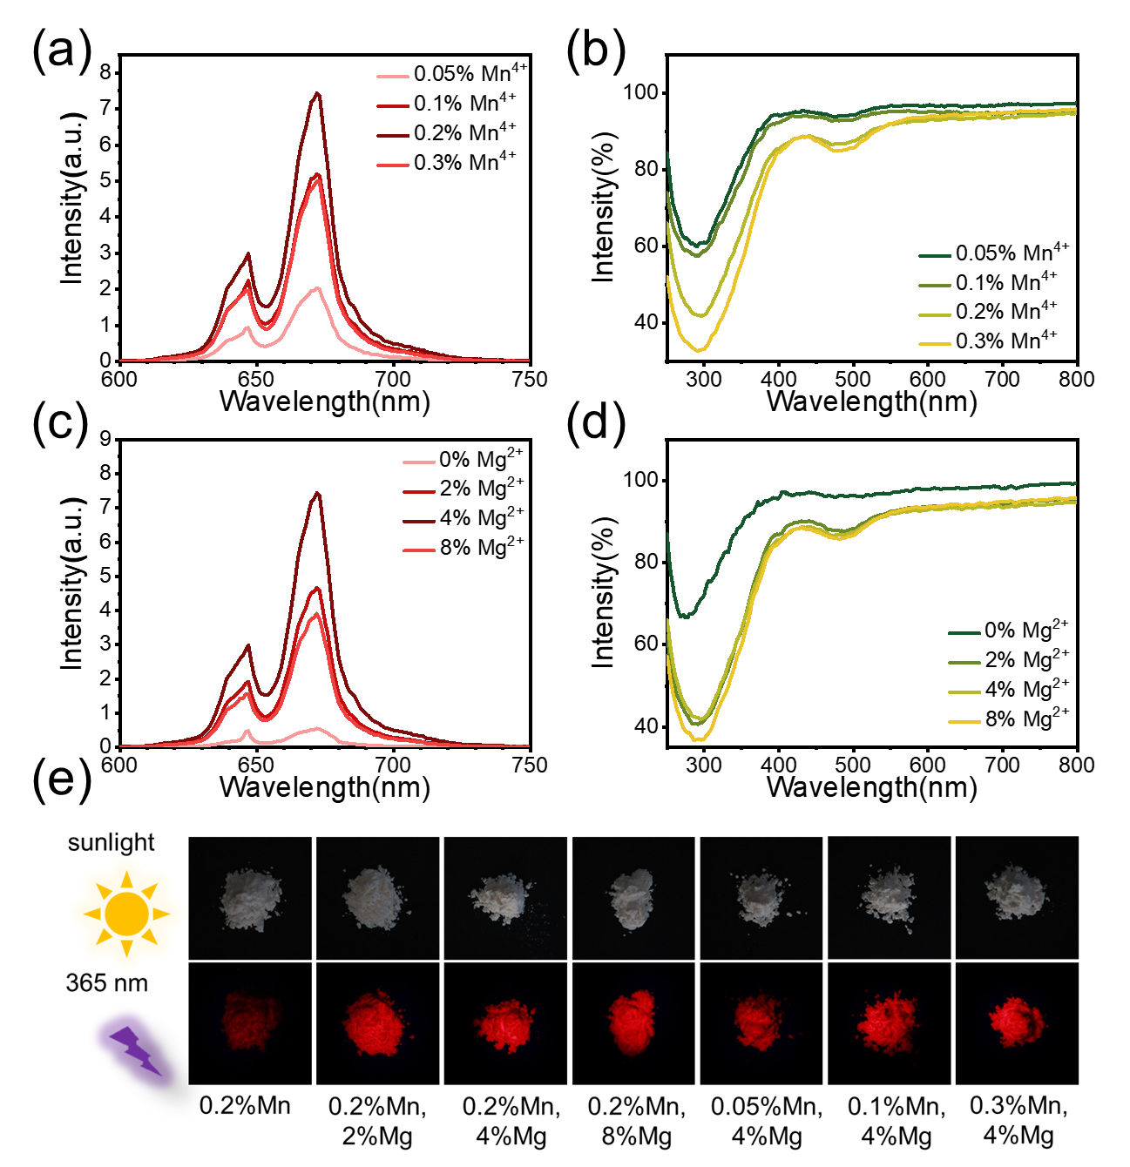
Fig. S9. (a) PL spectra and (b) diffuse reflectance spectra of YAG:xMn⁴⁺–4%Mg²⁺; (c) PL spectra and (d) diffuse reflectance spectra of YAG:0.2%Mn⁴⁺–yMg²⁺; (e) the figure of YAG:xMn⁴⁺–yMg²⁺.
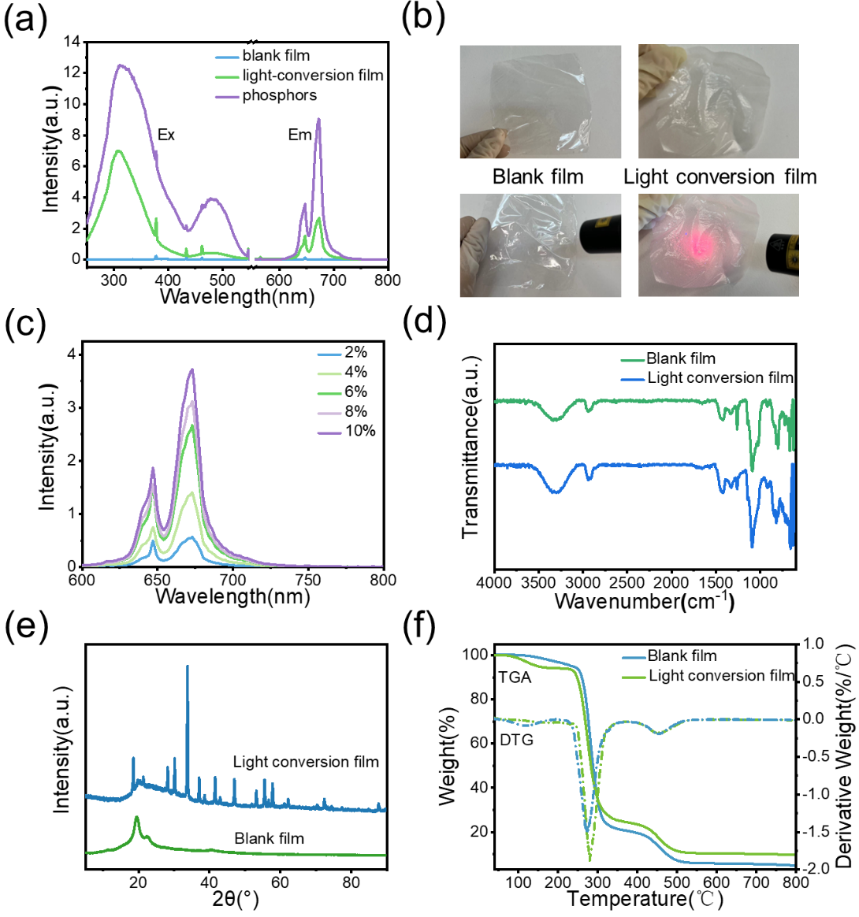
Fig. S10. (a, c) PL spectra and (b) pictures of light conversion film; (d) FTIR spectra, (e) XRD spectra, and (f) TGA curves of films.

References
[1] Poulos M, Giaremis S, Kioseoglou J, Arvanitidis J, Christofilos D, Ves S, et al. Lattice dynamics and thermodynamic properties of Y₃Al₅O₁₂ (YAG). J Phys Chem Solids 2022;162:110512.
[41] Toby BH. EXPGUI, a graphical user interface for GSAS. J Appl Crystallogr 2001; 34(2):210–13.

