Supplementary data for

Nanobubbles for the Mitigation of Composite Fouling in Wastewater Distribution Systems
Yang Xiao ^{a,b}, Bo Zhou ^{a,b}, Siyuan Tan ª, Lei Li ^{c}, Tahir Muhammad ª, Buchun Si ª, Changjian Ma^{d}, Sunny C. Jiang ^{e,}*, Yunkai Li ^{a,b,}*
ª College of Water Resources and Civil Engineering, China Agricultural University, Beijing 100083, China
^{b} Engineering Research Center for Agricultural Water-Saving and Water Resources (Ministry of Education of the People’s Republic of China), China Agricultural University, Beijing 100083, China
^{c} School of Environment and Civil Engineering, Dongguan University of Technology, Dongguan 523808, China
^{d} State Key Laboratory of Nutrient Use and Management, Institute of Agricultural Resources and Environment, Shandong Academy of Agricultural Sciences, Jinan, 250100, China
^{e} Department of Civil and Environmental Engineering, University of California-Irvine, Irvine, CA 92617, USA

* Corresponding author.
E-mail address: sjiang@uci.edu (C. Jiang), yunkai@cau.edu.cn (Y. Li)

This file includes:
Supplementary Information Section S1 to S3;
Supplementary Figs. S1 to S15;
Supplementary Tables S1 to S7.

Section S1
Nanobubbles (NBs) physical and chemical properties were characterized by concentration, bubble size including medium size, D10 and D50 size, bubble specific surface area (SSA), and surface pressure (ΔP). D10 size is the average bubble’ size in the lower 10% of all bubbles, and D50 size is the lower 50% of all bubbles. The concentration and sizes of NBs were tested by Nano-Particle tracking analysis (NanoSight NS300, Marlern, UK), and the distribution curves are shown in Fig. S1. SSA and ΔP are obtained by Eq. (1) and Eq. (2), respectively.
Eq. (1)
Where, A_{NB} and V_{NB} are the surface area and volume of NBs, r is the radius of NBs, m.
Eq. (2)
Where, σ is the surface tension, N m⁻¹, and r is the radius of NBs, m.

Section S2
Water pH and ORP were measured using a portable Mettler Toledo meter (Zurich; Type: S8-Field Kit) with different electrodes. Electrical conductivity (EC) was measured using DDSJ-319L conductivity meter (Manufacturer: Leici, China). Surface tension (ST) was determined by a surface tensiometer (Manufacturer: Huakun, China; Type: DT-102A). Chemical oxygen demand (COD) was tested by fast digestion-spectrophotometric method according to China Standard (No. HJ 828-2017). Biochemical oxygen demand (BOD) was determined by dilution and seeding method based on China Standard (GB/T 7488-1987). Zeta Potential (ZP) was tested by a Delsa Nano C analyzer (Manufacturer: Beckman Coulter, USA). AHPC was measured following the protocols of China national standard (No. GB4789.2-2016, plate counting method). Hydroxyl radical was tested by an electron spin resonance spectrometer (Manufacturer: Bruker, U.S.; Type: EMS Plus).

Section S3
The 16S rRNA genes (V3-V4) were amplified using the primers 338F (ACTCCTACGGGAGGCAGCAG) and 806R (ACTCCTACGGGAGGCAGCAG) [1]. The PCR amplicons were detected on a 2 percent agarose gel, purified using AxyPrep DNA Gel Extraction Kits (Axygen Biosciences, USA). The sequencing library was built using the NEXTFLEX® Rapid DNA-Seq Kit (Bioo Scientific, USA) and sequenced on the NovaSeq PE250 platform. The Fastp programme (https://github.com/OpenGene/fastp, version 0.20.0) [2] was used to control the quality of raw sequences, and FLASH software (http://www.cbcb.umd.edu/software/flash, version 1.2.7) [3] was used during the sequence assembly. The operational taxonomic units (OTUs) were clustered by the UPARSE pipeline (http://drive5.com/uparse/, version 7.1) [4] at 97% similarity. Silva 16S rRNA gene databases (v138) were used to annotate the species. Six replicates were tested for each experimental group.

Network analysis was performed to understand microbial interactions among the bacterial communities recovered from the foulants. An online platform (http://ieg4.rccc.ou.edu/mena/login.cgi) [5] was used to establish the networks for each group. Parameters described by [6] were selected to evaluate the topological characteristics of the networks, including R² of power law, network size, average connectivity, average clustering coefficient, average geodesic distance, and modularity. See Table S2 for additional information of the parameters. In addition, Gephi software (Version 0.9.1) was used to visualize the obtained networks. The topological roles of the OTUs in networks were determined by their connectivity within a module and among modules. OTUs were divided into four categories, including ordinary OTUs, module OTUs, connector OTUs, and network OTUs [7]. Their meaning and determination method are shown in Table S3.

A null-model-based framework [8] was used to assess the contributions of the ecological processes in community assembly. The change in phylogenetic community composition was described by βnearest-taxa index (βNTI), which was determined by an online pipeline (http://mem.rcees.ac.cn:8080). A value of |βNTI| > 2 implies that the community is mainly assembled by deterministic professes. If |βNTI| < 2, Bray−Curtis-based Raup−Crick (RC_{bary}) was further applied to evaluate the community assembly. Following the values of βNTI and RC_{bary}, five ecological processes that govern the microbial community structure were divided, including homogeneous selection, heterogeneous selection, homogenizing dispersal, dispersal limitation, and drift. The detailed determining method is described in Table S4.

Supplementary Figures
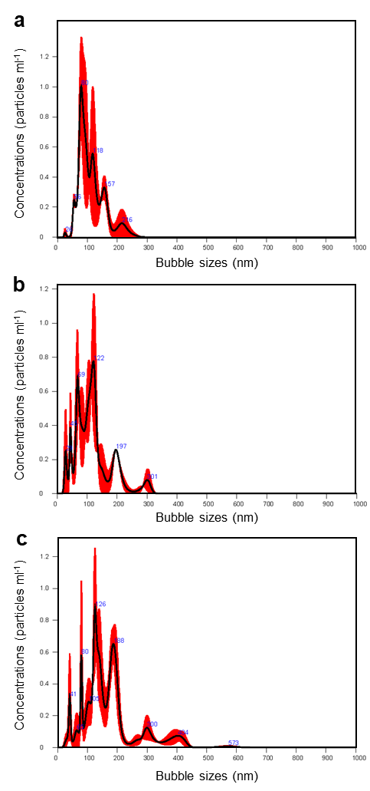

Fig. S1. Size distribution of saturated nanobubbles (NBs) in feed water. a, b, c are the results of NBs made from oxygen (O₂), helium (He), and nitrogen (N₂), respectively.

Fig. S2. Remove efficiencies of NBs on various foulants over time.

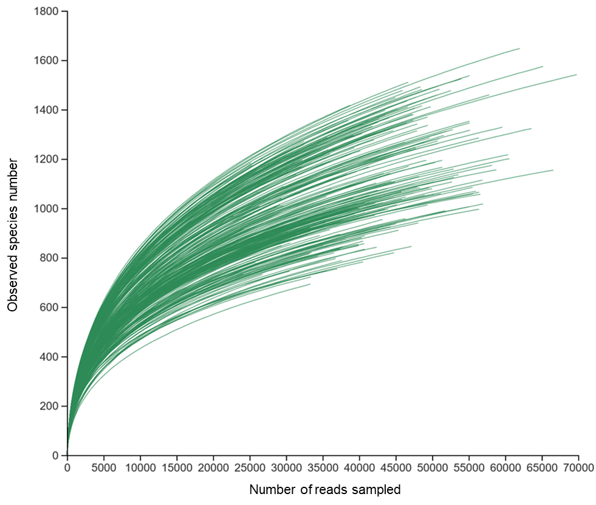

Fig. S3. Rarefaction curves of the sequenced microbial communities.

Fig. S4. Non-metric multidimensional scaling (NMDS) results of microbial communities. The labels are presented in Table 1. T1 (circles), T2 (squares) and T3 (triangles) represents three sampling timepoints at 300h, 600h and 900h.

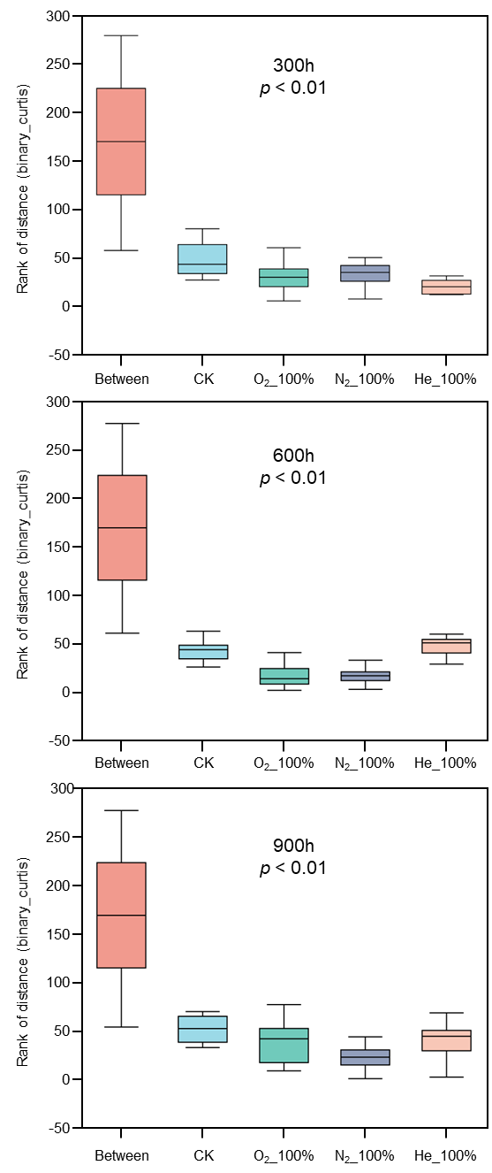

Fig. S5. Analysis of similarities (ANOSIM) among NB treatments by different gas types and controls (CK).

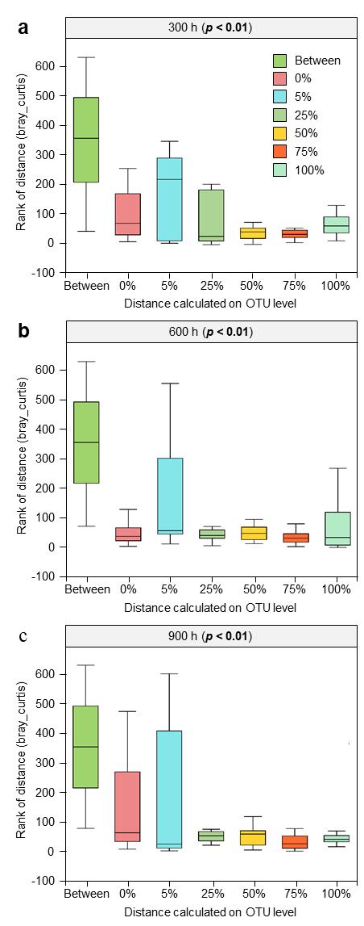

Fig. S6. Analysis of similarities (ANOSIM) among different oxygen NB concentrations.
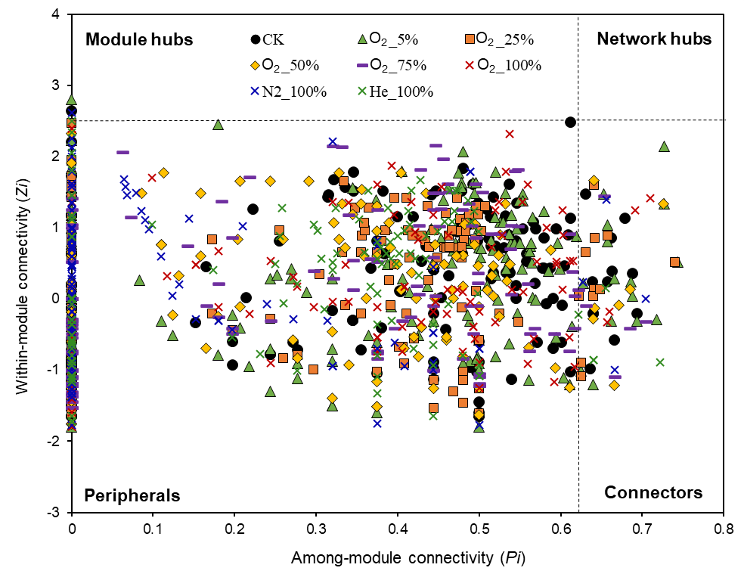

Fig. S7. Z-P plot of microbial networks.

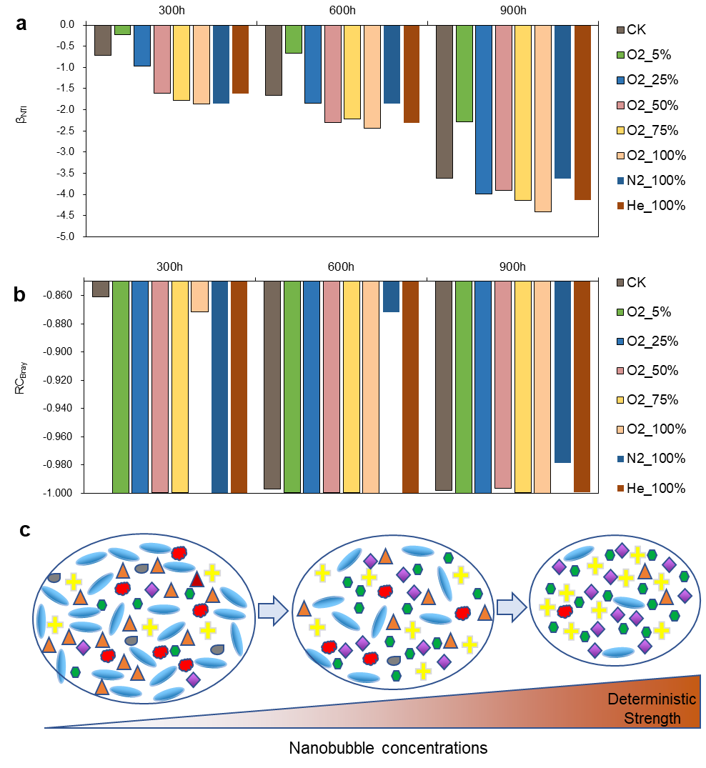

Fig. S8. Null model simulation of microbial communities. (a) and (b) are the variations of β_{NTI} and RC_{Bray} obtained by null model simulations. (c) shows the microbial community determinism process enhanced with the increase of nanobubble concentration and operation time.

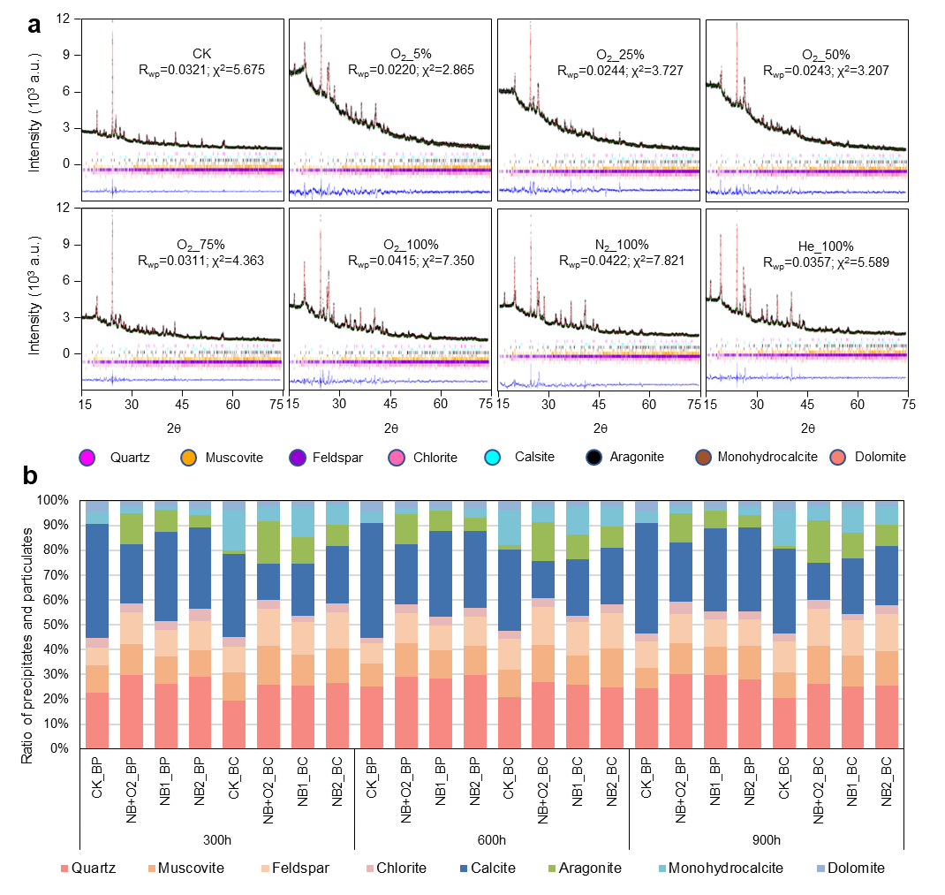
Fig. S9. The composition and ratio of particulates and salt precipitations in fouling. (a) Example of the X-ray diffraction (XRD) pattern taken at 900 h. Minerals (including particulates and precipitations) are depicted by color for quartz (SiO₂), Muscovite (K(Mg,Al)_{2.04}(Si_{3.34}Al_{0.66})O₁₀(OH)₂), Feldspar (KNaAlSi₃O₈), Chlorite ((Mg,Al)₆(Si,Al)₄O₁₀(OH)₈), Calcite (CaCO₃-R); Aragonite (CaCO₃-O); Monohydrocalcite (CaCO₃·H₂O) and Dolomite (CaMg(CO₃)₂). (b) Ratios of different minerals.

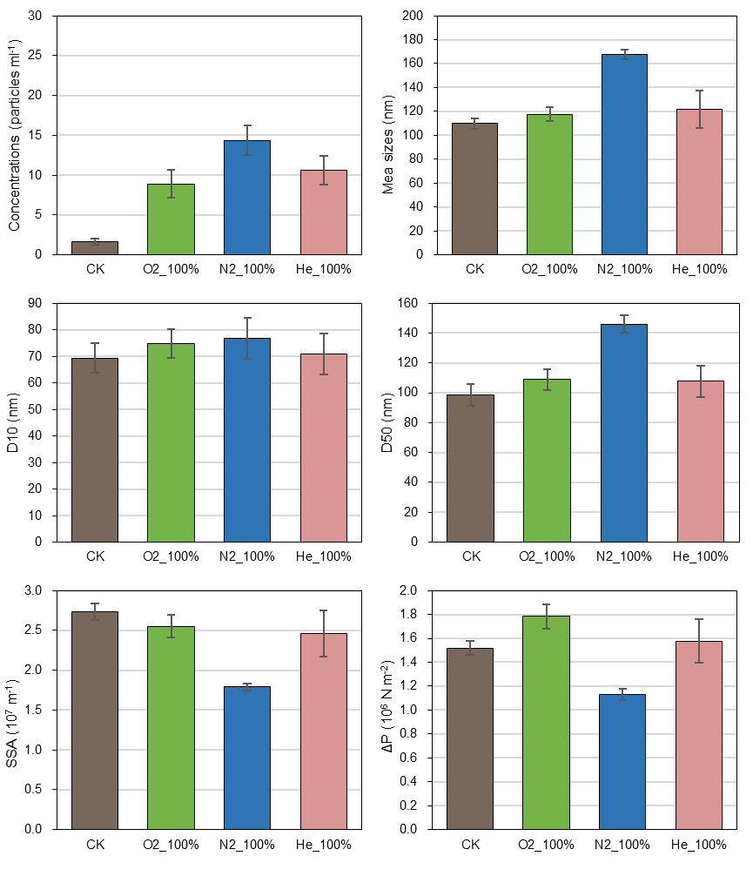

Fig. S10. Bubble properties for different saturated nanobubble groups. Specific surface areas (SSA), and additional surface pressures (ΔP).
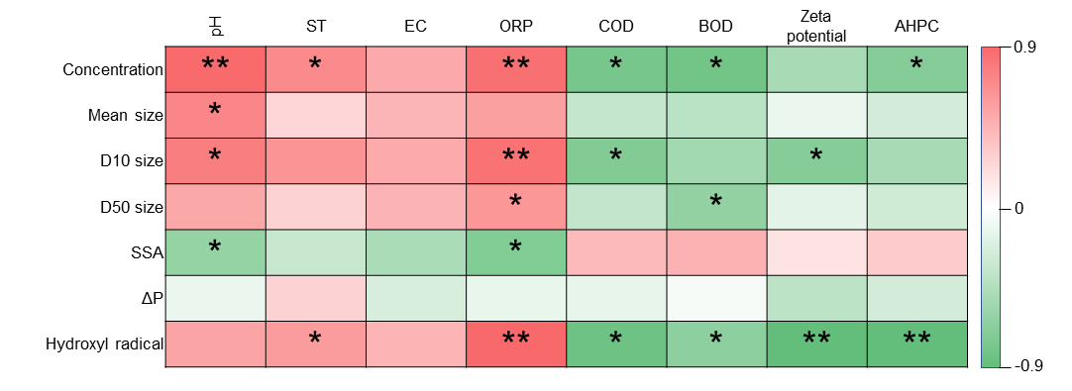

Fig. S11. Spearman correlations between bubble properties and water quality. The correlations were derived from the treatments of CK, O₂_100%, N₂_100%, and He_100%, because varied concentrations of oxygen nanobubbles had the same bubble characteristics (with the exception for bubble concentrations). Water quality in different experiment groups, including water pH, surface tension ST, electrical conductivity EC, oxidation reduction potentials ORP, zeta potential ZP, chemical oxygen demand COD, biochemical oxygen demand BOD and aerobic heterotrophic plate count AHPC, hydroxyl radical is represented by the highest intensity of ESR signal patterns. Specific surface areas (SSA), and additional surface pressures (ΔP). *, p < 0.05; **, p < 0.01.

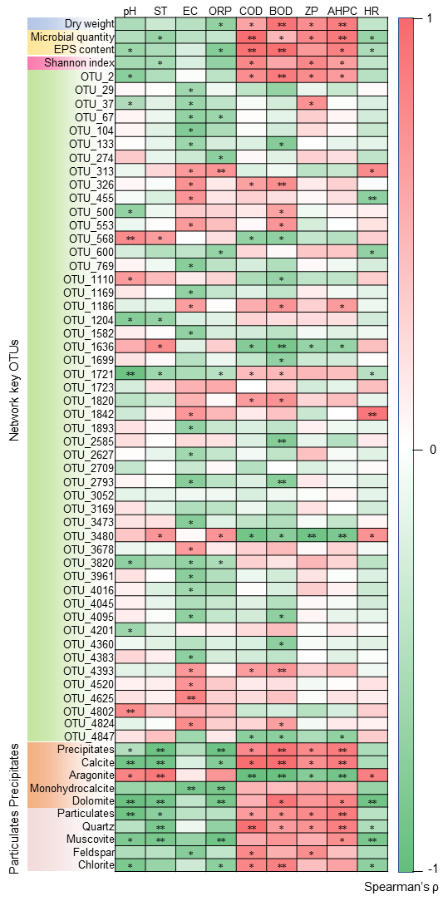

Fig. S12 Correlations between water quality and various foulants. EC, electrical conductivity; ST, surface tension; ORP, oxidation reduction potentials; ZP, zeta potential; COD, chemical oxygen demand; BOD, biochemical oxygen demand; AHPC, aerobic heterotrophic plate count; HR, the max values of hydroxyl radicals in electron spin resonance signal patterns. Transition from positive (red) to negative (green) correlation is shown on the color scale bar on the right. * and ** represent p < 0.05 and p < 0.01.

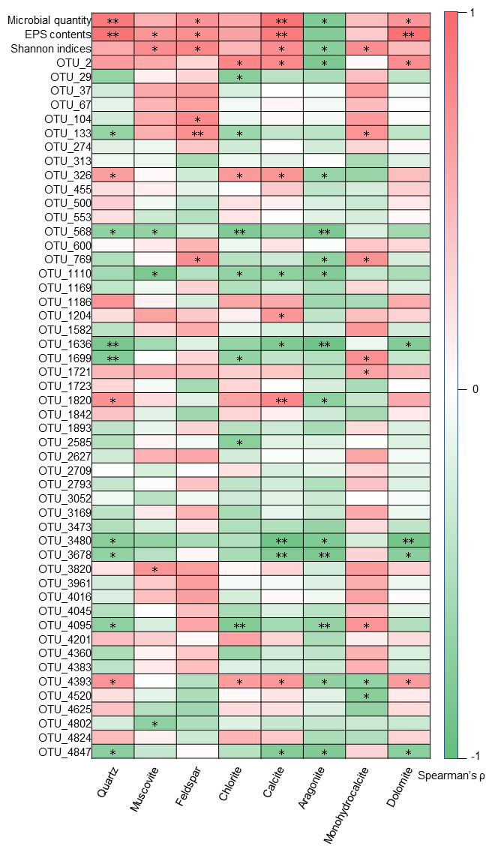

Fig. S13. Correlations between biological parameters and content of precipitates and particulates. Transition from positive (red) to negative (green) correlation is shown on the color scale bar on the right. * and ** represent p < 0.05 and p < 0.01.

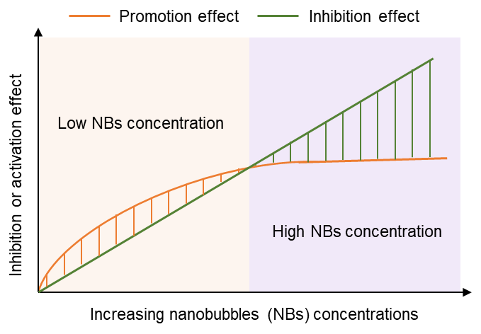

Fig. S14. Illustration of the inhibition and promotion effects of NBs on the growth of microorganisms.

Fig. S15. Effect of NBs on the deposition of particles. “Beginning” stands for the initial wastewater particle concentration, and the remaining bars stand for the particle concentrations after 4 h of NB-infusion. In control group (CK), no-NBs was added to the wastewater.

Supplementary Tables

Table S1. Water quality of the experimental water before NBs infusion.
Water quality characteristics | Average values
Total Hardness / TH (mg L⁻¹) | 669.4±81.3
Total Nitrogen / TN (mg L⁻¹) | 75.2±9.1
Total Phosphorus / TP (mg L⁻¹) | 6.09±0.48
Total Organic Carbon / TOC (mg L⁻¹) | 201.4±23.6
Chemical Oxygen Demand / COD (mg L⁻¹) | 410.0±76.3
Biochemical Oxygen Demand / BOD (mg L⁻¹) | 135.1±23.5
pH | 8.03±0.27
Electrical Conductivity / EC (mS cm⁻¹) | 2.21±0.24
Oxidation-Reduction Potential / ORP (mV) | -37.1±37.3
Surface Tension / ST (mN m⁻¹) | 83.3±9.3
Concentration of CO₃²⁻+HCO₃⁻ (mg L⁻¹) | 272.8±26.4
Concentration of PO₄³⁻ (mg L⁻¹) | 5.7±1.1
Concentration of NO₃⁻ (mg L⁻¹) | 22.6±0.4
Concentration of Ca²⁺ (mg L⁻¹) | 356.6±45.8
Concentration of Mg²⁺ (mg L⁻¹) | 357.4±45.1
Concentration of Fe³⁺ (mg L⁻¹) | 7.3±0.5
Note: The values represent for average ± standard deviation of water quality parameters. Water quality parameters during the experiment were tested at every 100 h. The testing methodologies are listed as follows. The total hardness (CaCO₃) was tested by EDTA titration method (No. GB/T 7477-1987); Total nitrogen (TN) was determined by alkaline potassium persulphate digestion-UV spectrophotometric method (No. HJ 636-2012); Total phosphorus (TP) was tested by ammonium molybdate spectrophotometry (No. GB/T 11893-1989); Total organic carbon (TOC) was tested by combustion oxidation non dispersive infrared absorption method (No. HJ 501-2009); The content of COD and BOD were tested by fast digestion-spectrophotometric method (No. HJ 828-2017) and dilution and seeding method (No. GB/T 7477-1987); pH and oxidation reduction potentials (ORP) were tested by a portable pH or ORP meter (Manufacturer: Mettler Toledo, Zurich; type: S8-Field Kit) with different electrodes; Electrical conductivity (EC) was measured by a conductivity meter (Manufacturer: Leici, China; type: DDSJ-319L); Surface tension (ST) was determined by a surface tensiometer (manufacturer: Huakun, China; type: DT-102A); The content of HCO₃⁻ was measured by acid-base indicator titration method; The content of PO₄³⁻ was determined by ammonium molybdate spectrometric method (No. GB/T 6913-2008); The content of PO₄³⁻ was tested by ultraviolet spectrophotometry method (HJ/T 346-2007); The contents of Ca²⁺, Mg²⁺, and Fe²⁺ were determined by inductively coupled plasma-atomic emission spectrometry (No. HJ 776-2015).

Table S2. Topological indexes in microbial networks.
Indexes | Description
R² of power law | It was used to describe the findings that most nodes in a network have few neighbors while few nodes have a large amount of neighbors.
Network size (n) | Total nodes in a network, one node stands for one OTU.
Average connectivity (avgK) | A higher average connectivity means a more complex network.
Average clustering coefficient (avgCC) | It shows how well a node is connected with its neighbors; the value ranges from 0 (non-connected) to 1 (fully connected).
Average geodesic distance (avgGD) | A smaller distance means all the OTUs (nodes) in the network are closer.
Modularity (M) | Modularity was used to describe the modularization degree of a network.

Table S3. Topological roles of OTUs (nodes) in microbial networks.
Node types | Properties | Meaning | Z and P values
Ordinary OTUs | Peripheral nodes | Whose links mainly stayed within their own modules. | Z < 2.5, P < 0.62
Module OTUs | Generalists | OTUs are highly connected within an individual module. | Z > 2.5, P < 0.62
Connector OTUs | Generalists | OTUs are highly connected among several modules. | Z < 2.5, P > 0.62
Network OTUs | Supergeneralists | OTUs are highly connected within an individual module and among several modules. | Z > 2.5, P > 0.62
Note: Z and P represent the interconnection within a module and among modules; a higher value means a higher connectivity.

Table S4. Ecological processes govern the community assembly.
Ecological processes | βNTI values | RC_{bary} values
Homogeneous selection | βNTI < -2 | —
Heterogeneous selection | βNTI > 2 | —
Homogenizing dispersal | |βNTI| < 2 | RC_{bary <} -0.95
Dispersal limitation | |βNTI| < 2 | RC_{bary} > 0.95
Drift/Undominated | |βNTI| < 2 | |RC_{bary}| < 0.95
Note: βNTI, β nearest-taxa index; and RC_{bary}, Bray−Curtis-based Raup−Crick.

Table S5. Permutational multivariate analysis of variance (PERMANOVA) within groups.
Comparation | Groups | Indexes | Df | Sums of Sqs | Mean Sqs | F. Model | R² | Pr (>F)
300h  NB types | CK | Group_factor  Residuals  Total | 3  20  23 | 1.3289867  1.8095207  3.1385075 | 0.4429956  0.0904760  - | 4.896275  -  - | 0.423445  0.576555  1 | < 0.01
300h  NB types | O₂_100%
300h  NB types | N₂_100%
300h  NB types | He_100%
300h  NB concentrations | O₂_0% | Group_factor  Residuals  Total | 5  30  35 | 1.2948799  0.6141488  1.9090288 | 0.2589751  0.0204716  - | 12.65048  -  - | 0.6782925  0.3217074  1 | < 0.01
300h  NB concentrations | O₂_5%
300h  NB concentrations | O₂_25%
300h  NB concentrations | O₂_50%
300h  NB concentrations | O₂_75%
300h  NB concentrations | O₂_100%
600h  NB types | CK | Group_factor  Residuals  Total | 3  20  23 | 1.0603843  1.9002096  2.9605938 | 0.3534613  0.0950142  - | 3.720237  -  - | 0.358166  0.641834  1 | < 0.01
600h  NB types | O₂_100%
600h  NB types | N₂_100%
600h  NB types | He_100%
600h  NB concentrations | O₂_0% | Group_factor  Residuals  Total | 5  30  35 | 1.0341357  0.3729235  1.4070592 | 0.2068271  0.0124308  - | 16.6383035  -  - | 0.7349624  0.2650375  1 | < 0.01
600h  NB concentrations | O₂_5%
600h  NB concentrations | O₂_25%
600h  NB concentrations | O₂_50%
600h  NB concentrations | O₂_75%
600h  NB concentrations | O₂_100%
900h  NB types | CK | Group_factor  Residuals  Total | 3  20  23 | 0.8660372  1.8391163  2.7051482 | 0.2886794  0.0919567  - | 3.139335  -  - | 0.320144  0.679856  1 | < 0.01
900h  NB types | O₂_100%
900h  NB types | N₂_100%
900h  NB types | He_100%
900h  NB concentrations | O₂_0% | Group_factor  Residuals  Total | 5  30  35 | 1.1260225  0.3688006  1.4948231 | 0.2252045  0.0122933  - | 18.3192058  -  - | 0.7532814  0.2467185  1 | < 0.01
900h  NB concentrations | O₂_5%
900h  NB concentrations | O₂_25%
900h  NB concentrations | O₂_50%
900h  NB concentrations | O₂_75%
900h  NB concentrations | O₂_100%
Note: Df, degree of freedoms; Sums of Sqs, sums of S squares deviations; Mean Sqs, mean square deviations; F. Model, F means test values; R² indicates the interpretation degree of sample differences with different groups; Pr < 0.05 indicates significant difference. In addition, O₂_0% is the same as control group (CK).

Table S6. Topological properties of microbial networks.
Groups | Similarity threshold | R2 of power law | Network sizes (n) | Total links | Average connectivity | Average clustering coefficient | Average path distance | Modularity
CK | 0.85 | 0.746 | 196 | 1456 | 14.857 | 0.357 | 2.821 | 0.435
O₂_5% | 0.85 | 0.823 | 216 | 1921 | 17.787 | 0.441 | 2.546 | 0.471
O₂_25% | 0.85 | 0.797 | 210 | 1651 | 15.723 | 0.376 | 2.712 | 0.411
O₂_50% | 0.85 | 0.812 | 180 | 1090 | 12.111 | 0.338 | 3.183 | 0.468
O₂_75% | 0.85 | 0.768 | 169 | 861 | 10.189 | 0.306 | 3.367 | 0.399
O₂_100% | 0.85 | 0.841 | 157 | 669 | 8.522 | 0.275 | 3.647 | 0.419
N₂_100% | 0.85 | 0.857 | 163 | 732 | 9.753 | 0.314 | 3.525 | 0.445
He_100% | 0.85 | 0.805 | 173 | 804 | 11.951 | 0.325 | 3.448 | 0.457

Table S7. Module hubs and connectors and key bacteria in microbial networks.
Groups | Generalists | OTU ID | Bacteria
CK | Module hubs | OTU_2793 | s__uncultured_bacterium_g__norank_f__norank_o__Bacteroidetes_VC2.1_Bac22
CK | Connectors | OTU_29 | s__unclassified_g__Turicibacter
CK | Connectors | OTU_274 | s__uncultured_bacterium_g__Luteococcus
CK | Connectors | OTU_769 | s__unclassified_f__Peptostreptococcaceae
CK | Connectors | OTU_1204 | s__Romboutsia_ilealis
CK | Connectors | OTU_1723 | s__uncultured_bacterium_mle1-9
CK | Connectors | OTU_1820 | s__uncultured_bacterium_g__Ornithinimicrobium
CK | Connectors | OTU_1842 | s__metagenome_g__norank_f__norank_o__R7C24
CK | Connectors | OTU_2041 | s__unclassified_g__Anaerovorax
CK | Connectors | OTU_2627 | s__unclassified_g__Xanthobacter
CK | Connectors | OTU_2709 | s__unclassified_g__Hydrogenophaga
CK | Connectors | OTU_2756 | s__uncultured_Sedimentibacter_sp._g__Sedimentibacter
CK | Connectors | OTU_3820 | s__metagenome_g__Hyphomicrobium
O₂_5% | Module hubs | OTU_553 | s__metagenome_g__norank_f__Xanthobacteraceae
O₂_5% | Connectors | OTU_133 | s__uncultured_bacterium_g__Desulfobulbus
O₂_5% | Connectors | OTU_500 | s__metagenome_g__norank_f__Xanthobacteraceae
O₂_5% | Connectors | OTU_1110 | s__unclassified_g__Glutamicibacter
O₂_5% | Connectors | OTU_1582 | s__uncultured_Roseomonas_sp._g__Roseomonas
O₂_5% | Connectors | OTU_1636 | s__Fermentimonas_caenicola
O₂_5% | Connectors | OTU_2310 | s__unclassified_g__Corynebacterium
O₂_5% | Connectors | OTU_2585 | s__unclassified_g__Flavobacterium
O₂_5% | Connectors | OTU_3169 | s__uncultured_bacterium_g__Flavobacterium
O₂_5% | Connectors | OTU_3961 | s__unclassified_g__Turicibacter
O₂_5% | Connectors | OTU_4016 | s__unclassified_g__Gemmatimonas
O₂_5% | Connectors | OTU_4045 | s__unclassified_f__Rhizobiaceae
O₂_5% | Connectors | OTU_4360 | s__unclassified_g__IMCC26207
O₂_5% | Connectors | OTU_4383 | s__uncultured_sludge_bacterium_g__norank_f__AKYG1722
O₂_5% | Connectors | OTU_4802 | s__unclassified_f__Rhodobacteraceae
O₂_5% | Connectors | OTU_4824 | s__unclassified_g__Corynebacterium
O₂_25% | Connectors | OTU_2 | s__uncultured_bacterium_g__Mesorhizobium
O₂_25% | Connectors | OTU_1110 | s__unclassified_g__Glutamicibacter
O₂_25% | Connectors | OTU_1169 | s__uncultured_prokaryote_g__norank_f__Spirochaetaceae
O₂_25% | Connectors | OTU_1431 | s__uncultured_bacterium_g__Raineyella
O₂_25% | Connectors | OTU_1699 | s__uncultured_bacterium_g__Dechlorobacter
O₂_25% | Connectors | OTU_1721 | s__uncultured_Clostridia_bacterium_g__Hydrogenispora
O₂_25% | Connectors | OTU_2585 | s__unclassified_g__Flavobacterium
O₂_25% | Connectors | OTU_3473 | s__Rhodobacter_sphaeroides_2.4.1
O₂_25% | Connectors | OTU_4095 | s__unclassified_g__Clostridium_sensu_stricto_1
O₂_25% | Connectors | OTU_4360 | s__unclassified_g__IMCC26207
O₂_25% | Connectors | OTU_4393 | s__Corynebacterium_xerosis
O₂_50% | Connectors | OTU_452 | s__uncultured_bacterium_g__Pseudaminobacter
O₂_50% | Connectors | OTU_769 | s__unclassified_f__Peptostreptococcaceae
O₂_50% | Connectors | OTU_1893 | s__uncultured_bacterium_g__Desulfomicrobium
O₂_50% | Connectors | OTU_3480 | s__unclassified_f__Comamonadaceae
O₂_50% | Connectors | OTU_4201 | s__uncultured_bacterium_g__Ilumatobacter
O₂_50% | Connectors | OTU_4520 | s__Dietzia_lutea
O₂_50% | Connectors | OTU_4847 | s__bacterium_QTYC46b
O₂_75% | Connectors | OTU_67 | s__unclassified_f__Peptostreptococcaceae
O₂_75% | Connectors | OTU_1431 | s__uncultured_bacterium_g__Raineyella
O₂_75% | Connectors | OTU_3052 | s__unclassified_g__norank_f__Gemmatimonadaceae
O₂_75% | Connectors | OTU_3678 | s__uncultured_bacterium_g__Ornithinicoccus
O₂_75% | Connectors | OTU_4625 | s__unclassified_f__Rhodobacteraceae
O₂_100% | Connectors | OTU_313 | s__uncultured_Gemmatimonas_sp._g__Gemmatimonas
O₂_100% | Connectors | OTU_1186 | s__Bdellovibrio_bacteriovorus
O₂_100% | Connectors | OTU_1820 | s__uncultured_bacterium_g__Ornithinimicrobium
O₂_100% | Connectors | OTU_3473 | s__Rhodobacter_sphaeroides_2.4.1
N₂_100% | Module hubs | OTU_326 | uncultured_bacterium_g__Aquabacterium
N₂_100% | Connectors | OTU_37 | unclassified_g__norank_f__Rikenellaceae
N₂_100% | Connectors | OTU_104 | unclassified_g__Pseudomonas
N₂_100% | Connectors | OTU_344 | unclassified_f__Hyphomicrobiaceae
N₂_100% | Connectors | OTU_568 | uncultured_bacterium_g__norank_f__Caldilineaceae
N₂_100% | Connectors | OTU_1533 | uncultured_bacterium_g__DSSF69
He_100% | Module hubs | OTU_568 | uncultured_bacterium_g__norank_f__Caldilineaceae
He_100% | Connectors | OTU_1533 | uncultured_bacterium_g__DSSF69
He_100% | Connectors | OTU_455 | uncultured_bacterium_g__norank_f__Caldilineaceae
He_100% | Connectors | OTU_600 | uncultured_bacterium_g__Camelimonas
He_100% | Connectors | OTU_4049 | Nitrosomonas_europaea

References
1. Gu, X., et al., Fusobacterium nucleatum causes microbial dysbiosis and exacerbates visceral hypersensitivity in a colonization-independent manner. Frontiers in microbiology, 2020. 11: p. 1281.
2. Chen, S., et al., fastp: an ultra-fast all-in-one FASTQ preprocessor. Bioinformatics, 2018. 34(17): p. i884-i890.
3. Magoč, T. and S.L. Salzberg, FLASH: fast length adjustment of short reads to improve genome assemblies. Bioinformatics, 2011. 27(21): p. 2957-2963.
4. Edgar, R.C., UPARSE: highly accurate OTU sequences from microbial amplicon reads. Nature methods, 2013. 10(10): p. 996-998.
5. Kong, X., et al., Dibutyl phthalate contamination remolded the fungal community in agro-environmental system. Chemosphere, 2019. 215: p. 189-198.
6. Deng, Y., et al., Molecular ecological network analyses. BMC Bioinformatics, 2012. 13(1): p. 113.
7. Olesen, J.M., et al., The modularity of pollination networks. Proceedings of the National Academy of Sciences, 2007. 104(50): p. 19891-19896.
8. Stegen, J.C., et al., Quantifying community assembly processes and identifying features that impose them. The ISME journal, 2013. 7(11): p. 2069-2079.

